Non-market impacts are the expected costs and benefits of an initiative that can’t be easily measured in dollar terms. Nevertheless, these impacts are often critical to whether a proposal would generate net social benefit and need to be incorporated into economic assessments.
Key points
- Non-market impacts can be broadly defined as changes to goods and services not traded in traditional markets. Examples of non-market impacts include changes in amenity, liveability, recreation, brand and animal welfare.
- It is important to include estimates of non-market impacts in economic assessments where possible to ensure the efficient allocation of public resources.
- There are several valuation methods that can be used to value non-market impacts. Some methods are versatile in measuring non-market impacts while others are more limited in scope. All methods have advantages and disadvantages.
- There are two main approaches to primary non-market valuation:
  - Revealed preference techniques rely on actual, observed market behaviour to derive non-market values, e.g. hedonic pricing and the travel cost method.
  - Stated preference techniques rely on asking people how much they would value changes to non-market goods and services in hypothetical situations, e.g. contingent valuation and choice modelling.
- The validity of revealed preference methods is more widely accepted than for stated preference methods.
- The predominant secondary valuation technique is benefit transfer. Benefit transfer is not a valuation method itself, but rather a technique for applying available estimates of non-market values to new policy contexts.
- The accuracy of benefit transfer may be low unless the primary study relates to a similar context and environment.

Introductory concepts
What are non-market values and non-market impacts and why are they important?
Many goods and services that are valued by society do not have a readily identifiable monetary (dollar) value, primarily because they are not traded in traditional markets. For example, the benefit an individual feels from viewing a piece of public art, or the benefit to society of bees pollinating plants, or the benefit of knowing that we can leave a healthy environment to our children.
Despite this, the value that individuals have for these goods and services can be empirically proven to exist. Such goods and services are termed as having ‘non-market values’ (NMV). While NMVs may not be easily measured in dollar terms, these goods and services are often quantifiable in other units, albeit sometimes only indirectly.
‘Non-market impacts’ (NMI) are the changes in non-market values due to a project or investment. Some commonly cited examples of non-market impacts arising from government policies and initiatives include changes in ‘amenity’, ‘wellbeing’ or ‘liveability’.
As noted in the Department of Treasury and Finance (DTF) Economic Evaluation for Business Cases Technical Guidelines, cost-benefit analysis (CBA) is the preferred approach for the evaluation of alternative investment proposals by government. CBA compares future costs and benefits using the common metric of market prices (a monetary unit). It is thus problematic for traditional CBA when the impacts of policies and initiatives do not have a monetary value attached to them.
The omission of relevant non-market impacts on either the benefit or cost side can distort options from an optimal outcome. Where NMVs are prevalent (as either a benefit or a cost), but the CBA of a policy or initiative is restricted to market impacts, then the analysis will be incorrect and welfare may in fact be reduced rather than enhanced by the initiative.
This guidance has been developed based on a report prepared for the Department of Economic Development, Jobs Transport and Resources by Jacobs Group and is designed to assist analysts in identifying and assessing the significance of non-market impacts when undertaking economic assessments based on:
- the nature of the non-market impact;
- the scale of the initiative; and
- whether value for money will be achieved through undertaking a valuation study.
Guidance is provided to determine whether attempts should be made to monetise or quantify the impact and, if so, the appropriate approach to take.
Why is it important to incorporate non-market values and impacts into economic assessments?
People are sometimes uncomfortable with the idea of estimating non-market values in dollar terms.
However, while monetising non-market values and impacts can raise questions (and can be a challenging and expensive task), when government investment causes non-market impacts, it is important to fully assess these impacts to ensure that public resources are being allocated to generate overall benefit to society.
Overview of non-market values and non-market impacts
Economists use a concept called Total Economic Value (TEV) to define and categorise different values important to society (see Figure 1).
Figure 1. Total Economic Value framework
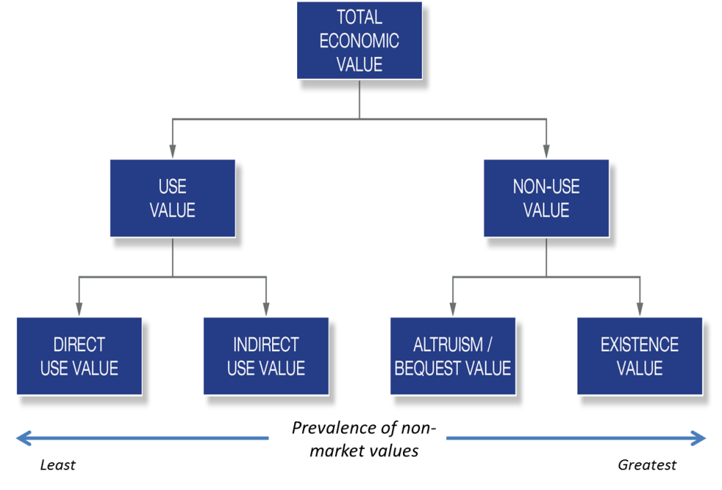
Use values
Use values come from the actual use of a good or service. Use values are more likely than other types of value to have a corresponding market activity that gives rise to a measure of value through a market price or return.
Use values can be categorised as either:
- Direct use values – resulting from direct human use of a non-market good or service. Examples include consumptive uses such as recreational fishing or attendance at a performance, or non-consumptive uses such as recreational use of a parkland or spiritual/cultural uses of the environment.
- Indirect use values – values people hold for vicarious and non-consumptive use of a good or service, even if one does not directly engage or consume that good or service. Examples include values placed on ecosystem regulation services such as water purification and soil fertility, watching a television programme about a cultural event, or the amenity value experienced from living near a rural landscape.
Indirect use values tend to be overlooked in a market setting but are sometimes reflected in market signals, for example, property prices influenced by proximity to attractive landscapes.
Non-use values
TEV also incorporates what are known as ‘non-use’ values. These include:
- Altruism and bequest values – the value an individual attaches to others’ current or future use of a good or service (either in this generation or future generations). For example, an individual might value land being available for traditional uses, or intergenerational equity in employment.
- Existence value – this is satisfaction gained from merely knowing that a non-market good or service exists. Examples of pure existence values include values placed on landscape, animal welfare, cultural heritage and social cohesion.
Which values are more likely to be non-market?
The prevalence of non-market values as part of TEV is greatest in the following value types, in order of greatest to least prevalence:
- Existence values
- Altruism/bequest values
- Indirect use values
- Direct use values – non-consumptive
For these types of values there is typically not direct reference to market prices, which makes valuation in economic terms much harder. For some values there is not even a reliable ‘behavioural trace’ that is suggestive of these values. For example, if someone often visits a gallery it may be possible to infer the recreational, direct use value derived from the gallery by observing the amount of money and time they devote to visiting the gallery. However, if someone values the existence of a cultural festival or a regional landscape but does not visit it, they might not exhibit any behaviour from which this value could be inferred – whether in monetary or quantitative or other terms.
Methods available to quantify or monetise non-market impacts
There are two basic ways to estimate how much people value non-market goods and services: researchers can observe behaviour to impute the dollar value in related markets or directly ask people how much they value a given non-market good or service.
Some methods are versatile in measuring non-market impacts while others have a more limited scope. All methods have their advantages and disadvantages. Appendix A contains a summary and comparison of each approach.
The aim of this guide is to provide an introduction to the main methods used.

Primary valuation techniques
Primary valuation techniques involve the collection of primary data through original research of non-market values for the specific policy, project or investment.
- Revealed preference studies
Revealed preference studies rely on actual, observed market behaviour to derive non-market values. The main revealed preference study methods are the travel cost method and hedonic pricing. The defensive expenditure method is also used, albeit less commonly.
Limitations: These revealed preference methods are only able to estimate use values. Non-use values are divorced from actual, observable market behaviour and therefore remain unrevealed.
Travel cost
The travel cost method is most commonly applied to valuing the environmental amenity associated with specific locations. Travel cost relies on a ‘behavioural trail’ to infer the existence of an otherwise invisible non-market value.
The travel cost method uses the cost (including time) that people incur to travel to a particular site (such as a national park) to derive the value they obtain from the visit. Surveys are used to collect data on the costs incurred by people.
The travel cost method often presumes a value of travel time, in addition to out of pocket expenses incurred such as petrol costs and on-site expenditures such as park entry fees. Travel time costs are generally taken to be a fraction of the average wage rate.
Limitations: Without clearly stated assumptions about travel time costs, studies are difficult to compare. Multiple motivations to travel or multiple destinations per trip may also obscure or confound the value attributed to a site, which provides researchers with further difficulties regarding how to attribute costs to various assets.
Hedonic pricing
Hedonic pricing derives non-market values from a ‘market trace’ with property prices being the most common example. It involves estimating implicit prices for a number of features that make up a good’s market price. The method has often been used to estimate environmental amenity values by analysing nearby house prices, whether in terms of a positive (e.g., near a park) or negative (e.g., near an airport flight path) impact.
This method exploits the fact that the prices of some market goods comprise a bundle of attributes that include non-market elements and uses statistical techniques to identify the implicit prices paid for those attributes.
For example, most hedonic pricing studies use regression analysis to ‘decompose’ house prices into the contributions that come from key characteristics, including size and layout (such as size, or number of bathrooms), location (such as proximity to transport, schools or parks) and non-market attributes (such as air quality, local amenity or social cohesion). This provides estimates of the implicit ‘price’ of each non-market attribute, which indicates how much house buyers would be willing to pay for one additional unit of the non-market attribute.
Limitations: The main problem with the technique is that hedonic pricing will always be limited to a small range of non-market goods and services that can be directly related to the price of specific marketed goods. Welfare measures such as consumer surplus and willingness to pay for a larger change in attributes cannot be calculated because of statistical complications and the strength of assumptions required.
Other revealed preference methods
Defensive expenditure method – also known as avoided cost or averting behaviour, this method infers the value that people place on non-market outcomes by examining what they pay to avoid or mitigate negative impacts. For example, the amount of money people spend on double-glazing windows could be used as a proxy for the costs of traffic noise.
- Stated Preference studies
Stated preference studies rely on researchers directly asking respondents about their willingness to pay or willingness to accept compensation for hypothetical changes to non-market goods or services. That is, respondents are asked to ‘state’ their preferences from which a value is estimated. Because stated preference studies rely on surveys rather than on observed behaviour, they can be used to estimate a range of non-use values.
The most common stated preference studies are:
- Contingent Valuation
- Choice Modelling
Contingent Valuation
Contingent valuation is a straightforward method which asks respondents about their willingness to pay (WTP) for a hypothetical change in a non-market good or service, or the minimum compensation they are willing to accept (WTA) to forego the change.
Various methods may be used to elicit a WTP or WTA amount, including a yes-no choice of accepting or rejecting a suggested amount. For example, questions could be presented in the following way:
- Are you willing to pay $20 per annum to preserve your local library?
- What amount are you willing to pay to attend an exhibition in your local town hall?
- How much would you be willing to accept in compensation for a reduction in air quality?
The changes to non-market good or service should be described in clear, unambiguous terms and within a relevant context.
A contingent valuation study may vary the hypothetical ‘payment vehicle’ for the willingness to pay amount. The payment vehicle is the method by which respondents’ payment would be hypothetically collected (e.g., an admission price to an event, utility bill or annual tax bill). Payment vehicles should be as realistic as possible.

Choice Modelling
Choice modelling (sometimes called choice experiments) presents individuals with a number of alternative scenarios, the attributes of which contain variations in a non-market attribute and a cost to the survey participant. A base case or ‘no policy change’ option is always presented as an option. By varying the levels of the attributes and presenting people with several choice sets, statistical methods can be used to quantify the trade-offs that people make between attributes (including calculation of implicit prices).
For example, a choice questionnaire for valuing Australian wetlands could ask: What management option would you prefer: A, B or C?
Attributes | Option A | Option B | Option C (no change)
Wetland conserved | 1000 ha | 800 ha | 700 ha
Bird species conserved | 40 | 30 | 25
Farm jobs protected | 15 | 16 | 20
Cost to household in local taxes over next 5 years | $30 / household | $15 / household | $0 / household

From responses to this questionnaire, researchers would be able to statistically calculate willingness to pay estimates for changes in the non-market attributes. In this example, those attributes are: area of wetland conserved, number of bird species protected and number of farm jobs protected.
Choice modelling is particularly useful when a range of policy options with different non-market outcomes are being compared.
Limitations of stated preference techniques
The robustness of stated preference methods is highly contentious, especially when used to estimate non-use or existence values. Stated preference techniques are subject to numerous potential biases and designing and commissioning a quality study is a costly and time-consuming exercise. Choice modelling in particular is much more complex to design and analyse than contingent valuation, but both methods require extremely careful design, planning, implementation and analysis of results in order to minimise potential problems.
Potential biases include:
- Anchoring / starting point bias – respondents’ answers are influenced by initial starting values.
- Strategic bias – respondents deliberately misrepresent their true willingness to pay (or willingness to accept) in order to manipulate the results. For example, if a respondent believes that their WTP response will result in a payment being collected this can cause the respondent to understate their true willingness to pay. On the other hand, if the respondent believes payment will only be collected from others, this can have the effect of overstating their WTP.
- Status quo bias – tendency for respondents to choose the ‘do nothing’ option for reasons other than utility differences between the ‘do nothing’ and other choice options.
- Hypothetical setting bias – the possibility that responses in a hypothetical setting are not consistent with reality (i.e., talk is cheap).
- Payment vehicle bias – where respondents’ bids may vary depending on the acceptability of the payment method, e.g., income tax, entrance fees, higher utility charges.
- Information effects –the type and amount of information given to respondents biases the value estimates provided.
- Yay / nay saying – where respondents are concerned with pleasing or countering interviewers.
- Protest responses – where refusal to answer may give ludicrously high WTP or untrue zero WTP (protest zeroes).
Table 1 presents a comparison of contingent valuation and choice modelling based on their key features.
Table 1. Comparison of Contingent Valuation and Choice Modelling
Key Feature | Contingent Valuation | Choice Modelling
Capacity to elicit values for a range of goods or services | May provide a more robust willingness-to-pay estimate of overall total value for a complex package of goods and services  Questionnaires can be adapted to break down overall willingness-to-pay to provide indicative values for a range of different components of value | Is best suited to surveys that attempt to ascertain marginal values for particular attributes (i.e., the value of a change from X to Y rather than the total value of an attribute).  However, only between five and six attributes including price can be assessed at one time. This may be fine for simple, familiar goods, but is less appropriate for a large, complex mix of goods.  Can be subject to the ’package problem’ where the value of the good/service in question is not necessarily equal to the sum of its parts. This may lead to over-estimation of the total value of the environmental good.
Amount of effort required | Requires far less pre-survey analysis and time to design the questionnaire | High. May be more suitable for use in benefit transfer, although some practitioners have debated this.
Capacity to test different variables through use of scenarios to minimise bias | Prone to certain biases. Unlike choice modelling, has the ability to look at only limited scenarios in one study. | Prone to certain biases. Is generally better at looking at a range of alternative scenarios

- Revealed versus stated preference techniques
As a general rule, estimates derived from observing behaviour in markets tends to be more credible than estimates elicited from survey questionnaires. Survey respondents may have little incentive to take the question seriously, or invest in obtaining the information necessary to answer it accurately or to answer questions truthfully. The Commonwealth Government’s Cost-benefit guidance note and United Kingdom Treasury’s Green Book recommend revealed preference techniques over stated preference techniques.
Secondary valuation techniques
In an ideal world primary research would estimate the specific non-market impacts of any given policy or investment proposal. However, primary research is costly and time consuming. Secondary valuation techniques are instead commonly used to estimate values from existing sources of non-market value estimates.
Benefit Transfer
Benefit transfer refers to the application of non-market values developed from other studies to a new context. In removing the need for primary research, benefit transfer can reduce the time and cost associated with estimating the economic values of changes to non-market goods and services.
There is a need to exercise care when transferring data from one study to another. Divergence in time, space and context between the original study and the current application should be as minimal as possible. Transferred values can be adjusted to account for differences in key variables; however, as a general rule, the more significant the policy issue, the more care is needed in transferring values from another study to minimise errors.
A shortage of suitable primary studies in Australia is likely to mean benefit transfer can only reliably used in a limited range of circumstances.
The following presents a list of key criteria for determining whether primary values would be suitable for use in benefit transfer:
- The primary study should be statistically sound, with a sufficient sample size and other design aspects that support the production of valid and reliable results (as should be the case for any stated or revealed preference study). If the original study is suspected of bias, its findings are clearly inappropriate to be reapplied elsewhere.
- The characteristics of the two non-market impacts (i.e. the original and current application) should be highly similar.
- The marginal change in the provision of benefits from the non-market good should be highly similar.
- The range of substitutes between the original and the current application should be similar, or allowed to be controlled for/adjusted prior to application. A willingness to pay for a unique or rare non-market impact is likely to be higher than for one which is more common, and hence adapting a value from elsewhere where it is relatively less/more rare is likely to reduce/increase its value.
- The characteristics of the population of the original study (including factors such as disposable income, age, education levels, etc.) should be comparable or differences should be accounted for through adjustments to unit values.
- The primary study should be as recent as possible (ideally within ten years).
Step-by-step guidance for addressing non-market impacts in an economic assessment
The first steps in any economic assessment are to define the problem and desired outcomes, develop the base case, and outline the options for implementing the initiative (solution). The following sections outline how to address any non-market impacts relevant to your economic assessment once these initial steps are complete.
Step 1. Identify and describe all costs and benefits (both market and non-market impacts)
Once you have defined the problem, developed the base case and decided on the best options for implementing the initiative, all expected costs and benefits for each project option should be identified and described.
It may help to consider previous similar initiatives and the types of costs and benefits associated with those. Reviewing past economic assessments may also provide an indication of how easily the non-market impacts can be quantified or monetised.
A range of potential non-market impacts are outlined below in Table 2 to assist analysts in exploring the different costs and benefits that may arise through government investment or policy decisions.
Table 2. Examples of non-market impacts
Use Value |  | Non-use value
Direct use value examples | Indirect use value examples | Bequest value examples | Existence value examples
Lifestyle  Health and well-being  Access  Comfort  Safety  Time savings  Recreation  Education  Research | Environment  Scenic amenity  Productivity  Social inclusion  Innovation  Liveability  Branding  Institutional trust  Knowledge sharing | Resilient communities  Traditional land uses  Intergenerational equity of employment and production  Future employment  Others’ accessibility  Heritage | Landscapes  Conservation  Animal welfare  Cultural heritage  Aesthetics  Spirituality  Symbolism  Traditions  Community spirit

In identifying non-market benefits and costs and assessing their significance, it is necessary to address the following questions:
What are the origins of the non-market impact?
The origins of the non-market impact may be due to:
- divergence between private prices and public values (externalities) or between private prices and private values (consumer surplus), suggesting that using market prices will dramatically understate the value of the goods and services; or
- the existence of a public good/s.
What is the impact?
Has the impact been defined using a commonly accepted definition (e.g. social and community, brand, culture and heritage, environmental) and is the non-market impact related to use or non-use?
What form does the non-market impact take?
Form is defined by:
- When and where the impact occurs – is the non-market impact quantifiable in terms of location or time (when and for how long has it been occurring) or another accepted form of measurement? Is there evidence that the non-market value is, or would be, long-lived and enduring, or is likely to be short lived?
- Who is being impacted – is there a basis for confidence about how extensive it may be among society?
How might the non-market impact ‘respond’ (positively or negatively) to the proposed policy initiative or investment?
- Is the non-market impact potentially observable in actual market behaviour or prices? For instance, a willingness to travel to visit a site with free admission or an influence upon adjacent property prices?
- What evidence is there that this project or policy change will cause a (significant) change in non-market values?
- Are there other policy changes or programs that are confounding the impact of this project?
- Are there endogenous (background) changes occurring that will influence this non-market value irrespective of our policy?
- Is a linear, inverse or other relationship able to be demonstrated or inferred from past studies between our policy/project and non-market values?
Is it possible to determine a baseline (counterfactual) for the non-market impact?
- If possible, define a baseline or counterfactual (what would happen to the non-market goods or services in the absence of the policy) to understand what the effects of a project or intervention might be.
- When the baseline is known, it may be possible to value the marginal change in the non-market good or service as a result of the policy (adverse or beneficial) as opposed to assigning a total value to a non-market good or service. For example, if the desired policy outcome is to protect a certain landscape type, the starting point is not “what is the value of this landscape?”, but rather “what is the value of the increase in benefits if we enhance the landscape through these measures?”
Step 2. Assess whether the non-market impacts identified warrant valuation
All market impacts can be quantified and monetised using prices determined by the market. However, non-market impacts by their very nature cannot and monetising them can be time consuming and expensive. The key question here is whether the inclusion or exclusion of non-market impacts identified in Step 1 is likely to significantly change which option is selected (i.e. is material to the choice of options). If yes, the non-market impact in question warrants valuation.
There are two approaches to assessing how to best incorporate a non-market impact into an economic assessment. Each uses similar concepts. It may be worth working through both approaches, especially where the decision is marginal.
Approach 1: Criteria and scoring framework
This approach uses four criteria that influence whether a non-market impact should be addressed in an economic assessment:
- Scale of the initiative, e.g., the total value of the initiative or number of stakeholders affected
- Magnitude of non-market impacts relative to total costs and benefits
- Extent to which non-market values could be used in future economic assessments
- Cost of undertaking primary or secondary non-market valuation activity.
Each of these criteria receive a score based on whether you assess it as ‘high’, ‘medium’ or ‘low’. You can then calculate an overall score, which can be used to determine whether the non-market impacts should ideally be monetised or whether a qualitative (or other quantitative) approach is more appropriate. Table 3 describes the key considerations for each criterion.
Table 3: Key considerations for assessing whether to quantify/monetise a non-market impact
Question | Key Considerations
Scale  Question 1:  How significant is the scale or risk of the initiative? | The scale and risk of the initiative will be primarily determined based on:  - total project cost or grant amount  - factors such as the number of stakeholders to be affected by the initiative  - any risks or uncertainties.  It will be up to each portfolio area or business unit to determine the thresholds at which the scale or risk of an initiative is deemed to be ‘large’, ‘medium’ or ‘small’. Generally, the more significant the scale or risk, the more effort should go into conducting as robust an economic assessment as possible.
Magnitude of NMIs  Question 2:  What is the magnitude of the NMIs compared to the other costs and benefits and value of the initiative as a whole? | The magnitude of the non-market impact is determined by:  - how important the impact is to the stated policy objectives or goals of the initiative  - the extent to which excluding the non-market impact from the economic assessment may result in selection of a sub-optimal project option.  To assess the contribution that non-market impacts may make to the choice of option, consider:  - which costs and benefits are likely to drive the investment or policy decision.  - quantifying and comparing the NMIs to overall impacts (i.e., assessing whether the non-market benefits are likely to exceed the identified costs). Alternatively, a form of break-even analysis can be undertaken to assess how significant the non-market benefits would need to be to generate a net social benefit (provided that the costs of the project and any market impacts have already been estimated).  - reviewing the literature base and seeking views from others if there is any uncertainty about the potential for non-market impacts or the focus of the assessment. This is especially relevant if there is community/public debate regarding the potential policy or investment options.  - the potential for double counting. This can occur where non-market impacts are double counted with market impacts or other non-market impacts. For example, an investment in a sculpture garden may give rise to a greater level of (unpriced) enjoyment by visitors to the area. The impacts may be captured via a survey to monetise or quantify the impact. Additional consideration of any benefits to personal wellbeing of the same project would overlap with, if not duplicate, the same impacts.
Potential re-use  Question 3:  Could any estimated values for NMIs be used in the future? | - Some non-market impacts may commonly arise for a number of different projects and therefore the values obtained through a non-market valuation study for one project could be applied to future projects through benefit transfer techniques.  - The extent to which values can be used in future economic assessments should be a key consideration when deciding whether to value non-market impacts.
Cost  Question 4:  What is the cost of undertaking non-market valuation studies? | - For the non-market impact(s) identified, early investigations should be undertaken to assess the time and resources required to undertake primary or secondary non-market valuation studies and whether these approaches will enable an accurate valuation of the impact.  - Typically, secondary (benefit transfer) studies will be more cost-effective than primary research activities.  - Consideration should also be given as to whether the non-market values can be estimated robustly with confidence through the secondary or primary research activities proposed.
Overall assessment | - Where the scale of the initiative is large and non-market impacts are expected to contribute substantially to the choice of option, it is likely to be worthwhile for non-market valuation activities to be undertaken.  - Conversely, where the initiative is of a smaller scale and non-market impacts are likely to be incidental to the decision-making process, a qualitative description may suffice.  - In cases where the initiative is of a moderate scale and non-market impacts are expected to contribute to a reasonable proportion of the project’s benefits, it may be worthwhile to attempt to quantify those impacts.

Table 4 details the scoring framework for the assessment. Score each criterion from 1 to 3 based on whether you assess it as ‘high’, ‘medium’ or ‘low’. Next, calculate an overall score by summing the first three scores and subtracting the fourth from the sub-total. The overall score can then be used to determine whether the non-market impacts should ideally be monetised or whether a qualitative or other quantitative approach is more appropriate.
Table 4: Criteria and scoring framework for assessing when to value non-market impacts
Criteria | High | Medium | Low
Scale of initiative | 3 | 2 | 1
Magnitude of non-market impacts relative to total costs & benefits | 3 | 2 | 1
Extent to which non-market values could be used in future economic assessments | 3 | 2 | 1
Subtotal (A + B + C) =
Cost of undertaking primary or secondary non-market valuation activity relative to the cost of the initiative | 3 | 2 | 1
Overall score (Subtotal - D) =

If your overall score is:
Between 6-8: Consider non-market valuation techniques (see Step 3)
Between 4-5: Consider quantifying non-market impacts
Between 0-3: Consider qualitative description of non-market impacts

It is important to note that the framework should be used as a guide only and the unique characteristics of each project should be taken into account when assessing whether to monetise or quantify non-market impacts.

Approach 2: Decision tree
This approach steps you through a series of questions to help assess how to best incorporate any non-market impacts into an economic assessment.
Figure 2: How should a non-market impact be included in an economic assessment?
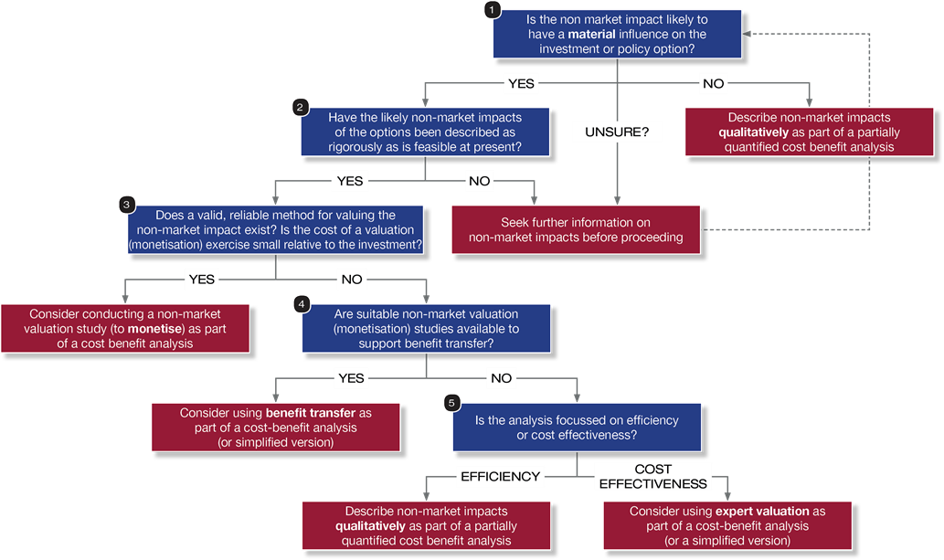
Table 5 steps you through each question.
Table 5: How should a non-market impact be included in an economic assessment?
Question | Key Considerations
Materiality/Significance  Question 1:  Are the non-market impacts in question likely to have a material influence on the choice of option? | - Do the stated policy objectives or goals relate to a non-market impact and therefore merit close consideration?  - Will excluding the non-market impact from the economic assessment result in selecting the wrong option and leading to unintended consequences?  - Can non-market impacts be included without being double counted?
If the answer to the majority of these materiality questions (each question of generally similar importance) is:
Yes – proceed with analysing what is already known about the potential non-market impacts (go to Question 2 – Have the likely non-market impacts of the options been described as rigorously as is feasible at present)
No – either describe the non-market impacts qualitatively as part of a partially quantified cost benefit analysis or seek further information on the non-market impacts
Causality  Question 2:  Have the likely non-market impacts of the options been described as rigorously as is feasible at present? | Are you able to answer the following questions about the non-market impact(s):  - What are the origins of the non-market impacts? (E.g. is the non-market impact related to public good(s) not captured in a market?)  - What is the impact? Has the impact been defined using a commonly accepted definition?  - What form does the non-market impact take? When and where is the impact occurring? Who is being impacted?  - How may the non-market impact ‘respond’ (positively or negatively) to the proposed policy initiative or investment?  - Are there other policy changes or programs which are confounding the impact of this project?  - Is it possible to determine a baseline (counterfactual) for the non-market impact?
Yes – Select the non-market impacts most likely to be affected by the policy and proceed to “Question 3 - does a valid, reliable method for valuing the non-market impact exist? Is the cost of a valuation (monetisation) exercise small relative to the investment?”
No – Seek further information on the non-market impacts before proceeding. Information/guidance may be sought from either review of past similar projects or policies, undertaking threshold value analysis and/or calculating replacement cost
Feasibility  Question 3:  Does a valid, reliable method for valuing the non-market impact exist? Is the cost of a valuation (monetisation) exercise small relative to the investment? | - Can the non-market impact be accurately valued?  - Are there a sufficient number of past primary valuation studies to inform or guide the accuracy of the proposed study?  - Are there sufficient reputable sources of data that can be used to inform/guide the accuracy of the proposed study?  - What is the cost of the study compared to the cost of the investment and the cost of choosing the wrong option?  - What is the cost and resources of a primary valuation study (stated or revealed preference valuation) relative to the overall expenditure on the policy? Is the cost affordable within departmental budgets?  - Are the costs and resources of a primary study to monetise non-market impacts regarded as less than the potential costs of choosing the wrong option?
Can the non-market impacts be accurately valued and the monetisation studies represent value for money:
Yes – proceed to selecting the most appropriate primary valuation technique
No – proceed to Question 4 – Are suitable non-market valuation (monetisation) studies available to support benefit transfer (secondary valuation technique)?
Secondary valuation study  Question 4: Are suitable non-market valuation (monetisation) studies available to support benefit transfer? | - Is the quality of preceding primary valuation studies sufficient to be used in a benefit transfer study?  - Are the preceding primary valuation studies sufficiently relevant to be used in a benefit transfer study? (E.g. differences in socio-economic circumstances, availability of market substitutes, timeliness.)
Are preceding primary valuation studies of sufficient quality and relevance:
Yes – Consider using Benefit Transfer as part of the economic assessment
No – Proceed to Question 5 – Is the analysis focused on efficiency or cost effectiveness?
Quantification and evaluation  Question 5:  Is the analysis focused on efficiency or cost effectiveness? | - Are there established indices or metrics that can be used to quantify the change in the non-market impact? If so use these to measure the non-market impact.  - Is the objective to measure the efficiency of addressing the non-market impact? If so use a cost efficiency measure.  - Is the objective to measure cost effectiveness of different options to address the non-market impact? If so use multi-criteria analysis.
Step 3. Select an appropriate valuation technique
A primary valuation study should be considered where:
- the scoring framework completed in Step 2 yields a score between 6 and 8. In other words, the non-market impact is material to the choice of option and valuation represents value for money given the scale of the investment
- there are no appropriate primary studies already completed which could be used to transfer values to the initiative under consideration (benefit transfer).
Where a primary valuation study is to be undertaken, the next decision point is choosing the most appropriate method to use. The decision tree in Figure 3 can be used to determine which valuation technique is most suitable for the particular non-market impact under consideration.
Figure 3. Decision Tree for selection of valuation study
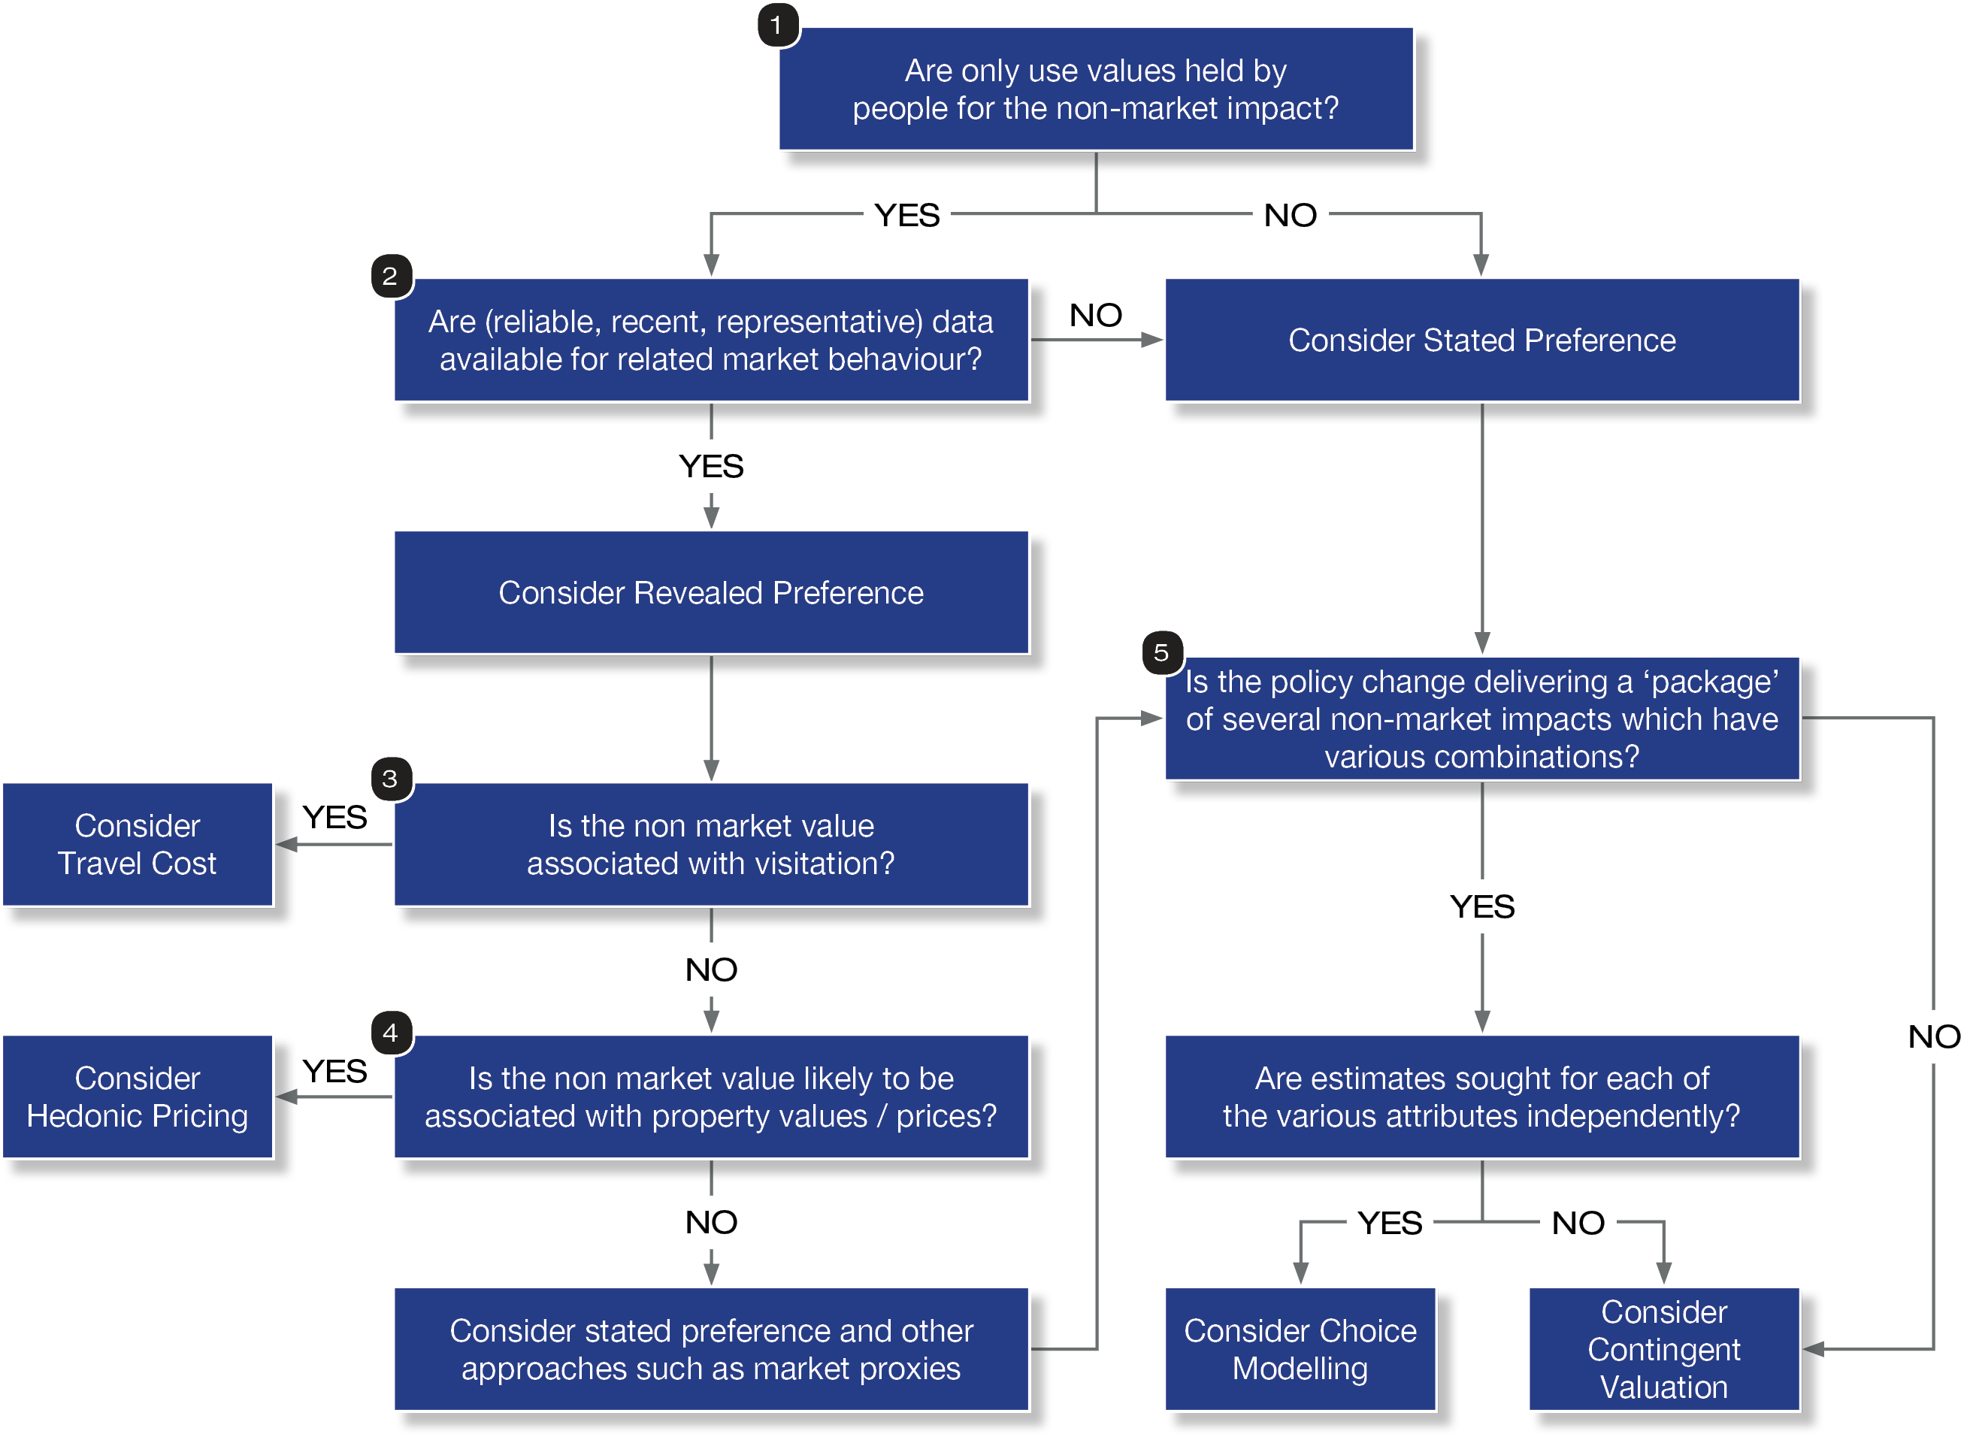

Table 6 steps you through each question.
Table 6: How to select the appropriate method to value a non-market impact
Question | Explanation
Question 1:  Are only use values held by people for the non-market impact? | - This question asks whether non-use values are relevant in addition to use values. If only use values are relevant, revealed preference methods such as the travel cost method and hedonic pricing, which rely on actual observed market behaviour, may be appropriate.  - If non-use values are relevant, revealed preference methods are inappropriate and stated preference techniques should be considered.
Yes – Only use values are relevant. Proceed to Question 2.
No – Non-use values are relevant. Consider a stated preference study and proceed to Question 5.
Question 2:  Are there reliable, recent and representative data available for related market behaviour? | - If use values are regarded as appropriate and sufficient to capture a non-market impact for an economic assessment, a revealed preference (or ‘observed behaviour’) approach is appropriate – but only if market data are available.  - These approaches derive monetary values for non-market impacts from actual, measurable and observable market transactions and behaviour. If the measures of market behaviour are not consistent, reliable, recent or relevant enough, a revealed preference study will not be possible to apply.  - For instance, a hedonic pricing method may appear to be the most suitable approach to infer values for a new public open space by measuring corresponding changes in property values within a short distance. However, if there are only very few actual property transactions recorded before or since, or if there are other known effects which may confound property values changes at the same time, the method won’t be useful.
Yes – Proceed to Question 3.
No – Consider a stated preference study and proceed to Question 5.
Question 3:  Is the non-market impact associated with visitation? | - If the non-market impact requires visitation or is associated with intentional, deliberate travel to enjoy its benefits, then the travel cost method is ideal.
Yes – Consider the travel cost method.
No – Proceed to Question 4.
Question 4:  Is the non-market impact associated with changes in property prices? | - Analysts should assess whether the non-market impact is associated with positive or negative changes in property prices. For example, aircraft noise is associated with reductions in property values while access to reliable public transport is associated with positives impacts on property prices.  - If the change isn’t associated with either visitation or a change in property prices, then revealed preference valuation studies are unlikely to provide a credible or reliable result and a stated preference valuation study should be considered instead.
Yes – Consider hedonic pricing.
No – Proceed to Question 5.
Question 5:  Is the policy change delivering a ‘package’ of several non-market impacts which have various combinations? | - Analysts should assess whether the policy change will lead to a set of non-market impacts or just one key non-market impact.
Yes – Numerous non-market impacts will be affected. Proceed to Question 6.
No – Impacts will be confined to one non-market impact. Consider contingent valuation.
Question 6:  Are estimates sought for each of the various attributes independently? | - If a proposed policy would affect a package of likely non-market impacts and individual values are also sought for each attribute, then choice modelling is the only stated preference technique which can estimate the value of each individual non-market impact individually.  - If a proposed policy would impact a single non-market impact or a single monetary estimate is sought for an impact to a bundle of non-market impacts, then contingent valuation is appropriate for estimating a single willingness to pay amount.
Yes – Consider choice modelling.
No – Consider contingent valuation.

How to plan and undertake a valuation study
When planning and undertaking a valuation study (to include non-market impacts as part of an economic assessment) the analyst should give consideration to:
- Designing quality primary valuation studies
- Ensuring double counting of benefits is avoided
- Outsourcing the primary valuation study
- Ensuring reliable and valid data inputs are sourced and used
- Reporting the results of the valuation study.
Appendices B and C provide checklists to guide the development of stated and revealed preference studies, respectively.
Designing quality primary valuation studies
Primary valuation studies require careful planning and design to deliver quality findings and results. Further guidance on designing and planning primary valuation studies is provided in Environmental Policy Analysis: A Guide to Non-Market Valuation (Baker and Ruting, 2014).
Avoid double counting of benefits
It is useful to classify different types of values to avoid the double counting of benefits.
Keep non-market impacts and economic production measures separate
Total Economic Value is a social welfare or ‘utility’ measure which is equal to the market price (or expenditure) plus the consumer surplus value (the additional benefit gained above what is ‘paid’). It is not comparable or additive with meaures of economic impact such as Gross Value Added or estimates of income which may be used to indicate value or an increased value of production within the economy. Measures of economic production such as GDP or GSP should not be added to estimates of Total Economic Value and monetised measures of consumer surplus should be estimated via stated or revealed preference studies.
There may also be benefits (or costs) included in a cost benefit analysis that are measured in terms of changes to productivity (not production as above). These wider economic impacts, which are referred to in the DTF Economic Evaluation for Business Cases Technical Guidelines (DTF, 2013, p.20) are most commonly assessed for transport projects which achieve a transformational scale of land use impact, but are also claimed to exist for other portfolios where impacts such as ‘innovation-spillover’ and ‘brand impact’ are more relevant. DTF guidance suggests that these productivity-related non-market impacts, which may be monetised by various methods, should be expressed separately from other, more direct cost-benefit outcomes, as they represent evolving areas of research which are still founded on a relatively small number of empirical case studies.
Can non-market impacts be included without the non-market impacts themselves being double counted?
If non-market impacts and their measurement are not adequately mapped out, there is a risk some calculated non-market impacts may cover the same impacts, resulting in double counting.
For example, an investment in a sculpture garden in a public open space may give rise to a greater level of enjoyment and utility by visitors and residents to the area. The impacts may be captured via assessment of the direct benefits expressed by visitors and residents via a survey to monetise or quantify the impact. Additional consideration of any ‘liveability’ or personal wellbeing impacts of the same project would likely overlap with, if not duplicate, the same impacts as had already been considered. The liveability or wellbeing impacts should not be regarded as material over and above what has already been measured.
Social and community values (e.g., liveability, amenity, personal wellbeing) in particular are vulnerable to double-counting. For this reason, any economic assessment considering these forms of non-market impact should consider whether they address impacts already captured.
Can non-market impacts be included without being double counted as a cost?
It is important to avoid double counting non-market impacts with market-impacts. For example, non-market impacts might initially be sufficiently material as to influence the selection of a preferred policy option, but they could then be mitigated or removed such that inclusion of the non-market impact would double count the issue.
For example, if a highway extension produces non-market impacts in the form of noise (a negative externality) those noise impacts could be mitigated through an engineered noise barrier. To include the noise impacts as a non-market impact while also including the costs of an engineered noise barrier would be to double-count the issue. In this example, further attempts to monetise the non-market noise impacts are unnecessary. A quantitative assessment should be sufficient to identify what the adverse effects are and what mitigation is needed in order to achieve an acceptable or regulated level.
When should studies be outsourced?
Primary valution studies may need to be outsourced to specialists who are familiar with the nuances of each technique. The need to outsource benefit transfer studies will depend on the skills available in-house.
Each valuation study will involve a combination of several areas of expertise, including:
- Experimental design, covering issues such as:
  - Form of study (revealed or stated preference)
  - Sub-form of study (whether choice modelling or contingent valuation for a stated preference study; or hedonic pricing, travel cost or other method for revealed preference)
  - Sample area and size
  - Dependent and independent variables to include
  - Econometric techniques to apply.
- Survey technique including:
  - Questionnaire design
  - Pre-testing – including focus groups and random testing of the questionnaire
  - Delivery method
  - Treatment of non-response.
- Analysis and interpretation of results – including:
  - Validity and reliability of results (including applicability to use in a cost-benefit analysis)
  - Demonstrated absence or presence of bias in results
  - Implications that may be drawn from the study in terms of how the results can be used to inform policy choices.
It is recommended that all primary valuation studies are commissioned and designed to be usable as benefit transfer studies at a later date, and that the methods and results are recorded and presented in a form that facilitates this.
Using valid and reliable data sources
Using valid and reliable data inputs is critical to the production of defensible and robust findings. Analysts should assess the validity and reliability of their data sources and, where possible, reference reputable sources.
Principles of valid and reliable data
Data inputs into non-market valuation studies and techniques can be deemed reliable and valid if they meet the following criteria:
- Recently produced
- Large sample sizes relative to the population
- Data aligns with assumptions of economic theory (utility theory) and of Total Economic Value
- Sensitivity testing has been conducted
- Data is in line with other widely accepted estimates in similar contexts, taking into account differences in what is being measured and techniques used
- Internal consistency
- Data can be replicated.
Reputable sources of non-market valuation data
The table below provides a summary (not exhaustive) of data sources; their purpose and geographic region covered which may be potentially applicable to non-market valuation studies.
Table 5: Examples of reputable data sources for potential use in non-market valuation studies
Source | Purpose | Geographic Regions covered
General
New Zealand Non-market Valuation Database | Non-market valuation studies that have been undertaken in New Zealand | New Zealand
Unit cost database | National costs derived from government reports and academic studies. To forecast the costs and benefits associated with a program or project, prior to the undertaking of more detailed Cost Benefit Analysis. | United Kingdom
Social and community values
Social Value Bank | For basic assessment of social impacts, to provide evidence of value for money and to compare the impact of different programs. | United Kingdom
The Global Value Exchange | Database of values, outcomes, indicators and stakeholders. A free platform for information to be shared enabling greater consistency and transparency in measuring social and environmental values. | International
Environmental values
Ecosystem Service Valuation Database | Economic values of ecosystem services | International
Review of Externality Data | Externalities produced from policies that have sustainable development at their core | International
ValuebaseSwe | Survey of empirical economic valuation studies on environmental change in Sweden | Sweden
Beneficial use Values database | Economic values for beneficial uses of water resources | North America
Envalue | Promote greater access to and use of environmental values in decision-making | International
Environmental Valuation Reference Inventory EVRI | Assist economists to use benefits transfer to value environmental services | International
Ecosystem Services Database | Economic values of ecosystem services | International

The following websites provide the links to these NMV data sources:
- New Zealand Non-market Valuation Database
- Unit cost database
- The Global Value Exchange
- Social value bank
- EVRI
- Envalue
- Ecosystem Service Valuation Database
- Review of Externality Data
- ValuebaseSwe
- Beneficial Use Values Database
- EconPapers
- Biodiversity Economics
Reporting results with confidence
In reporting the findings and results of a non-market valuation study, the following should be easily accessible to the relevant decision-makers/stakeholders:
- The quantification of change (e.g., the impact) and how robust it is considered to be; and
- The confidence that can be placed on the valuation data itself.
It is necessary to fully understand these uncertainties and reflect them in the level of confidence that can be placed on the resulting non-market valuation estimate.
The use of sensitivity analysis in this process is also very important. Within a CBA, valuation results should identify how much the valuation data would have to rise or fall to change the overall decision. These are referred to as ‘switching values’ and these should be shown explicitly to support any view presented on the confidence of the assessment.

Useful references
Baker, R. and Ruting, B. (2014) Environmental Policy Analysis: A Guide to Non-Market Valuation, Productivity Commission Staff Working Paper, Canberra. Available at: http://www.pc.gov.au/research/supporting/non-market-valuation/non-market-valuation.pdf

Commonwealth of Australia (2016) Cost-benefit guidance note. Department of the Prime Minister and Cabinet, Canberra. Available at: https://www.dpmc.gov.au/resource-centre/regulation/cost-benefit-analysis-guidance-note.

Department of Treasury and Finance (Victoria) (2013) Economic Evaluation for Business Cases Technical Guidelines. Available at: http://www.dtf.vic.gov.au/sites/default/files/2018-03/Economic%20Evaluation%20-%20Technical%20Guide.doc.

HM Treasury (2020), The Green Book – Appraisal and Evaluation in Central Government. The Stationery Office, London. Available at: https://www.gov.uk/government/publications/the-green-book-appraisal-and-evaluation-in-central-governent.

Appendix A: Summary of common techniques used to monetise non-market values
Technique | Data | Advantages | Disadvantages
Hedonic pricing  (Revealed Preference) | Property prices and characteristics of good | Based on market prices  Accounts for different land use decisions | Complex to implement and interpret  Does not capture non-use values  Requires large data sets to control for other variables that affect price
Travel cost method  (Revealed Preference) | Survey users of a site about their monetary and travel time costs, distance travelled; also need regional population | Based on actual behaviour of people  Relatively inexpensive method  Results generally easy to interpret | Does not capture non-use and option values  May be biased by base assumption of equal opportunity and travel costs across individuals  Difficult to apply when there are multiple reasons for making a trip (i.e. how to attribute the demand to travel when there are multiple attractions at a destination)
Contingent valuation method  (Stated Preference) | Survey that presents a scenario and elicits willingness to pay  Willingness to pay data is generated from the technique itself, after a specific scenario is presented to a respondent. | Highly flexible – can be used to estimate the economic value of both use and non-use values | Complex and expensive to apply  Potentially affected by a range of respondent biases which must be removed / controlled via specific techniques and methods  May be ‘gamed’ via protest responses or unrealistically high bids  Sensitive to framing of the survey and information provided e.g. initial bids, indicative values, type and amount of information given to respondents
Choice modelling method  (Stated Preference) | Survey that asks respondents to accept or reject a series of prices/outcome pairs designed to establish prices for changes to individual attributes of the outcomes | Does not directly ask willingness to pay, so avoids some of the criticisms of Contingent Valuation  Can obtain values for individual attributes of a good or service  More difficult to ‘game’ than Contingent Valuation. | Complex and expensive to apply  Can be difficult to interpret results  Does not directly value goods, but rather is used to assess the values of different options  Bias – depends on parameters estimated for changes in an attribute; respondents’ bids may vary depending on the acceptability of the payment vehicle  Highly sensitive to framing of the survey and information provided e.g. initial bids, indicative values, type and amount of information given to respondents
Benefit transfer | Valuation data from similar situations | Inexpensive and quick method | Can be highly inaccurate as many factors can differ between even seemingly similar situations

Appendix B: Checklist for designing quality revealed preference valuation studies
Use the checklist below to inform/guide the design of a revealed preference valuation study or assess a study prepared by a consultant. The checklist provides the different criteria/features of a revealed preference study. The checklist should be used to support the selection of a primary valuation study technique. The checklist can also be used to test the quality of preceding revealed preference valuation studies and their usefulness for inclusion in a benefit transfer study.
Revealed preference valuation studies (such as the travel cost method or hedonic pricing) are technically complex and benefit greatly from expert assistance. The checklist below is simplified and policy analysts should seek further guidance as required.

Key Survey Feature | Key Considerations
Is the research question being asked well-defined? | Is the non-market impact being assessed largely related to use values (i.e. not non-use?)  Has a well-defined research question and a testable hypothesis been articulated?  Has the study perspective been described, and has the study been placed in a particular decision-making or policy context?
Linkage between a non-market value and an observable market activity | Is there evidence (such as literature reviews, focus groups, or other scientific methods) which indicate the existence of such a link?
Identification of people’s actual preferences | Revealed preferences may not be same as actual preferences. To test if the survey is at risk of bias by not appropriately identifying actual preference apply the following guidance/checks:  Is the survey likely to be impacted by one of the following five factors that increase the likelihood of a gap between people’s actual preferences and their revealed preferences:  - Passive choice – people passively accept defaults that are chosen by others.  - Complexity – is the survey likely to be impacted by needing to make difficult decisions thereby causing people to delay choice and increasing the fraction of individuals that accept default options. Complexity biases choice, since people tend to avoid more complicated alternatives and complexity adds noise to choices, making distinctions between elements of value more difficult to identify.  - Limited personal experience  - Third-party marketing – there are some cases where such preferences may not deserve normative weight due to influence of third party marketing  - Intertemporal choice – revealed preference discounting rates do not necessarily reflect people actual preferences. For instance, if people make choices that imply a consistent discount rate, it is not obvious that economists should give that revealed discount rate normative weight.  If the survey is likely to be impacted by one of the factors there are six approaches that jointly contribute to the identification of actual (normative) preferences within a revealed preference valuation study. Survey design should consider applying one or more of the following approaches:  - Structural estimation – the model forces the researcher to make clear assumptions about behavioural biases while enabling the researcher to simultaneously identify both actual preferences and the underlying behavioural model;  - Active decisions – the use of an active decision mechanism can be used to force individuals to explicitly state their own preferences;  - Asymptotic choice – the investment behaviour of experienced workers is more informative in terms of identifying actual preferences than the behaviour of inexperienced workers who have not experienced changes over time, so disproportionate weight should be given to the investment behaviour of longer-serving workers when attempting to identify actual investment preferences;  - Aggregated revealed preferences – actual preferences can sometimes be inferred from the central tendencies of aggregate distributions of behaviour, negating individual error-prone decisions;  - Reported preferences – with self-reporting, people can inflate or deflate preferences, while behaviour has real consequences. However, self-reporting can be used to assess someone’s confidence that their behavioural choices are optimal, therefore providing confidence that revealed preferences reflect actual values;  - Informed preferences – the contribution of expert or informed opinion in preference identification can play an important role in the identification of actual preferences.
Will the data be collected and analysed appropriately? | Have preferences been elicited appropriately, given the research question?  Has appropriate respondent information been collected (such as demographic, attitudinal, etc)?  Is the sampling strategy justified (including, sample size, stratification, and methods of recruitment)? If using a stratified sample, have respondent characteristics been examined and tested?  Has the quality of the responses been examined (for example, rationality, validity, reliability)?  Has the model estimation been conducted appropriately?
Are the results and conclusions valid? | Did study results reflect testable hypotheses and account for statistical uncertainty?  Are study conclusions supported by the evidence and compared with existing findings in the literature?  Are study limitations and the ability to draw wider conclusions about other locations or examples from it adequately discussed?
Is the presentation of the study clear, concise, and complete? | Are the study importance and research context adequately described?  Are the study data-collection instrument and methods described?  Are the study implications clearly stated and understandable to a wide audience?

Appendix C: Checklist for designing quality stated preference valuation studies
Use the checklist below to inform/guide the design of a stated preference valuation study or assess a study designed by a consultant. The checklist provides the different criteria/features of a study and indicates whether the criteria/feature is essential, preferred or additional and why. The checklist should be used to support the selection of a primary valuation study technique and can also help test the quality of preceding studies and their usefulness for inclusion in a benefit transfer study.

Feature | Essential | Preferred | Additional | Key Considerations
Survey Pre-Testing |  |  |  | Has pre-testing of the Stated Preference survey been carried out – for example via focus groups or one-on-one interviews?
Survey Piloting |  |  |  | Has a survey pilot been undertaken to assess the information presented (ideally using 25 to 100 respondents)?
Survey Method |  |  |  | Does the questionnaire design match the data collection method (e.g. telephone surveys do not work where visual aids are necessary and face-to-face interviews are preferred for complex, unfamiliar goods)?
Survey Sample Selection |  |  |  | Has a “probabilistic” design for sample selection been used (e.g. simple random sampling, systematic sampling, stratified sampling, cluster sampling)?
Survey Sample Size |  |  |  | Have the following number of respondents been surveyed, at a minimum?  250 - for ‘open ended’ Contingent Valuation (where respondents offer an unprompted, unrestricted willingness to pay);  500 - for ‘closed ended’ (‘discrete choice’ or ‘referendum’) Contingent Valuation where respondents are presented with a ‘take it or leave it at this price’. The willingness to pay measure, and average and median willingness to pay are derived from all answers; and  200 - per survey for Choice Modelling, depending on the number of attributes presented.
Survey - Split samples |  |  |  | Has a split sample approach to the key hypothesis testing been done (different people presented with different information to prove the impact of the difference)? If so, were the sample sizes of the subgroups considered large enough? The overall sample size in these cases should be larger than in ‘sample size’ above. This may be reduced where more information per respondent it collected (i.e. in Choice Modelling)
Survey Population covered: use and non-use |  |  |  | Is it clear as to what populations the non-market values being measured relate to?
 |  |  |  | For non-use surveys: is distance from the site in question determined for respondents, and then used appropriately in the analysis (i.e. testing for non-use ‘distance decay’ where more distance from the impact correlates with lower willingness to pay)? For user surveys: is distance from the site in question determined for respondents, or the frequency that they visit the site?
Information provision on good -nature/extent |  |  |  | Is the information provided about the change being valued reasonably clear and unambiguous, with an appropriate use of aids such as text, photos, maps, charts etc.?
 |  |  |  | Has additional time been given to respondents to consider what they are being asked to value? For example, after being asked the valuation questions, were respondents asked to provide their answer once they have completed the rest of the survey or are they contacted at a later date to give their answer to the valuation question?
Policy Scenario |  |  |  | Is the policy change described clearly and is it likely to be perceived as realistic and feasible? For example, willingness to pay, rather than willingness to accept, tends to (but does not always) create a more credible scenario where respondents are more likely to believe the change proposed.
Multi-dimensional policy |  |  |  | If the policy change is part of a more encompassing multidimensional policy that involves simultaneous or sequential change, is this recognised and addressed in the questionnaire design? For example, are respondents first asked to value the more inclusive policy and then to partition that total value across its components, or are at least made aware of the issue?
Payment Vehicle credibility |  |  |  | Is the payment vehicle clearly described and likely to be employed in real life decisions?
Question format |  |  |  | Does the study use either a payment card or dichotomous choice question format? (Note: all payment vehicles have pros and cons associated with their use however these two are recommended)
Time period |  |  |  | Is it clear over what time period people have to pay (e.g. each visit, one off, every year, over x years)?
Unit of value |  |  |  | Is the unit of value clearly defined? (e.g. $/visit, or $/visitor/yr, or $/household/yr)
Substitutes |  |  |  | Is the issue of substitute availability addressed (e.g. are respondents reminded that alternative ‘goods, sites, experiences’ exist)?
Income constraints |  |  |  | Have people been reminded of their income constraints and the other things they may wish to spend their money on?
WTP positive bid analysis |  |  |  | Have the reasons for positive bids been identified and dealt with appropriately in the analysis (e.g. strategic bids omitted)?
WTP protest bid analysis |  |  |  | Have the reasons for bids of ‘zero WTP’ been ascertained and their responses dealt with appropriately in the analysis (e.g. were protest bids omitted)? How high was the ‘protest rate’? Did it indicate a lack of acceptance of the scenario presented?
 |  |  |  | Have respondents been allowed to give their own reason (i.e. in the form of an open-ended question) rather than selecting from a list of predefined reasons why they gave a zero bid?
WTP understanding and ‘ex-post’ testing |  |  |  | Have respondents been asked at the end about their understanding of questions and the credibility of the willingness to pay questions?
 |  |  |  | Have respondents been contacted after the survey and asked to confirm their willingness to pay values and reliability of their responses? It is recognised that respondents may have changed their values since the survey; however, confirmation of original responses could add a level of confidence to the results.
Biases/  Aggregation issues |  |  |  | Does the study discuss and adjust for potential sampling biases in willingness to pay values? For example, skewed respondent age, employment or income classes, and interviewer bias etc.
Publication |  |  |  | Have the details/results of this study been published in a refereed journal? A study would need to be reviewed and approved by 3 recognised experts to be published. If the study was completed by a non-academic group (e.g. consultants), this criterion is likely to be not applicable.

Jacobs Group (2016) Valuing Non Market Impacts in Economic Assessments, report prepared for the Department of Economic Development, Jobs, Transport and Resources.
A ‘behavioural trace’ is a transaction that is correlated with a purely non-market impact, for example, an increase in the number of people attending a free public event indicates an increase in the value of the event.
The base case can be understood as what would occur in a business-as-usual scenario where there is no decision to undertake additional government investment or policy reform.
Note this list is not exhaustive.
Baker, R. and Ruting, B. (2014) Environmental Policy Analysis: A Guide to Non-Market Valuation, Productivity Commission Staff Working Paper, Canberra. http://www.pc.gov.au/research/supporting/non-market-valuation/non-market-valuation.pdf
All primary data should ideally be used to contribute to the global database of valuation data. There are several examples, with the leading database for primary study results being the Environmental Valuation Reference Inventory (EVRI), of which the Australian Govenrment is a sponsor.

