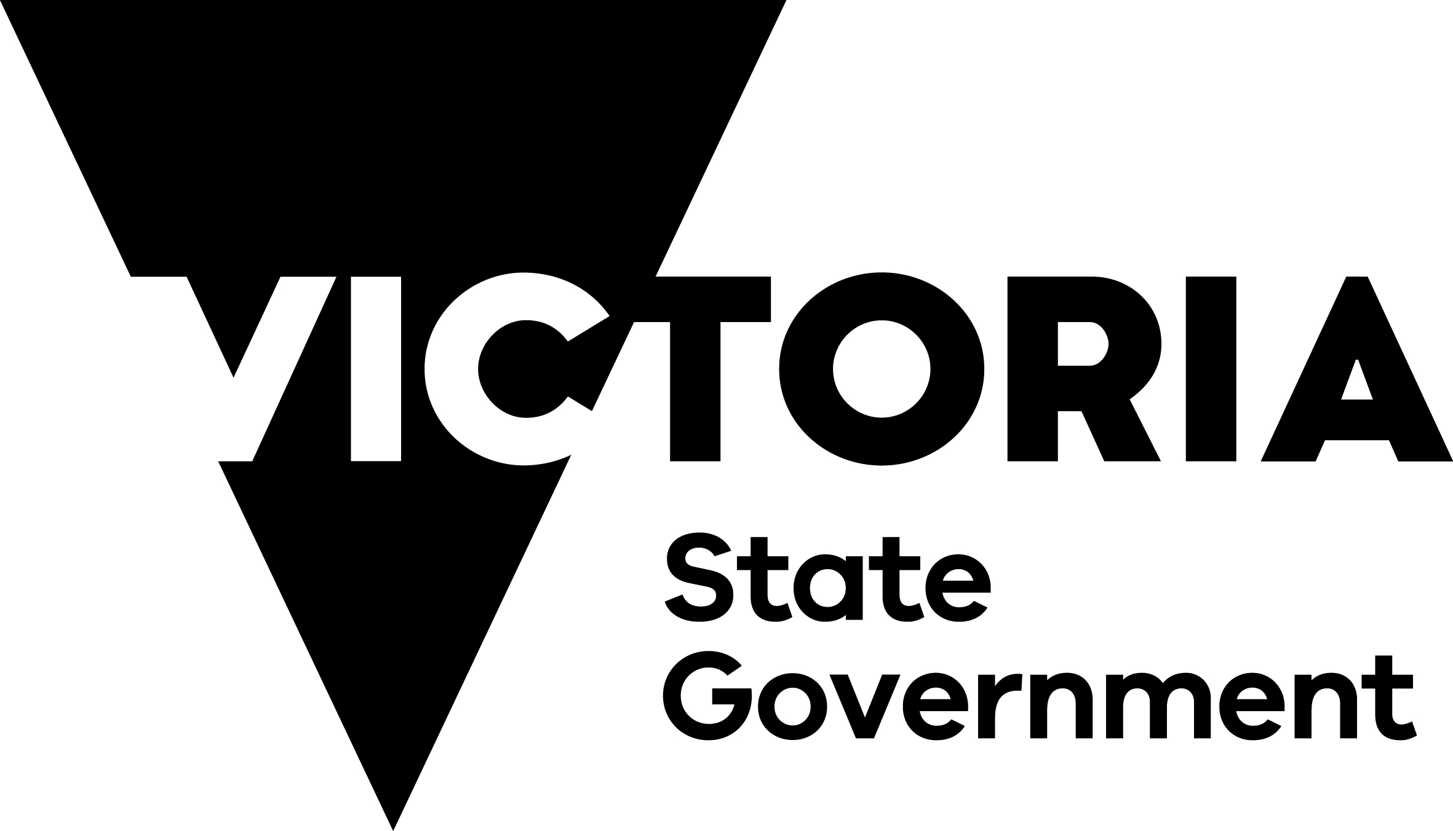

Sustainable Hunting Action Plan

2021‑2024

Implementation Guide
Customer Service Centre 136 186
djpr.vic.gov.au/game-hunting
Table of Contents
Introduction 1
Governance and Responsibilities 1
Objective 1 – Informing and educating hunters 2
Objective 2 – Collaborating and partnering 2
Objective 3 – Monitoring and research 3

Introduction
The Sustainable Hunting Action Plan 2021–2024 (the plan) builds on the success of the 2016–2020 plan to grow the economic, environmental and social benefits of responsible sustainable and safe hunting in Victoria.
This Implementation Guide is to be used in conjunction with the plan and sets out the actions, responsibilities, governance arrangements and anticipated completion dates required for its implementation.

Governance and Responsibilities
A key objective of the plan is to strengthen collaboration and partnerships between government, agencies, Traditional Owners, hunters and the community to continue to grow sustainable and responsible hunting.
The plan was developed through consultation with key stakeholders, and DJPR will lead the implementation of the plan in consultation with key delivery partners including the Game Management Authority (GMA), the Department of Environment, Land, Water and Planning (DELWP) and Parks Victoria.
The tables shown below specify the actions each department and agency is responsible for implementing. Progress will be communicated on the Sustainable Hunting Action Plan website. Those departments and agencies listed as secondary may still be responsible for implementing the action, or parts of the action, to assist the primary department or agency.
The Department of Jobs, Precincts and Regions (DJPR) will evaluate the plan’s effectiveness and implementation following its conclusion in 2024.

Objective 1 – Informing and educating hunters
Action | Responsible Agency – DJPR | Responsible Agency – GMA | Responsible Agency – DELWP | Responsible Agency – Parks Vic. | Expected  Completion Date
1.1 Provide better access to information – by delivering practical enhancements to the More to Explore app to help improve knowledge about hunting locations. | Secondary | Secondary | Primary | Secondary | App enhancements completed by June 2024
1.2 Educate and train new hunters – by developing a new online firearm safety education module. | Secondary | Primary | Secondary | Secondary | Module available August 2022
1.2 Educate and train new hunters – by starting introductory education sessions for new or aspiring game hunters. | Secondary | Primary | Secondary | Secondary | Sessions available by February 2023
1.3 Enhance hunter education – by developing online video learning modules for game hunters wanting to increase their knowledge of hunting laws, responsible hunting methods and firearm safety. | Secondary | Primary | Secondary | Secondary | Modules available September 2022
1.4 Improved animal welfare – by establishing a working group responsible for developing and implementing a wounding reduction action plan for waterfowl and quail in Victoria. | Secondary | Primary | Secondary | Secondary | Waterfowl wounding reduction plan released August 2022  Stubble Quail wounding reduction plan released December 2023
1.4 Improved animal welfare – by developing a wounding reduction action plan for deer. | Secondary | Primary | Secondary | Secondary | Deer wounding reduction action plan released June 2024

Objective 2 – Collaborating and partnering
Action | Responsible Agency – DJPR | Responsible Agency – GMA | Responsible Agency – DELWP | Responsible Agency – Parks Vic. | Completion Date
2.1 Monitor social and economic benefits – by continuing a study to determine the contribution of hunting to the economy. Studies took place in 2013, 2019 and a further study will be undertaken in 2024. | Primary | Secondary | Secondary | Secondary | Study published  by June 2024
2.2 Partner with the community to promote safe, responsible and sustainable hunting – through a new grant program which will promote innovative new projects that align with the plan. It is expected that the grant program will include opportunities for:  - regional and tourism events  - habitat restoration and conservation projects  - education and research. | Primary | Secondary | Secondary | Secondary | Grant program opens 2022
2.3 Partner with Traditional Owners – by working with Traditional Owners to deliver the Traditional Owner Game Management Strategy (TOGMS) that will build their participation in hunting, land management and conservation. | Primary | Secondary | Secondary | Secondary | Implementation plan completed by June 2022  Ongoing implementation from July 2022

Objective 3 – Monitoring and research
Action | Responsible Agency – DJPR | Responsible Agency – GMA | Responsible Agency – DELWP | Responsible Agency – Parks Vic. | Completion Date
3.1 Undertake research, monitoring and evaluation – by monitoring to measure the success of the Waterfowl Wounding Reduction Action Plan. | Secondary | Primary | Secondary | Secondary | Ongoing program, report published by November each year
3.1 Undertake research, monitoring and evaluation – by ongoing quail abundance surveying to monitor population trends and ensure the sustainability of quail hunting. | Secondary | Primary | Secondary | Secondary | Ongoing monitoring program commences January 2022  Report published  July 2022
3.1 Undertake research, monitoring and evaluation – by repeating the hog deer abundance and distribution study. | Secondary | Primary | Secondary | Secondary | Survey commences November 2022  Report published by June 2023
3.1 Undertake research, monitoring and evaluation – by conducting deer research that determines the contribution of different types of recreational hunting as a deer control tool both  for initial and ongoing deer reduction programs. | Secondary | Primary | Secondary | Secondary | Agreed research scope July 2022  Research design and planning June 2023  Surveys undertaken November 2023 and November 2024  Report published  June 2025
3.2 Develop a game duck adaptive harvest management framework and strategy – continue this important work by engaging technical experts to provide guidance on the identification of sustainable levels of harvest for reference during development of the harvest framework and strategy in consultation with key stakeholders. | Primary | Secondary | Secondary | Secondary | Technical experts engaged 2022  Development of harvest framework and harvest strategy by December 2023

