Contents
Portfolio performance reporting – non-financial 2
Changes to the department during 2018–19 2
Reporting progress towards achieving departmental objectives in the report of operations 4
Objective 1: 4
Progress towards achieving this objective 4
Performance against output performance measures 6
Objective 2: Foster a competitive business environment 6
Progress towards achieving this objective 6
Performance against output performance measures 8
Objective 3: Be a globally connected economy 9
Progress towards achieving this objective 9
Performance against output performance measures 11
Objective 4: Build prosperous and liveable regions and precincts 12
Progress towards achieving this objective 12
Performance against output performance measures 13
Regional Development 14
Continuing to invest and support rural and regional initiatives 14
Objective 5: Grow vibrant, active and creative communities 16
Progress towards achieving this objective 16
Objective 6: Promote productive and sustainably-used natural resources 28
Progress towards achieving this objective 28

Portfolio performance reporting – non-financial
The portfolio performance reporting – non-financial section includes the:
- report on progress towards achieving objectives, incorporating key initiatives and projects
- report on performance against output performance measures.

Changes to the department during 2018–19
The objectives and outputs for the new Department of Jobs, Precincts and Regions reflect the machinery
of government changes as shown in Table 1.

Table 1: Changes to the departmental objectives and outputs during 2018–19
2018–19 departmental objective | 2018–19 output | Reason for change
Objective 1: Create and maintain jobs | Jobs | This objective reflects the machinery of government changes and alignment to the department’s mission statement.
Objective 2: Foster a competitive business environment | Industry, Innovation and Small Business | This objective reflects the machinery of government changes and alignment to the department’s mission statement.
Objective 3: Be a globally connected economy | Trade and Global Engagement | This objective reflects the machinery of government changes and alignment to the department’s mission statement.
Objective 4: Build prosperous and liveable regions and precincts | Priority Precincts and Suburban Development  Regional Development | This objective reflects the machinery of government changes and alignment to the department’s mission statement.
Objective 5: Grow vibrant, active and creative communities | Creative Industries Access, Development and Innovation  Creative Industries Portfolio Agencies  Cultural Infrastructure and Facilities  Sport, Recreation and Racing  Tourism and Major Events | This objective reflects the machinery of government changes and alignment to the department’s mission statement.
Objective 6: Promote productive and sustainably-used natural resources | Agriculture  Resources | This objective reflects the machinery of government changes and alignment to the department’s mission statement.

All outputs that have been transferred into the department during 2018–19 as a result of machinery of government changes are shown below.

Table 2: Changes to the departmental output structure
2018–19 outputs | Reason for change | 2018–19 DJPR outputs
Gambling, Liquor and Racing | The racing component of the output was transferred from Department of Justice and Regulation and combined with Sport and Recreation | Sport, Recreation and Racing.
Government-wide leadership, reform and implementation | The Latrobe Valley Authority component of this output was transferred from Department of Premier and Cabinet and has been included in the Regional Development output | Regional Development.
Industry and Enterprise Innovation | Transferred from Department of Economic Development, Jobs, Transport and Resources  This output has been renamed to clarify that it includes the Small Business portfolio | Industry, Innovation and Small Business.
Jobs and Investment | Transferred from Department of Economic Development, Jobs, Transport and Resources  This output has been renamed to reflect the transfer of Invest Victoria to the Department of Treasury and Finance | Jobs.
Major Projects | Transferred from Department of Economic Development, Jobs, Transport and Resources  This output has been renamed to reflect the establishment of the Priority Precincts portfolio | Priority Precincts and Suburban Development.
Sport and Recreation | The Sport and Recreation output was transferred from Department of Health and Human Services as a result of machinery of government changes, and combined with the Racing portfolio | Sport, Recreation and Racing.
Suburban Development | This output was transferred from Department of Environment, Land Water and Planning as a result of machinery of government changes and has been combined with the Priority Precincts portfolio | Priority Precincts and Suburban Development.
Sustainably Manage Fish, Game and Forest Resources | Transferred from Department of Economic Development, Jobs, Transport and Resources  The Forest and Game Management components of this sub-output have been included in the Agriculture output | Agriculture.
Tourism, Major Events and International Education | Transferred from Department of Economic Development, Jobs, Transport and Resources  The International Education component of this output has been transferred to the Trade and Global Engagement output to reflect the alignment between these two areas | Tourism and Major Events.
Trade | Transferred from Department of Economic Development, Jobs, Transport and Resources  This output name has been expanded to reflect the department’s broader international engagement objectives | Trade and Global Engagement.

Reporting progress towards achieving departmental objectives in the report of operations
The department is focused on growing our state’s economy and ensuring it benefits all Victorians – by creating more jobs for more people, building thriving places and regions, and supporting inclusive communities.
This section reports the department’s progress on its 2018–19 departmental objectives through a range of indicators.

Objective 1:

Create and maintain jobs
This objective seeks to secure a growing, sustainable and equitable jobs market for all Victorians by working with businesses to increase job opportunities, support people into meaningful employment, and attract the investment and talent needed to foster job growth.

Progress towards achieving this objective
In 2018–19, the department reported progress against this objective using the following objective indicators and outputs:

Objective Indicators
- People employed in Victoria

Outputs
- Jobs

Indicator: People employed in Victoria

Table 3: People employed in Victoria
Measure (unit of measure) | 2015–16 | 2016–17 | 2017–18 | 2018–19
Number of people employed in Victoria (number) * | 3,097,714 | 3,207,526 | 3,271,527 | 3,352,500

Figure 1: Number of people employed in Victoria
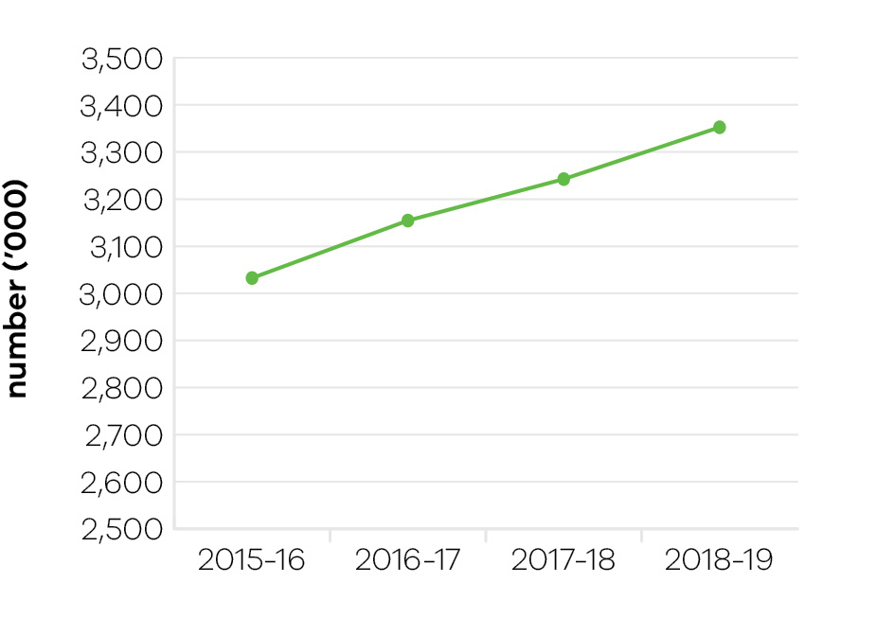
In 2018–19, the department continued its work to ensure that all Victorians have the opportunity to benefit from the strong levels of economic growth and job creation in Victoria. The department exceeded its investment and jobs targets by facilitating 174 projects, generating more than $2.4 billion in new capital investment, creating 7192 full-time equivalent jobs and delivering 20 new company headquarters in Victoria. These figures include 59 regional investment projects worth more than $1.1 billion in new capital expenditure, that is expected to create 1910 jobs.
The Jobs Victoria suite of initiatives provided the tailored employment support required by long-term unemployed jobseekers facing barriers to employment to enter the workforce. More than 2,000 long-term jobseekers were supported into employment that was sustained for at least 26 weeks through 2018–19, bringing the total number to more than 4000 people since the inception of Jobs Victoria in October 2016.
Jobs Victoria offered support to over 2400 workers facing retrenchment in 2018–19. The Jobs Victoria Workers in Transition Program provides retrenched workers with tailored information packs and in-person information sessions that are usually delivered on site at their employers’ premises. This support is delivered as early as possible to best enable retrenched workers to transition to new employment opportunities. A key focus of this program is on identifying new job opportunities with other employers that might suit the skills and experience of the retrenched workers. This work leverages efforts by Jobs Victoria to engage employers to identify employment opportunities for long-term jobseekers and to support employers to meet their workforce needs.
Jobs Victoria also works to facilitate direct employment opportunities for young jobseekers through programs such as the Youth Employment Scheme. This program provides young people aged 15 to 24 with an opportunity to work in the Victorian Public Service for 12 months while completing accredited training. Almost 300 young people commenced traineeships under the Youth Employment Scheme in 2018–19. The department is working with the Victorian Council of Social Service to expand similar opportunities to the community services sector through the delivery of the Community Traineeship Program.
The department also supported the implementation of the ‘Local Jobs First’ Policy, delivered in response to legislation strengthening the Local Jobs First Act 2003, which was passed in August 2018. The policy now comprises the Victorian Industry Participation Policy (VIPP) and the Major Project Skills Guarantee (MPSG). It supports Victorian businesses and workers by ensuring that small and medium size enterprises (SMEs) are given a full and fair opportunity to compete for government contracts.
Jobs Victoria includes programs that aim to leverage Victorian Government procurement and record levels of infrastructure spending to deliver benefits to Victoria’s most high-needs jobseekers. In 2018–19, dedicated services were established to connect young people from Aboriginal and migrant communities as well as women into employment on Victoria’s major projects. This builds on the work of the MPSG, which requires that at least 10 per cent of labour hours worked on major Victorian Government funded infrastructure projects is delivered by apprentices, trainees and engineering cadets.
Since December 2014 to June 2019, the government has set local content requirements under ‘Local Jobs First’ for 126 Strategic Projects, with a combined total value of over $64.5 billion and supporting 35,000 local jobs. Since its introduction, the MPSG has been applied to 116 projects worth over $63 billion, which have committed to more than four million contracted hours for 3700 apprentices, trainees and cadets.
The Local Jobs First Act 2003 also established a Local Jobs First Commissioner. The Commissioner provides advocacy, facilitation and compliance functions and works closely with industry and government departments to create opportunities for SMEs, workers, apprentices, trainees and cadets. In 2018–19, the department supported the assessment of 1230 overseas qualifications to assist overseas qualified professionals gain employment in the Victorian labour market and fill skill gaps for employers.
The department also nominated 1967 investor and business migrants and 3011 skilled migrants to migrate to Victoria, which includes 1142 international student graduates. Of the nominated skilled migrants, 428 had completed a PhD, including 272 international student graduates who recently completed their PhD in Victoria.

Performance against output performance measures
Table 4 represents performance against the Jobs output. This output includes initiatives to support existing workers and businesses by connecting Victorians experiencing disadvantage to job opportunities, supporting Aboriginal economic inclusion, working with the community to create and support social enterprises; as well as attracting new investment and talent into Victoria to grow the economy and share the benefits of economic prosperity.

Table 4: Output – Jobs
Performance measures | Unit of measure | 2018–19  actual | 2018–19  target | Performance variation (%) | Result

Quantity
Disadvantaged jobseekers who achieve sustainable employment (minimum number of 26 weeks) | number | 2159 | 2050 | 5.3 | ✓
Positive employment conditions and support by Jobs Victoria partners have contributed to a slight over-achievement of target outcomes.
Government Youth Employment Scheme traineeships commenced | number | 298 | 280 | 6.4 | ✓
The department worked closely with other departments and agencies to support the recruitment of trainees and maximise YES opportunities, and numbers were slightly above expectations.
Retrenched workers supported with employment assistance | number | 2423 | 2000 | 21.2 | ✓
Program efficiencies enabled greater coverage of retrenchments.
Social enterprises assisted | number | 113 | 60 | 88.3 | ✓
Strong interest in the Boost Your Business Social Enterprise Capability Voucher Stream and social enterprise certification has contributed to a greater number of social enterprises assisted.
Victoria’s market share of nominated investor and business migrants | per cent | 45 | 45 | 0.0 | ✓
Quality
Client satisfaction with investor, business and skilled migration services provided | per cent | 88 | 85 | 3.5 | ✓
Client satisfaction with services delivered to support industry transition | per cent | 95 | 85 | 11.8 | ✓
Timeliness
Average processing time for investor, business and skilled migration visa nomination applications | days | 20 | 20 | 0.0 | ✓
Cost
Total output cost | $ million | 157.7 | 162.6 | -3.0 | ✓
Note:
✓ Performance target achieved or exceeded
 Performance target not achieved – within 5 per cent variance
■ Performance target not achieved – exceeds 5 per cent variance

Objective 2: Foster a competitive business environment
This objective seeks to grow Victorian industries and businesses by working with priority industry sectors, supporting growth and innovation opportunities for industry, supporting start-ups and small businesses, and assisting industries in transition.

Progress towards achieving this objective
In 2018–19, the department reported progress against this objective using the following objective indicators and outputs:

Objective Indicators
- Change in Victoria’s real gross state product
- Engagement with businesses

Outputs
- Industry, Innovation and Small Business

Indicator: Change in Victoria’s real gross state product

Table 5: Change in Victoria’s real gross state product
Measure (unit of measure) | 2015–16 | 2016–17 | 2017–18 | 2018–19
Change in Victoria’s real gross state product (per cent) | 3.51 | 3.33 | 3.5 | Data available in November 2019

Figure 2: Change in Victoria’s real gross state product
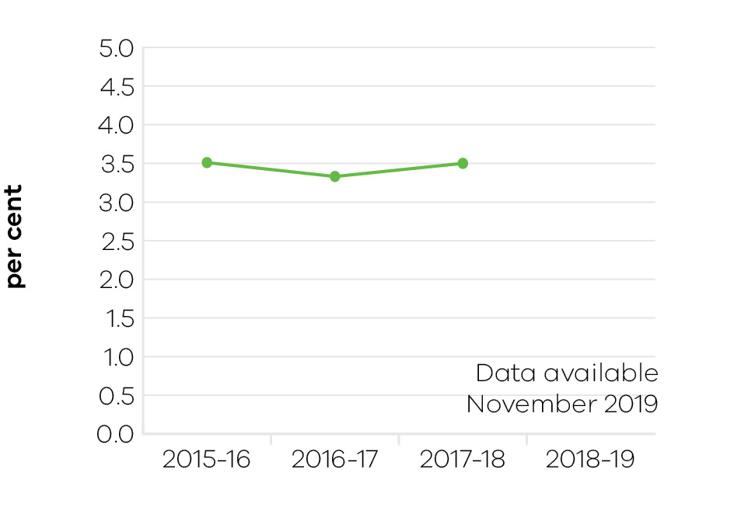
Victoria’s above-trend economic growth in recent years continued, with Victoria’s real gross state product (GSP) growing by 3.5 per cent in 2017–18, above national growth of 2.8 per cent.

Indicator: Engagement with businesses

Table 6: Engagement with businesses
Measure (unit of measure) | 2015–16 | 2016–17 | 2017–18 | 2018–19
Engagement with businesses (number) | 14,782 | 15,014 | 14,401 | 14,630

Figure 3: Engagement with businesses
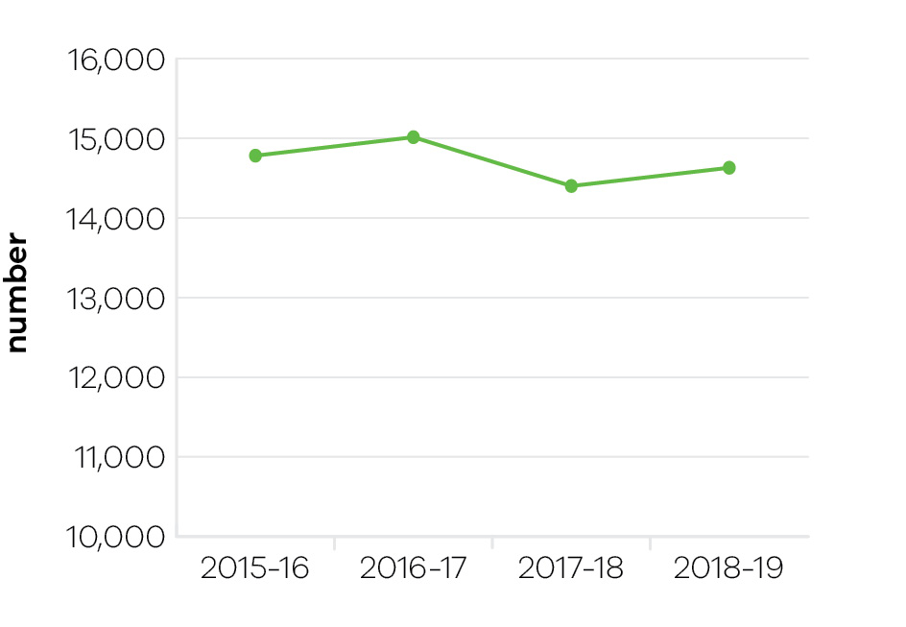
Business engagement and investment facilitation is undertaken by the department across a network of Victorian Government Business Offices (VGBOs) including five metro-based VGBOs in Melbourne. Metropolitan regions including North, West, South, East and Inner Melbourne.
The department engaged with 14,630 business in 2018–19 through specific business engagement meetings and by leveraging Victoria’s major events. Engagements were deliberately focused towards growth-oriented firms looking to invest or re-invest in Victoria and create new job opportunities.
The Automotive Transition Plan was delivered, assisting businesses and workers affected by the cessation of passenger car manufacturing, including delivery of four jobs fairs with more than 200 exhibitors, more than 5500 jobs on offer and more than 11,700 people attending.
A review of regulatory reform opportunities in the construction sector was undertaken as part of the Small Business Regulation Review program. The reforms identified through the review are expected to save small businesses in the construction sector between $21.3 million and $42.6 million per year once fully implemented.
The department supported over 400 digital tech events, engaging 15,000 people across Victoria through the 2018 Digital Innovation Festival (DIF2018) and secured important national conferences that enabled Victorian businesses to connect with local, national and global networks in biotechnology, medical technology and pharmaceutical, professional services and digital technology. These included iAwards and ACS Reimagination, FinTech Awards and Intersekt, and AusBiotech, Australia Biotech Invest & Partnering, and AusMedtech.
LaunchVic continued its support of the Victorian start-up community, with a particular focus on health start-ups and investor education. New industry capabilities in biotechnology, manufacturing and biobanking were initiated to address key gaps in the medical technologies and pharmaceuticals sector.
Business Victoria digital channels had 3,960,835 sessions and participation in small business events and business programs reached 45,023 participants.

Performance against output performance measures
Table 7 represents performance against the Industry, Innovation and Small Business output. This output provides access to information and connections and builds the capability of Victorian businesses and industry to develop and effectively use new practices and technologies to increase productivity and competitiveness, advocating for a fair and competitive business environment, and supporting small businesses.

Table 7: Output – Industry, Innovation and Small Business
Performance measures | Unit of measure | 2018–19  actual | 2018–19  target | Performance variation (%) | Result

Quantity
Businesses whose growth and productivity issues are resolved by the department | number | 2145 | 1200 | 78.8 | ✓
An increased number of employers were assisted through the employment of skilled workers whose migration has been facilitated through the Skilled and Business Migration Program. This employment helps businesses fill critical skill shortages in order to foster growth and productivity.
Companies and Industry Associations supported by Future Industries Fund | number | 185 | 100 | 85.0 | ✓
The maturation of the Future Industries Fund grants resulted in a larger number of organisations being supported through the fund.
Companies or new entrants supported through the LaunchVic initiative | number | 144 | 120 | 20.0 | ✓
There was an increase in the number of LaunchVic funded program activities coming to market, reflecting a lag between providing funding to grant round recipients and them actually being in a position to start delivering programs to start-ups and new entrants. It also reflects an increase in demand from the growing start-up sector for more training and mentoring in growing and developing their businesses.
Engagements with businesses | number | 14,630 | 14,000 | 4.5 | ✓
Industry roundtables and engagement forums | number | 75 | 75 | 0.0 | ✓
Major research and evaluation projects completed | number | 6 | 6 | 0.0 | ✓
New mobile base stations facilitated | number | 39 | 45 | -13.3 | ■
Mobile carriers complete tower builds and manage schedules. Changes to the roll-out schedule, usually attributable to third party construction approvals, has caused some delays in the tower build. The department continues to work with the mobile carriers to ensure the tower build is as timely as possible, including through assisting with approvals from government agencies and liaising with Commonwealth and local governments as needed.
Participation in Small Business Victoria targeted and inclusive events and business programs | number | 45,023 | 30,000 | 50.1 | ✓
Performance exceeded the target due to overlap of the final Small Business Festival and the first Business Victoria Local Events (new program) delivered in the same year.
Visits to Business Victoria digital channels | number (million) | 3,960,835 | 3,000,000 | 32.0 | ✓
Performance exceeded the target due to digital campaigns such as the Long Service Leave campaign to Victorian businesses delivering higher than anticipated visits.
Quality
Client satisfaction of small business information, referral, mentoring service and business programs | per cent | 93 | 90 | 3.3 | ✓
Client satisfaction with the Victorian Government Business Offices | per cent | 97.5 | 80 | 21.9 | ✓
The high level of satisfaction is due to proactive engagement with businesses and successful outcomes from government supported initiatives.
Client satisfaction with Victorian Small Business Commission mediation service | per cent | 93 | 85 | 9.4 | ✓
Performance exceeding the target reflects mediation participants’ acknowledgement of the value added by the VSBC alternative dispute resolution process in accessing efficient, timely and high-quality mediations.
Proportion of business disputes presented to the Small Business Commission successfully mediated | per cent | 82 | 75 | 9.3 | ✓
Performance exceeded the target due to a range of factors including dispute type and monetary amount, good faith participation by the parties and the mediator selection process.
Cost
Total output cost | $ million | 163.9 | 194.3 | -15.6 | ✓
The 2018–19 result was lower than budget due to the rephase of various programs into future years.
Note:
✓ Performance target achieved or exceeded
 Performance target not achieved – within 5 per cent variance
■ Performance target not achieved – exceeds 5 per cent variance

Objective 3: Be a globally connected economy
This objective seeks to connect Victoria to the world by helping Victorian businesses successfully trade into global markets, and growing Victoria’s proportion of international student enrolments in Australia.

Progress towards achieving this objective
In 2018–19, the department reported progress against this objective using the following objective indicators and outputs:

Objective Indicators
- Export sales generated from government programs
- International students attracted to Victoria

Outputs
- Trade and Global Engagement

Indicator: Export sales generated from government programs

Table 8: Export sales generated from government programs
Measure (unit of measure) | 2015–16 | 2016–17 | 2017–18 | 2018–19
Export sales generated as a result of participation in government programs ($ million) | 459 | 648 | 807 | 668

Figure 4: Export sales generated from government programs
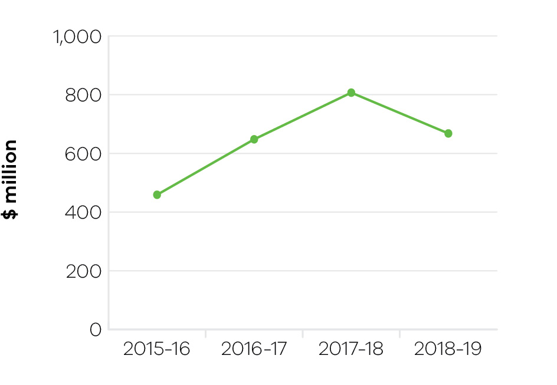
In total, Victorian Government programs resulted in $2.6 billion of actual export sales over the four-year period from 2015–16. In 2018–19 the result was $668 million of actual export sales, an increase of 46 per cent since 2015–16. This result was achieved through the department’s delivery of services to connect Victorian companies to international buyers and networks to foster business opportunities, as well as services to build the skills, knowledge and capability of Victorian businesses to enter and succeed in global markets.
Results in 2018–19 were outcomes from traditionally strong export sectors such as food and fibre, and services sectors including health and medical technologies. The State’s services exports continue to increase in importance, growing to represent over 45 per cent of exports in the 2018 calendar year (latest available ABS data). This was reflected in strong outcomes in sectors such as medical technologies, professional services, water and environmental services and financial technologies.
Strong outcomes were achieved in the State’s two largest trading markets being China and the United States. There were also strong outcomes in emerging economies in South East Asia and Latin America building on the release of the South East Asia Trade and Investment Strategy in September 2018 and the Latin America Trade and Investment Strategy in May 2018. Traditional markets, such as the UK and Europe, continue to remain important to exporters, particularly in advanced manufacturing and defence.
The department’s suite of export and trade programs are provided by staff based in Melbourne and throughout its 22 Victorian Government Trade and Investment Network offices, providing tailored support to assist firms to realise and capture export sales. Services include provision of market intelligence, introductions to key contacts in-market, promotion of industry capability and ongoing support and advice.
The department’s Outbound and Inbound Trade Mission Programs, Asia Gateway and Export Skills programs are vital to generating export sales. Collectively the department’s trade and export programs promote, champion, partner and elevate the status of Victorian businesses taking their products and services to the world, engaging 2525 companies in 2018–19. This includes over 850 Victorian companies being involved in the Inbound and Outbound Trade Mission Programs.

Indicator: International students attracted to Victoria

Table 9: Victoria’s proportion of international student enrolments in Australia
Measure (unit of measure) | 2015–16 | 2016–17 | 2017–18 | 2018–19
Victoria’s proportion of all international student enrolments in Australia (per cent) | 30 | 31 | 32 | 32
Note: Financial year data on international student enrolments is not available. Figures in the table are calendar year data reflecting the academic year, capturing peaks and troughs of enrolment periods.

Figure 5: Victoria’s proportion of all international student enrolments in Australia
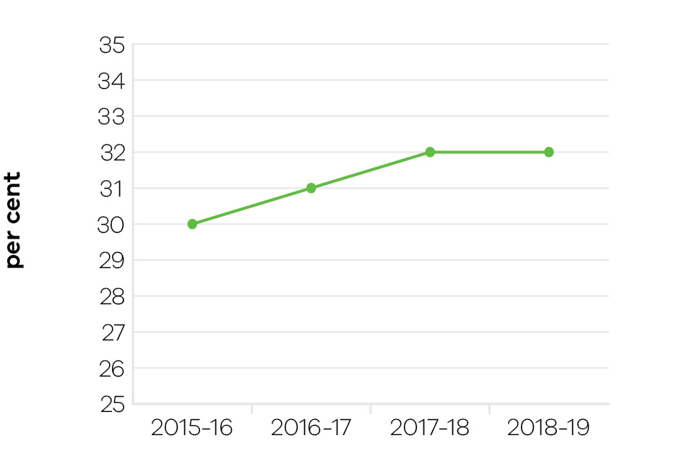
Victoria’s national share of international student enrolments continues to grow, from 30 per cent of Australia’s international enrolments in 2015–16 to 32 per cent in 2018. As a result of strong enrolments growth, the international education sector generated a record high $11.8 billion in export revenue and supported almost 79,000 jobs in 2018. Victoria was also ranked as Australia’s best city for student experience and the third best in the world (QS Best Student Cities 2018).
Victoria continues to outperform national average international education enrolment growth, and other Australian jurisdictions. In 2018, international student enrolments rose 11.4 per cent from 2017, surpassing national average growth (10.1 per cent) and growth in key competitor states New South Wales (11.2 per cent) and Queensland (9.6 per cent). Strong growth was driven by high performing Asian markets, notably China and India, Victoria’s top two source countries for international students. These two markets account for almost 50 per cent of Victoria’s international enrolments.
Supporting diversity across student markets, sectors, course types and education providers is an ongoing priority for the department, to protect the sector from downturns. This is driving the department’s focus on emerging growth regions such as South East Asia and Latin America, as well as sub-sectors which have the capacity to grow their international student cohort, such as Technical and Further Education (TAFE) institutes.

Performance against output performance measures
Table 10 represents performance against the Trade and Global Engagement output. This output promotes business growth opportunities by connecting organisations to global business opportunities in priority markets and supporting the establishment and deepening of strategic commercial partnerships. It also positions Victoria as a destination of choice for international students.

Table 10: Output – Trade and Global Engagement
Performance measures | Unit of measure | 2018–19  actual | 2018–19  target | Performance variation (%) | Result
Quantity
Actual export sales generated as a result of participation in government programs | $ million | 668 | 550 | 21.5 | ✓
Performance exceeded target as companies participating in export programs achieved higher than anticipated results with particularly strong export sales to China and the US.
Clients engaged in export and trade programs | number | 2525 | 2500 | 1.0 | ✓
International delegates participated in the inbound trade mission program | number | 564 | 550 | 2.5 | ✓
Proportion of all international students studying in Victoria | per cent | 32 | 30 | 6.7 | ✓
Strong growth in student enrolments, in Victoria and nationally, was driven by high performing Asian markets such as China and India. This is the latest available full year data (calendar year 2018), published by the Commonwealth Department of Education and Training in March 2019.
Significant interactions with Victorian agri‑food companies and exporters, international customers and trading partners that facilitate export and investment outcomes for Victoria | number | 259 | 250 | 3.6 | ✓
Quality
Client satisfaction with export assistance offered | per cent | 95 | 90 | 5.6 | ✓
Result reflects strong support for the quality of services provided, involving a more tailored approach to the delivery of programs and services, particularly through the Access Program and the Trade Mission Program.
Cost
Total output cost | $ million | 38.6 | 40.3 | -4.2 | ✓
Note:
✓ Performance target achieved or exceeded
 Performance target not achieved – within 5 per cent variance
■ Performance target not achieved – exceeds 5 per cent variance

Objective 4: Build prosperous and liveable regions and precincts
This objective seeks to ensure that Victoria’s precincts, suburbs and regions are developed to create places where all Victorians have an opportunity to participate in communities that are well-connected, prosperous, vibrant and diverse.
Suburban Development makes a unique contribution to this goal through its six Metropolitan Partnerships that are changing the way government works by placing a stronger focus on community engagement and co-design.

Progress towards achieving this objective
In 2018–19, the department reported progress against this objective using the following objective indicators and outputs:

Objective Indicators
- Priority precincts developed and delivered
- Community satisfaction in public places

Outputs
- Priority Precincts and Suburban Development
- Metropolitan Partnerships engagement and advice
- Regional Development

Indicator: Priority precincts developed and delivered
The new Priority Precincts Portfolio was established in January 2019 to lead and coordinate the development of Victoria’s priority precincts, which include Parkville, Arden, Fishermans Bend, Richmond to Docklands and Sunshine.
To support this new portfolio and the Suburban Development Portfolio, separate business units from DPC, DELWP and the former DEDJTR were brought together to form the new Precincts and Suburbs Group, thereby providing a single point of expertise and accountability in precinct and suburb policy, design and delivery. This ensures that going forward, the most important urban renewal precincts within Melbourne are properly planned to protect the liveability of the whole city, while delivering additional jobs and opportunities for business and education more broadly.
The Priority Precincts Portfolio has continued to deliver on the economic projects within its purview, contributing substantially towards the State’s gross domestic product. For example, the expansion of the Melbourne Convention and Exhibition Centre (MCEC) has helped deliver $1.1 billion to the Victorian economy in its first year, attracting prestigious international and national events to Melbourne. The MCEC expansion added almost 20,000 square metres of flexible space including meeting rooms, banquet rooms and a 9000 square metre exhibition hall, as well as the 347-room hotel, Novotel South Wharf. The expansion of MCEC has taken its capacity to 70,000 square metres and has been a key factor in the growth of the event economy.
Going forward, the newly established Precincts and Suburbs Group will ensure that all identified priority precincts are developed and delivered in accordance with an effective prioritisation and sequencing methodology, in order to maximise value creation and capture opportunities for the State.

Indicator: Community satisfaction in public places
The objective indicator ‘community satisfaction in public places’ is a measure from the annual Local Government Community Satisfaction Survey conducted by Local Government Victoria. This is a state-wide telephone survey that collects direct feedback from the community about their local council area. This indicator measures how well the community facilities and amenities suit the community’s needs, as well as the appearance of public areas, community consultation and engagement, and planning for population growth in the area. Local communities, including youth and small businesses, have an opportunity to influence government decision-making through the Metropolitan Partnerships led by the Office for Suburban Development and the annual program of engagement activities. The results in table 11 demonstrate the percentage of people that felt their area was performing well under those measures.

Table 11: Community satisfaction in public spaces
Measure (unit of measure) | 2015–16 | 2016–17 | 2017–18 | 2018–19
Community satisfaction in public spaces – Metropolitan¹ | 73 | 73 | 73 | n/a
Community satisfaction in public spaces – Interface¹ | 66 | 66 | 68 | n/a
Appearance of public areas | n/a | n/a | n/a | 91
Community consultation and engagement | n/a | n/a | n/a | 56
Planning for population growth in the area | n/a | n/a | n/a | 52
1 The data collection method for this indicator changed in 2018–19. The previous question regarding community satisfaction in public spaces was replaced with three questions regarding appearance, engagement and planning for growth.

Performance against output performance measures
Table 12 represents performance against the Priority Precincts and Suburban Development output. This output delivers activities to build vibrant and prosperous precincts and suburbs that drive economic growth and opportunities. The department works collaboratively with government, industry and community stakeholders to support Victoria’s priority precincts and identify opportunities for the development and delivery of initiatives to strengthen Melbourne’s economy, create jobs and improve suburban liveability. This includes the department’s role in supporting six Metropolitan Partnerships that harness input from local people to help define key priorities for development and revitalisation of Melbourne suburbs.

Table 12: Output – Priority Precincts and Suburban Development
Performance measures | Unit of measure | 2018–19  actual | 2018–19  target | Performance variation (%) | Result
Quantity
Annual assemblies held for Metropolitan Partnerships | number | 6 | 6 | 0.0 | ✓
Number of economic projects in delivery | number | 15 | 15 | 0.0 | ✓
Quality
Economic projects being delivered in accordance with contracted cost (within 5 per cent variation) | number | 10 | 10 | 0.0 | ✓
Economic projects being delivered in accordance with contracted scope | number | 10 | 10 | 0.0 | ✓
Participants satisfied with their experience of partnership assemblies | per cent | 86 | 80 | 7.5 | ✓
The high satisfaction score in 2018 was mainly due to the Inner South-east and Western Metropolitan Partnership event, with 92 per cent of participants satisfied or very satisfied with the opportunities provided to share and discuss the priorities for the region.
Across all events in 2018, the majority of participants were satisfied or very satisfied with their ability to discuss and input to the priorities of the region.
Timeliness
Economic projects being delivered in accordance with contracted timelines (within 5 per cent variation) | number | 10 | 10 | 0.0 | ✓
Fishermans Bend Employment Precinct plan finalised | date | Late 2020 | June 2019 | n/a¹ | ■
1 Variance cannot be calculated for date measures.
The Fishermans Bend Framework (October 2018) sets the high-level aspirations for the Employment Precinct. The Framework notes that “over the next 12 months, state and local government will collaborate with industry and key stakeholders to plan the Fishermans Bend National Employment and Innovation Cluster. This will follow a separate timeframe from the other four precincts”.
The Employment Precinct Plan is interlinked with and dependent on planning for the former GMH site, the Fishermans Bend Tram, the West Gate Park Masterplan, and the Webb Dock Rail Freight Plan, and work has been delayed to allow alignment with these key projects. It is envisaged that a draft Employment Precinct Plan will be ready for government consideration by the end of 2019, and is expected to be finalised and public in mid-late 2020 depending on the planning pathway required.
Five-year Plans for Jobs, Services and Infrastructure endorsed | per cent | 100 | 100 | 0.0 | ✓
Partnership priorities receiving a government response by 30 June | per cent | 100 | 100 | 0.0 | ✓
Cost
Total output cost | $ million | 44.9 | 35.9 | 25.0 | ■
The 2018–19 result was higher than budget primarily due to additional funding for the Fitzroy Gasworks program.
Note:
✓ Performance target achieved or exceeded
 Performance target not achieved – within 5 per cent variance
■ Performance target not achieved – exceeds 5 per cent variance

Regional Development
Rural and regional Victorians account for a quarter of the state’s population and generate a $76 billion regional economy. The Victorian Government, through Regional Development Victoria (RDV), works to ensure that Victoria’s rural and regional communities share in the benefits of the state’s economic growth by investing in infrastructure and services to create jobs and sustain thriving and prosperous regional cities and towns.
Operating in partnership with local communities, industry and across all tiers of government, RDV’s efforts in 2018–19 resulted in all regional development performance targets being exceeded, continuing a trend of improved output over the past four years, and to regional Victoria having the highest performing economy in rural Australia.

Continuing to invest and support rural and regional initiatives
In the past year RDV continued to support economic development and service delivery projects (215) in rural and regional Victoria, facilitating $1.8 billion of new investment that will create 1910 direct jobs. In addition, over $56.5 million in export sales for regional businesses was generated as a result of participation in government programs.
RDV’s approach to regional development recognises that policy solutions and programs in regional and rural areas need to be bespoke and involve real consultation with local communities. With its network of offices across the state and a range of different funding mechanisms RDV has been able to target programs and policies to the needs of particular communities – to grow regional economies while, at the same time, enhancing liveability and the community spirit that underpins country life.
More than 45 projects were progressed in 2018–19 under the Government’s $500 million Regional Jobs and Infrastructure Fund (RJIF) and the Regional Tourism Infrastructure Fund, which together delivered more than $51.81 million in grant payments against a total project value of $435.77 million. RDV also provided oversight that facilitated the approval of five economic infrastructure projects under the RJIF, with a total of $17.25 million in grants towards overall project costs of $44.3 million.
Investment in Regional Partnerships Priority Projects continues, with the additional $8.7 million investment in 2018–19 to commence projects including the Falls to Hotham Iconic Walk, Mallee Innovation Centre, Silo Art Study, Driving Gippsland’s Food and Fibre Agenda and Grampians Cycle Plan.
Round three of the Wine Growth Fund provided support to 78 projects to develop tourism and visitation to regional wineries and wine regions. Through the Food Source Victoria program, RDV worked with Agriculture Victoria to match new (and strengthen existing) agri-food business alliances with innovative business growth opportunities.
Regional manufacturers were supported under the Future Industries Manufacturing Program (FIMP), establishing Regional Manufacturing Clusters. New dairy industry investments were facilitated over the year including ACM Holdings at Girgarre, Freedom Foods at Shepparton and Organic Dairy Farmers at Geelong. Such investments in the dairy industry provided the support to pivot to high value exports following the closure of processing plants by Murray Goulburn.
The Stronger Regional Communities Plan continues to invest in initiatives that help rural and regional towns attract families and young people to live and work locally. The community-led approach creates and enhances the conditions for economic growth and building community capabilities to drive change and improve liveability. Initiatives include Winter Wonderland, Live Like a Local campaign in East Gippsland, investment in retractable chairs for Foster Arts Music Drama Association, Grampians New Resident and Workforce Attraction Strategy and the Harmony Van Initiative : a project in the Wimmera Southern Mallee region to develop a food van that delivers training showcasing multi-cultural cuisines and gives new culinary experiences to regional trainees, connecting communities with new arrivals, migrants and refugees seeking asylum.
Job creation, and programs and support for employers to set up, relocate or grow their businesses in rural and regional Victoria are important. So, too, is recognising that people are often looking for more than a job when they move to regional Victoria – they are looking to be part of a community. Targeted investment in infrastructure that families rely on is an integral way in which RDV has helped increase the prosperity and liveability of Victoria’s regional areas.
RDV supported the creation of 1910 jobs in 2018–19, through a mixture of investment and facilitation across business, community and government networks.
Supporting jobs in regions provides an opportunity to build upon regional strengths, incubate industry development and innovation, while also addressing rural and regional inequality driven by limited local job opportunities. Job creation projects include Rationale Skincare (103 jobs), Greenham Gippsland (180 jobs), Freedom Foods (80 jobs), Carbon Revolution (500 jobs), and CT4 (62 jobs): a global cloud hosting services provider, working collaboratively with Federation University in Ballarat to develop cyber security skills in the region.
Strong participant satisfaction Participant satisfaction remains a key indicator as to whether programs and interactions are meetings the needs of Rural and Regional Victorians. 93 per cent of participants surveyed responded that they were satisfied with the response and support provided by RDV in 2019. This result continues the trend of improved satisfaction through RDV’s focus on stakeholder engagement and place-based access.
Table 13 represents performance against the Regional Development output. This output guides engagement with industry and communities to identify opportunities to support job growth and new investment in regional Victoria, including support and services to grow regional jobs and capability in regional communities.

Table 13: Output – Regional Development
Performance measures | Unit of measure | 2018–19  actual | 2018–19  target | Performance variation (%) | Result
Quantity
Actual export sales generated for regional businesses as a result of participation in government programs | $ million | 56.5 | 55 | 2.7 | ✓
Economic development and service delivery projects supported | number | 215 | 120 | 79.2 | ✓
The actual was boosted by multiple factors including: several Regional Partnerships projects that were meant to commence in 2017–18 but were delayed until 2018–19; many Regional Jobs Fund (RJF) projects that were meant to come online in 2017–18 but were delayed until 2018–19; and a higher number of Stronger Regional Communities Plan (SRCP) projects than anticipated.
Jobs in regional Victoria resulting from government investment facilitation services and assistance | number | 1910 | 1200 | 59.2 | ✓
This figure was boosted by five or six projects that will generate significant jobs in electric vehicle manufacturing, meat processing (abattoirs), growing and processing medical cannabis and dairy processing.
New investment in regional Victoria resulting from government facilitation services and assistance | $ million | 1177 | 700 | 68.1 | ✓
This figure is higher than the target due to investments in four renewable energy projects to the value of over $200 million each which will be amortised over two to/or three years.
Quality
Participant satisfaction with implementation of Regional Development Victoria programs | per cent | 92 | 90 | 2.2 | ✓
Cost
Total output cost | $ million | 348.8 | 394.8 | -11.7 | ✓
The 2018–19 result was lower than budget primarily due to the rephase of various programs into future years, including the Regional Jobs and Infrastructure Fund.
Note:
✓ Performance target achieved or exceeded
 Performance target not achieved – within 5 per cent variance
■ Performance target not achieved – exceeds 5 per cent variance

Objective 5: Grow vibrant, active and creative communities
This objective seeks to increase the economic, social and cultural value of the creative, sport and recreation industries to Victoria, grow the number and yield of visitors, position Victoria as a major events destination, and ensure the best cultural and sporting experiences are accessible to everyone.

Progress towards achieving this objective
In 2018–19, the department reported progress against this objective using the following objective indicators and outputs:

Objective Indicators
- Attendances at Creative Industries agencies and funded Major Performing Arts organisations
- Employment in the Creative Industries sector
- Employment in the Visitor Economy sector
- Tourists attracted to Victoria
- Increase rates of community engagement, including through participation in sport and recreation
- Wagering turnover on Victorian racing as a proportion of the national market

Outputs
- Creative Industries Access, Development and Innovation
- Creative Industries Portfolio Agencies
- Cultural Infrastructure and Facilities
- Sport, Recreation and Racing
- Tourism and Major Events

Indicator: Attendances at Creative Industries agencies and funded Major Performing Arts organisations

Table 14: Attendances at Creative Industries agencies
Measure (unit of measure) | 2015–16 | 2016–17 | 2017–18 | 2018–19
Attendances at creative industries portfolio agencies (number (‘000)) | 11,403 | 11,766 | 13,170 | 12,786

Figure 6: Attendances at Creative Industries portfolio agencies
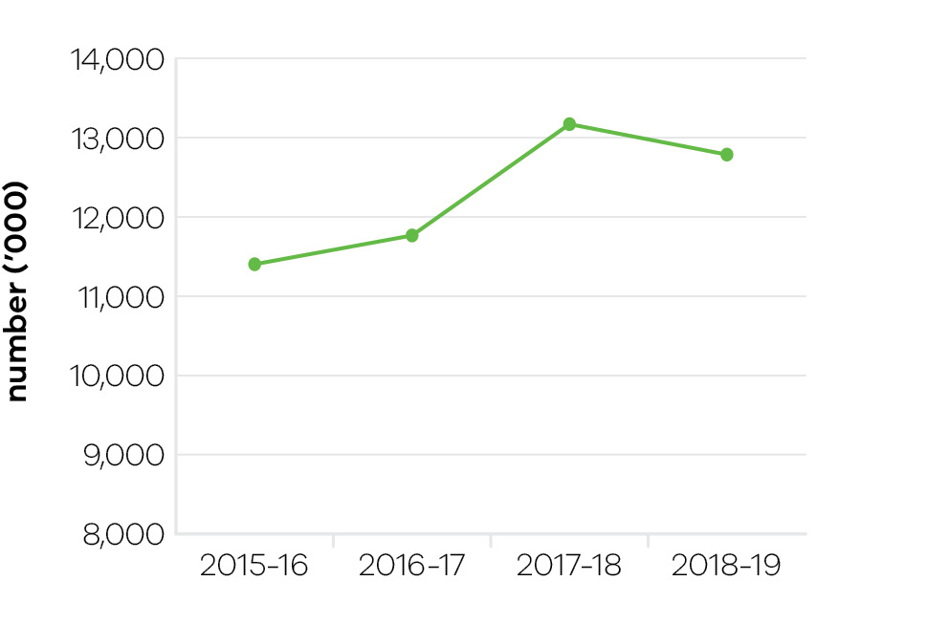
In 2018–19, Victoria’s state-owned arts and cultural institutions – Arts Centre Melbourne, Australian Centre for the Moving Image (ACMI), Docklands Studios Melbourne, Film Victoria, Geelong Performing Arts Centre, Melbourne Recital Centre, Museums Victoria, National Gallery of Victoria (NGV), and State Library Victoria – were attended by 12.8 million visitors continuing to exceed targets and close to the record level set in 2017–18. Attendance has steadily grown at these institutions over the last five years from 10 million visitors.
Major exhibitions attracting large crowds during 2018–19 included:
- Wonderland at ACMI, celebrating Lewis Carroll’s timeless tale and Alice’s adventures on film;
- Mahatma Gandhi: An Immigrant at the Immigration Museum, exploring Gandhi’s fight against social injustice in South Africa;
- Revolutions: Records and Rebels at Melbourne Museum, from the Victoria and Albert Museum in London and Museum Victoria’s collection, telling the story of 1966–70 as five years that shook the world;
- MoMA at NGV: 130 Years of Modern and Contemporary Art providing a unique survey of the iconic collection of New York’s Museum of Modern Art; and
- Terracotta Warriors: Guardians of Immortality, more than 150 treasures of historic Chinese art and design from the Qin dynasty (221 – 207 BCE) at the NGV with Cai Guo-Qiang: The Transient Landscape exposing traditional Chinese materials, paper, porcelain and silk to gunpowder explosions during a series of live ignitions.

Table 15: Attendances at funded Major Performing Arts organisations
Measure (unit of measure) | 2015–16 | 2016–17 | 2017–18 | 2018–19
Attendances at funded Major Performing Arts organisations (number (‘000)) | 954 | 904 | 1067 | 1127

Figure 7: Attendances at funded Major Performing Arts companies
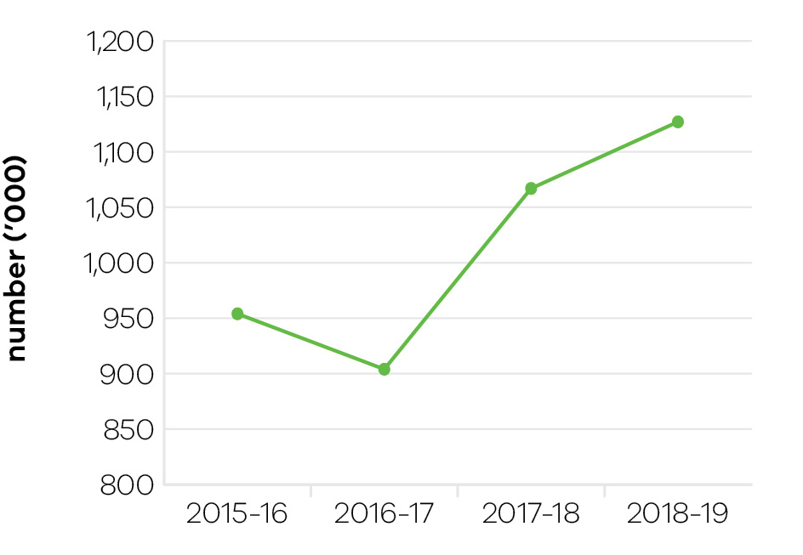
Funded Major Performing Arts companies recorded continuing growth in attendances in 2018–19 driven by programming. Victorian funded Major Performing Arts companies in 2018–19 were Melbourne Theatre Company, The Australian Ballet, Opera Australia, Orchestra Victoria, Melbourne Symphony Orchestra, Malthouse Theatre and Circus Oz.
Design work commenced on the Melbourne Arts Precinct Transformation project with the appointment of Melbourne practice HASSELL in partnership with New York’s SO-IL to begin the precinct masterplan and design the outdoor component of the project, comprising 18000 square metres of new and renewed public space. Schematic design of the Reimagining Arts Centre Melbourne project has been completed, describing the project three-dimensionally and defining its character and operation.

Indicator: Employment in the Creative Industries sector

Table 16: Employment in the Creative Industries sector
Measure (unit of measure) | 2015–16 | 2016–17 | 2017–18 | 2018–19
Number of first jobs in the creative industries (number) | 230,000 | 243,000 | 261,000 | 289,000

Figure 8: Number of first jobs in the creative industries
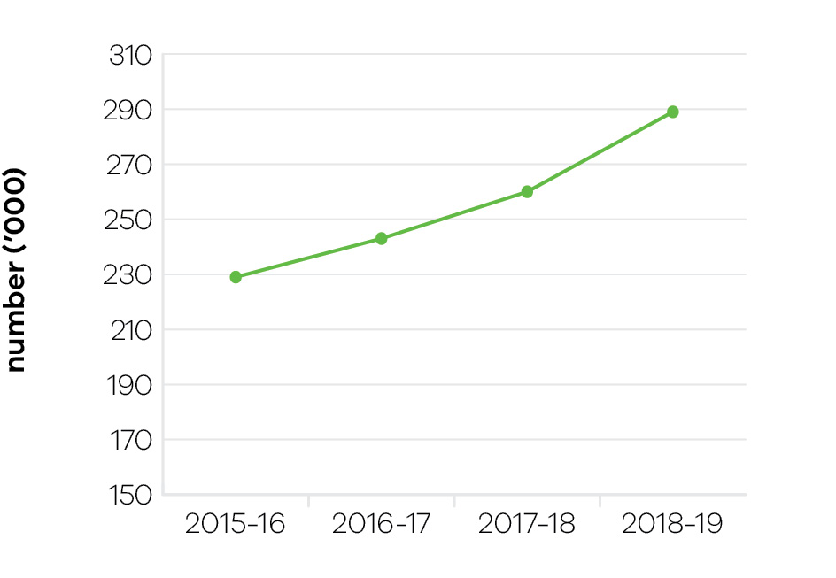
Implementation of Victoria’s first creative industries strategy, Creative State, continues to be supported through the 2018–19 State Budget. Creative State is a strategy to build the state’s film, television, digital games, design, fashion and arts sectors. Key actions have contributed to supporting and growing the state’s creative enterprises, creating new jobs and employment opportunities, and bringing social and cultural benefits to Victorians. Strong growth in the number of jobs in the creative industries sector has been experienced over the last four years.
Creative Victoria has also strengthened the global profile and export potential of Victoria’s creative industries in 2018–19 through nine outbound delegations involving 365 representatives from across the state’s digital games, design, screen, music and arts sectors including the largest ever creative industries mission to Hong Kong Business of Design Week, and 15 Victorian international showcases presenting over 30 Victorian companies to the world, including major representations in the Australia Festival in Japan and India. In addition, nine inbound delegations included over 100 international industry leaders to the state, including key platform events such as Melbourne International Games Week, Melbourne Design Week, Melbourne Fashion Festival, Melbourne Art Fair and Dance Massive, as well as the establishment in Melbourne of the Australia Performing Arts Marketplace.

Indicator: Employment in the Visitor Economy sector

Table 17: Employment in the Visitor Economy sector
Measure (unit of measure) | 2015–16 | 2016–17 | 2017–18 | 2018–19
Number of jobs in the visitor economy sector (number) * | 202,400 | 219,800* | 232,700 | Data not yet available
* Changes to the inputs used to produce this data have resulted in revised historical estimates that should not be compared to previously published results.

Figure 9: Employment in the Visitor Economy sector
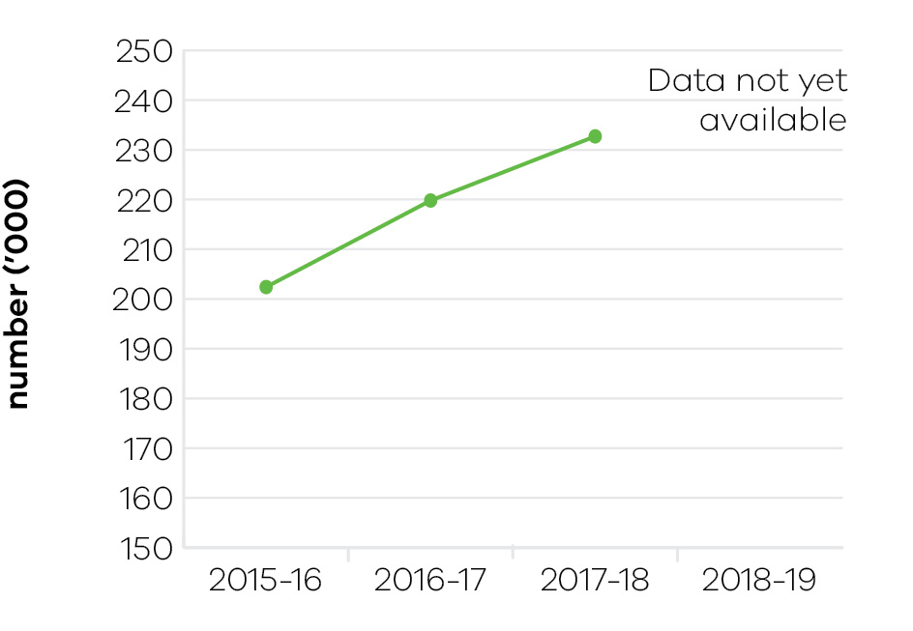
In 2017–18 (latest full financial year data available), tourism generated a total of 232,700 jobs directly and indirectly (or 7.2 per cent of employment in Victoria).

Indicator: Tourists attracted to Victoria

Table 18: Tourists attracted to Victoria
Measure (unit of measure) | 2015–16 | 2016–17 | 2017–18 | 2018–19
Number of domestic overnight visitors (number (million)) | 21.2 | 22.5 | 24 | 27.8
Number of international visitors (number (million)) | 2.5 | 2.7 | 3 | 3.1
Visitor expenditure: domestic ($ billion) | 15.8 | 17.4 | 18.8 | 21.5
Visitor expenditure: international ($ billion) | 6.7 | 7.3 | 8 | 8.5
Visitor expenditure: regional Victoria (domestic) ($ billion) | 7.6 | 8.2 | 9.1 | 10.4
Visitor expenditure: regional Victoria (international) ($ million) | 401 | 513 | 570 | 582

Figure 10: Number of domestic overnight visitors
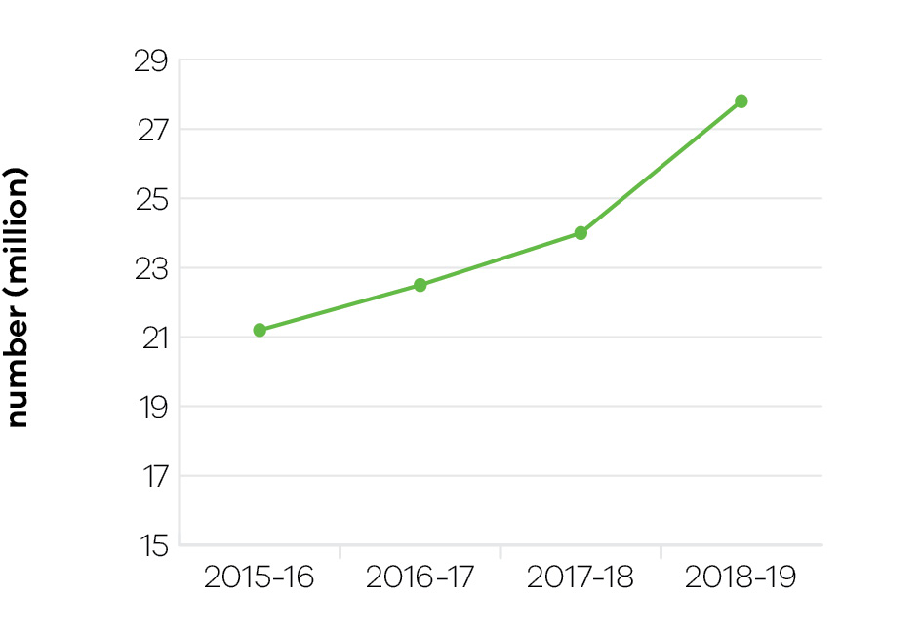

Figure 11: Number of international visitors
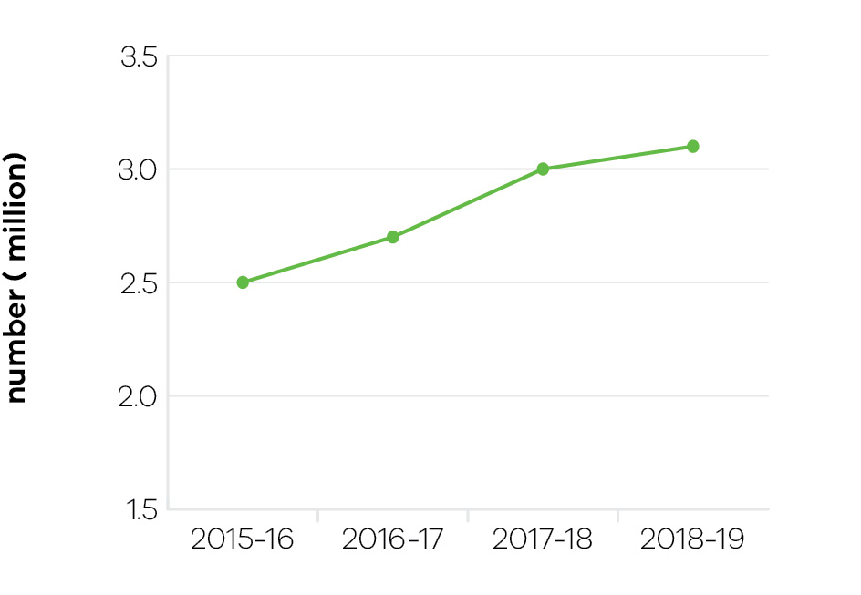

Figure 12: Visitor expenditure: domestic
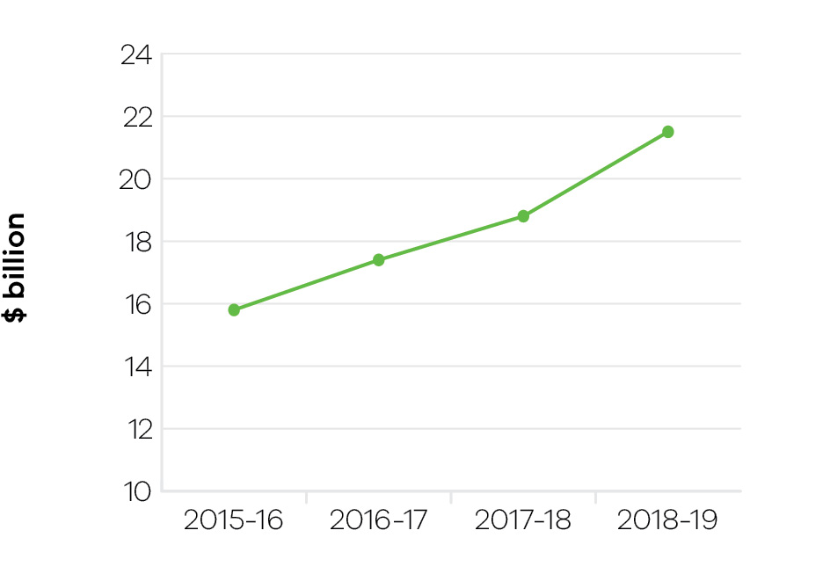

Figure 13: Visitor expenditure: international
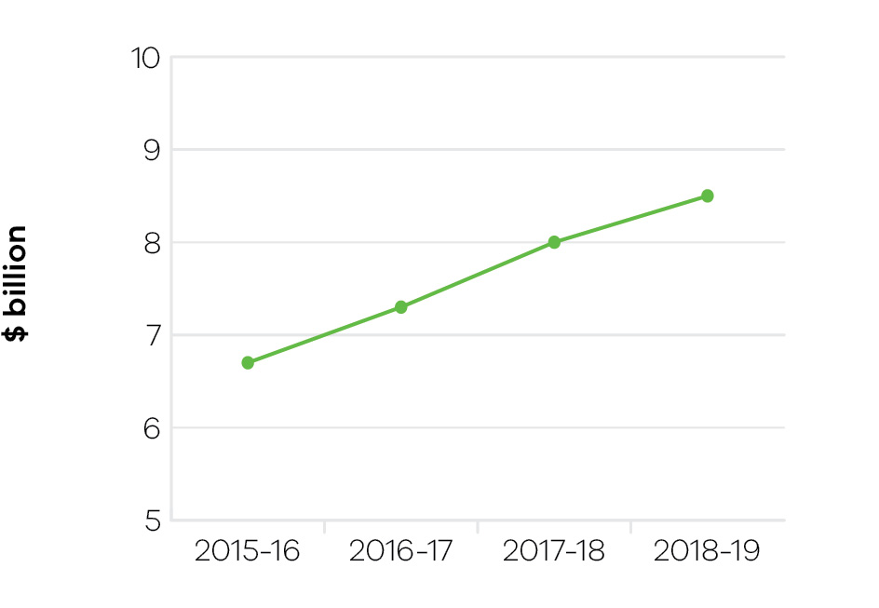

Figure 14: Visitor expenditure: regional Victoria (domestic)
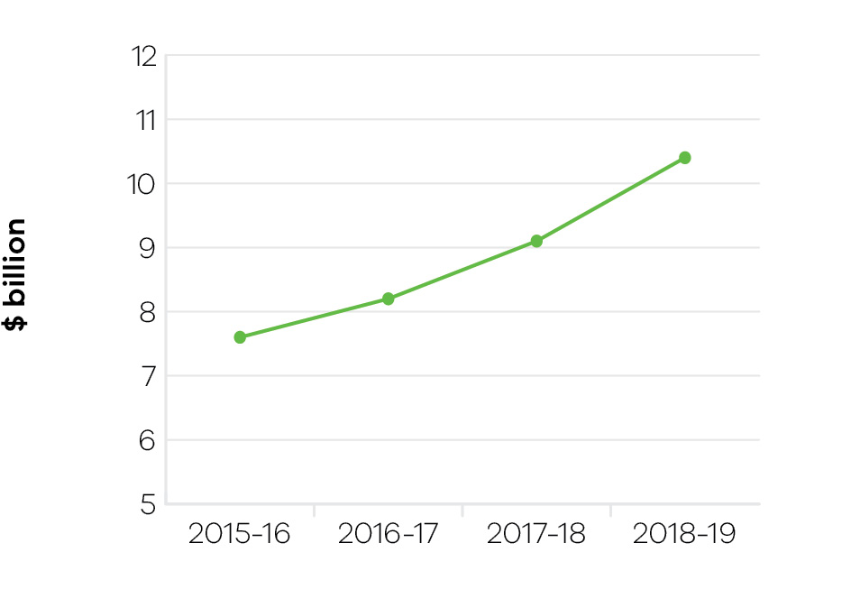

Figure 15: Visitor expenditure: regional Victoria (international)
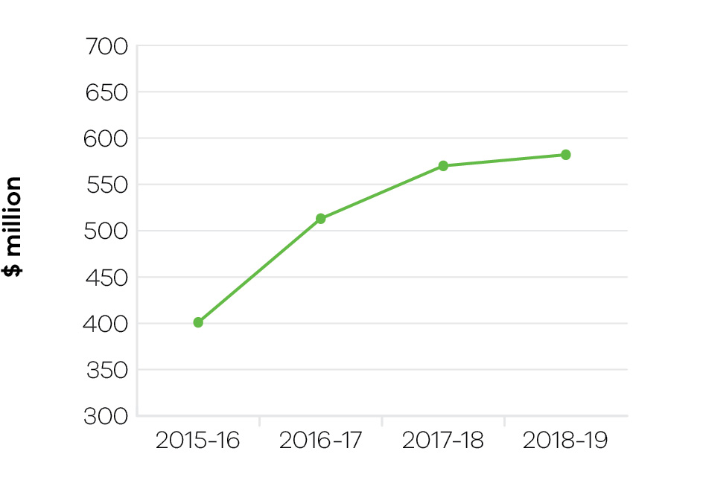
As at the year ending March 2019 (latest available), there were 90.6 million total visitors to and within Victoria, and the total expenditure was $30 billion.
- International visitation and expenditure – stronger than expected performance recorded which has exceeded targets, with Victoria’s growth against these measures higher than the national performance. This has been driven by high growth from key Asian markets such as China, India and Taiwan.
- Domestic visitation and expenditure – exceeded 2018–19 targets due to stronger than expected performances from both domestic day trip and overnight visitor expenditure in Victoria. Strong growth was noted from both intrastate and interstate visitor markets.
- Intrastate visitation and expenditure – exceeded 2018–19 targets due to stronger than expected growth against these measures. During this period, Visit Victoria commenced its marketing campaign Your Happy Space, aimed at encouraging more intrastate visitors to travel to regional Victoria.

Indicator: Increase rates of community engagement, including through participation in sport and recreation

Table 19: Increase rates of community engagement, including through participation in sport and recreation
Measure (unit of measure) | 2015–16 | 2016–17 | 2017–18 | 2018–19
Percentage of adult Victorians participating in sport at least once per year (per cent) | 87.5 | 89.2 | 90.9 | 91.6

Figure 16: Percentage of adult Victorians participating in sport at least once per year
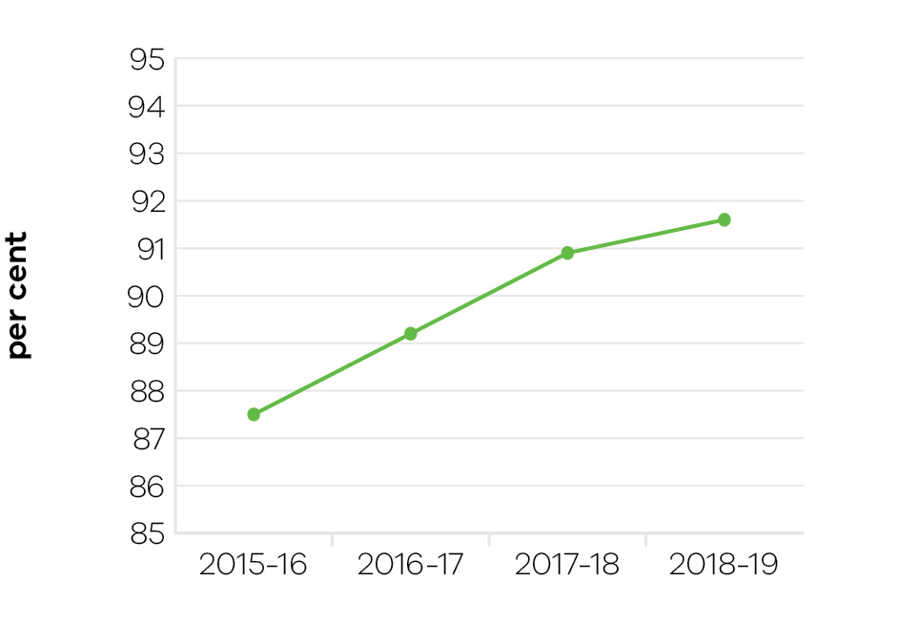
In 2018–19, 91.6 per cent of adult Victorians reported participating in sport at least once per year. There has been an upward trend in participation in sport since 2015–16, when 87.5 per cent of the adult population reported participating in sport at least once per year.
The annual increases in participation in sport and recreation are integral to delivering whole of government outcomes, particularly to enable healthy Victorians, safe and just communities, quality infrastructure, as well as a strong and thriving economy.
Increasing opportunities for participation in sport and active recreation would not be possible without the 580,000 volunteers who give their time to support local clubs, organisations and events.
The sport and recreation sector provides $9.2 billion annual gross value-add annually and supports 71,000 equivalent full-time jobs. Every dollar spent on sport is estimated to return $7.80 to our community.
The increase in participation in sport over the last four years has also been facilitated through the Supporting Victorian Sport and Recreation (SVSR) Program, which had provided funding to 100 state sporting associations and recreation bodies when it concluded on 30 June 2019. The government is continuing to support a strong sport sector through the Together More Active program, launched in April 2019, which succeeds the SVSR program.

Infrastructure
Victoria has developed world class sporting infrastructure, including 44 state facilities supporting 30 professional teams and high-performance programs.
State government investment has contributed toward the provision of 10,000 community sport facilities across Victoria, leisure and recreation centres, as well as an extensive network of over 2000 trails and thousands of playgrounds, parks and sport reserves, which further support sport and recreation participation.
Investment in major sports facilities was bolstered through $225 million allocated to the redevelopment of Marvel Stadium in the 2018–19 Budget. This investment has ensured community engagement in sport is maintained across the state, and ensured the AFL Grand Final stays at the MCG until at least 2057.
Investment in world class infrastructure has also supported the continued success of our athletes and professional sporting teams and enabled a calendar of major sporting events that add over $1.8 billion per year to the State’s economy. As an example, the 2019 Australian Open Tennis saw a record 796,000 spectators visit Melbourne Park, which alone contributed $290 million to the Victorian economy.

Women’s participation
The government’s strong commitment to increase women’s participation and leadership in sport and recreation has also been integral to lifting overall participation rates.
The Victorian Government has committed over $30 million to the Female-Friendly Facilities Fund over the past five years to upgrade existing and develop new infrastructure to support female participation in sport and active recreation.
There has been a significant increase in female participation across a range of non-traditional female sports, such as Australian Rules football, cricket and football. In the past decade, the number of female Australian rules football teams has increased 20-fold, from 58 teams in 2010 to over 1000 teams in 2019, with more than 28,500 participants.

Indicator: Wagering turnover on Victorian racing as a proportion of the national market

Table 20: Wagering turnover on Victorian racing as a proportion of the national market
Measure (unit of measure: per cent) | 2015–16 | 2016–17 | 2017–18 | 2018–19
Wagering turnover on Victorian racing as a proportion of the national market | 39.3 | 39.1 | 38.2 | 38.5

Figure 17: Wagering turnover on Victorian racing as a proportion of the national market
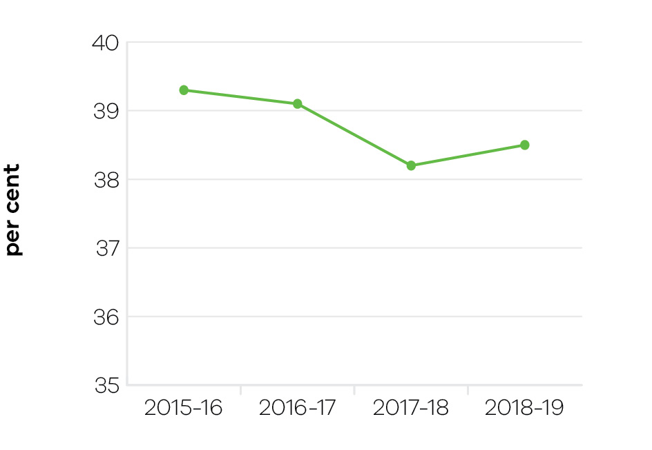
Victorian Government support for racing is based on its economic, social and cultural contribution to communities across Victoria. The objective indicator of Tabcorp customers nationwide who bet on Victorian racing as a proportion of the national market is used to determine the health of the Victorian racing industry. The measure includes all racing turnover held by Tabcorp on Victorian racing events.
While Victoria has approximately 25 per cent of the national population and hosts around 25 per cent of the national racing program, it attracts almost 40 per cent of the national wagering pool. In 2018–19, 38.5 per cent of the national wagering pool was held by Victoria, which is a slight increase from the 2017–18 proportion of 38.2 per cent.
The proportion of the national wagering pool held by Victoria has remained reasonably consistent from 2014–15 to 2018–19 and indicates a high level of public confidence in Victorian racing.
Strong wagering levels are reliant on maintaining premium racing and strong field sizes. A key lever for attracting participants is the level of prizemoney on offer and in 2018–19 the Victorian Government made a commitment to provide $40 million to increase the prizemoney on offer across the three racing codes in Victoria. This included $33 million for thoroughbred racing, bringing the total prize money and bonuses on offer in that racing code to more than $255 million per annum, a 47 per cent increase since 2015.

Performance against output performance measures
Table 21 represents performance against the Creative Industries Access, Development and Innovation output. This output supports the creative industries to deliver economic, social and cultural benefit through talent and leadership; the creative and business ecology; innovation and social impact; participation and place making; and international engagement.

Table 21: Output – Creative Industries Access, Development and Innovation
Performance measures | Unit of measure | 2018–19  actual | 2018–19  target | Performance variation (%) | Result
Quantity
Attendances at major performing arts organisations | number (000) | 1127 | 980 | 15.0 | ✓
The higher result is due to increased attendance driven by programming.
Creative Learning Partnerships | number | 12 | 18 | -33.3 | ■
The lower result is due to program re-design offering higher value grants resulting in fewer projects overall.
Design organisations supported | number | 44 | 40 | 10.0 | ✓
The higher result is due to key industry associations attending the Hong Kong Business of Design Week, which was a one-off event in December 2018 and featured Melbourne design organisations in Hong Kong.
International market development and exchange initiatives | number | 12 | 12 | 0.0 | ✓
Organisations recurrently funded | number | 140 | 142 | -1.4 | ○
Project companies and artists funded | number | 465 | 475 | -2.1 | ○
Project companies and artists funded which are regionally based | per cent | 26 | 23 | 13.0 | ✓
The higher result was due to a number of touring programs specifically targeting smaller towns around regional centres.
Regional Touring Victoria destinations | number | 83 | 70 | 18.6 | ✓
A higher number of touring programs specifically targeting smaller towns were supported.
Regionally based organisations recurrently funded | number | 53 | 54 | -1.9 | ○
Quality
Grant recipients who met or exceeded agreed outcomes | per cent | 81 | 85 | -4.7 | ○
Public information rated ‘informative’ or ‘very informative’ by grant applicants | per cent | 91 | 90 | 1.1 | ✓
Timeliness
Performance and grant agreements acquitted within timeframes specified in the funding agreement | per cent | 84 | 83 | 1.2 | ✓
VicArts Grant acquittals assessed within 30 days of submission date | per cent | 91 | 95 | -4.2 | ○
VicArts Grant applications processed within 45 days for Ministerial consideration | per cent | 100 | 100 | 0.0 | ✓
Cost
Total output cost | $ million | 81.8 | 80.6 | 1.5 | ○
Note:
✓ Performance target achieved or exceeded
 Performance target not achieved – within 5 per cent variance
■ Performance target not achieved – exceeds 5 per cent variance

Table 22 represents performance against the Creative Industries Portfolio Agencies output. This output promotes, presents and preserves our heritage and the creative industries through Victoria’s creative industries agencies: Arts Centre Melbourne, Australian Centre for the Moving Image (ACMI), Docklands Studios Melbourne, Film Victoria, Geelong Performing Arts Centre, Melbourne Recital Centre, Museums Victoria, National Gallery of Victoria (NGV), and the State Library Victoria.

Table 22: Output – Creative Industries Portfolio Agencies
Performance measures | Unit of  measure | 2018–19  actual | 2018–19  target | Performance variation (%) | Result
Quantity
Additional employment from production supported by Film Victoria | number | 8347 | 8880 | -6.0 | ■
The unpredictability of screen production cycles, including variations between different projects funded and production delays, has yielded a lower than expected result.
Agency website visitation | Number (000) | 22,255 | 21,000 | 6.0 | ✓
The majority of agencies achieved significant increases in their website traffic. This is the result of high impact exhibitions and programs, investment in online search interfaces, and the general organic growth in this channel as customers increasingly prefer to book online.
Members and friends of agencies | number | 60,792 | 52,100 | 16.7 | ✓
The overall number of members and friends of agencies grew as a result of successful member campaigns and popular programs and exhibitions.
Students participating in agency education programs | number | 531,174 | 550,000 | -3.4 | ○
Users/attendances at all agencies | number (000) | 12,786 | 10,700 | 19.5 | ✓
The success of programs and exhibitions across agencies resulted in growth in attendances in 2018–19.
Value of film, television and digital media production supported by Film Victoria | $ million | 251 | 207 | 21.3 | ✓
The higher result is due to a large value project supported by the Victorian Government.
Volunteer hours | number | 89,363 | 98,900 | -9.6 | ■
More than half of the agencies grew their volunteer base, with one agency doubling its target hours and exceeding target. However, a few agencies with larger volunteer bases experienced a reduction which has been attributed to natural attrition of older volunteers.
Quality
Agency collections storage meeting industry standard | per cent | 83 | 86 | -3.5 | ○
Visitors satisfied with visit: Arts Centre Melbourne | per cent | 96 | 95 | 1.1 | ✓
Visitors satisfied with visit: Australian Centre for the Moving Image | per cent | 95 | 94 | 1.1 | ✓
Visitors satisfied with visit: Geelong Performing Arts Centre | per cent | 97 | 98 | -1.0 | ○
Visitors satisfied with visit: Melbourne Recital Centre | per cent | 97 | 95 | 2.1 | ✓
Visitors satisfied with visit: Museums Victoria | per cent | 95 | 95 | 0.0 | ✓
Visitors satisfied with visit: National Gallery of Victoria | per cent | 96 | 95 | 1.1 | ✓
Visitors satisfied with visit: State Library Victoria | per cent | 92 | 90 | 2.2 | ✓
Cost
Total output cost | $ million | 432.0 | 378.8 | 14.0 | ■
The 2018–19 result was higher than budget primarily due to additional agency expenditure funded by third party revenue.
Note:
✓ Performance target achieved or exceeded
 Performance target not achieved – within 5 per cent variance
■ Performance target not achieved – exceeds 5 per cent variance

Table 23 represents performance against the Cultural Infrastructure and Facilities output. This output supports Victorian cultural venues and state-owned facilities through strategic assessment and provision of advice on portfolio infrastructure proposals and projects. The output includes consolidation of portfolio asset management plans and management of funding programs for maintenance and minor capital works.

Table 23: Output – Cultural Infrastructure and Facilities
Performance measures | Unit of  measure | 2018–19  actual | 2018–19  target | Performance variation (%) | Result
Quantity
All facility safety audits conducted | number | 16 | 16 | 0.0 | ✓
Infrastructure development projects underway | number | 5 | 5 | 0.0 | ✓
Quality
State‑owned tenanted cultural facilities maintained to agreed service standards | per cent | 90 | 90 | 0.0 | ✓
Success measures of projects achieved | per cent | 88 | 90 | -2.2 | ○
Timeliness
Cultural Facilities Maintenance Fund projects delivered within agreed timeframes | per cent | 86 | 90 | -4.4 | ○
Cost
Total output cost | $ million | 138.5 | 105.6 | 31.2 | ■
The 2018–19 result was higher than budget primarily to account for the transfer of land as part of the Collingwood Arts Precinct project.
Note:
✓ Performance target achieved or exceeded
 Performance target not achieved – within 5 per cent variance
■ Performance target not achieved – exceeds 5 per cent variance

Table 24 represents performance against the Sport, Recreation and Racing output. This output provides strategic leadership and investment in the sport, recreation and racing industries through innovation, sector and industry development and funding support. It supports community participation and inclusion in the sport, recreation and racing sectors by strengthening the capacity of sport and recreation organisations to deliver participation opportunities, improving community sport and recreation facilities across the state and guiding the development and management of state-level sporting facilities and events, to encourage participation by all Victorians.
This output also supports the development of the Victorian racing industry through strategic investment in world class racing and training infrastructure, the promotion of animal welfare and integrity initiatives and encourages participation and investment in the breeding industry to cement Victoria’s position as Australia’s premier racing state.

Table 24: Output – Sport, Recreation and Racing
Performance measures | Unit of  measure | 2018–19  actual |  | 2018–19  target |  | Performance variation (%) |  | Result
Quantity
Combat sports licences, registrations and permits issued | number | 628 |  | 550 |  | 14.2 |  | ✓
A higher than anticipated number of applications for licences and registrations was received due to variable demand from industry participants.
Community Facility Grants: number approved | number | 320 |  | 170 |  | 88.2 |  | ✓
A larger than expected number of project approvals across the relevant programs is due to additional funding being provided to meet high demand for community sporting facilities.
Number of projects in progress that relate to the planning and development of state level facilities | number | 17 |  | 10 |  | 70.0 |  | ✓
An increased number of projects are in progress due to investment in additional priority projects.
Racing industry development initiatives | number | 7 |  | 7 |  | 0.0 |  | ✓
Racing matters processed (including licences, permits and grant applications) | number | 357 |  | 300 |  | 19.0 |  | ✓
The Office of Racing, Racing Victoria, Harness Racing Victoria and Greyhound Racing Victoria have worked in partnership on the quality VRIF Racing Attraction Program applications and encouraged clubs to submit requests for funding six months in advance of event dates. This has provided clubs with a greater opportunity to promote events and maximise attendance. This has resulted in a significant increase in the quality and number of approved applications received this year.
Events Facilitated: Sport and Recreation | number | 70 |  | 75 |  | -6.7 |  | ■
The Significant Sporting Events Program supported the staging of 70 international or national level sporting events, with more than half of these events held in regional Victoria. An additional 46 events were approved for facilitation in future years and, as such, it is anticipated that the target of 300 events over the four years to 2021–22 will be achieved.
Sport and recreation organisations undertaking programs or activities to enhance participation | number | 100 |  | 90 |  | 11.1 |  | ✓
There was a growth in the number of organisations formally recognised as State Sporting Associations, during the reporting period. This reflects the growing demand in diversity of sport and recreation opportunities in Victoria.
Sporting club grants: number approved | number | 940 |  | 650 |  | 44.6 |  | ✓
A larger than expected number of grant approvals is due to additional funding being provided to meet high demand from sporting clubs to strengthen operations and skills development.
Number of sports with athletes on Victorian Institute of Sport (VIS) scholarships | number | 33 |  | 25 |  | 32.0 |  | ✓
The addition of new sports for the Tokyo Olympics resulted in an increase in the number of sports with athletes on VIS scholarships.
Victorian Institute of Sport scholarship holders on national teams/squads | per cent | 69 |  | 60 |  | 15.0 |  | ✓
The number of VIS athletes on national teams and squads exceeds the target due to the high number of international championships held during the last financial year, thereby creating greater opportunities for athletes.
Quality
Contract management of outdoor recreation camps meets agreed key performance indicators | per cent | 97 |  | 90 |  | 7.8 |  | ✓
Continuous improvement requirements of camps leases has resulted in a higher than expected actual.
Timeliness
Annual Community Sport and Recreation Awards held | date |  | February  2019 |  | June  2019 |  | 0.0¹ |  | ✓
The date of the event was changed from June 2019 to February 2019 to avoid date conflicts and promote maximum attendance.
Cost
Total output cost | $ million | 247.4 |  | 341.8 |  | -27.6 |  | ✓
The 2018–19 result was lower than budget primarily due to the timing of payments related to Sport and Recreation grant programs.
Note:
✓ Performance target achieved or exceeded
 Performance target not achieved – within 5 per cent variance
■ Performance target not achieved – exceeds 5 per cent variance
1 Variance cannot be calculated for date measures

Table 25 represents performance against the Tourism and Major Events output. This output maximises employment and the long-term economic benefits of tourism and major events to Victoria by developing and marketing the state as a competitive destination.

Table 25: Output – Tourism and Major Events
Performance measures | Unit of  measure | 2018–19  actual | 2018–19  target | Performance variation (%) | Result
Quantity
Major sporting and cultural events facilitated | number | 21 | 23 | 27.8% | ✓
Due to a higher number of events being formally contracted and delivered in 2018–19.
Events facilitated in 2018–19 include: White Night Geelong 2018 (Oct 2018), White Night Bendigo 2018 (Sept 2018), Golf – World Cup of Golf (Nov 2018), Fast Five Netball World Series (Oct 2018), WWE Super Show-down (Oct 2018), Australian Tennis Open (Jan 2019), Exhibition: Nelson Mandela My Life Exhibition (Sept 2018 onwards), Melbourne ESports Open (Sept 2018), Australian Basketball Package (FIBA World Cup Asian Qualifiers), 6-day Cycling Melbourne (Feb 2019), Cadel Evans Great Ocean Road Race 2019 (Jan 2019), Tudors to Windsors: British Royal Portraits – Bendigo Art Gallery (Mar 2019 onwards), Melbourne Food and Wine Festival (Mar 2019), Virgin Australia Melbourne Fashion Festival (Mar 2019), Harry Potter and the Cursed Child (Feb 2019 onwards), FIG: Individual Apparatus World Cup (Gymnastics), NRL All Stars (Feb 2019), World Superbike Championships (Feb 2019), Jayco Herald Sun Tour (Jan 2019), Festival of Sails (Jan 2019), Australian International Airshow (Mar 2019) Rip Curl Pro, Melbourne Winter Masterpieces: Terracotta Warriors & Cai Guo-Qiang.
Visit Victoria’s total engaged digital audience | number (million) | 4.8 | 5.4 | -11.1 | ■
Due to a lower marketing and social media spend directed at data acquisition and a stronger focus on establishing digital foundations for future success by Visit Victoria in 2018–19.
Visitor expenditure: domestic | $ billion | 21.5 | 19.4 | 10.8 | ✓
Stronger than predicted growth from the domestic sector with year-on-year spend growth of 11.4 per cent.
This is the latest available data to March 2019 from the National Visitor Survey published in July 2019.
Visitor expenditure: international | $ billion | 8.5 | 8 | 6.3 | ✓
Stronger than predicted double-digit spend growth from international markets, especially high growth Asian markets.
This is the latest available data to March 2019 from the National Visitor Survey published in July 2019.
Visitor expenditure: regional Victoria (domestic) | $ billion | 10.4 | 9.2 | 13.0 | ✓
Stronger than predicted growth in domestic regional spend with an increase of 10.8 per cent compared to the previous year.
This is the latest available data to March 2019 from the National Visitor Survey published in July 2019.
Visitor expenditure: regional Victoria (international) | $ million | 582 | 550 | 5.8 | ✓
The number of international overnight visitors to regional Victoria increasing at a double-digit pace year-on-year to reach 588,000, driven by both Eastern and Western markets.
This is the latest available data to March 2019 from the National Visitor Survey published in July 2019.
Visitor expenditure: regional Victoria (intrastate overnight) | $ billion | 5.4 | 4.6 | 17.4 | ✓
Stronger than predicted growth in regional intrastate overnight spend with an increase of 14 per cent compared to the previous year.
This is the latest available data to March 2019 from the National Visitor Survey published in July 2019.
Visitors (domestic overnight) | number (million) | 27.8 | 25 | 11.2 | ✓
Stronger than predicted year-on-year growth in domestic overnight visitors to Victoria of 11.8 per cent driven by both the intrastate and interstate markets.
This is the latest available data to March 2019 from the National Visitor Survey published in July 2019.
Visitors (international) | number (million) | 3.1 | 3 | 3.3 | ✓
Visitors: regional Victoria (intrastate overnight) | number (million) | 15.3 | 13.6 | 12.5 | ✓
Stronger than predicted year-on-year growth in intrastate overnight visitors to regional Victoria.
This is the latest available data to March 2019 from the National Visitor Survey published in July 2019.
Quality
Value of media coverage generated: domestic | $ million | 21.9 | 21.9 | 2.9 | ✓
Value of media coverage generated: international | $ million | 49.8 | 45 | 10.7 | ✓
Timeliness
Completion of post‑event reports and economic impact assessments of each event (where required) within agreed timeframes | per cent | 100 | 100 | 0.0 | ✓
Cost
Total output cost | $ million | 228.8 | 153.6 | 49.0 | ■
The 2018–19 result was higher than budget due to additional major events funding that was held centrally until contractual arrangements were finalised.
Note:
✓ Performance target achieved or exceeded
 Performance target not achieved – within 5 per cent variance
■ Performance target not achieved – exceeds 5 per cent variance

Objective 6: Promote productive and sustainably-used natural resources
This objective supports more productive, globally competitive, sustainable and jobs-rich agriculture, food and fibre, and resources sectors and creates the conditions to grow the forestry and game resource economies. The department delivers the objective in collaboration with partners, local communities and industry to deliver outcomes that provide benefits to all Victorians.

Progress towards achieving this objective
In 2018–19, the department reported progress against this objective using the following objective indicators and outputs:

Objective Indicators
- Value of Victorian agriculture production
- Value of Victorian food and fibre exports
- Metres drilled for minerals exploration in Victoria
- Level of production of minerals and extractives

Outputs
- Agriculture
- Agriculture Industry Development and Regulation
- Agriculture Research
- Biosecurity and Agriculture Services
- Sustainably manage forest and game resources
- Resources
The department supports a productive, globally competitive and sustainable Victorian economy for our innovative and resilient agriculture, food and fibre sector. The department works with the community and industry to enhance productivity; connect the sector with international markets and create jobs; support growth; maintain effective biosecurity and improve the welfare of domestic and production animals.

Indicator: Value of Victorian agriculture production

Table 26: Value of Victorian agriculture production
Measure (unit of measure) | 2015–16 | 2016–17 | 2017–18 | 2018–19
Gross value of Victorian agriculture production ($ billion) | 13.1 | 14.0 | 14.9 | Data available  in May 2020

Figure 18: Gross value of Victorian agriculture production
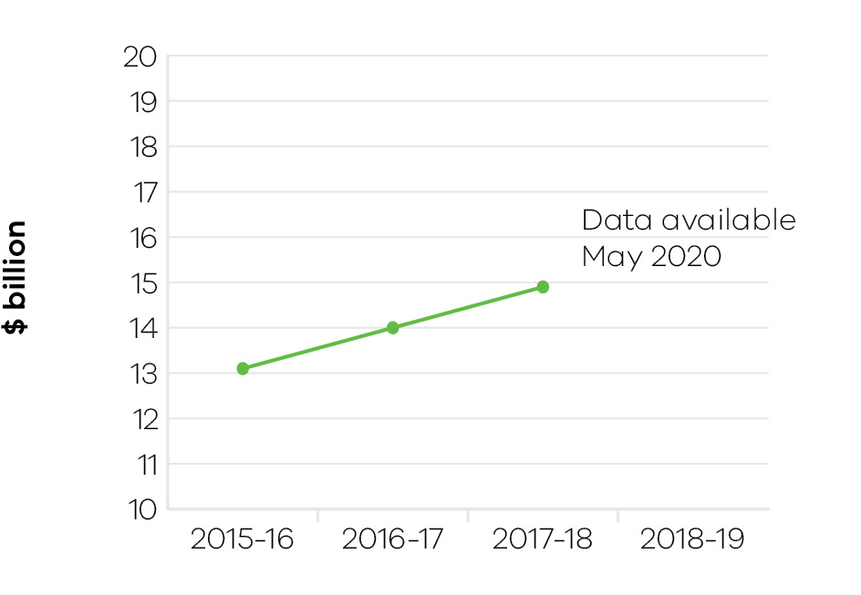
The total value of agriculture production in Victoria increased by 6.4 per cent to $14.9 billion in 2017–18 (the latest available data), compared to $14.0 billion in 2016–17. There were increases in the value of production in broadacre livestock, dairy and horticulture industries driven by strong export and domestic prices. The value of broadacre crop production decreased due to the dry start to the season.
Dry seasonal conditions prevailed in 2018–19 across most of the state with drought in Central and East Gippsland, and Northern and North West Victoria also severely affected. The Victorian Government’s Drought Support package is providing support to affected farming families and their communities. This includes on-farm drought infrastructure and pasture recovery grants, business assistance, mental health and small business support and community resilience initiatives.
The Rural Financial Counselling Service, which provides free and impartial financial counselling to farmers and related small businesses experiencing, or at risk of, financial hardship has been in high demand. Additionally, Agriculture Victoria has delivered technical support activities for farm businesses on feeding, watering and management of stock, pasture management and climate information.
Agriculture Victoria also delivered relief and recovery to fire and flood incidents impacting agricultural land, such as the Gippsland fires in March 2019. The department’s long-term research and innovation partnerships with industry is helping offset the impact of these climate effects. Agriculture Victoria has developed the world’s first genomic breeding value for heat tolerance in dairy cows, which improves animal welfare outcomes and results in less impact on milk production. A partnership with the grains industry has delivered accelerated breeding technologies. This has contributed to the development of new oilseed, cereal and pulse germplasms and varieties with improved grain yield, grain quality, disease resistance and heat tolerance.
Innovation on farm is also being enhanced by implementation of the government’s Digital Agriculture Strategy. The department is procuring network coverage to deliver an On-farm Internet of Things (IoT) Trial across four regions and farm types: horticulture (Tatura), sheep (Serpentine), dairy (Maffra) and cropping (Birchip). Agriculture Victoria is also developing a catalogue of on-farm IoT devices and applications to trial.
The department is implementing the government’s Agriculture Energy Investment Plan that supports Victorian farmers to improve energy efficiency and lower emissions. Over 450 applications, worth over $3 million for free energy assessments, have been considered and 55 applications been received from farmers for grants to manage energy costs, improve energy reliability and support own-generation capacity.
Through Animal Welfare Victoria, the department has responsibility for implementing the government’s Animal Welfare Action Plan. During 2018, implementation of legislation began with commencement of animal sales permits and commercial breeder applications to reform the dog breeding and pet shop industry. The Pet Exchange Register has been established to improve traceability of dogs and cats. Also, the Animal Welfare Fund grant program supported non-government, not for-profit organisations to improve the welfare of animals.

Indicator: Value of Victorian food and fibre exports

Table 27: Value of Victorian food and fibre exports
Measure (unit of measure) | 2015–16 | 2016–17 | 2017–18 | 2018–19
Food and fibre exports from Victoria ($ billion) | 12.1 | 12.8 | 14.1 | Data available in October 2019

Figure 19: Food and fibre exports from Victoria
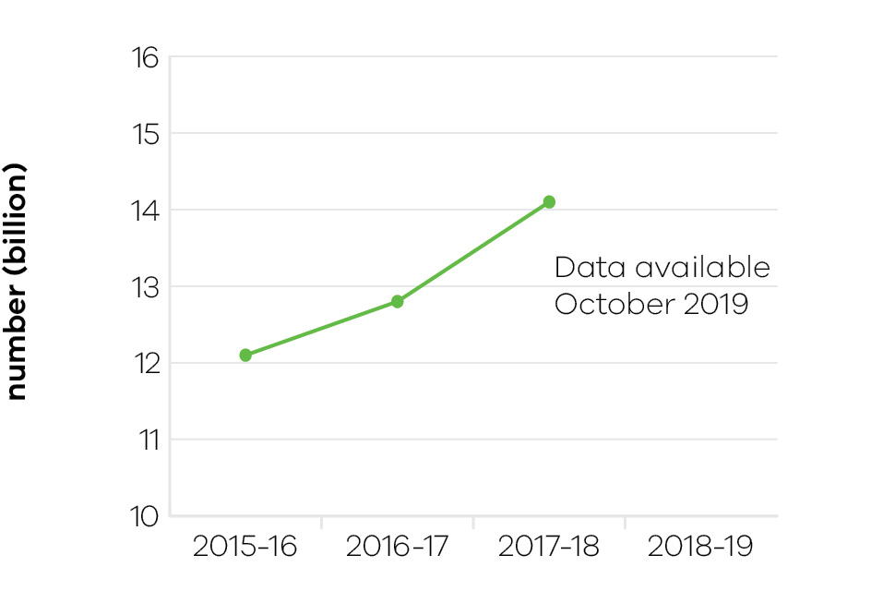
The government has a target to grow Victorian food and fibre exports to $20 billion per annum by 2030. Food and fibre exports from Victoria grew by $1.37 billion, to reach a record $14.1 billion for the 2017–18 period. Victoria is Australia’s largest exporter of food and fibre products accounting for 27 per cent of Australian food and fibre exports in 2017–18. The most valuable food and fibre export were meat ($3.3 billion), animal fibre ($2.1 billion) and dairy ($1.9 billion). China is the primary market for food and fibre exports growing by 27 per cent and worth $4.6 billion to the state. Exports to Japan and the USA also grew strongly in 2017–18.
Victoria is implementing a robust electronic traceability system for sheep and goats to manage disease and other threats to market access. Saleyards have scanned 3.2 million electronically tagged sheep and goats and abattoirs have read 5 million tags. The Managing Fruit Fly Program is developing and delivering Regional Action Plans to provide a coordinated and collaborative approach with industry and the community across Victoria to mitigate this pest threat to horticulture exports.
In 2018–19, Agriculture Victoria responded to a range of emergency animal disease and plant pest and disease detections, including a detection of the bee parasite Varroa mite, Brown marmorated stink bug, Khapra beetle and bacteria Pseudomonas syringae pv Actinidiae, which is a threat to the kiwi fruit industry.
The Agriculture Infrastructure and Jobs Fund (AIJF) delivered key projects and programs to promote the performance and resilience of the agriculture sector. AIJF invested in enabling economic infrastructure along agriculture supply chains, with over 30 Local Roads to Market projects completed in 2018–19.

Indicator: Metres drilled for minerals exploration in Victoria

Table 28: Metres drilled for minerals exploration in Victoria
Measure (unit of measure) | 2015–16 | 2016–17 | 2017–18 | 2018–19
Metres drilled for minerals exploration in Victoria (metres) | 147,167 | 191,658 | 191,229 | Data available in October 2019

Figure 20: Metres drilled for minerals exploration in Victoria
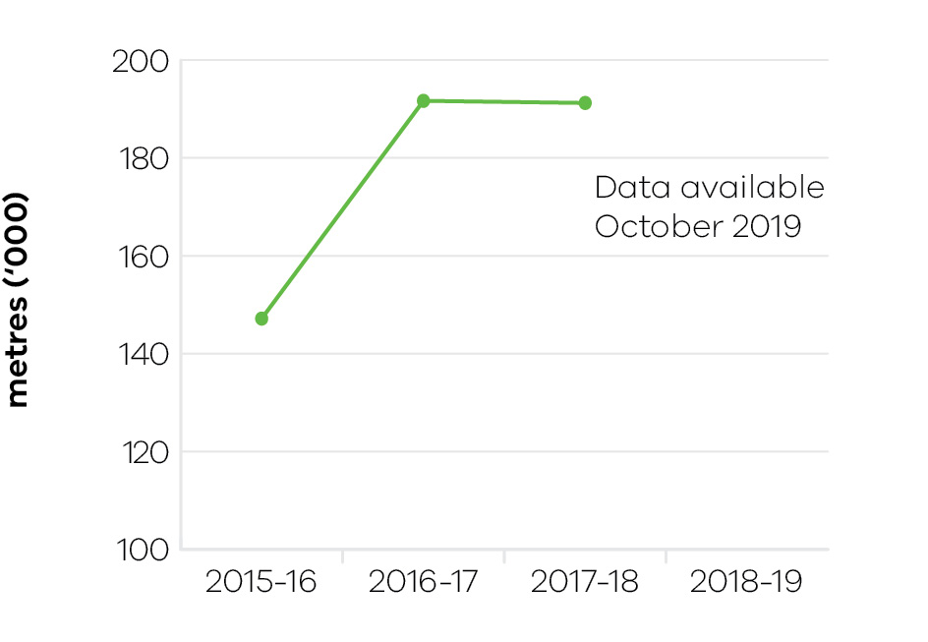
The level of metres drilled for minerals exploration in Victoria during 2017–18 was 191,229 metres, maintaining the level of exploration activity from 2016–17. The mix of exploration drilling changed during 2017–18 with drilling linked to mining licences dropping from 63 per cent to 53 per cent, and drilling linked with exploration and retention licences increasing from 37 per cent to 47 per cent. This reflects an increase in exploration activity for new mineral resource deposits.
The increase in exploration drilling activity from 2014–15 through to 2017–18 has more than doubled, mainly due to increased drilling associated with the Fosterville gold mine in central Victoria. Exploration success at the Fosterville gold mine has driven a substantial increase in reserves and production, with significant further exploration planned in the future. An example of the benefits of this success is the announcement on 8 March 2019 of a new cement infrastructure plant for the Fosterville mine.
This plant will enable by-product rock to be re-inserted underground, reducing tailings and extending the life of the mine. It will generate 60 jobs during construction and deliver 30 new, ongoing, full time jobs.
To highlight opportunities for resources investment in Victoria and attract new exploration to the State, the Geological Survey of Victoria entered into a 10-year collaborative research agreement with the Mineral Exploration Co-operative Research Centre in 2018–19, which is aimed at developing technologies to increase the discovery of new mineral deposits. This will enable pre-competitive drilling in Victoria focused on gold prospectivity in northern Victoria and support applied geoscience research to improve mineral exploration targeting.
Victoria was represented by the Geological Survey of Victoria (GSV) at the world’s premier mineral exploration and mining convention – the Prospectors and Developers Association of Canada annual conference, held in March 2019 in Toronto. The event attracts over 25,000 participants from over 135 countries. GSV presented geological information to highlight the mineral opportunities available in Victoria. Promoting the State’s geology supports the new ground release planned in 2019–20 near the Lockington area in central Victoria aimed at attracting new exploration investment.
The first exploration licence under the Stavely Ground Release Tender (six successful tenderers were announced in October 2018) was granted in March 2019. Combined, new investment of over $20 million is expected to be delivered in the Stavely region in western Victoria through this initiative.

Indicator: Level of production of minerals and extractives

Table 29: Level of production of minerals and extractives
Measure (unit of measure) | 2015–16 | 2016–17 | 2017–18 | 2018–19
Annual production of brown coal (1000 tonnes) | 59,757 | 56,095 | 45,062 | Data available in October 2019
Annual production of gold (ounces) | 256,653 | 329,452 | 364,225 | Data available in October 2019
Annual production of antimony (tonnes) | 5945 | 5138 | 2570 | Data available in October 2019
Annual production of mineral sands (tonnes) | 200,107 | 164,353 | 100,286 | Data available in October 2019
Annual production of extractives (million tonnes) | 47.3 | 57.4 | 57.87 | Data available in October 2019

Figure 21: Annual production of brown coal
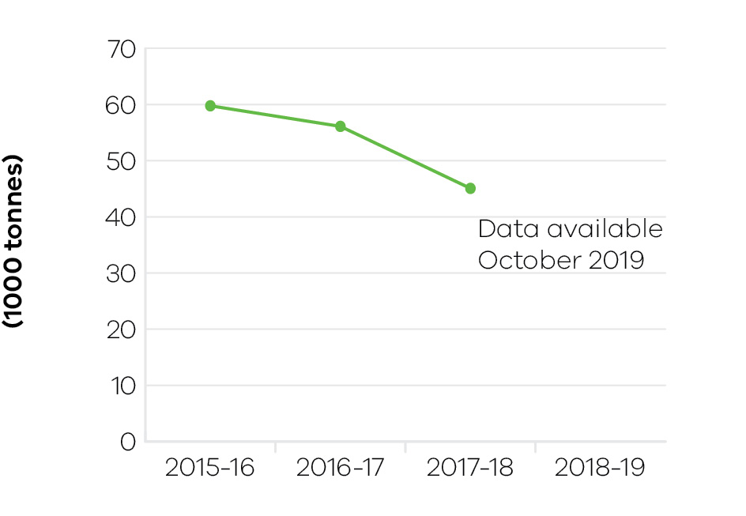

Figure 22: Annual production of gold
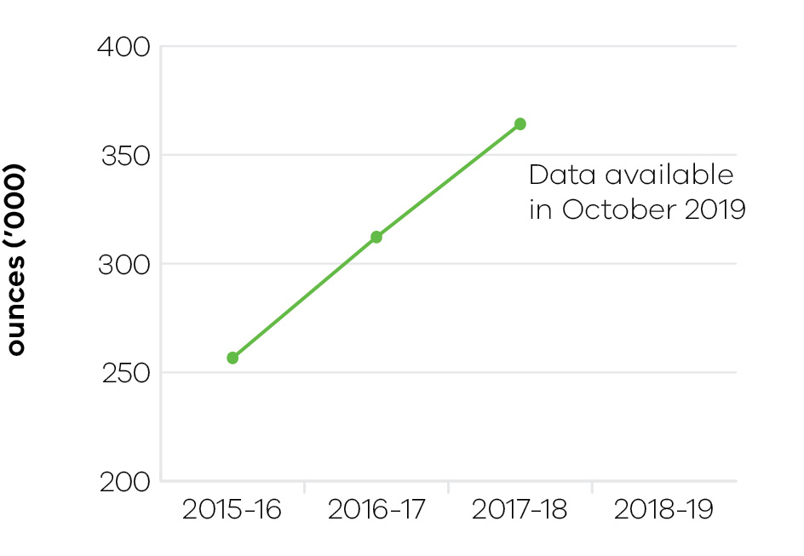

Figure 23: Annual production of antimony
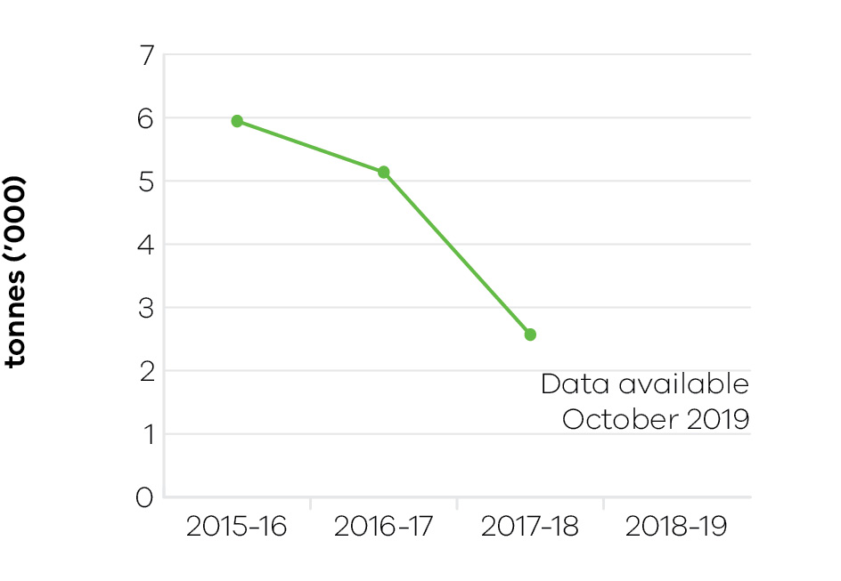

Figure 24: Annual production of mineral sands
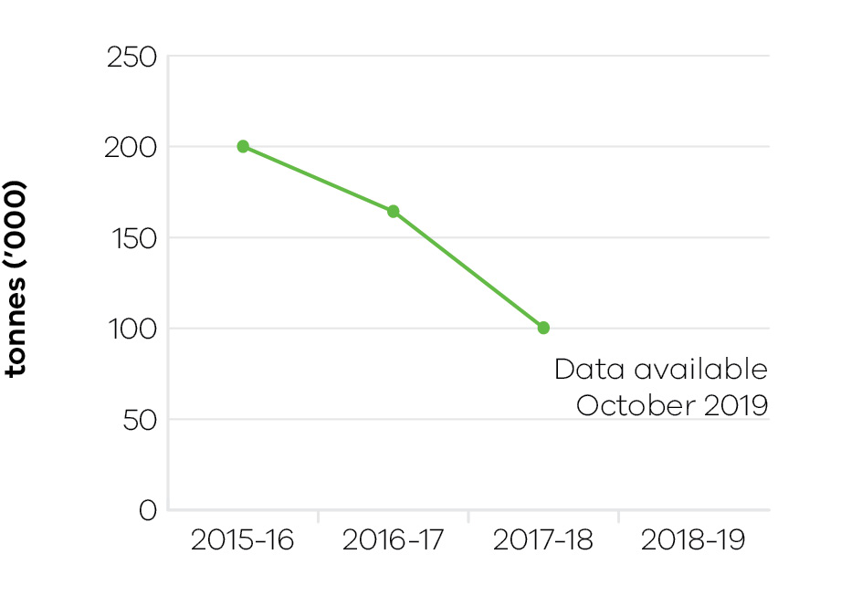

Figure 25: Annual production of extractives
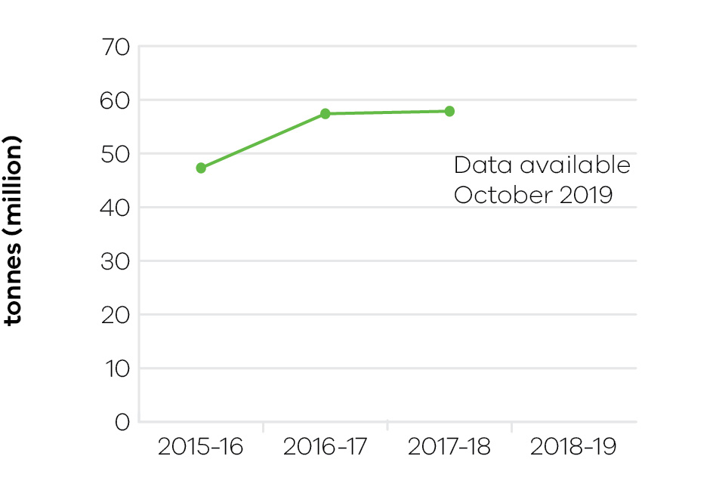
Gold production in Victoria continues to grow with an increase of almost 17 per cent in 2017–18 compared to 2016–17. As highlighted above, this is being driven by successful exploration and growing reserve levels at the Fosterville gold mine. This growth is expected to continue at Fosterville with production forecast to rise to approximately 600,000 ounces during 2019 and 2020.
Production of extractives (sand, stone and gravel) in 2017–18 was 57.87 million tonnes, maintaining the level from 2016–17. With demand for new housing and infrastructure development (road and rail projects) increasing, production of extractives is forecast to grow significantly over coming years.
Brown coal production at 45.062 million tonnes in 2017–18 was 20 per cent lower than 2016–17 reflecting the closure of the Hazelwood coal mine on 31 March 2017. The level of mineral sands production decreased to 100,286 tonnes in 2017–18 down from 164,353 tonnes in 2016–17. This reflects the completion of key projects in western Victoria however new mineral sands projects are proposed in the Murray and Gippsland Basins. Antimony is also produced from Australia’s only antimony mine at Costerfield in central Victoria.
To support a growing and sustainable earth resources sector and deliver new jobs and investment, the department progressed several initiatives in 2017–18.
In March 2019, a new partnership agreement was announced with the Australasian Institute of Mining and Metallurgy (AusIMM) that aims to encourage more women at senior levels, attracting talent into the resources sector and support clearer career pathways for secondary and tertiary students. The Victorian government is contributing $310,000 over three years to support skills development in the Resources sector through this agreement.
As part of the work program to improve the regulation of the State’s earth resources, new Guidelines were released in February 2019, setting out the application requirements for industry and explaining the regulation assessment process. The Guidelines also include an updated risk framework that helps standardise the risk management approach and focus regulatory efforts on higher risk activities.
The regulations covering mineral resources in Victoria have been re-made due to the existing regulations expiring on 30 June 2019. Industry and the community provided feedback during March and April 2019 as part of the Regulatory Impact Statement process. Key areas of change include clarifying risk management plans, setting new rehabilitation plan requirements and implementing new streamlined reporting requirements. The new regulations commenced on 1 July 2019 – Mineral Resources (Sustainable Development) (Mineral Industries) Regulations 2019.
As part of the Victorian Gas Program (VGP), Victoria’s largest ever airborne gravity survey was completed in January 2019. The survey covered 32,000 km in the Otway Geological Basin (south-west Victoria) to support the VGP geoscientific and technical studies program. The survey data will be used to map sub-surface geological structures to inform the gas work program and the potential for new onshore conventional gas and offshore gas resources in the region.
The 2nd Progress Report for the VGP was released on 28 February 2019. This report builds on the first report published in January 2018 and provides a summary of the technical studies undertaken to date.
Tender applications for the five acreage release blocks in offshore south-west Victoria closed in February 2019 and are currently being assessed by the regulator. Offshore gas exploration has the potential to find new sources of gas for Victoria.
The Victorian government committed $5 million in June 2019 to support the $45 million Carbon Dioxide Cooperative Research Centre (CO2CRC) Otway Research Project – Stage 3. This investment (including funding from the Commonwealth and industry) will help to transform the Otway national research facility into the best CO₂ storage testing facility in the world. The scientific research will operate through to 2022 and provide important information for the development of carbon capture and storage (CCS) technologies such as that being developed through the CarbonNet Project in Gippsland. The Victorian government has supported the CO2CRC since 2004–05.
On 22 May 2019, new land access tools were released to support rural landholders in negotiating with mineral explorers seeking to access their land for exploration activities. The tools will assist with access to private property, setting farm biosecurity protocols and managing any impacts on crops including potential compensation.
The 5th Annual International Mining and Resources Conference was successfully held between 29 October and 1 November 2018. Over the four days, more than 6000 attendees came together from over 85 countries for networking and business opportunities focused on mining and mining equipment technology and services. This event highlights Melbourne’s position as a global mining and mining services hub. In addition, Melbourne also hosted the International Council on Mining and Metals bi-annual forum, this is the first time this event has been hosted in the southern hemisphere.
A new Minerals Resources Strategy: State of Discovery was released by the former Minister for Resources on 28 August 2018 at the Stawell Gold Mine. This strategy highlights key actions to grow the resources sector including actions to build community confidence in the social, environmental and economic performance of the sector, improving the State’s attractiveness for minerals investment and strengthening Victoria’s position as a global mining and mining services centre.

Performance against output performance measures
Table 30 represents performance against the Agriculture output. This output supports a more productive, competitive, sustainable and jobs-rich food and fibre sector, and creates the conditions to grow the forestry and game resource economies by delivering policy advice, regulation and support to meet consumer and community expectations for agriculture, forestry and game industry development, pets and animal welfare, regulatory policies and frameworks.

Table 30: Output – Agriculture
Performance measures | Unit of measure | 2018–19  actual | 2018–19  target | Performance variation (%) | Result
Quantity
Animal pest, disease and residue control programs maintained to ensure Victorian agricultural produce complies with food safety and biosecurity standards required to access markets | number | 5 | 5 | 0.0 | ✓
Applications for intellectual property protection | number | 16 | 16 | 0.0 | ✓
Client interactions with land health services | number | 1731 | 1700 | 1.8 | ✓
Clients engaged with agriculture productivity services | number | 4672 | 3910 | 19.5 | ✓
The actual result exceeded the target due to one-off additional drought support services.
Commercial technology licence agreements finalised | number | 16 | 16 | 0.0 | ✓
Farms and related small businesses facing significant adjustment pressures supported to make better informed decisions by the Rural Financial Counselling Service | number | 1850 | 1700 | 8.8 | ✓
The actual result exceeded the target due to increased demand for the Rural Financial Counselling Services caused by drought, dry conditions and dairy industry pressures.
In addition, changes to and increased demand for other financial support such as the Commonwealth’s Farm Household Allowance, contributed to increased client numbers.
During the year, additional funding was provided for additional resources in Gippsland, North East and North West Rural Financial Counselling Services to enable them to respond to this increased demand.
Genetic improvement of dairy cows achieved through breeding contributing to increased milk production and dairy productivity | per cent | 1 | 1 | 0.0 | ✓
Improved agricultural productivity services, programs and products developed | number | 10 | 10 | 0.0 | ✓
Inspections or audits of scientific establishments undertaken to provide assurance of compliance with relevant industry standards for animal welfare | number | 25 | 25 | 0.0 | ✓
Key bioscience platform technologies established | number | 1 | 1 | 0.0 | ✓
Known state prohibited weed sites monitored and treated in line with the relevant weed action plan | per cent | 99 | 95 | 4.2 | ✓
New or amended Interstate Certificate Assurance (ICA) or other market access accreditations developed to restore or enable trade | number | 6 | 2 | 200.0 | ✓
The actual result exceeded the target primarily driven by a number of factors not directly influenced by the department. These external factors included changes to chemical registration, national policy, industry demand, or in response to new pests and/or diseases.
Plant pest, disease and residue control programs maintained to ensure Victorian agricultural produce complies with food safety and biosecurity standards required to access markets | number | 6 | 6 | 0.0 | ✓
Postgraduate‑level/PhD students in training | number | 66 | 65 | 1.5 | ✓
Properties inspected for invasive plant and animal priority species | number | 2803 | 2700 | 3.8 | ✓
Strategies developed to overcome identified trade barriers | number | 7 | 7 | 0.0 | ✓
Value of co‑investment from external (non‑state) funding sources attracted to the department’s research projects that support productive agriculture | $ million | 38 | 38 | 0.0 | ✓
Quality
Client satisfaction rating of agricultural productivity services | number | 9 | 8 | 12.5 | ✓
The actual result exceeded the target due to on-going emphasis on design of client focussed services.
Key statutory obligations relevant to the Game Management Authority complied with (tabling annual report, audits, business plan and board appointments) | per cent | 100 | 100 | 0.0 | ✓
Key statutory obligations relevant to VicForests complied with (tabling annual report, audits, corporate plan and board appointments) | per cent | 100 | 100 | 0.0 | ✓
National biosecurity, agriculture/veterinary chemical use and animal welfare programs implemented in accordance with agreed plans | per cent | 100 | 95 | 5.3 | ✓
The actual result exceeded the target due to Victoria responding to all requests associated with 61 national work programs. Key contributions were made to development of the Aquatic Animal Health Deed, the Intergovernmental Agreement on Biosecurity (IGAB) review, carp control, red imported fire ant, citrus canker, browsing ants, khapra beetle, fruit fly and traceability.
Satisfaction rating of industry investors in agriculture productivity research and development | number | 9 | 6 | 50.0 | ✓
The actual result exceeded the target due to the success of the new partnership model where research is jointly designed, delivered and evaluated through a direct engagement and long-term partnership model with industry.
Scientific and technical publications subjected to independent peer review in international and national journals that promote productive agriculture | number | 269 | 260 | 3.5 | ✓
Timeliness
Animal health certificates issued within specified timeframes to support international market access | per cent | 95 | 95 | 0.0 | ✓
Initial action taken to respond to reported emergency animal and plant pest, disease and natural disaster incidents complies with national agreements and obligations | per cent | 100 | 100 | 0.0 | ✓
Plant health certificates issued within specified timeframes at the Melbourne Wholesale Fruit and Vegetable Market to support domestic market access | per cent | 99 | 95 | 4.2 | ✓
Provision of technical advice, diagnostic identification tests on pests and diseases including suspected exotics within agreed timeframes | per cent | 88 | 85 | 3.5 | ✓
Research project milestones and reports completed on time | per cent | 94 | 85 | 10.6 | ✓
The actual result exceeded the target due to improved portfolio management processes implemented.
Cost
Total output cost | $ million | 485.8 | 490.8 | -1.0 | ✓
Note:
✓ Performance target achieved or exceeded
 Performance target not achieved – within 5 per cent variance
■ Performance target not achieved – exceeds 5 per cent variance

Table 31 represents performance against the Resources output. This output develops and delivers policy, programs and regulation to enable investment and generate jobs through the sustainable development of the State’s earth resources, including extractives, minerals and petroleum.
The department acquires and provides access to high-quality geoscience data and knowledge to inform government decision making and attract new investment and jobs to the State. It develops and implements legislative and regulatory reforms in the earth resources sector to improve outcomes for all stakeholders.
Supporting investment in resources and low emission technologies, the department fosters innovation, productivity, jobs and trade in the State’s earth resources sector. Through strategic resource and related land use planning, new opportunities are able to be identified for Victoria’s earth resources, along with supporting major infrastructure development in the State.
The department also regulates the earth resources sector through transparent, consistent and timely regulatory processes that provide industry with confidence to invest and have regard to the needs of communities and minimise impacts to the environment.

Table 31: Output – Resources
Performance measures | Unit of  measure | 2018–19  actual | 2018–19  target | Performance variation (%) | Result
Quantity
Community and stakeholder engagement information forums | number | 56 | 45 | 24.4 | ✓
The higher 2018–19 result is due mainly to increased forums associated with Latrobe Valley coal mine rehabilitation, new work plan guidelines sessions and additional forums associated with the Stavely ground release in Western Victoria.
Quality
Exploration and mining licences which are active | per cent | 80.5 | 82.5 | -2.4 | ○
Timeliness
Delivery of key CarbonNet milestones, in line with funding agreements and agreed project deliverables | per cent | 83 | 100 | -17.0 | ■
The lower 2018–19 result is due to further work required to review and assess commercialisation options for the project.
Delivery of key milestones consistent with agreed timelines for the Victorian Gas Program | per cent | 86 | 100 | -14.0 | ■
Geological modelling for the Otway Basin rescheduled into 2019–20 due to a change in service provider that was unable to complete the work program in 2018–19.
Exploration licence applications, mining industry work plans and mining licence applications processed within regulatory timeframes | per cent | 98 | 95 | 3.2 | ✓
Facilitate the delivery of resources projects in line with grant agreements and project milestones | per cent | 83 | 100 | -17.0 | ■
The lower 2018–19 result is mainly due to delays in securing drilling services by proponents as part of the TARGET exploration grants program and further analysis and engagement required for longer term supply options of extractives as part of the strategic extractive resource areas pilot project.
Industry geoscience data packages released for minerals and petroleum sectors consistent with agreed timelines | number | 11 | 10 | 10.0 | ✓
An additional Victorian Gas Program technical report was published ahead of schedule.
Regulatory audits completed within agreed timelines | per cent | 100 | 98 | 2.0 | ✓
Cost
Total output cost | $ million | 85.8 | 169.4 | -49.4 | ✓
The 2018–19 result was lower than budget due to scheduling changes for key work programs including CarbonNet and the Victorian Gas Program.
Note:
✓ Performance target achieved or exceeded
 Performance target not achieved – within 5 per cent variance
■ Performance target not achieved – exceeds 5 per cent variance

