Regional Tourism Review

Consultation findings
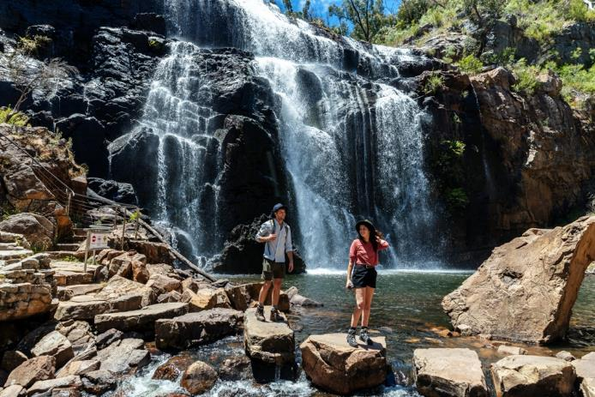
Consultation snapshot
In March 2019, the Minister for Tourism, Sport and Major Events, Martin Pakula, and the then Minister for Regional Development, Jaclyn Symes, commissioned the Regional Tourism Review (the review). The review’s goal was to give our regions the support and opportunities they need to grow in the tourism market.
Minister for Regional Development, Mary-Anne Thomas, led the consultations and oversaw the work of the Department of Jobs, Precincts and Regions in her role as Special Adviser for the Regional Tourism Review.

Some of the regional tourism professionals we spoke to

Kathryn Mackenzie
Echuca Moama Tourism
Industry experts such as Kathryn Mackenzie– CEO, Echuca Moama Tourism – were integral to the review.
Kathryn attended the regional industry conversation in Echuca with other industry professionals.
“The tourism industry is currently in dynamic change, perhaps the most significant in my lifetime. The government’s review is timely and greatly needed.”

Matt Sykes
Young tourism professional
“When I heard about the Regional Tourism Review at the Victorian Tourism Industry Council conference in July, my first thought was, where is the space for young voices? We’re talking about our future.”
Matt is the founder and CEO of Regeneration Projects. He clearly sees how young voices can help the industry on a new path.
“The review is a rare opportunity to dream big and set a visionary, environmentally driven goal for the industry.”

Marc Higgins
Gunaikurnai Land and Waters Aboriginal Corporation
Traditional Owners are closely tied to the new way forward for Victorian tourism.
Marc Higgins, Chief Operating Officer of the Gunaikurnai Land and Waters Aboriginal Corporation (GLAWAC) attended the Lakes Entrance regional industry conversation. He was highly involved with the review and had many discussions with the review team.
“GLAWAC sees expanding our participation in tourism across Gunaikurnai Country as fundamental for our future,” Marc said.
“Gunaikurnai Country in Gippsland is some of the most beautiful in the world. The Traditional Owner organisation, GLAWAC welcomes the government’s continued investment in and review of the sector.”

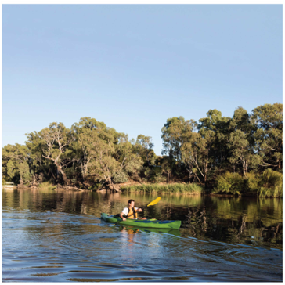

A new way forward
In 2019, the Special Adviser and the Regional Tourism Review team travelled across the state to meet those who know what regional tourism needs – the people in rural and regional Victoria.
The review sought the real, lived experience of Victoria’s regional tourism industry through extensive consultation that made sure local voices were heard.
The review consulted broadly – including with local businesses, industry leaders, local government, Regional Tourism Boards, Regional Partnerships, Traditional Owners and Aboriginal communities, community groups and local residents. This document provides an overview of those conversations – how they worked, what we heard, and what comes next.

How we consulted
The Special Adviser and the review team met stakeholders for one-on-one, early consultations to help us understand how best to consult: where to go, who to talk to and what to ask. In early consultations, stakeholders frequently identified five key themes that present opportunities for regional tourism:
- strengthening our tourism offering
- making the most of our marketing spending
- supporting industry
- enhancing Regional Tourism Boards
- better coordinating efforts.
We used these themes to frame consultations, along with a focus on community engagement.
The Regional Tourism Review discussion paper was released in July 2019 to help us tap into community and industry knowledge from all over the state. There was a strong response to the discussion paper, which demonstrates the level of interest and passion regional Victorians have for tourism.
Stakeholders responded to the discussion paper in two main ways:
- 533 formal submissions through the Engage Victoria website
- 662 participants at 18 roundtable consultations across the state.
Stakeholders gave extensive feedback and were generous with their time. The following sections summarise their responses.

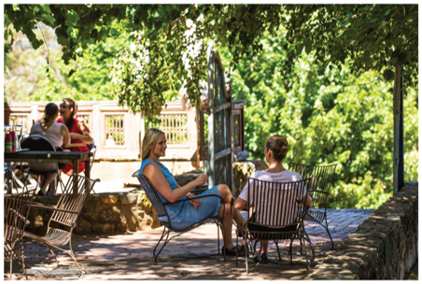

What we heard
Stakeholders identified the challenges and opportunities that need to be addressed to realise the potential of regional tourism.

Setting the scene

Defining regional victoria
We asked stakeholders to define regional Victoria for tourism purposes. They did not have a clear consensus on what constitutes regional Victoria, but agreed we should better recognise the diversity of regional Victoria, the range of visitor types across the state, and why visitors travel where they do. Some stakeholders highlighted issues specific to councils in the interface between metropolitan and regional areas.

Measuring success
Most stakeholders said their regions need to increase both visitors and yield, but that growth should reflect local capacity to support and manage visitation. Stakeholders also flagged the possibility of a wider range of success measures, including levels of dispersal, jobs growth and export earnings, as well as social, cultural and environmental impacts and outcomes.
Visitor economy metrics need to include employment, gross regional product, gross value add etc to demonstrate the social and cultural impacts within communities.
– Great Ocean Road Regional Tourism

Theme 1: Strengthening our tourism offering
Stakeholders said that unique, artisanal and authentic local offerings, ‘hidden gems’, history and heritage, and Aboriginal experiences should be further developed and showcased.
Many areas rely heavily on traditional school breaks, camping, caravanning and affordable family holiday activities. These types of holidays attract large numbers of visitors to regional areas and are important to many Victorians.
Stakeholders consistently raised nature-based experiences as a key opportunity for regional Victoria. They suggested a new nature-based strategy could drive work in this area. Regional Victoria offers many unique natural assets and lesser-known experiences for visitors.
As well as prominent international attractions such as the Great Ocean Road and Phillip Island, people identified many other experiences and destinations with great potential including the Grampians, Gippsland, Victoria’s alpine areas, outback Victoria and the Murray. Stakeholders expressed concern and confusion about access to parks for activities such as rock climbing, hunting, fishing, camping and four-wheel driving. We also heard there are significant opportunities to further build regional Victoria’s strong epicurean credentials, and to continue to grow our compelling arts and culture offering.
Many stakeholders told us there is a lack of accommodation in regional Victoria, particularly high-end and boutique accommodation. They saw online booking platforms (such as Stayz and Airbnb) as sometimes necessary, but with some adverse impacts, including on housing supply and affordability. These affect many local communities and regional tourism businesses.
People also said the way visitors access information is changing. While many travellers research destinations before visiting, many also use mobile services to look at options while travelling. Visitors also want to talk face-to-face with locals to understand local offerings and experiences. Visitor services and facilities must keep pace with these changing visitor habits and expectations.

Government’s role
People said that government’s role (including local councils) is key, particularly for providing public transport, essential services and infrastructure.
Many stakeholders highlighted the importance of state and local government investment in products such as national parks and local galleries.
Stakeholders said a lot of work has already been done to identify regional priorities that will strengthen our tourism offering. From this work, people often mentioned opportunities such as thermal spas and mineral springs, hiking and cycling, Aboriginal experiences, and high-end dining and accommodation. Many also noted opportunities for ‘hero projects’ such as a signature eco-lodge and international-standard walking trails. There is a desire to see this work recognised in government planning.
Planning these projects also will need to consider the risks of a changing climate, including more frequent and intense weather events and bushfires, changes in rainfall and sea level, and impacts on flora and fauna.

Theme 2: Making the most of our marketing spending
Stakeholders told us marketing activities should be adequately resourced and better coordinated. Marketing by Visit Victoria, Regional Tourism Boards, local tourism organisations and councils can be fragmented. This means limited resources are not spent as effectively as they could be, and inconsistent messaging can undermine efforts to attract visitors.
There needs to be a more collaborative marketing approach, one that focuses on the bigger picture and ensures marketing funds are not spread across smaller campaigns that have less impact. There is a need for a regional marketing strategic plan, a regional brand with clear roles and responsibilities for stakeholders, and a destination master plan aligned with marketing activities. People also want greater sharing of research and information to support better marketing decisions.
Stakeholders noted that Visit Victoria has a key role in setting the strategic marketing plan for Victoria. Regional Tourism Boards could be a pathway for industry,
councils and communities to elevate their marketing priorities for consideration by government in its statewide branding activities. However, not all stakeholders held these views – a small number proposed devolving all regional marketing to Regional Tourism Boards or giving Visit Victoria responsibility for all regional marketing.
Stakeholders emphasised the importance of a strategic marketing plan to provide long-term direction for all our partners.
People said regional Victoria needs its own brand; distinct from Melbourne.
A regional brand should reflect the unique and less prominent experiences found in regional Victoria, as well as highlighting the experiences we want to be known for. These include Victoria’s distinctive landscapes, heritage towns and hidden local attractions.
Stakeholders also said that events could be better promoted. Events attract visitors outside of peak periods. They also offer a chance for regions to celebrate their identity, both for locals and visitors. Stakeholders saw an opportunity to expand support for new events, and to make the most of existing events to attract visitors and increase the visibility of specific regions. Stakeholders noted the success of regional extensions of popular events, such as the World’s Longest Lunch and White Night, and suggested replicating this model for more events.
… there are currently too many websites, social media accounts and collaterals. This is confusing for operators and consumers.
– Industry stakeholder
Although there is support for regional marketing programs and events, more collaboration across the state to develop local/regional marketing programs would assist.
– City of Ballarat
Regional Victoria requires a strategic marketing strategy (which is adequately funded) – based around regional itineraries that maximise visitor experiences rather than a few hero destinations.
– Murray Regional Tourism

Theme 3: Supporting industry
Stakeholders said many small businesses are held back by limited opportunities to build skills to grow their business. They felt the government could do more to help individual businesses build capability, such as understanding how to reach and work with suppliers, and how to improve accessible tourism offerings for people with disabilities. Stakeholders frequently highlighted two key issues for industry capability:
- Labour and skills challenges – including attraction and retention, industry seasonality, housing affordability and the perception of tourism as a career. Many regional businesses find it difficult to attract and retain staff to cope with seasonal fluctuations, and there are ongoing shortages of important skills (such as chefs).
- Digital capability – such as connecting to sales channels, promoting businesses and regions, and understanding markets. Tourism businesses rely on digital services to perform well, and it is important they have access to the right training, as well as high-speed internet and mobile coverage, to enable digital solutions.
The COVID-19 pandemic and recent bushfires also highlighted the importance of crisis management and planning, as well as building the resilience of businesses so they have the best chance of recovering from disasters and other shocks.
Undertake a destination skills gap analysis and develop a multi service provider training package program that aligns to drive employment outcomes.
– Mornington Peninsula Shire
Stakeholders identified that though some Traditional Owners and Aboriginal communities had a strong interest in creating Aboriginal tourism experiences, this opportunity had been underdeveloped. Aboriginal leaders face significant competing demands for their time and involvement, making it difficult for them to be the sole drivers of cultural tourism development.
At the same time, there is a lack of business and investment facilitation support for Aboriginal tourism experiences. New facilitation services need to understand these challenges and work responsively to ensure new Aboriginal tourism products are led by Traditional Owners and Aboriginal communities.
The biggest elephant in the room is ‘red tape’. Regulation is not keeping up with the changing landscape of the tourism industry.
– Rural City of Wangaratta
Stakeholders overwhelmingly reported that planning and approvals for new investments and burdensome red tape pose significant challenges. Many said that the system is overly complex, and it can be difficult to know who to talk to and what needs to be done.
They provided extensive feedback on the challenges of navigating the complex planning system, and the need to make it more responsive to help good projects get going, and, where possible, provide a single point of contact or ‘concierge’.
Businesses and potential investors look to government for direction and support to deliver important projects through this system. They want clarity on how the system works and what to expect. People felt addressing these issues would help bring new and improved visitor experiences to the regions and could unlock significant new opportunities.
Community engagement was also flagged as a potential area for improvement, to help industry engage with communities to gain and maintain a social licence for tourism projects. Overall, there is good support for tourism in regional communities, but some areas face crowding in peak periods and some development proposals risk local goodwill. Communities want to be involved in tourism planning and decisions that affect them directly. Stakeholders felt stronger community engagement would encourage buy-in and would help tourism be more responsive to local needs.

Theme 4: Enhancing Regional Tourism Boards
Regional Tourism Boards were first established in 2008, with 11 now operating across Victoria. They set regional strategic directions and work with industry, local councils and the Victorian Government to drive tourism in their region.
Stakeholders broadly support Regional Tourism Boards, with some working well and others showing good potential. They said high-performing boards engage with councils and industry, and see the benefits of regional collaboration. Their partners invest in the boards to drive regional and local marketing, strategy and industry development activities. They are influential in setting regional priorities and in providing a clear voice to government.
Boards are the key point of contact between local industry, councils and government on tourism marketing, destination planning, industry development and tourism product priorities. They have a key role in the immediate response to crises, connecting local industry and travellers with government, as well as in recovery planning.
Stakeholders recognise the boards deliver services that most councils and businesses would find difficult to provide on their own. They also play an important role in engaging with local businesses and the community.
Many people at regional conversations said government should not unnecessarily change things that work well, but there are real opportunities to strengthen boards. People described key ingredients for success:
- clear roles and responsibilities across boards, local councils and Visit Victoria to reduce duplication and support long-term success
- a collaborative cross-regional approach led by boards, working with councils, industry and local tourism organisations to feed through to the Victorian Government
- skills-based boards with senior local council and industry participation
- transparent priority setting, including strategy and advocacy that reflects local community and business aspirations, and broader regional industry development needs
- increased capacity and capability supported by scale and resources to deal with complex issues.
Overall, stakeholders saw board remit, capacity and resources as vital to meet regional tourism objectives. Boards need to be given authority by councils and government to deliver clear outcomes for their region, and they need skilled staff and the means to deliver those outcomes.
Stakeholders also said any changes to boards will need to recognise they are a partnership between governments and industry, and all partners will need to be brought along.
Recognising RTBs as the pathway and single point of contact for Visit Victoria is critical.
– Corangamite Shire Council
There is an opportunity for RTBs, government and industry to develop their strategies collaboratively to increase the propensity of buy-in.
– South Gippsland Shire Council

Theme 5: Better coordinating effort
Many stakeholders contribute to the success of regional tourism across government, industry and the community, but there is a sense we are not working together.
Stakeholders overwhelmingly called for a clearer strategic direction for regional tourism in the form of a statewide plan with key components:
- state infrastructure and product priorities
- industry development
- branding strategy
- workforce solutions
- visitor dispersal.
Stakeholders said strategic planning should be collaborative, including all levels of government, and engage the community, industry and visitors to drive priorities. They said having multiple plans and activities causes duplication, confusion, and conflicting outcomes for regional tourism. They gave the example of regions chasing the same visitor branding and product, leading to few differences in their offerings, and similar events being held at the same time leading to fewer visitors for each. The regions have mixed voices, and there is not a clear case being made for the most important priorities.
There are also opportunities for improved relationships and collaboration to solve these issues. People highlighted the importance of clarity of roles and responsibilities at all levels – this was seen as a key reason for duplication and conflicting outcomes in regions.
Businesses said knowing who, when and where to go to in government for permits, planning approvals and other issues was difficult, as was knowing who to contact for marketing. People said there was limited engagement on local and regional priorities and a lack of information on what these are. Businesses and individuals want clear pathways to talk to the right people about their needs and interests. They are often time poor, find it difficult to navigate red tape, and would greatly benefit from timely support.
Regional businesses also want access to better data to drive decision making, including local data and new ways of collecting data. These data sources can help regions and businesses to understand how tourism is contributing to the local area and identify future opportunities.
Entities appear to work in silos and compete with each other, to the detriment of the industry.
– Australian Regional Tourism
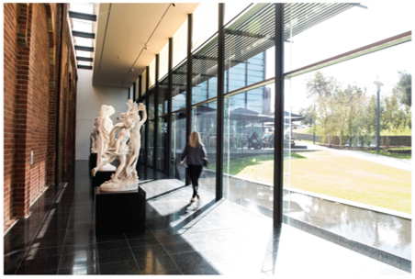

Moving forward
We would like to thank stakeholders for their ongoing support and contributions.
During 2020, we sought additional advice on the impacts of the bushfires and COVID-19 on the visitor economy, pathways to recovery and opportunities to build long-term resilience.
Consultations that were undertaken for the Regional Tourism Review and in 2020 have been instrumental in shaping the government’s Visitor Economy Recovery and Reform Plan. This plan will provide the framework for us to work together to overcome recent challenges and put the visitor economy back on the path to growth and success.

