NON-FINANCIAL
PERFORMANCE

Portfolio performance reporting – non-financial
As at 30 June 2020, DJPR had 146 non-cost output performance measures, published in the 2019–20 Budget Papers.
The department met or exceeded 73 per cent (107 measures) of the 2019–20 output performance measure targets. Due to the impacts of the bushfires and/or coronavirus (COVID-19), 27 per cent (39 measures) of performance measures did not meet their targets. Many of these measures relied on physical/social interactions and travel or were impacted by diverted resources to recovery efforts.
For those performance measures which were not as significantly affected, mitigation strategies included a greater emphasis on an online presence to replace usual activities or services where feasible. In addition, increased support provided to businesses and industry in response to these events resulted in some measures exceeding their targets.
The portfolio performance reporting – non-financial section includes the:
- Report on progress towards achieving objectives, incorporating key initiatives and projects
Report on performance against output performance measures.

Reporting progress towards achieving departmental objectives in the report of operations
The department is focused on growing the state’s economy and ensuring it benefits all Victorians – by creating more jobs for more people, building thriving places and regions, and supporting inclusive communities.
This section reports the department’s progress on its 2019–20 departmental objectives through a range of indicators.

Objective 1: Create and maintain jobs
This objective seeks to secure a growing, sustainable and equitable jobs market for all Victorians by working with businesses to increase job opportunities, support people into meaningful employment, and attract the investment and talent needed to foster job growth.

Progress towards achieving this objective
In 2019–20, the department reported progress against this objective using the following objective indicators and outputs:

Objective Indicators
People employed in Victoria

Outputs
Jobs

Indicator: People employed in Victoria

Table 1: People employed in Victoria
Measure (unit of measure) | 2016–17 | 2017–18 | 2018–19 | 2019–20
Number of people employed in Victoria (number) | 3,207,526 | 3,271,527 | 3,352,500 | 3,391,800

Figure 1: Number of people employed in Victoria
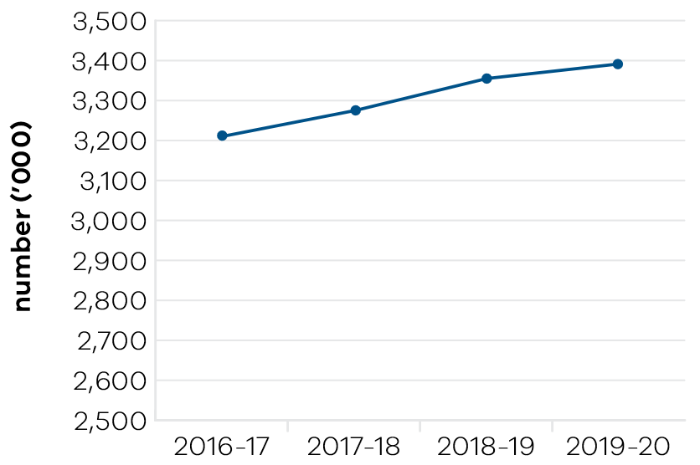
In 2019–20, the department contributed to the government’s investment attraction and facilitation function by facilitating private sector investment outcomes and monitoring the health of Victoria’s key companies and employers. This resulted in the creation of 5000 jobs and secured $2.3 billion in new investment. The investment outcomes were achieved across a wide range of industry sectors including information communication technologies, life sciences, agriculture, food manufacturing, energy, automotive manufacturing, aerospace, retail trade, tourism and professional services.
In 2019–20, the department supported the assessment of 986 overseas qualifications to assist overseas qualified professionals gain employment in the Victorian labour market and fill skills gaps for employers. The department also nominated 1750 business and investor migrants and 3543 skilled migrants to live, work and undertake business activity in Victoria, which included 1043 skilled migrants in regional Victoria. Of the 3543 skilled migrants, 384 had completed a PhD and an additional 1290 were international student graduates of Australian universities.
Restrictions on travel and changes to the economy and labour market due to coronavirus (COVID-19) affected the delivery of the migration program. The program was modified to target onshore skilled migrants and those with skills that could contribute to the coronavirus (COVID-19) response and economic recovery.
In August 2018, the Local Jobs First Act 2003 was amended, and the department implemented the Local Jobs Policy which comprises the Victorian Industry Participation Policy and the Major Project Skills Guarantee (MPSG). It supports Victorian businesses and workers by ensuring that small and medium sized enterprises (SMEs) are given a full and fair opportunity to compete for government contracts.
The Local Jobs First Act 2003 also established a Local Jobs First Commissioner. The Commissioner provides advocacy, facilitation and compliance functions while working closely with industry and government departments to create opportunities for SMEs, workers, apprentices, trainees and cadets.
Since December 2014 to June 2020, the government has set local content requirements under the Local Jobs First for 160 strategic projects, with a combined total value of over $87.6 billion and supporting 35,000 local jobs. Since its introduction, the MPSG has been applied to 137 projects worth over $53.1 billion, which have committed to more than 4.55 million contracted hours for 3389 apprentices, trainees and cadets.
Since late 2016, Jobs Victoria services have supported almost 13,000 jobseekers into work, most of whom were long-term unemployed or at risk of long-term unemployment. A key feature of the Jobs Victoria model is strong employer engagement: over 5000 employers have recruited via Jobs Victoria services, and the independent evaluation found evidence of employers repeat hiring and even creating vacancies as a result of positive experiences with Jobs Victoria services.

Performance against output performance measures
Table 2 represents performance against the Jobs output. This output includes initiatives to support existing workers and businesses by connecting Victorians experiencing disadvantage to job opportunities, supporting Aboriginal economic inclusion, working with the community to create and support social enterprises; as well as attracting new investment and talent into Victoria to grow the economy and share the benefits of economic prosperity.

Table 2: Output – Jobs
Performance measures | Unit of measure | 2019–20 actual | 2019–20 target | Performance variation (%) | Result
Quantity
Disadvantaged jobseekers who achieve sustainable employment (minimum number of 26 weeks) | number | 2362 | 2225 | 6.2% | ü
Higher result due to additional funding being awarded to Jobs Victoria partners in September and October 2019 along with some partners achieving greater than anticipated outcomes.
Government Youth Employment Scheme  traineeships commenced | number | 229 | 280 | -18.2% | n
Lower result due to the impacts of coronavirus (COVID-19) as departments and agencies not able to recruit at the same levels as prior years.
Retrenched workers supported with employment assistance | number | 1929 | 2000 | -3.6% | ™
Social enterprises assisted | number | 238 | 150 | 58.7% | ü
Higher result due to new services being offered to social enterprises by Social Traders in response to coronavirus (COVID-19); and higher than expected uptake of membership of the Victorian Social Enterprise Network.
Victoria’s market share of nominated investor  and business migrants | per cent | 38 | 45 | -15.6% | n
Lower result due to the increase in the overall size of the business migrant cohort in Australia, leading to a lower market share for Victoria. In addition, other jurisdictions (e.g. NSW, SA and QLD) have become more active participants in the business and investor program.
Quality
Client satisfaction with investor, business and skilled migration services provided | per cent | 90 | 85 | 5.9% | ü
Higher result due to stronger satisfaction from the skilled migrant cohorts surveyed. Compared to results from last year, there was a significant improvement in satisfaction with the client experience with the Skilled and Business Migration Program, including knowledge of the nomination/migration process, and the accuracy of information or advice received.
Timeliness
Average processing time for investor, business and skilled migration visa nomination applications | days | 23 | 20 | 15.0% | n
Higher result due to a surge in visa nomination applications due to coronavirus (COVID-19) travel restrictions.
Cost
Total output cost | $ million | 1159.4 | 131.1 | 784.0% | n
The 2019–20 result was higher than budget primarily due to additional funding for the Business Support Fund, Economic Survival Package and Working for Victoria Fund.
Note:
ü Performance target achieved or exceeded
™ Performance target not achieved – within 5 per cent variance
n Performance target not achieved – exceeds 5 per cent variance

Objective 2: Foster a competitive business environment
This objective seeks to grow Victorian industries and businesses by working with priority industry sectors, supporting growth and innovation opportunities for industry, supporting start-ups and small businesses, and assisting industries in transition.

Progress towards achieving this objective
In 2019–20, the department reported progress against this objective using the following objective indicators and outputs:

Objective Indicators
- Change in Victoria’s real gross state product
Engagement with businesses

Outputs
Industry, Innovation and Small Business

Indicator: Change in Victoria’s real gross state product

Table 3: Change in Victoria’s real gross state product
Measure (unit of measure) | 2016–17 | 2017–18 | 2018–19 | 2019–20
Change in Victoria’s real gross state product (per cent) | 3.33 | 3.5 | 3.0 | Data available November 2020

Figure 2: Change in Victoria’s real gross state product
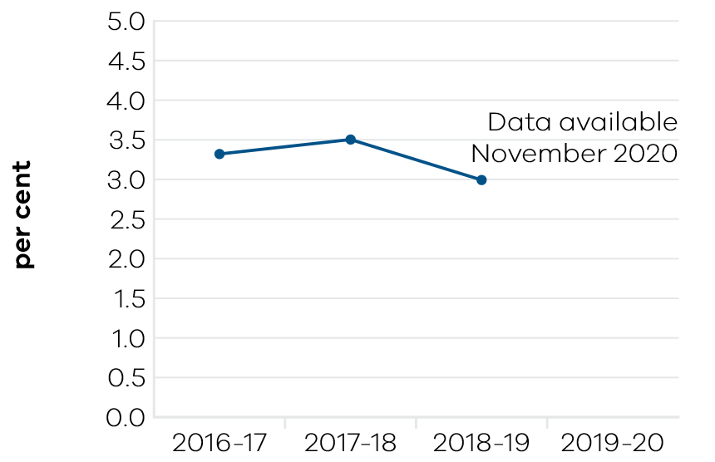

Indicator: Engagement with businesses

Table 4: Engagement with business
Measure (unit of measure) | 2016–17 | 2017–18 | 2018–19 | 2019–20
Engagement with businesses (number) | 15,014 | 14,401 | 14,630 | 12,344

Figure 3: Engagement with businesses
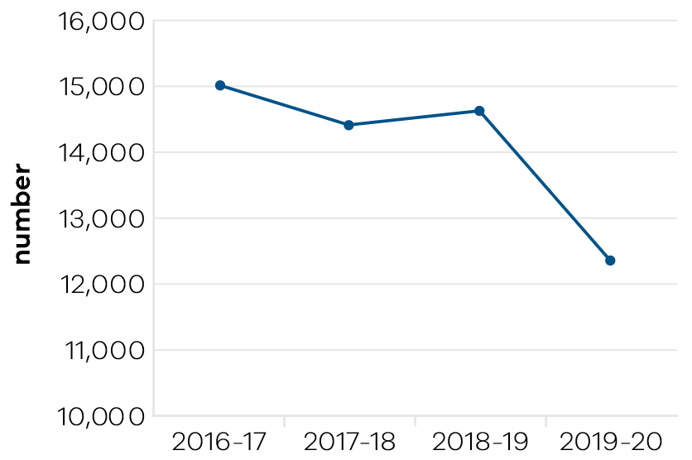
In 2019–20, the department engaged with 12,344 businesses through a network of Victorian Government Business Offices (VGBOs) including five metro based VGBOs in Melbourne. Traditional business engagement focuses on major growth-oriented firms looking to invest or re-invest in Victoria and create new job opportunities. However, in 2019–20 a significantly large volume of engagements was recorded due to coronavirus (COVID-19) related matters, including access to the Business Support Fund.
In 2019–20, the Better Approvals Project was delivered to an additional 42 councils out of a total of 51 councils to date. Early indications show that this has led to a significant reduction in council permit approval times for small businesses, averaging a 73 per cent improvement. Reduced red tape has helped local businesses to open and expand faster. As part of the Small Business Regulation Review (SBRR), the SBRR Construction Sector Action Statement was launched in August 2019. It is expected to save small businesses at least $21.3 million a year once fully implemented by helping regulators interact better through the Small Business Engagement Charters and by developing clearer, more targeted regulatory information.
The department supported over 500 digital tech events, engaged 20,000 people across Victoria and secured important national conferences that enabled Victorian businesses to connect with local, national and global networks in digital technology, professional services, the biotechnology, medical technology and pharmaceutical industries. These conferences included the Australian Information Industry Association iAwards, Australian Computer Society Reimagination, FinTech Awards and Intersekt, and AusBiotech, Australia Biotech Invest & Partnering, and AusMedtech.
For LaunchVic, the 2019–20 reporting year saw an increased focus on scaling start-ups (‘scaleups’). Overall, 47 scaleups were supported through a program run by Skalata Ventures, Startmate, Australian Sports Technologies Network, Australia China Health Accelerator and The Actuator.

Performance against output performance measures
Table 5 represents performance against the Industry, Innovation and Small Business output. This output provides access to information and connections and builds the capability of Victorian businesses and industry to develop and effectively use new practices and technologies to increase productivity and competitiveness, advocating for a fair and competitive business environment, and supporting small businesses.

Table 5: Output – Industry, Innovation and Small Business
Performance measures | Unit of measure | 2019–20 actual | 2019–20 target | Performance variation (%) | Result
Quantity
Businesses whose growth and productivity issues are resolved by the Department | number | 1497 | 1200 | 24.8% | ü
Higher result due to an increase in program payments that support businesses growth and address productivity issues during the period. The metrics do not include businesses funded through the Business Support Fund.
Companies or new entrants supported through the LaunchVic initiative | number | 133 | 70 | 90.0% | ü
Higher result due to an increase in participation in the startup ecosystem across Victoria and demand for LaunchVic funded programs from the rapidly growing startup sector.
Engagements with businesses | number | 12,344 | 14,000 | -11.8% | n
Lower result due to access impediments as a result of coronavirus (COVID-19). In addition, a number of staff who would undertake business-as-usual engagements were enlisted to assist with the coronavirus (COVID-19) response.
Industry roundtables and engagement forums | number | 29 | 42 | -31.0% | n
Lower result due to the large number of industry roundtables and engagement forums that were scheduled to be held in person. Although a number of forums were held online, the outcome has been impacted due to a number of forums being deferred beyond 2019-20 or cancelled.
New mobile base stations facilitated | number | 43 | 45 | -4.4% | ™
Participation in Small Business Victoria targeted  and inclusive events and business programs | number | 30,536 | 30,000 | 1.8% | ü
Visits to Business Victoria digital channels | number | 5,293,814 | 3,000,000 | 76.5% | ü
Higher result due to increased website traffic. The Business Victoria digital channels were the WoVG online business information point to provide businesses with bushfire and coronavirus (COVID-19) information and the portals for applying for support funding.
Quality
Client satisfaction of small business information, referral, mentoring service and business programs | per cent | 93.45 | 90 | 3.8% | ü
Client satisfaction with the Victorian Government Business Offices | per cent | 77.4 | 80 | -3.2% | ™
Client satisfaction with Victorian Small Business Commission mediation service | per cent | 90.2 | 85 | 6.1% | ü
Higher result due to applicants and respondents both reporting high levels of satisfaction. Renewal of the Victorian Small Business Commission mediators enabled a refreshing of experience and skills contributing to this BP3 measure being exceeded.
Proportion of business disputes presented to the Victorian Small Business Commission successfully mediated | per cent | 81.6 | 75 | 8.8% | ü
Higher result due to the renewal of the Victorian Small Business Commission’s two mediator panels (Metro and Regional), which enabled a refreshing of experience and skills, contributing to the positive result. The high success rate has continued despite moving to remote mediations due to the coronavirus (COVID-19) impacts.
Proportion of business disputes resolved by the Victorian Small Business Commission prior to mediation | per cent | 38 | 30 | 26.7% | ü
Higher result due to effective application of alternative dispute resolution process and preliminary assistance by the Victorian Small Business Commission’s Dispute Resolution Officers. The result is supported by positive client feedback. The resolution rate has increased despite the impact of coronavirus (COVID-19).
Cost
Total output cost | $ million | 122.8 | 153.5 | -20.0% | ü
The 2019–20 result was lower than budget due to the timing of payments relating to the delivery of various programs.
Note:
ü Performance target achieved or exceeded
™ Performance target not achieved – within 5 per cent variance
n Performance target not achieved – exceeds 5 per cent variance

Objective 3: Be a globally connected economy
This objective seeks to connect Victoria to the world by helping Victorian businesses successfully trade into global markets, and growing Victoria’s proportion of international student enrolments in Australia.

Progress towards achieving this objective
In 2019–20, the department reported progress against this objective using the following objective indicators and outputs:

Objective Indicators
- Export sales generated from government programs
International students attracted to Victoria

Outputs
Trade and Global Engagement

Indicator: Export sales generated from government programs

Table 6: Export sales generated from government programs
Measure (unit of measure) | 2016–17 | 2017–18 | 2018–19 | 2019–20
Actual export sales generated as a result of participation in government programs ($ million) | 648 | 807 | 668 | 709

Figure 4: Export sales generated from government programs
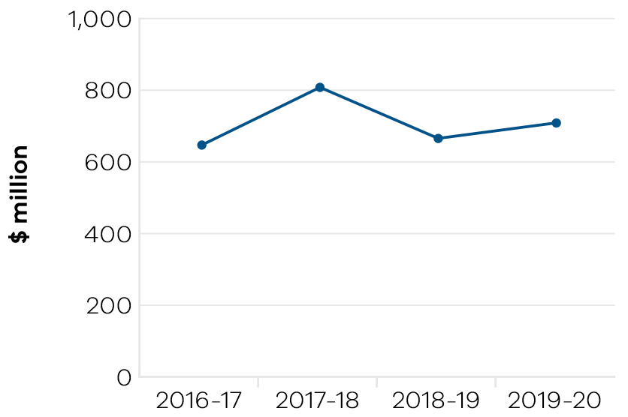
In total, Victorian Government programs resulted in $3.3 billion of actual export sales over the five-year period from 2015–16. In 2019–20, the result was $709 million of actual export sales. This result was achieved through the department’s delivery of services to connect Victorian companies to international buyers and networks to foster business opportunities, as well as services to build the skills, knowledge and capability of Victorian businesses to enter and succeed in global markets.
Strong outcomes were achieved in key Asian markets, including China, as well as the United States. Notable outcomes were also observed in key markets throughout South East Asia, India, Latin America and in the MENA (Middle East and North Africa Region). These outcomes are particularly significant given the need for Victorian businesses to diversify their markets of focus. These outcomes follow from strategies released in 2018 including the Victorian Government India Strategy, the South East Asia Trade and Investment Strategy, and Latin America Trade and Investment Strategy.
The department’s suite of export and trade programs are provided by staff based in Melbourne and throughout the 22 Victorian Government Trade and Investment Network offices, providing tailored support to assist firms to realise and capture export sales. Services include provision of market intelligence, introductions to key contacts in-market, promotion of industry capability and ongoing support and advice.
The department’s Outbound and Inbound Trade Mission Programs, Asia Gateway and Export Skills program are also vital to generating export sales. Collectively the department’s trade and export programs promote, champion, partner and elevate the status of Victorian businesses taking their products and services to the world, engaging 2265 companies in total across all programs in 2019–20. This includes over 550 Victorian companies being involved in the Inbound and Outbound Trade Mission Programs.
The department has closely monitored the onset of coronavirus (COVID-19), including anticipated impact on exports. The closure of international borders to personal and business travel and falling global demand is having an immediate and significant impact on trade, especially services exports including international education and tourism. The department has commenced delivery of new and refreshed export programs and services to enable businesses to remain engaged in international trade during this time, for example through transitioning to delivering virtual trade missions.

Indicator: International students attracted to Victoria

Table 7: Victoria’s proportion of international student enrolments in Australia
Measure (unit of measure) | 2016–17 | 2017–18 | 2018–19 | 2019–20
Victoria’s proportion of all international student enrolments in Australia (per cent) | 31 | 32 | 32 | 32
Note: Financial year data on international student enrolments is not available. Figures in the table are calendar year data reflecting the academic year and capturing peaks and troughs of enrolment periods.

Figure 5: Victoria’s proportion of all international student enrolments in Australia
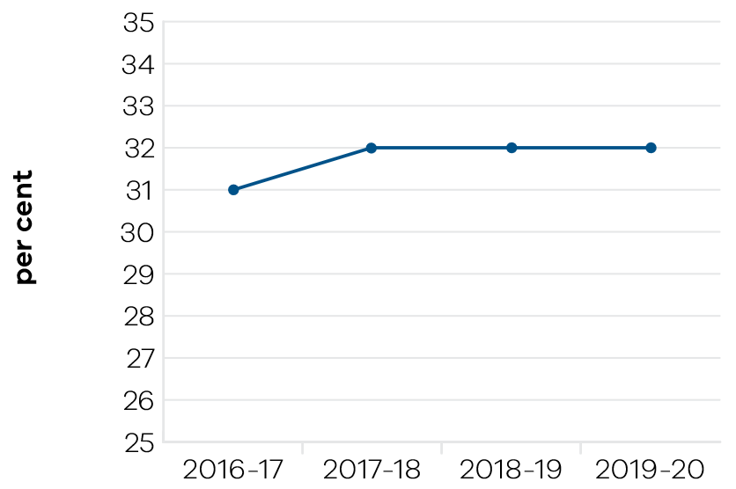
Victoria’s national share of international student enrolments continues to grow, from 31 per cent of Australia’s international enrolments in 2016–17 to 32 per cent in 2019–20. As a result of strong enrolment growth, the international education sector generated a record high $13.7 billion in export revenue for the state in 2019 and supported around 79,000 Victorian jobs in 2018 (latest available data). Melbourne also retained its ranking as Australia’s best student city and the third best in the world (QS Best Student Cities 2019).
In 2019, Victoria’s international student enrolment numbers were up 10.6 per cent year on year, surpassing national average growth (9.7 per cent) and growth in key competitor states New South Wales (9.4 per cent) and Queensland (7.9 per cent). Growth was largely driven by South Asian markets, including India, Nepal and Sri Lanka.
The 2019–20 bushfires and the coronavirus (COVID-19) pandemic are expected to impact on the overall number of international students in Australia. Australian Bureau of Statistics data indicates that overseas student visa holder arrivals to Australia are down by close to 100 per cent, from around 46,040 arrivals in June 2019, to less than 60 in June 2020. This dramatic decline in new student visa holder arrivals has significant ramifications for the future of the international education sector.
Despite the significant decline in new student visa holder arrivals, large numbers of current international students remain onshore. Throughout the coronavirus (COVID-19) pandemic, the department has strengthened its existing suite of onshore student support programs. This includes expanded case management, accommodation support and free legal advice, online and over the phone through the Study Melbourne Student Centre, to meet increased requests for assistance from international students. In 2019–20, the department commenced delivery of the $45 million International Student Emergency Relief Fund to support international students experiencing lost or reduced employment and financial hardship as a result of coronavirus (COVID-19). This support reinforces the State’s reputation as a safe and welcoming destination for future international students.

Performance against output performance measures
Table 8 represents performance against the Trade and Global Engagement output. This output promotes business growth opportunities by connecting organisations to global business opportunities in priority markets and supporting the establishment and deepening of strategic commercial partnerships. It also positions Victoria as a destination of choice for international students.

Table 8: Output – Trade and Global Engagement
Performance measures | Unit of measure | 2019–20 actual | 2019–20 target | Performance variation (%) | Result
Quantity
Actual export sales generated as a result of participation in government programs | $ million | 709 | 550 | 28.9% | ü
Higher result due to stronger than expected export outcomes by businesses participating in government programs, including participation in trade missions in prior years.
Clients engaged in export and trade programs | number | 2265 | 2500 | -9.4% | n
Lower result due to the cancellation of major trade shows and exhibitions in key global markets (as a result of coronavirus (COVID-19)) in the second half of the year.
International delegates participated in the inbound trade mission program | number | 593 | 550 | 7.8% | ü
Higher result due to the high level of participation in inbound trade missions prior to the impact of coronavirus (COVID-19) travel restrictions.
Number of Victorian companies assisted by Wine Industry initiatives | number | 65 | 60 | 8.3% | ü
Higher result due to strong industry engagement in the first half of the year.
Significant interactions with Victorian agri-food companies and exporters, international customers and trading partners that facilitate export and investment outcomes for Victoria | number | 195 | 250 | -22.0% | n
Lower result due to the cancellation of major trade shows and exhibitions in key global markets (as a result of coronavirus (COVID-19)) in the second half of the year.
Victoria’s proportion of all international student enrolments in Australia | per cent | 32.2 | 30 | 7.3% | ü
Higher result due to continued growth in student enrolments in high performing Asian markets such as India. This is the latest available nationwide full year data (calendar year 2019).
Visits to the Global Victoria website | number | 130,000 | 100,000 | 30.0% | ü
Higher result due to boosting of engagement with stakeholders through the website and other online activities, particularly during the final months of the year.
Quality
Client satisfaction with export assistance offered | per cent | 92 | 90 | 2.2% | ü
Cost
Total output cost | $ million | 61.0 | 42.2 | 45.0% | n
The 2019–20 result was higher than budget primarily due to additional funding for the International Student Emergency Relief Fund.
Note:
ü Performance target achieved or exceeded
™ Performance target not achieved – within 5 per cent variance
n Performance target not achieved – exceeds 5 per cent variance

Objective 4: Build prosperous and liveable regions and precincts
This objective seeks to ensure that Victoria’s precincts, suburbs and regions are developed to create places where all Victorians have an opportunity to participate in communities that are well-connected, prosperous, vibrant and diverse.
Suburban Development makes a unique contribution to this goal through its six Metropolitan Partnerships that are changing the way government works by placing a stronger focus on community engagement and co-design.

Progress towards achieving this objective
In 2019–20, the department reported progress against this objective using the following objective indicators and outputs:

Objective Indicators
- Priority precincts developed and delivered
Community satisfaction in public places

Outputs
- Priority Precincts and Suburban Development
Regional Development

Indicator: Priority precincts developed and delivered
Through its whole of government oversight in Priority Precincts, the portfolio has delivered on the identification of, planning for and development in key areas of opportunity. This has established a long-term focus on precincts and their importance to Victoria’s economic performance as well as the future liveability of Victoria’s urban centres.
Delivery of two large-scale urban renewal projects has been much progressed. An agreed approach for the former General Motors Holden (GMH) site at Fishermans Bend will maximise value of this key asset for Victorians. This will see the site curated as an innovation hub focused on advanced manufacturing, engineering and design helping to create up to 40,000 jobs in the employment precinct.
This former GMH site will also host a new University of Melbourne Engineering School Campus, attracting up to 20,000 students and for which development facilitation work continues. As part of the Victorian Government’s $2.7 billion Building Works package, funding of $6 million has been provided for ‘Gateway to GMH’ stimulus projects providing streetscape upgrades, greening and placemaking.
Jointly with the Department of Environment, Land Water and Planning (DELWP), the Priority Precincts portfolio is providing planning facilitation to support delivery of a strong pipeline of development. This includes $2.18 billion in project value at various stages of development and a further $3.3 billion under assessment. Together these projects will deliver 13,000 homes, including over 330 in affordable housing, plus nearly 300,000 square metres of employment floor space.
The new Arden Metro Tunnel station is a key driver for a thriving new neighbourhood in Melbourne’s inner north-east. Ambitions for Arden include curation of an employment and innovation precinct with potential for 34,000 jobs in the life sciences, digital and education sectors. The government’s vision for an exemplar urban renewal development in Arden is captured by the jointly developed draft Arden Structure Plan. The plan was publicly released by the Victorian Planning Authority and City of Melbourne in June and is the subject of an extensive community consultation.
Melbourne’s more mature precincts including Parkville and Richmond to Docklands have benefited from portfolio oversight that has helped secure CSL global headquarters for Victoria, attract Hollywood’s Dick Cook Studios to Docklands Studios and facilitate AFL plans for a Marvel Stadium upgrade.
Strategic effort focused on Melbourne’s west has been rewarded by a new Footscray Priority Precinct. Announced in December 2019, this western gateway and key cultural asset will support a big uptick in jobs for Victorians as the $1.5 billion Footscray Hospital and the new Footscray Learning Precinct are delivered.
Recently, Footscray has been in a period of change, as the population in Melbourne’s west has expanded. More people are being drawn to Footscray, and the government has an important role to play in shaping the future of this growing area. In coordinating planning for the future of Footscray, the portfolio has collaborated on whole of government priorities for transport, housing affordability, liveability, economic growth and jobs creation.
A collaborative vision for Sunshine as capital of the west and the preferred airport rail route progressed well and has seen the precinct attract $6.2 million in Building Works funding for stimulus projects to improve Sunshine streetscapes and connectivity.
A large portfolio contingent has been deployed to support Victoria’s coronavirus (COVID-19) response and delivered some key initiatives, including the state’s flagship jobs program Working for Victoria.

Indicator: Community satisfaction in public places

Table 9: Community satisfaction in public places
Measure (unit of measure) | 2016–17 | 2017–18 | 2018–19 | 2019–20
Appearance of public areas (per cent) | n/a | n/a | 72* | 72
Community consultation and engagement (per cent) | n/a | n/a | 56 | 55
Planning for population growth in the area (per cent) | n/a | n/a | 52 | 51
*The figure published in 2018–19 was a misprint and has been corrected in this report.

Figure 6: Appearance of public areas
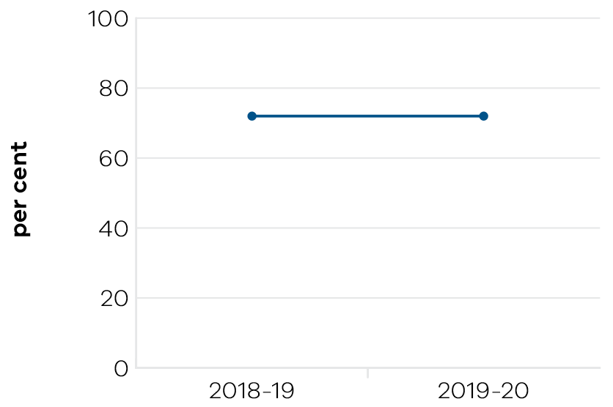

Figure 7: Community consultation and engagement
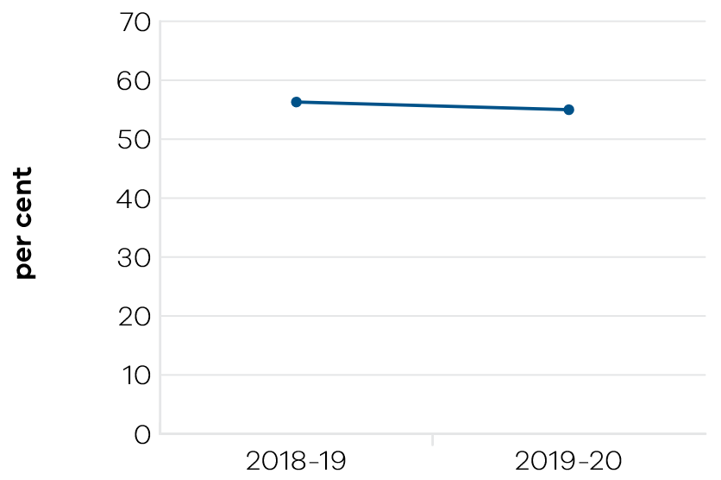

Figure 8: Planning for population growth in the area
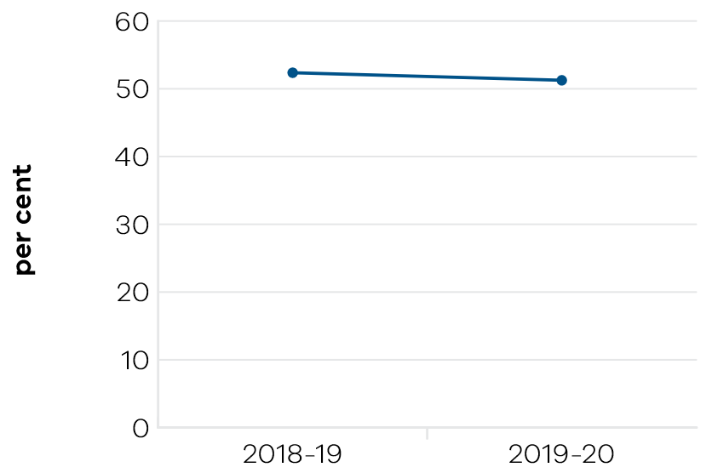
The objective indicator seeks to measure the government’s suburban development vision that “All of Melbourne’s residents will have affordable and reliable access to jobs, services and infrastructure, no matter where they live.” (Suburban Development Statement, May 2017)
Outcomes for 2020 demonstrate a minor variation in performance that is reflective of Victoria’s significant infrastructure program causing short-term impacts to amenity in key locations including the CBD (e.g. Metro Tunnel station development) and locations impacted by major projects including the Level Crossing Removal Authority crossing removals. Sustaining these high rates of community satisfaction is the result of key improvements in selected locations driven in part through the Suburban Development’s portfolio’s investments in suburban revitalisation initiatives. It is also the result of ongoing state support to local governments to deliver community infrastructure and facilities, including libraries, sport and recreation facilities, and specific support provided to interface councils through the government’s Growing Suburbs Fund.
Performance outcomes are expected to improve over time as major city shaping projects are completed and lead to improved local amenity around key activity centres and transport interchanges.

Regional Development
Rural and regional Victorians account for a quarter of the state’s population. In 2019–20, the government, through Regional Development Victoria (RDV), worked to ensure that Victoria’s rural and regional communities shared in the benefits of the state’s economic growth. This was achieved by investing in infrastructure and services to create jobs which will sustain thriving and prosperous regional cities and towns.
Operating in partnership with local communities, industry and across all tiers of government, RDV’s efforts in 2019–20 resulted in all regional development performance targets being exceeded. This continued the improved output trend from the past several years, and for regional Victoria to have the highest performing economy in rural Australia.
RDV’s approach to regional development recognised that policy solutions and programs in regional and rural areas need to be bespoke and involve real consultation with local communities. With its network of offices across the state and through a range of funding mechanisms, RDV was able to target programs and policies to the needs of particular communities – to grow regional economies while, at the same time, enhance the liveability and the community spirit that underpins country life.
RDV supported 148 economic and service delivery projects, securing $840 million new investments in regional Victoria, generating $56 million in export sales for regional businesses, that facilitated the creation of 1215 jobs. In the annual Regional Wellbeing survey, RDV achieved a rating of 100 per cent for participant satisfaction with the implementation of RDV programs. Areas of improvement cited in the survey results included the clarity of the information provided regarding RDV’s grant program, the support provided to participants during the application stage, and the communication with participants regarding application decisions.
Investment in Regional Partnerships Priority Projects continued in 2019–20. Projects included Falls to Hotham Iconic Walk, Murray River Adventure Trail, and Driving Gippsland’s Food and Fibre Agenda.
RDV supported delivery of a considerable number of projects through the Regional Jobs and Infrastructure Fund in 2019–20. This consisted of 33 projects funded through the Regional Infrastructure Fund, 29 funded through the Stronger Regional Communities Program, 46 funded through the Regional Jobs Fund and three via Special Development Projects.
Throughout 2019–20, RDV continued to facilitate and develop the Ballarat GovHub, breaking ground in early 2019 with site excavation completed and construction commencing. RDV continued to work closely with Development Victoria and the Department of Treasury and Finance, along with a range of stakeholders, to support the transition of government tenants into the Ballarat GovHub (due 2021) including 600 new and relocated positions.
Construction of the Latrobe Valley GovHub is underway with completion expected ahead of schedule in October 2020. The project is a three-storey regional employment hub that will support economic growth, the creation of jobs and driving the industries of the future. This commitment forms part of the government’s response to transitioning the Latrobe Valley (after the closure of Hazelwood Power Station and Mine) and delivers on the government’s policy to strengthen and grow regional economies. The Latrobe GovHub is expected to bring an additional 300 jobs to the CBD of Morwell and has employed up to 100 people during construction. Forty-one local contractors have been hired, accounting for 71 per cent local engagement. Discussions have been held with Traditional Landowners, Gunaikurnai Land and Waters Aboriginal Corporation regarding the installation of art works completed by local Aboriginal artists and Aboriginal students at TAFE Gippsland, interpretive panels, a welcome to country and smoking ceremony for the buildings’ opening.
In March 2020, the government signed a Project Agreement for the Geelong City Deal; a 10-year plan to revitalise Geelong and unlock the potential of the Great Ocean Road economy. The Australian Government, Victorian Government and City of Greater Geelong will deliver $370 million in government investment to the region. This investment will support Geelong’s continued economic diversification, growth of the visitor economy and a thriving city centre. It is estimated implementation of the projects under The City Deal will create up to 1000 jobs.
The second half of the financial year saw major challenges across rural and regional Victoria. The ‘black summer‘ bushfires of December 2019 and January 2020 had a significant and negative impact on tourism and business. This was predominantly felt in the Hume and Gippsland regions. These regions then faced additional hardship from the coronavirus (COVID-19) pandemic resulting in substantial revenue loss and redundancies across the region. RDV worked closely with major businesses to understand the output impact of coronavirus (COVID-19), and its resulting challenges and opportunities. Continued support will include continuous business health check calls, and the Working for Victoria initiative matching redundant workers with available roles.

Performance against output performance measures
Table 10 represents performance against the Priority Precincts and Suburban Development output. This output delivers activities to build vibrant and prosperous precincts and suburbs that drive economic growth and opportunities. The department works with government, industry and community stakeholders to identify opportunities for the development and delivery of initiatives to strengthen Melbourne’s economy, create jobs and improve suburban liveability. The department works collaboratively to support Victoria’s priority precincts and develop Melbourne’s suburbs through the six Metropolitan Partnerships.

Table 10: Output – Priority Precincts and Suburban Development
Performance measures | Unit of measure | 2019–20 actual | 2019–20 target | Performance variation (%) | Result
Quantity
Annual assemblies held for Metropolitan Partnerships | number | 6 | 6 | 0.0% | ü
Priority precincts in the design or delivery phase | number | 8 | 8 | 0.0% | ü
Projects in the planning or delivery phase to support and facilitate the revitalisation of Broadmeadows and Frankston | number | 6 | 6 | 0.0% | ü
Quality
Integrated Precinct Plans in place for priority precincts  in the design or delivery phase | per cent | 100 | 90 | 11.1% | ü
Higher result due to integrated precinct plans being developed for all identified priority precincts in the 2019-20 financial year.
Participants satisfied with their experience  of partnership assemblies | per cent | 91.5 | 80 | 14.4% | ü
Higher result due to increased satisfaction reported by participants in their experience of partnership assemblies, the result of an expanded consultation process introduced this year that allowed deep dives into topics of particular interest to stakeholders.
Timeliness
Delivery of financial obligations for departmental  Public Private Partnership projects in accordance  with contractual timelines | per cent | 100 | 85 | 17.6% | ü
Higher result due to the department having met all contractually required financial commitments for the Public Private Partnership projects it is responsible for within required timeframes for the year.
Partnership priorities receiving a government response by 30 June | per cent | 100 | 100 | 0.0% | ü
Cost
Total output cost | $ million | 23.7 | 22.8 | 4.0% | ™
Note:
ü Performance target achieved or exceeded
™ Performance target not achieved – within 5 per cent variance
n Performance target not achieved – exceeds 5 per cent variance

Table 11 represents performance against the Regional Development output. This output guides engagement with industry and communities to identify opportunities to support job growth and new investment in regional Victoria, including support and services to grow regional jobs and capability in regional communities.

Table 11: Output – Regional Development
Performance measures | Unit of measure | 2019–20 actual | 2019–20 target | Performance variation (%) | Result
Quantity
Actual export sales generated for regional businesses as a result of participation in government programs | $ million | 56 | 55 | 1.8% | ü
Economic development and service delivery  projects supported | number | 148 | 60 | 146.7% | ü
Higher result due to more projects being funded than planned, to stimulate regional economies.
Jobs in regional Victoria resulting from government investment facilitation services and assistance | number | 1215 | 1200 | 1.3% | ü
New investment in regional Victoria resulting from government facilitation services and assistance | $ million | 840 | 700 | 20.0% | ü
Higher result due to a number of large renewable energy projects amortised over two years, which inflated the investment numbers by more than $100 million.
Quality
Participant satisfaction with implementation  of Regional Development Victoria programs | per cent | 100 | 90 | 11.1% | ü
Higher result due to improvements in Regional Development Victoria’s approach to grant management, support provided to participants during application stage, and for participants being kept informed about decisions on applications.
Cost
Total output cost | $ million | 279.2 | 311.4 | -10.0% | ü
The 2019–20 result was lower than budget primarily due to the timing of payments relating to the delivery of various programs.
Note:
ü Performance target achieved or exceeded
™ Performance target not achieved – within 5 per cent variance
n Performance target not achieved – exceeds 5 per cent variance

Objective 5: Grow vibrant, active and creative communities
This objective seeks to increase the economic, social and cultural value of the creative, sport and recreation industries to Victoria, grow the number and yield of visitors, position Victoria as a major events destination, and ensure the best cultural and sporting experiences are accessible to everyone.

Progress towards achieving this objective
In 2019–20, the department reported progress against this objective using the following objective indicators and outputs:

Objective Indicators
- Attendances at Creative Industries agencies
and funded Major Performing Arts organisations
- Employment in the Creative Industries sector
- Employment in the Visitor Economy sector
- Tourists attracted to Victoria
- Increase rates of community engagement, including through participation in sport
and recreation
Wagering turnover on Victorian racing as a proportion of the national market

Outputs
- Creative Industries Access, Development and Innovation
- Creative Industries Portfolio Agencies
- Cultural Infrastructure and Facilities
- Sport, Recreation and Racing
Tourism and Major Events

Indicator: Attendances at Creative Industries agencies and funded Major Performing Arts organisations

Table 12: Attendances at Creative Industries portfolio agencies
Measure (unit of measure) | 2016–17 | 2017–18 | 2018–19 | 2019–20
Attendances at creative industries portfolio agencies (number (‘000)) | 11,766 | 13,170 | 12,786 | 9,417

Figure 9: Attendances at Creative Industries portfolio agencies
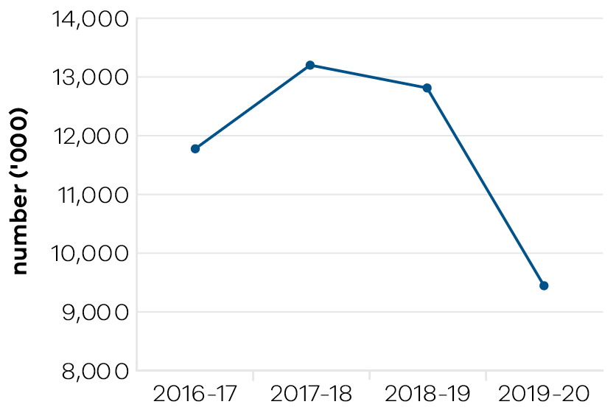
In 2019–20, Victoria’s state-owned arts and cultural institutions – Arts Centre Melbourne, Australian Centre for the Moving Image (ACMI), Docklands Studios Melbourne, Film Victoria, Geelong Arts Centre, Melbourne Recital Centre, Museums Victoria, National Gallery of Victoria (NGV), and State Library Victoria – were attended by 9.4 million visitors, a reduction on the record levels set in earlier years. The decline in attendances occurred as a result of the restrictions in place to slow the spread of coronavirus (COVID-19).
Major exhibitions which attracted large crowds during 2019–20 prior to the impact of the coronavirus (COVID-19) pandemic included:
- KAWS: Companionship in the Age of Loneliness larger-than-life sculptures and colour-filled paintings of hybrid cartoon and human characters at the NGV;
- The world premiere exhibition at the NGV of the work of two of the most significant and influential artists of the late twentieth century in Keith Haring | Jean-Michel Basquiat: Crossing Lines;
- Velvet, Iron, Ashes, the iconic Ashes Urn on exclusive loan from Marylebone Cricket Club
in London, at the State Library of Victoria;
- The restored 19th century Great Melbourne Telescope, originally located at the Melbourne Observatory, on display at Scienceworks;
- Revolutions: Records and Rebels at Melbourne Museum, from the Victoria and Albert Museum in London and Museum Victoria’s collection, telling the story of 1966–70 as five years that shook the world;
- Wonderland, curated by ACMI, celebrating Lewis Carroll’s timeless tale and Alice’s adventures on film on tour to the Art Science Museum, Singapore and Te Papa, Wellington, New Zealand; and;
- DreamWorks Animation, curated by ACMI in association with the DreamWorks studio, exploring their collaborative and visionary approach to animation, art, technology and storytelling, on tour to Centro Cultural Banco do Brasil, Belo Horizonte, Brazil and the National Museum of Australia.

Table 13: Attendances at funded Major Performing Arts organisations
Measure (unit of measure) | 2016–17 | 2017–18 | 2018–19 | 2019–20
Attendances at funded Major Performing Arts organisations (number (‘000)) | 904 | 1067 | 1127 | 1169

Figure 10: Attendances at funded Major Performing Arts companies
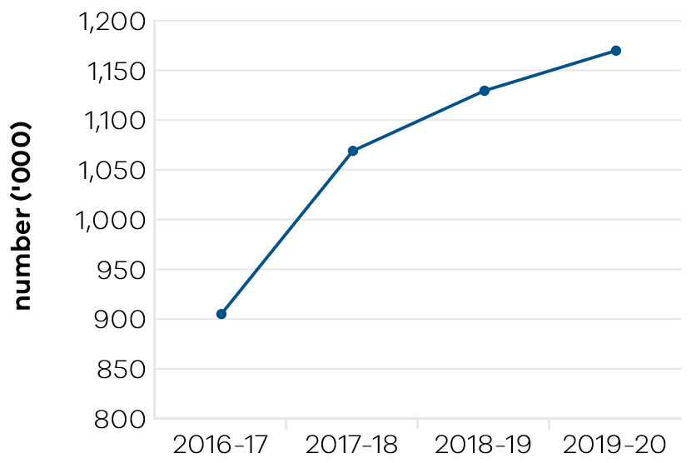

Funded Major Performing Arts companies recorded continuing growth in attendances in 2019–20 driven by programming and the inclusion of a new company. Note that the figures in the above table are for the calendar year ending in that financial year, in line with companies’ programming and so do not reflect the impact of the measures associated with coronavirus (COVID-19).
Victorian funded Major Performing Arts companies in 2019–20 were Melbourne Theatre Company, The Australian Ballet, Opera Australia, Orchestra Victoria, Melbourne Symphony Orchestra, Malthouse Theatre, Circus Oz and Victorian Opera.

Indicator: Employment in the Creative Industries sector

Table 14: Employment in the Creative Industries sector
Measure (unit of measure) | 2016–17 | 2017–18 | 2018–19 | 2019–20
Number of first jobs in the creative industries (number) | 243,000 | 261,000 | 289,000 | 292,000

Figure 11: Number of first jobs in the creative industries
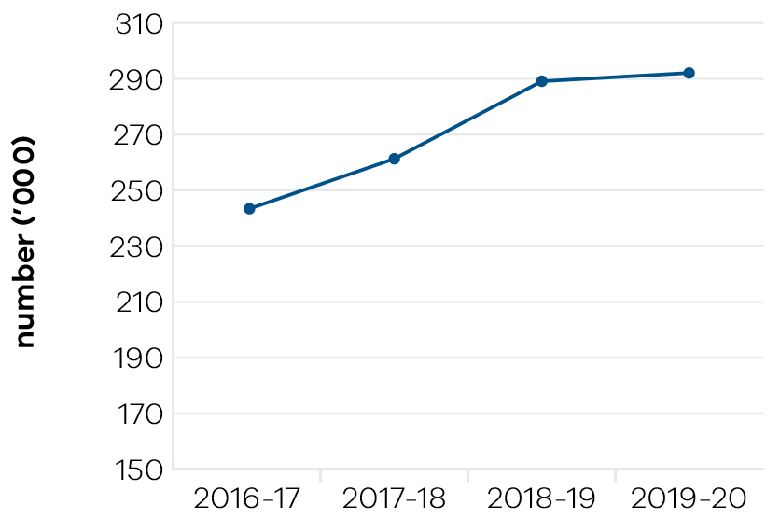
Implementation of Victoria’s first creative industries strategy, Creative State, continues to be supported through the 2019–20 State Budget. Creative State builds the state’s film, television, digital games, design, fashion and arts sectors. Key actions have contributed to supporting and growing the state’s creative enterprises, creating new jobs and employment opportunities, and bringing social and cultural benefits to Victorians. Employment in the creative industries in 2019–20 is 8.6 per cent of the total employment in Victoria.
Creative Victoria has also strengthened the global profile and export potential of Victoria’s creative industries in 2019–20 through support for inbound/outbound delegations and showcases including Chengdu Music City Convention, Hong Kong Fashion Summit, Gamescom in Cologne, Melbourne International Games Week, Keir Choreographic Award, Melbourne Design Week, Melbourne Fashion Festival, Melbourne International Film Festival, Sangam Performing Arts Festival of South Asia and Diaspora, Arts Centre Melbourne’s Asia Triennial of Performing Arts and the inaugural Australia Performing Arts Marketplace gathering in Melbourne.
Growth in the number of jobs in the creative industries sector has continued over the last four years. The rate of growth in 2019–20 is lower than previous years due to the coronavirus (COVID-19) pandemic. The reported figure is an average over four quarterly Australian Bureau of Statistics survey results and consequently does not fully reflect the impact of coronavirus (COVID-19).
The government announced a range of relief and rescue packages and initiatives during 2019–20 supporting continued employment in the creative industries in Victoria.
Over $49 million in direct, targeted relief assistance was provided to the sector through:
- The Survival Package to Help Save Arts Jobs, announced on 26 April 2020;
- Victoria Together, announced on 1 May 2020; and
The Victorian Government Experience Economy Survival Package, announced on 13 May 2020.
The 21 March 2020 Economic Survival Package to Support Businesses and Jobs assisted over 5000 creative industries businesses through the Business Support Fund and waived liquor licensing fees for 2020 affected live music venues.
Live music venues, with a turnover of less than $50 million have been covered by the Commercial Tenancy Relief Fund. Announced on 5 May 2020, the More Support for Much-Loved Pubs, Clubs, Restaurants initiative assisted additional licensed live music venues with turnover greater than $50 million and not covered by the Commercial Tenancy Relief Scheme with rent relief.
Supporting Thousands More Workers During Coronavirus (COVID-19) was announced on 5 May 2020, providing fortnightly payments of up to $1500 before tax to casual public sector workers, up until the end of September. This package supported workers at portfolio agencies, such as ticket staff at the Melbourne Museum who have been ineligible for the Commonwealth JobKeeper program.

Indicator: Employment in the Visitor Economy

Table 15: Employment in the Visitor Economy
Measure (unit of measure) | 2016–17 | 2017–18 | 2018–19 | 2019–20
Number of jobs in the visitor economy sector (number) * | 235,100 | 247,900 | 263,300 | Data expected  June 2021
* Source: State Tourism Satellite Account 2018–19, Tourism Research Australia. Changes to the inputs used to produce this data have resulted in revised historical estimates that should not be compared to previously published results.

Figure 12: Employment in the Visitor Economy sector
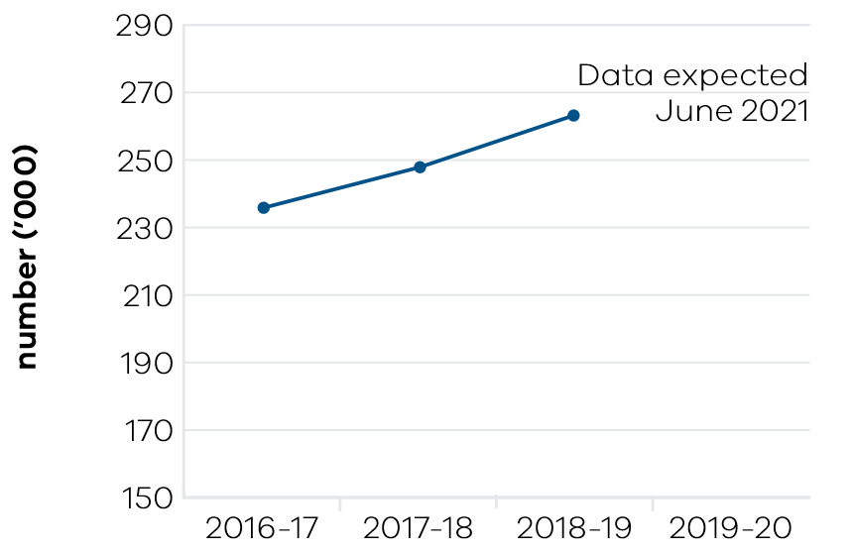
In 2018–19 tourism in Victoria generated 263,300 jobs. Tourism jobs have grown year-on-year (+6.2 per cent) at a rate well above the rate of jobs growth in the Victorian economy overall (+3.3 per cent).
This has been consistent over the longer term (2013–14 to 2018–19), with tourism jobs growing at an average annual rate of 6.7 per cent, more than double the state’s jobs growth of 3.1 per cent per annum, adding more than 73,000 new tourism jobs to the state in this five-year period.
Looking at the distribution of tourism jobs across Victorian industries, cafés, restaurants and takeaway food services (30 per cent) accounted for the largest share of direct tourism employment, followed by retail trade (16 per cent), accommodation (14 per cent) and education and training (10 per cent).

Indicator: Tourists attracted to Victoria

Table 16: Tourists attracted to Victoria
Measure (unit of measure) | 2016–17 | 2017–18 | 2018–19 | 2019–20
Number of domestic overnight visitors (number (million)) | 22.5 | 24 | 27.8 | 28.3
Number of international visitors (number (million)) | 2.7 | 3 | 3.1 | 2.8
Visitor expenditure: domestic ($ billion) | 17.4 | 18.8 | 21.5 | 23.2
Visitor expenditure: international ($ billion) | 7.3 | 8 | 8.5 | 8.1
Visitor expenditure: regional Victoria (domestic) ($ billion) | 8.2 | 9.1 | 10.4 | 11.3
Visitor expenditure: regional Victoria| (international) ($ million) | 513 | 570 | 582 | 538

Figure 13: Number of domestic overnight visitors
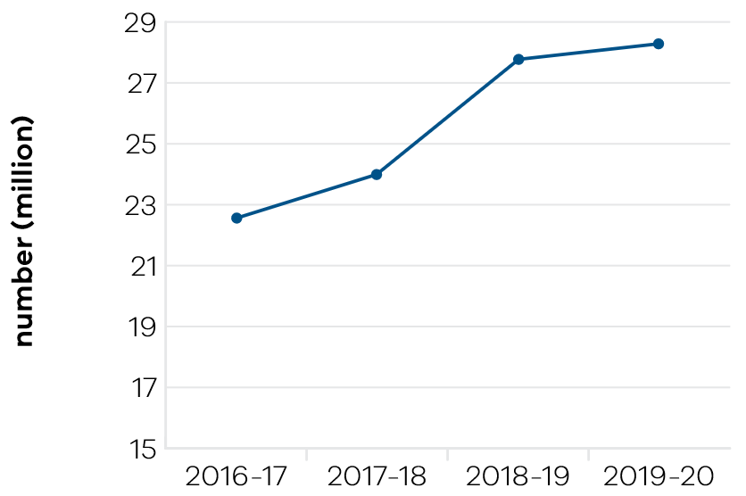

Figure 14: Number of international visitors
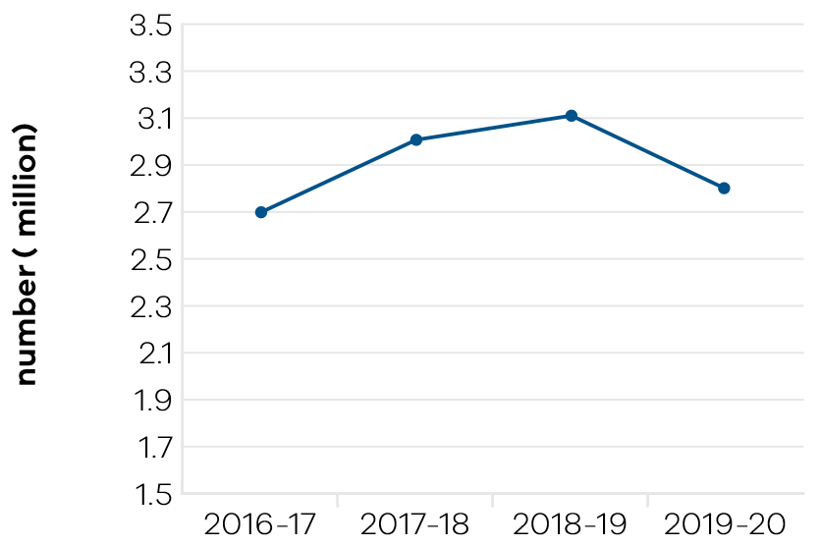

Figure 15: Visitor expenditure: domestic
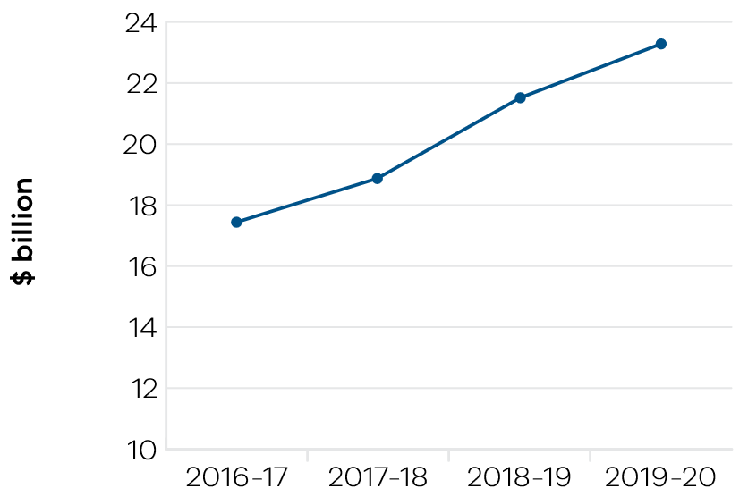

Figure 16: Visitor expenditure: international
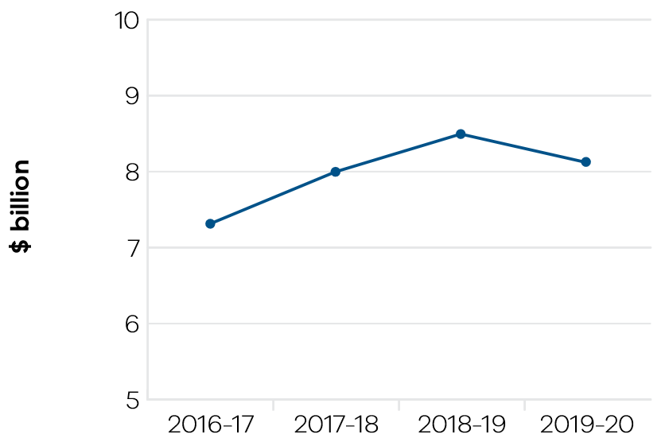

Figure 17: Visitor expenditure: regional Victoria (domestic)
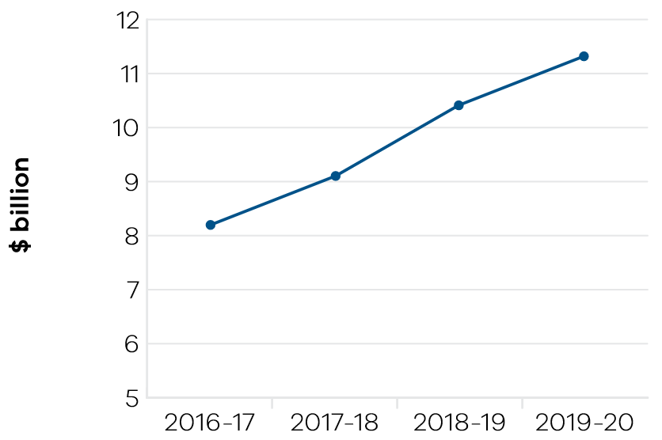

Figure 18: Visitor expenditure: regional Victoria (international)
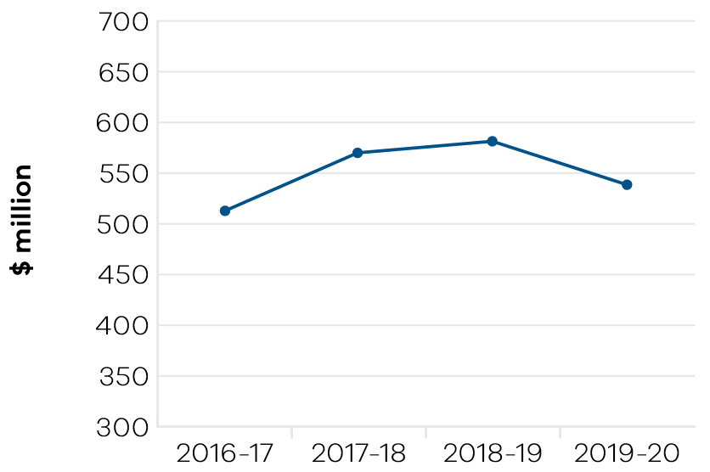
As at year ending March 2020, according to the latest available data from Tourism Research Australia, there were 95.5 million total visitors to and within Victoria, and the total expenditure was $31.3 billion.
Despite the effects of the summer bushfires and the impact of coronavirus (COVID-19), domestic overnight tourism in Victoria showed solid growth for the year ending in March 2020, following a strong 2019. This reflects the key marketing activities by Visit Victoria over 2019 which included the successful roll out of the Your Happy Space marketing campaign encouraging Melbournians to visit regional Victoria.
The department continued to work with Visit Victoria to secure and deliver world-class major events, business events and regional events, including Come From Away, the ICC T20 Women’s World Cup Final, UFC243, The President’s Cup and Boomers vs USA Basketball.
Although, indicators for quarter three show sharp declines across all key measures compared to the same period last year; as the negative impacts of the dual crises started to take hold on travel movement across the country. This has impacted most parts of the tourism and major events industry with reduced visitation across the State and cancellation or postponement of events such as the Formula One Australian Grand Prix.
The coronavirus (COVID-19) outbreak had a significant negative impact on key international measures in the latest year ending March 2020 results. International spend growth in Victoria was at its lowest level on record since the year ending June 2006.
The department worked closely with Visit Victoria, the Victoria Tourism Industry Council, Regional Tourism Boards, portfolio entities and the tourism industry to provide advice and support during the January 2020 Victorian bushfires and the coronavirus (COVID-19) pandemic.

Indicator: Increase rates of community engagement, including through participation in sport and recreation

Table 17: Increase rates of community engagement, including through participation in sport and recreation
Measure (unit of measure) | 2016–17 | 2017–18 | 2018–19 | 2019–20
Percentage of adult Victorians participating in sport at least once per year (per cent) | 89.2 | 90.9 | 91.6 | Data available October 2020

Figure 19: Percentage of adult Victorians participating in sport at least once per year
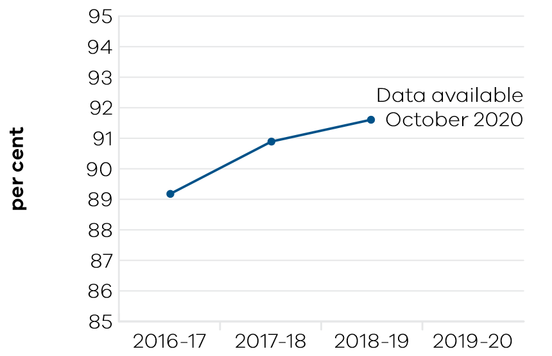
Victoria has seen an upward trend in participation in sport since 2015–16, when 87.5 per cent of the adult population reported participating in sport at least once per year through to 91.6 per cent in 2018–19. The half year figure of 91.3 per cent, indicated a consistent upward trend for the first half of 2019–20. Full year data is not available until October 2020, however, the restrictions imposed on participation in sport and recreation due to the coronavirus (COVID-19) outbreak will have impacted participation rates.
Annual increases in participation in sport and recreation are integral to delivering whole of government outcomes, particularly to enable healthy Victorians, safe and just communities, quality infrastructure, as well as a strong and thriving economy.
Increasing opportunities for participation in sport and active recreation would not be possible without the 580,000 volunteers who give their time to support local clubs, organisations and events.
The sport and recreation sector provides $9.2 billion gross value-add annually and supports 71,000 equivalent full-time jobs. Every dollar spent on sport is estimated to return $7.80 to our community.
The increase in participation in sport over the last four years has also been facilitated through the Supporting Victorian Sport and Recreation (SVSR) Program, which had provided funding to 100 state sporting associations and recreation bodies when it concluded on 30 June 2019. The government continues to support a strong sport sector through the Together More Active program, launched in April 2019, which succeeds the SVSR program.
Opportunities for Victorians to participate in professional or high-performance sport are supported by the number of national sporting organisations that call Victoria home. There are 98 recognised national sporting organisations and 32 of those are based in Victoria. In addition, Victoria supports 45 professional sports teams competing at the highest level, nationally or internationally, in their sport.
The victorious ICC Women’s T20 World Cup squad, which beat India in the final at the MCG in March 2020 included six Victorians, who made up 40 per cent of the overall squad. The success of Victorian cricketers can be attributed to the investment into the Victorian Cricket and Community Centre at Junction Oval, which was completed in 2018.
The addition of Richmond Football Club into the 2020 Australian Football League – Women (AFLW) competition has resulted in eight out of the 10 Victorian AFL teams supporting a women’s team in the national competition, creating even more opportunities for Victorian athletes, especially those that are traditionally under-represented.
Victoria has developed world class sporting infrastructure, including 44 state facilities supporting 45 professional teams and high-performance programs. The government’s investment has contributed toward the provision of 10,000 community sport facilities across Victoria, leisure and recreation centres, as well as an extensive network of over 2000 trails and thousands of playgrounds, parks and sport reserves, which further support sport and recreation participation.
Investment in major sports facilities was bolstered through the $15.3 million investment in the Home of Golf at Sandringham, $13.25 million to upgrade Melbourne Arena, and the commencement of detailed planning for the State Basketball Centre and Kardinia Park Stadium upgrade stage five. The $64.6 million upgrade of the State Netball Hockey Centre and $271.55 million investment in Melbourne Park redevelopment are progressing.
These investments have maintained community engagement in sport across the state. Investment in world class infrastructure has also supported the continued success of our athletes and professional sporting teams and enabled a calendar of major sporting events that added over $1.8 billion per year to the state’s economy in 2018–19. As an example, the Australian Open Tennis in 2020 saw a record 812,174 spectators visit Melbourne Park, which alone contributed $388 million to the Victorian economy.
The government’s strong commitment to increase women’s participation and leadership in sport and recreation has been integral to lifting overall participation rates. The government has committed over $37 million to the Female-Friendly Facilities Fund over the past five years to upgrade existing, and develop new infrastructure to support female participation in sport and active recreation. There has been a significant increase in female participation across a range of non-traditional female sports, such as Australian Rules football, cricket and soccer. In the past decade, the number of female Australian Rules football teams has increased 20-fold, from 58 teams in 2010 to over 1000 teams in 2019, with more than 28,500 participants.

Indicator: Wagering turnover on Victorian racing as a proportion of the national market

Table 18: Wagering turnover on Victorian racing as a proportion of the national market
Measure (unit of measure) | 2016–17 | 2017–18 | 2018–19 | 2019–20
Wagering turnover on Victorian racing as a proportion of the national market (per cent) | 39.1 | 38.2 | 38.5 | 37.5

Figure 20: Wagering turnover on Victorian racing as a proportion of the national market
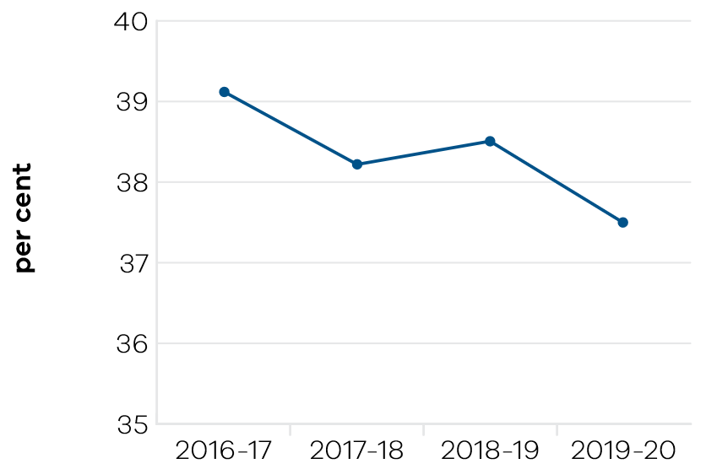
Government support for racing is based on its economic, social and cultural contribution to communities across Victoria. The objective indicator of Tabcorp customers nationwide who bet on Victorian racing as a proportion of the national market is used to determine the health of the Victorian racing industry. The measure includes all racing turnover held by Tabcorp on Victorian racing events.
While Victoria has approximately 25 per cent of the national population and hosts around 25 per cent of the national racing program, it attracts almost 40 per cent of the national wagering pool. In 2019–20, 37.9 per cent of the national wagering pool was held by Victoria, slightly down from 38.5 per cent in 2018–19 and 38.2 per cent in 2017–18. This significant market share reflects confidence in the racing product and in the integrity of Victorian racing.
The variance may partly reflect the diversification of the wagering market and the Victorian racing industry’s broadcast and wagering strategies which target growth across all sectors of the market, including non-TAB wagering providers. Wagering service providers other than Tabcorp have increased their market share in recent years as the popularity of fixed odds and online wagering has grown. The Victorian racing industry has sought to maximise revenue from all wagering sources which may have contributed to a decline in national share with Tabcorp. It may also be the result of increased interstate competition from both New South Wales and Queensland. New South Wales has made significant increases to prizemoney and programmed new feature races in direct competition with established Victorian events, while Queensland has included a large number of former non-TAB race meetings in its broadcast and wagering schedule.
Strong wagering levels are reliant on maintaining premium racing and strong field sizes, particularly in the face of rapidly increasing competition from New South Wales. A key lever for attracting participants is the level of prizemoney on offer and in 2019–20 the Victorian Government delivered the second phase of its commitment to provide $40 million over two years to increase the prizemoney on offer across the three racing codes in Victoria.

Performance against output performance measures
Table 19 represents performance against the Creative Industries Access, Development and Innovation output. This output supports the creative industries to deliver economic, social and cultural benefit through talent and leadership; the creative and business ecology; innovation and social impact; participation and place making; and international engagement.

Table 19: Output – Creative Industries Access, Development and Innovation
Performance measures | Unit of measure | 2019–20 actual | 2019–20 target | Performance variation (%) | Result
Quantity
Attendances at major performing arts organisations | number (000) | 1169 | 1000 | 16.9% | ü
Higher result due to an unexpected higher attendance at performances.
Creative Learning Partnerships | number | 14 | 14 | 0.0% | ü
Design organisations supported | number | 18 | 22 | -18.2% | n
Lower result due to the economic impacts and physical distancing measures in place for coronavirus (COVID-19). The Melbourne Design Week event scheduled for March 2020 was cancelled and the Design to Thrive program had lower participation by small and medium enterprises and not for profit companies.
International market development and exchange initiatives | number | 10 | 12 | -16.7% | n
Lower result due to the economic impacts and physical distancing measures as a result of coronavirus (COVID-19). The Game Developers Conference was cancelled in March and one International Engagement Funding was postponed.
Organisations recurrently funded | number | 140 | 142 | -1.4% | ™
Project companies and artists funded | number | 981 | 450 | 118.0% | ü
Higher result due to the coronavirus (COVID-19) response program Sustaining Creative Workers, which resulted in over 600 grants being paid in May and June 2020.
Project companies and artists funded which are regionally based | per cent | 25 | 23 | 8.7% | ü
Higher result due to the coronavirus (COVID-19) response program Sustaining Creative Workers. Grant recipients were spread across the State, with a dedicated stream to affected creative professionals in regional Victoria.
Regional Touring Victoria destinations | number | 17 | 70 | -75.7% | n
Lower result due to the impact of coronavirus (COVID-19) restricting travel.
Regionally based organisations recurrently funded | number | 54 | 54 | 0.0% | ü
Quality
Grant recipients who met or exceeded agreed outcomes | per cent | 74 | 85 | -12.9% | n
Lower result due to coronavirus (COVID-19) which impacted the ability of grant recipients to meet the outcomes agreed to prior to the pandemic.
Public information rated ‘informative’ or ‘very informative’ by grant applicants | per cent | 90 | 90 | 0.0% | ü
Timeliness
Performance and grant agreements acquitted within timeframes specified in the funding agreement | per cent | 52 | 83 | -37.3% | n
Lower result due to the impact of coronavirus (COVID-19) which impacted the performance and grant agreement timeframes.
VicArts Grant acquittals assessed within 30 days of submission date | per cent | 98 | 95 | 3.2% | ü
VicArts Grant applications processed within 45 days for Ministerial consideration | per cent | 100 | 100 | 0.0% | ü
Cost
Total output cost | $ million | 73.9 | 72.6 | 2.0% | ™
Note:
ü Performance target achieved or exceeded
™ Performance target not achieved – within 5 per cent variance
n Performance target not achieved – exceeds 5 per cent variance

Table 20 represents performance against the Creative Industries Portfolio Agencies output. This output promotes, presents and preserves the state’s heritage and the creative industries through Victoria’s creative industries agencies: Arts Centre Melbourne, ACMI, Docklands Studios Melbourne, Film Victoria, Geelong Arts Centre, Melbourne Recital Centre, Museums Victoria, NGV and the State Library Victoria.

Table 20: Output – Creative Industries Portfolio Agencies
Performance measures | Unit of measure | 2019–20 actual | 2019–20 target | Performance variation (%) | Result
Quantity
Additional employment from production supported by Film Victoria | number | 4140 | 6740 | -38.6% | n
Lower result due to the impact of coronavirus (COVID-19) with many productions unable to commence.
Agency website visitation | number (000) | 21,365 | 21,200 | 0.8% | ü
Members and friends of agencies | number | 57,495 | 57,000 | 0.9% | ü
Students participating in agency education programs | number | 343,763 | 550,000 | -37.5% | n
Lower result due to the impact of coronavirus (COVID-19) which meant school groups were unable to attend various education programs hosted by agencies.
Users/attendances at Arts Centre Melbourne | number (000) | 2048 | 2800 | -26.9% | n
Lower result due to closures brought about by coronavirus (COVID-19).
Users/attendances at Australian Centre for the Moving image | number (000) | 674 | 800 | -15.8% | n
Lower result due to closures brought about by coronavirus (COVID-19).
Users/attendances at Geelong Arts Centre | number (000) | 153 | 185 | -17.3% | n
Lower result due to closures brought about by coronavirus (COVID-19).
Users/attendances at Melbourne Recital Centre | number (000) | 157 | 230 | -31.7% | n
Lower result due to closures brought about by coronavirus (COVID-19).
Users/attendances at Museums Victoria | number (000) | 1489 | 2000 | -25.6% | n
Lower result due to closures brought about by coronavirus (COVID-19).
Users/attendances at National Gallery of Victoria | number (000) | 2073 | 2235 | -7.2% | n
Lower result due to closures brought about by coronavirus (COVID-19).
Users/attendances at State Library Victoria | number (000) | 1654 | 2250 | -26.5% | n
Lower result due to closures brought about by coronavirus (COVID-19).
Value of film, television and digital media production supported by Film Victoria | $ million | 157 | 161 | -2.5% | ™
Volunteer hours | number | 81,353 | 98,900 | -17.7% | n
Lower result due to the impact of coronavirus (COVID-19) and closures at the agencies.
Quality
Agency collections storage meeting industry standard | per cent | 84 | 86 | -2.3% | ™
Visitors satisfied with visit: Arts Centre Melbourne | per cent | 94 | 95 | -1.1% | ™
Visitors satisfied with visit: Australian Centre for the Moving Image | per cent | 95 | 95 | 0.0% | ü
Visitors satisfied with visit: Geelong Arts Centre | per cent | 98 | 98 | 0.0% | ü
Visitors satisfied with visit: Melbourne Recital Centre | per cent | 97 | 95 | 2.1% | ü
Visitors satisfied with visit: Museums Victoria | per cent | 97 | 95 | 2.1% | ü
Visitors satisfied with visit: National Gallery of Victoria | per cent | 95 | 95 | 0.0% | ü
Visitors satisfied with visit: State Library Victoria | per cent | 93 | 90 | 3.3% | ü
Cost
Total output cost | $ million | 438.0 | 399.4 | 10.0% | n
The 2019–20 result was higher than budget primarily due to additional agency expenditure funded by the Experience Economy Survival Package and third-party revenue.
Note:
ü Performance target achieved or exceeded
™ Performance target not achieved – within 5 per cent variance
n Performance target not achieved – exceeds 5 per cent variance

Table 21 represents performance against the Cultural Infrastructure and Facilities output. This output supports Victorian cultural venues and state-owned facilities through strategic assessment and provision of advice on portfolio infrastructure proposals and projects. The output includes consolidation of portfolio asset management plans and management of funding programs for maintenance and minor capital works.

Table 21: Output – Cultural Infrastructure and Facilities
Performance measures | Unit of measure | 2019–20 actual | 2019–20 target | Performance variation (%) | Result
Quantity
All facility safety audits conducted | number | 16 | 16 | 0.0% | ü
Infrastructure development projects underway | number | 5 | 5 | 0.0% | ü
Quality
State-owned tenanted cultural facilities maintained  to agreed service standards | per cent | 60 | 90 | -33.3% | n
Lower result due to the impact of coronavirus (COVID-19) closing the facilities and preventing contractors from accessing the sites.
Success measures of projects achieved | per cent | 88 | 90 | -2.2% | ™
Timeliness
Cultural Facilities Maintenance Fund projects delivered within agreed timeframes | per cent | 92 | 90 | 2.2% | ü
Cost
Total output cost | $ million | 114.3 | 112.3 | 2.0% | ™
Note:
ü Performance target achieved or exceeded
™ Performance target not achieved – within 5 per cent variance
n Performance target not achieved – exceeds 5 per cent variance

Table 22 represents performance against the Sport, Recreation and Racing output. This output provides strategic leadership and investment in the sport, recreation and racing industries through innovation, sector and industry development and funding support. It supports community participation and inclusion in the sport, recreation and racing sectors by strengthening the capacity of sport and recreation organisations to deliver participation opportunities, improving community sport and recreation facilities across the state and guiding the development and management of state-level sporting facilities and events, to encourage participation by all Victorians.
This output also supports the development of the Victorian racing industry through strategic investment in world class racing and training infrastructure, the promotion of animal welfare and integrity initiatives and encourages participation and investment in the breeding industry to cement Victoria’s position as Australia’s premier racing state.

Table 22: Output – Sport, Recreation and Racing
Performance measures | Unit of measure | 2019–20 actual | 2019–20 target | Performance variation (%) | Result
Quantity
Combat sports licences, registrations and permits issued | number | 487 | 550 | -11.5% | n
Lower result due to the impact of coronavirus (COVID-19) which led to a reduction in the number of events held.
Community Facility Grants: number approved |  | 167 | 170 | -1.8% | ™
Organisations submitting nominations for the Community Sport and Recreation Awards |  | 72 | 70 | 2.9% | ü
Projects in progress that relate to the planning and development of state level facilities | number | 22 | 10 | 120.0% | ü
Higher result due to a significant number of state level projects currently in progress.
Racing industry development initiatives | number | 7 | 9 | -22.2% | n
Lower result due to the impact of coronavirus (COVID-19) which led to changed priorities for the racing industry.
Racing matters processed (including licences, permits and grant applications) | number | 258 | 300 | -14.0% | n
Lower result due to the impact of coronavirus (COVID-19) which led to many events being cancelled.
Significant Sporting Events Program – Events Facilitated | number | 60 | 75 | -20.0% | n
Lower result due to the impact of coronavirus (COVID-19) on the sector and staging of events, which resulted in events being cancelled.
Sport and recreation organisations undertaking programs or activities to enhance participation | number | 109 | 90 | 21.1% | ü
Higher result due to several new organisations becoming recognised as either a State Sporting Association or State Sport and Recreation Body.
Sporting club grants: number approved | number | 695 | 750 | -7.3% | n
Lower result due to the higher average value and lower number of grants. The same aggregate funding was distributed for both years.
Sports with athletes on Victorian Institute of Sport (VIS) scholarships | number | 46 | 25 | 84.0% | ü
Higher result due to the Tokyo Olympics originally expected to be run in July–August 2020. The number of sports programs through the Victorian Institute of Sport increased as a result of National Sporting Organisations providing additional funding to ensure the greatest opportunity for athletes aspiring to qualify for the Olympic and Paralympic Games have the chance to represent Australia.
Victorian Institute of Sport scholarship holders  on national teams/squads | per cent | 71 | 60 | 18.3% | ü
Higher result due to the strong performance of the Victorian Institute of Sport in developing athletes for selection in national teams or squads.
Quality
Contract management of outdoor recreation camps meets agreed key performance indicators | per cent | 92 | 90 | 2.2% | ü
Timeliness
Facilitate the delivery of the Community Cricket Program milestones in line with grant agreements | per cent | 0 | 90 | -100.0% | n
No result due to the impact of coronavirus (COVID-19) on the timing of assessment and outcomes for the first round of the Community Cricket Program.
Cost
Total output cost | $ million | 285.5 | 374.9 | -24.0% | ü
The 2019–20 result was lower than budget primarily due to the timing of payments related to Major Stadia Funding program.
Note:
ü Performance target achieved or exceeded
™ Performance target not achieved – within 5 per cent variance
n Performance target not achieved – exceeds 5 per cent variance

Table 23 represents performance against the Tourism and Major Events output. This output maximises employment and the long-term economic benefits of tourism and major events to Victoria by developing and marketing the state as a competitive destination.

Table 23: Output – Tourism and Major Events
Performance measures | Unit of measure | 2019–20 actual | 2019–20 target | Performance variation (%) | Result
Quantity
Major sporting and cultural events facilitated | number | 19 | 18 | 5.6% | ü
Higher result as the forecasted target was based on secured and potential events at the time of reporting, and Visit Victoria was able to facilitate an additional event in 2019–20.
Events facilitated in 2019–20 include: 2020 World Sailing Championships, Australian Open Tennis, AUS-X Open, Boomers versus USA Basketball, Cadel Evans Great Ocean Road Race, Come From Away, Festival of Sails, FIG Individual Apparatus World Cup, FIM Superbike World Championship, Harry Potter and The Cursed Child, Helpmann Awards, ICC T20 Women’s World Cup 6 Matches (incl. Final), Jayco Herald Sun Tour, Melbourne Esports Open, The Presidents Cup, UFC243, Virgin Australia Melbourne Fashion Festival, White Night Ballarat, White Night Melbourne Reimagined.
Visit Victoria's total engaged digital audience | number (million) | 5 | 5.4 | -7.4% | n
Lower result due to the impact of coronavirus (COVID-19), travel restrictions and no Visit Victoria paid media activity.
Visitor expenditure: domestic | $ billion | 23.2 | 20.6 | 12.6% | ü
Higher result due to growth in total domestic expenditure in Victoria following a strong 2019 calendar year (and shift to 100 per cent mobile phone interviewing from January 2019 which had an upward influence on survey results).
This is the latest available data to March 2020 from the National Visitor Survey published in July 2020.
Visitor expenditure: international | $ billion | 8.1 | 8.7 | -6.9% | n
Lower result due to the impact of coronavirus (COVID-19) and associated restrictions on international travel.
This is the latest available data to March 2020 from the International Visitor Survey published in July 2020.
Visitor expenditure: regional Victoria (domestic) | $ billion | 11.3 | 9.9 | 14.1% | ü
Higher result due to growth in total domestic expenditure in regional Victoria following a strong 2019 calendar year (and shift to 100 per cent mobile phone interviewing from January 2019 which had an upward influence on survey results).
This is the latest available data to March 2020 from the National Visitor Survey published in July 2020.
Visitor expenditure: regional Victoria (international) | $ million | 538 | 580 | -7.2% | n
Lower result due to the impact of coronavirus (COVID-19) and associated restrictions on international travel.
This is the latest available data to March 2020 from the International Visitor Survey published in July 2020.
Visitor expenditure: regional Victoria (intrastate overnight) | $ billion | 5.8 | 5.1 | 13.7% | ü
Higher result due to growth in intrastate overnight expenditure in regional Victoria following a strong 2019 calendar year (and shift to 100 per cent mobile phone interviewing from January 2019 which had an upward influence on survey results).
This is the latest available data to March 2020 from the National Visitor Survey published in July 2020.
Visitors (domestic overnight) | number (million) | 28.3 | 26 | 8.8% | ü
Higher result due to growth in domestic overnight visitor trips in Victoria, following a strong 2019 calendar year (and shift to 100 per cent mobile phone interviewing from January 2019 which had an upward influence on survey results).
This is the latest available data to March 2020 from the National Visitor Survey published in July 2020.
Visitors (international) | number (million) | 2.8 | 3.2 | -12.5% | n
Lower result due to the impact of coronavirus (COVID-19) and associated restrictions on international travel.
This is the latest available data to March 2020 from the International Visitor Survey published in July 2020.
Visitors: regional Victoria (intrastate overnight) | number (million) | 15.6 | 14.1 | 10.6% | ü
Higher result due to growth on intrastate overnight visitors in regional Victoria, following a strong 2019 calendar year (and shift to 100 per cent mobile phone interviewing from January 2019 which had an upward influence on survey results).
This is the latest available data to March 2020 from the National Visitor Survey published in July 2020.
Quality
Value of media coverage generated: domestic | $ million | 39 | 22 | 77.3% | ü
Higher result due to the promotion of a number of activities.
Value of media coverage generated: international | $ million | 52 | 46 | 13.0% | ü
Higher result due to virtual trips to Victoria.
Timeliness
Completion of post-event reports and economic  impact assessments of each event (where required)  within agreed timeframes | per cent | 100 | 100 | 0.0% | ü
Cost
Total output cost | $ million | 228.4 | 123.5 | 85.0% | n
The 2019–20 result was higher than budget due to additional major events funding that was held centrally until contractual arrangements were finalised.
Note:
ü Performance target achieved or exceeded
™ Performance target not achieved – within 5 per cent variance
n Performance target not achieved – exceeds 5 per cent variance

Objective 6: Promote productive and sustainably-used natural resources
This objective supports more productive, globally competitive, sustainable and jobs-rich agriculture, food and fibre, and resources sectors and creates the conditions to grow the forestry and game resource economies. The department delivers the objective in collaboration with partners, local communities and industry to deliver outcomes that provide benefits to all Victorians.

Progress towards achieving this objective
In 2019–20, the department reported progress against this objective using the following objective indicators and outputs:

Objective Indicators
- Value of Victorian agriculture production
- Value of Victorian food and fibre exports
- Metres drilled for minerals exploration in Victoria
Level of production of minerals and extractives

Outputs
- Agriculture
- Agriculture Industry Development and Regulation
- Agriculture Research
- Biosecurity and Agriculture Services
- Sustainably manage forest and game resources
Resources
The department supports a productive, globally competitive and sustainable Victorian economy for the state’s innovative and resilient agriculture, food and fibre sector. The department works with the community and industry to enhance productivity; connect the sector with international markets and create jobs; support growth; maintain effective biosecurity and improve the welfare of domestic and production animals.

Indicator: Value of Victorian agriculture production

Table 24: Value of Victorian agriculture production
Measure (unit of measure) | 2016–17 | 2017–18 | 2018–19 | 2019–20
Gross value of Victorian agriculture production  ($ billion) | 14.0 | 14.9 | 15.8 | Data available  May 2021

Figure 21: Gross value of Victorian agriculture production
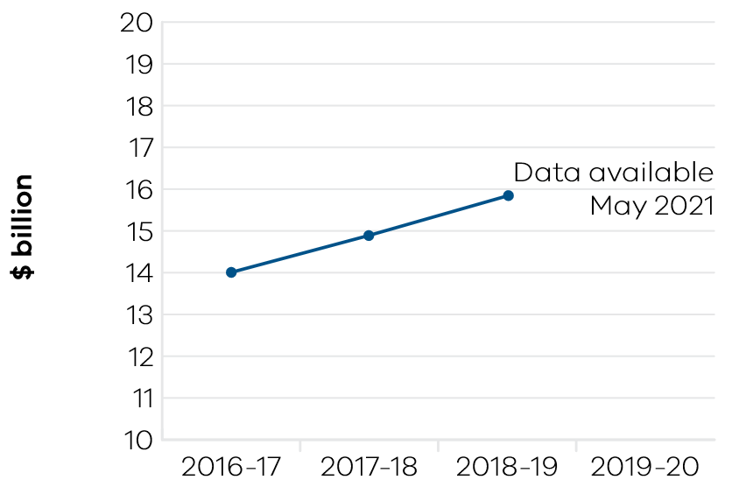
The total value of agriculture production in Victoria increased by seven per cent to $15.8 billion in 2018–19 (the latest available data), compared to $14.9 billion in 2017–18. There were increases in the value of production in broadacre livestock, dairy and horticulture industries driven by strong export and domestic prices. The value of broadacre crop production increased due to the seasonal conditions and strong feed grain market.
Dry seasonal conditions prevailed in 2019–20 across parts of the state, particularly in East and Central Gippsland and the far North West. The Victorian Government’s Drought Support package provided support to affected farming families and their communities. This included Resilience Grants, Household Relief payments, farm machinery grants, mental health support, small business support and community resilience initiatives. Agriculture Victoria staff facilitated technical support activities for impacted farm businesses.
Agriculture Victoria also led efforts to deliver animal welfare relief, agricultural loss and damage assessment and recovery services to primary producers impacted by the 2019–20 summer bushfires. This included technical support activities for farm businesses on feeding, watering and management of stock, pasture management and climate information.
The Rural Financial Counselling Service, which provides free and impartial financial counselling to farmers and related small businesses experiencing, or at risk of, financial hardship saw increased demand for services due to drought, bushfires and the coronavirus (COVID-19) pandemic. The cumulative impact resulted in a record 1900 active clients at 30 June 2020.
Agriculture Victoria has continued to support the agriculture sector to respond to climate change. The government endorsed the establishment of the Victorian Agriculture and Climate Change Council just prior to the end of 2019–20. Victoria maintained a strong presence in national climate change initiatives, leading the preparation of advice to Agriculture Ministers on a nationally coordinated approach to support the sector. This culminated in the Agriculture and Climate Change work program, unanimously endorsed by the Agriculture Ministers and led to establishment of the Climate Change Task Group to oversee implementation.
The department’s long-term research and innovation partnerships with industry, academia and the value chain are supporting the Victorian agriculture sector to embrace AgTech, digital technologies and make the transition to smart farms. Agriculture Victoria has developed sensor-based technologies for real time estimates of pasture yield at plot and paddock scales. These technologies have the potential to improve pasture utilisation by up to 20 per cent and increase dairy farm profitability. Agriculture Victoria also integrates AgTech and multidisciplinary team approaches in pulse genetic improvement to optimise yield and yield stability across an expanded range of pulse-growing regions. Grain growers are provided with better varieties faster, which enhances growers’ profitability.
Innovation on-farming has been enhanced by implementation of the government’s Digital Agriculture Strategy. The $12 million On-Farm Internet of Things Trial delivered network infrastructure across four trial regions and four Agriculture Victoria SmartFarms. Agriculture Victoria has also delivered ongoing research and innovation programs providing productivity and sustainability benefits to Victoria’s farmers. The $30 million Agriculture Energy Investment Plan delivered seven million dollars in on-farm energy assessments and $10 million in grants to farmers to improve their energy efficiency.
Through Animal Welfare Victoria, the department has responsibility for implementing the government’s Animal Welfare Action Plan. Activity has improved the management of pet sales with the implementation of the Pet Exchange Register. Delivery of Round eight of the Animal Welfare Fund Grants Program has enabled shelters and foster carers to purchase equipment or upgrade or expand their services and not-for-profit and community vet clinics to maintain and expand their services in areas of need around Victoria.

Indicator: Value of Victorian food and fibre exports

Table 25: Value of Victorian food and fibre exports
Measure (unit of measure) | 2016–17 | 2017–18 | 2018–19 | 2019–20
Food and fibre exports from Victoria  ($ billion) | 12.8 | 14.1 | 14.2 | Data available  May 2021

Figure 22: Food and fibre exports from Victoria
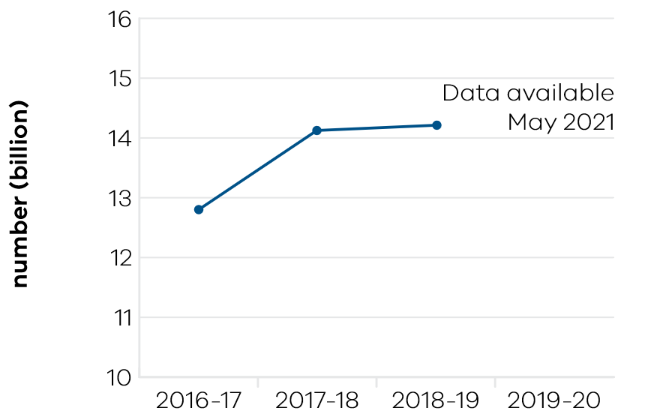
The government has a target to grow Victorian food and fibre exports to $20 billion per annum by 2030. In 2018–19, Victoria maintained its strong export performance, generating food and fibre exports valued at $14.2 billion despite challenges caused by drought and dry seasonal conditions. This was an increase of $98 million on the previous year– keeping Victoria as the nation’s largest food and fibre exporter with 27 per cent of the national total.
The value of Victorian food and fibre exports in 2018–19 increased by one per cent on the previous year. This was accompanied by a 31 per cent decline in volume, mostly due to lower grain production caused by seasonal conditions and Victorian grain being sold domestically to support the national shortfall. High value exports – especially meat, wool and dairy – collectively accounted for 57 per cent of the total value of the state’s food and fibre exports.
The value of food exports alone was $10.4 billion, an increase of $175 million on the previous year. The value of fibre exports decreased by $77 million on the previous year to $3.8 billion in response to market volatility and seasonal conditions. Victoria is the second largest wool producing state and the largest wool exporter, producing 23 per cent of Australia’s total wool accounting for 52 per cent of the nation’s exports in 2018–19.
Export performance for Victorian meat products remained strong despite challenging domestic conditions. The meat industry had a particularly strong year, increasing export value by 23 per cent to $4.1 billion, making meat Victoria’s most valuable food and fibre export.
Meat exports from Victoria were valued at $4.1 billion in 2018–19, an increase of $765 million (23 per cent) on 2017–18. Beef ($1.75 billion) and sheep meat ($1.73 billion) were the most valuable meat export categories, comprising 84 per cent of Victorian meat exports. The USA was Victoria’s largest meat export destination at $1.019 billion. Meat exports to China increased by $214 million to $687 million (up 45 per cent).
Despite the challenging seasonal conditions reducing domestic milk production, the value of Victorian dairy exports increased by two per cent to $1.95 billion in 2018–19. The major markets saw strong growth, especially in China (14 per cent), and Taiwan (14 per cent) with sales of $472 million and $67 million respectively. Exports to South Korea decreased by 12 per cent and Hong Kong, Taiwan and Philippines also saw minor declines. China overtook Japan as the largest export market for dairy products in 2018–19, valued at $472 million, despite exports to Japan increasing $10 million (two per cent) to $452 million.
Dry conditions during harvest rounded off a very successful 2018–19 season for Victorian horticulture. Exports increased by 38 per cent to be valued at $1.6 billion. China was the major market for Victorian horticultural exports increasing by 133 per cent and accounting for 36 per cent of the total value of horticulture exports.
Table grapes and almonds had a record-breaking year reaching over half a billion dollars in exports. Victoria exported 91 per cent of Australia’s table grapes valued at $504 million (up 43 per cent) on 2017–18. China was the largest market for table grapes valued at $199 million (up 39 per cent on 2017–18). Almond exports from Victoria increased by 63 per cent in value compared to the previous year.
Agriculture Victoria is working with industry to deliver consistent high-quality products that meet consumer expectations and build trust for Australian products among overseas consumers.
A key component in expanding Victoria’s agriculture exports is the eight million dollar Growing Food and Fibre Markets program. the program involved a partnership between the Victorian Government and Citrus Australia to trial traceability technologies along the citrus supply chain from tree to table.
In 2020, the trial used fingerprint labelling and blockchain technologies to trace more than 400,000 kilograms of premium varieties of oranges to over 50 retail stores in China. The trial has boosted the export potential of the citrus industry by improving the ability to trace produce across supply chains. It also enables demonstration of the premium quality attributes of Victorian produce in increasingly competitive global markets.
In addition, trials of an innovative approach to managing Queensland fruit fly (QFF) that commenced in 2018-19 resulted in over 1000 tonnes of cherries and berries being produced with no detections of QFF. These projects were delivered in collaboration with Citrus Australia, Cherry Growers Australia, Hort Innovation and CSIRO, who worked alongside our Agriculture Victoria Researchers.
The state invested in strengthening its food safety systems by using whole genome sequencing to improve its response capability for food safety incidents. This protects the state’s international reputation for high quality, premium produce. Additionally, the program identified opportunities for strategic investment that support an approach for Victorian food and beverage producers to capture a bigger share of the growing global food service market.
Agriculture Victoria worked to enhance grower, agronomist and industry-wide awareness of actions needed to meet importing country requirements. This included Maximum Residue Limits, as part of the Chemical Use for Market Access project.
These projects are a key part of the state government’s drive to boost the export potential and value of Victoria’s food and fibre exports to $20 billion by 2030.

Resources

Indicator: Metres drilled for minerals exploration in Victoria

Table 26: Metres drilled for minerals exploration in Victoria
Measure (unit of measure) | 2016–17 | 2017–18 | 2018–19 | 2019–20
Metres drilled for minerals exploration in Victoria (metres) | 191,658 | 191,229 | 337,654 | Data available  October 2020
Source: Geological Survey of Victoria, (GSV) mineral companies’ exploration reports that GSV is required to audit.

Figure 23: Metres drilled for minerals exploration in Victoria
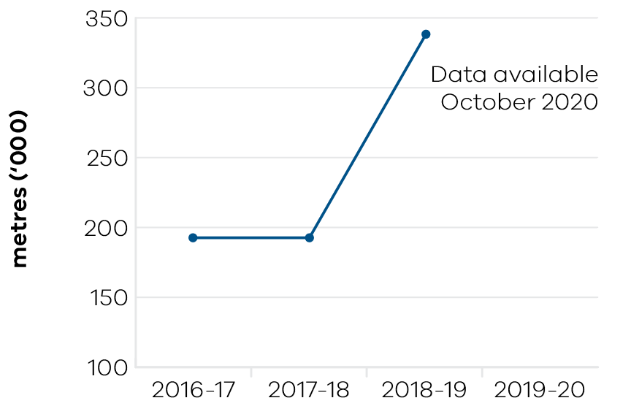
The level of metres drilled for minerals exploration in Victoria during 2018–19 was 337,654 metres. This represents an increase of 77 per cent compared to 2017–18. The increased level of minerals drilling in 2018–19 reflected a combination of drilling at existing mining licences such as the Fosterville gold mine in Central Victoria and increased drilling activity for new resources deposits across the State. Another driver was the re-opening of the Stawell gold mine during 2018 with a focus on underground exploration. This led to the recommissioning of the processing plant (first gold pour 31 January 2019) and new jobs, with 200 employees engaged.
The level of metres drilled for minerals exploration has increased by almost four times since 2014–15 reflecting the renewed interest for exploring in Victoria. The Fosterville gold mine is an example of mining success in Victoria, with record gold production levels being forecast of approximately 600,000 ounces per year. Initiatives such as the Stavely minerals initiative in Western Victoria and the North Central Victorian goldfields release are aimed at attracting further exploration investment in the State.
Spending on minerals exploration in Victoria is at its highest level since records began, with the Australian Bureau of Statistics data showing exploration expenditure reaching $35.6 million in quarter three. For the 12 months to March 2020 total minerals exploration expenditure was $124 million. Minerals exploration licence activity is surging with 30 applications submitted in February 2020 – the highest monthly number in five years. This number is expected to grow further, with the North Central Victorian Goldfields Ground Release tender process progressing during 2020 (the tender for exploration rights over four large prospective blocks closed 14 February 2020).
Further examples of promoting investment in the state’s resources sector include: More than 7000 participants from over 80 countries attended the International Mining and Resources Conference in Melbourne in October 2019. The conference was held for the sixth time, promoting new opportunities for investment in the state’s earth resources and the broader mining equipment, technology and services sector.
The Minister for Resources launched the new Regional Innovation Accelerator program in Bendigo in October 2019. The four-year program is focused on driving innovation and investment for local businesses in the Mining Equipment, Technology and Services (METS) sector. The METS sector contributed $13.6 billion to the Victorian economy in 2016–17.
In May 2020, the Minister for Resources announced the roll-out of a new program to help the METS sector. The METS Regional Innovation Accelerator online program is designed to help regionally based METS businesses engage with local mining companies, fast-track product innovation and promote their services. The 2020 winter program consists of weekly online seminars over a period of eight weeks.

Indicator: Level of production of minerals and extractives

Table 27: Level of production of minerals and extractives
Measure (unit of measure) | 2016–17 | 2017–18 | 2018–19 | 2019–20
Annual production of brown coal  (1000 tonnes) | 56,095 | 45,062 | 42,256 | Data available  October 2020
Annual production of gold  (ounces) | 312,229 | 364,225 | 567,501 | Data available  October 2020
Annual production of antimony  (tonnes) | 5138 | 2570 | 2016 | Data available  October 2020
Annual production of mineral sands  (tonnes) | 164,353 | 100,286 | 0 | Data available  October 2020
Annual production of extractives  (million tonnes) | 57.4 | 57.87 | 62.72 | Data available  October 2020
Source: Earth Resources Regulation 2018–19 Statistical Report

Figure 24: Annual production of brown coal
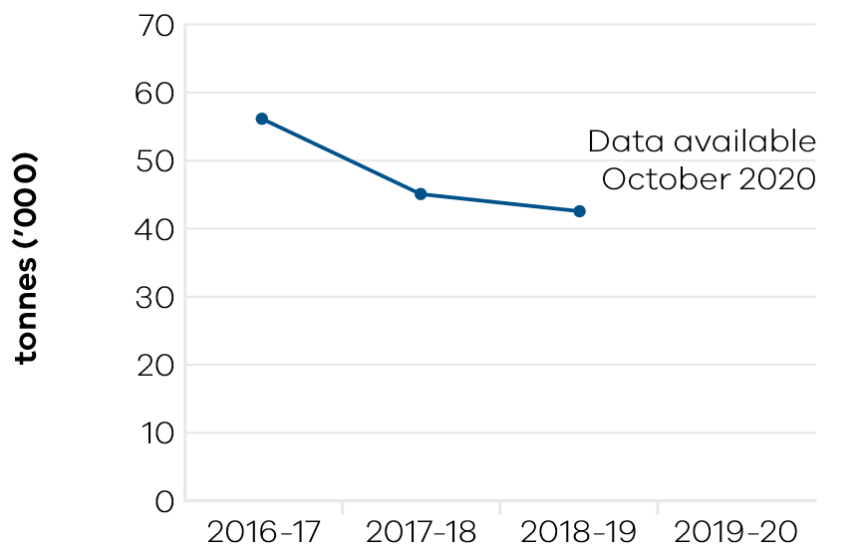

Figure 25: Annual production of gold
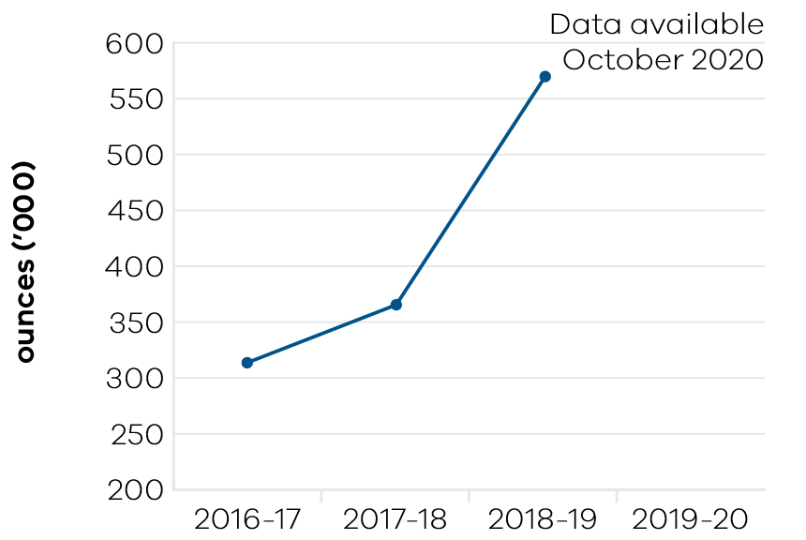

Figure 26: Annual production of antimony
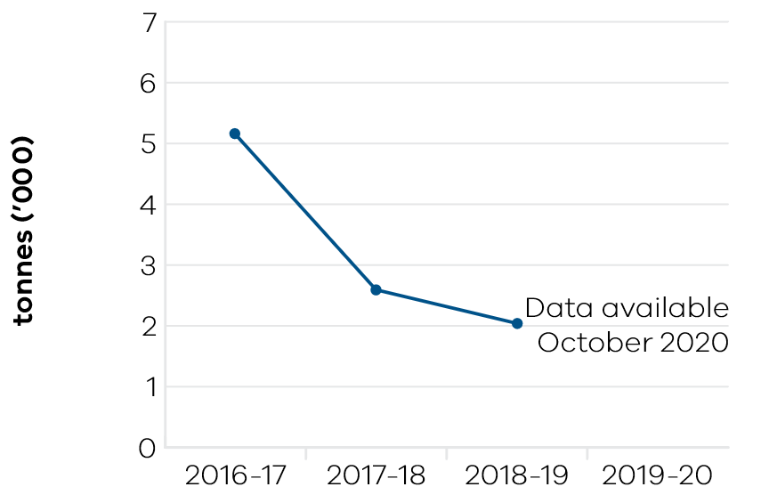

Figure 27: Annual production of mineral sands
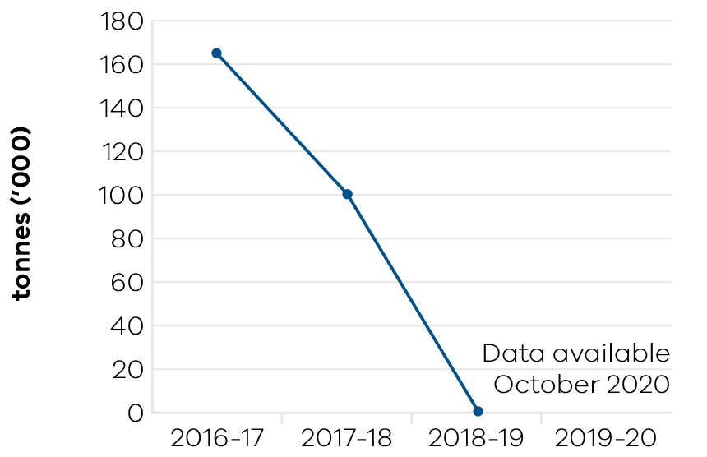

Figure 28: Annual production of extractives
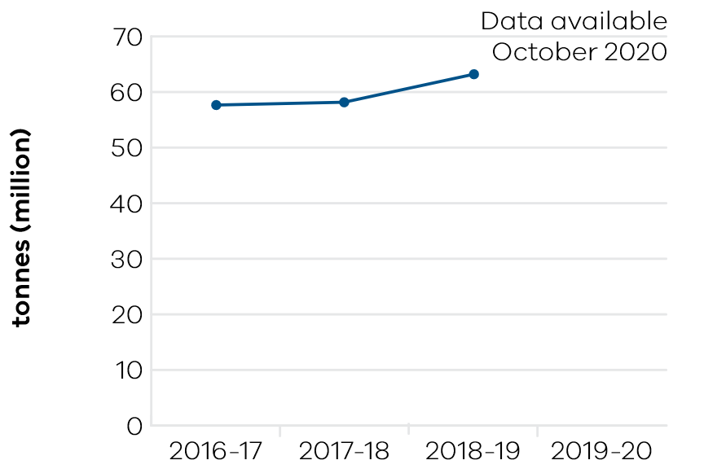
Gold production in Victoria continues to grow with an increase of almost 56 per cent in 2018–19 compared to 2017–18. As highlighted above, this is being driven by successful exploration and growing reserve levels at the Fosterville gold mine in central Victoria (Kirkland, the mine operator, has reported an increase in production for the June 2020 half-year production of 17 per cent compared to the previous half-year period). Production of extractives (sand, stone and gravel) in 2018–19 was 62.72 million tonnes, representing an increase of eight per cent from 2016–17. Production of extractives is forecast to grow significantly over coming years to support Victoria’s significant infrastructure program covering major construction and transport initiatives.
Brown coal production at 42.256 million tonnes in 2018–19 was six per cent lower than 2017–18 reflecting reduced production levels for the Loy Yang and Yallourn coal mines. The level of mineral sands production was nil, reflecting the completion of key projects in western Victoria. The potential for new mineral sands projects for the Murray and Gippsland Basins is significant. The Fingerboards Mineral Sands Project in the Glenaladale deposit, about 20km northwest of Bairnsdale in East Gippsland, Victoria, is currently progressing through the Environment Effects Statement process. The project has the potential to be a major producer of zircon, ilmenite, rutile and rare earths. This project may create 200 direct jobs over the 15 to 20-year life of the project.

Performance against output performance measures
Table 28 represents performance against the Agriculture output. This output delivers services to the agriculture, food and fibre sectors to enhance productivity, connect the sector with international markets, create jobs, support growth and maintain effective biosecurity.
This output delivers effective and efficient regulation, compliance, emergency management, biosecurity research and development, and diagnostic services to protect and enhance market access by addressing trade barriers and managing the risks of pests, diseases and chemical use. The department undertakes research and development to develop new technologies and practices and provides services to enhance their adoption to increase farm productivity and supply chain efficiencies. It provides policy advice and support to industries and businesses to innovate, manage economic and climatic volatility, natural disasters and biosecurity emergencies, and meet consumer and community expectations for food quality, food safety and animal welfare and environmental standards.
The output also creates the conditions to grow the natural resources economy by ensuring forestry and game resources are sustainably allocated and used for both recreational and commercial purposes.

Table 28: Output – Agriculture
Performance measures | Unit of measure | 2019–20 actual | 2019–20 target | Performance variation (%) | Result
Agriculture Industry Development and Regulation
This sub-output supports a more productive, competitive, sustainable and jobs-rich food and fibre sector by delivering policy advice, regulation and support to meet consumer and community expectations for agriculture industry development, pets and animal welfare, regulatory policies and frameworks.
Quantity
Farms and related small businesses facing significant adjustment pressures supported to make better-informed decisions by the Rural Financial Counselling Service | number | 1900 | 1700 | 11.8% | ü
Higher result due to additional funding provided by both the Victorian and Commonwealth governments in response to increased demand for rural financial counselling support due to drought, bushfires and coronavirus (COVID-19).
Inspections or audits of scientific establishments undertaken to provide assurance of compliance with relevant industry standards for animal welfare | number | 20 | 25 | -20.0% | n
Lower result due to the impacts of coronavirus (COVID-19) reflecting the inability to undertake physical inspections and audits due to social distancing measures to minimise risks to DJPR or facility animal care staff. These are largely regulatory assessments of practices and processes and do not have a direct/immediate impact on animal welfare. Any animal welfare issues identified or reported will be handled through usual processes.
Number of workshops / mentoring programs | number | 66 | 50 | 32.0% | ü
Higher result due to the impacts of coronavirus (COVID-19) reflecting a change in the delivery mechanism and higher demand due to business challenges created by coronavirus (COVID-19) restrictions. Online workshops were more accessible for attendees resulting in more registrations than expected than under the preferred traditional face to face delivery model.
Scholarships awarded | number | 13 | 12 | 8.3% | ü
Higher result due to additional budget reallocated to the program to support 13 recommended recipients for the 2019 Young Farmer Scholarships program.
Strategic agriculture industry development  and regulatory policy briefings | number | 8 | 8 | 0.0% | ü
Visits of the Responsible Pet Ownership program  to Victorian kindergartens and primary schools | number | 1076 | 3100 | -65.3% | n
Lower result is due to the impact of coronavirus (COVID-19) and the program moving to online delivery.
Quality
Grant recipients who met or exceeded agreed outcomes | per cent | 75 | 75 | 0.0% | ü
Timeliness
Performance and grant agreements acquitted within timeframes specified in the funding agreement | per cent | 90 | 90 | 0.0% | ü
Cost
Total output cost | $ million | 217.2 | 171.5 | 27.0% | n
The 2019–20 result was higher than budget primarily due to the accounting treatment of Royal Melbourne Showgrounds Redevelopment contractual obligations and additional funding for Drought Response.
Agriculture Research
This sub-output supports more productive, competitive, sustainable and jobs-rich food and fibre sectors by delivering research and innovation to develop innovative new technologies and farming systems that increase food and fibre productivity and product quality.
Quantity
Applications for intellectual property protection | number | 17 | 16 | 6.3% | ü
Higher result due to an additional application proceeding to acceptance quicker than expected due to no objections raised by IP Australia.
Commercial technology licence agreements finalised | number | 16 | 16 | 0.0% | ü
Genetic improvement of dairy cows achieved through breeding contributing to increased milk production and dairy productivity | per cent | 1 | 1 | 0.0% | ü
Key bioscience platform technologies established | number | 1 | 1 | 0.0% | ü
Postgraduate-level/PhD students in training | number | 68 | 65 | 4.6% | ü
Value of co-investment from external (non-state) funding sources attracted to the Department’s research projects that support productive agriculture | $ million | 39.3 | 39 | 0.8% | ü
Quality
Satisfaction rating of industry investors in agriculture productivity research and development | number | 9 | 7 | 28.6% | ü
Higher result is due to the continued success of the new partnership model where research is jointly designed, delivered and evaluated through a direct engagement and long-term partnership model with industry.
Scientific and technical publications subjected to independent peer review in international and national journals that promote productive agriculture | number | 274 | 260 | 5.4% | ü
Higher result due to a focus on publication preparation under the coronavirus (COVID-19) workplace restrictions. The focus on publication preparation will continue in 2020–21 while restrictions, including the inability to travel, continue. This will be a targeted short term approach. Upon return to work practices existing publication targets will apply.
Timeliness
Provision of technical advice, diagnostic identification tests on pests and diseases including suspected exotics within agreed timeframes | per cent | 87 | 85 | 2.4% | ü
Research project milestones and reports completed  on time | per cent | 91.7 | 90 | 1.9% | ü
Cost
Total output cost | $ million | 145.7 | 142.9 | 2.0% | ™
Biosecurity and Agriculture Services
This sub-output delivers biosecurity, agriculture and emergency management services and regulatory programs which support the food and fibre sector to achieve sustainable growth while managing risks and minimising adverse impacts to the economy, environment and public health and safety.
Quantity
Animal pest, disease and residue control programs maintained to ensure Victorian agricultural produce complies with food safety and biosecurity standards required to access markets | number | 5 | 5 | 0.0% | ü
Clients engaged with agriculture services | number | 4966 | 4300 | 15.5% | ü
Higher result due to increased uptake of demand-driven services associated with drought, dry seasonal conditions and bushfire recovery.
Improved agricultural services, program and products developed | number | 10 | 10 | 0.0% | ü
Known state prohibited weed sites monitored and treated in line with the relevant weed action plan | per cent | 91 | 95 | -4.2% | ™
New or amended Interstate Certificate Assurance (ICA) or other market access accreditations developed to restore or enable trade | number | 8 | 2 | 300.0% | ü
Higher result is due to a number of factors not directly influenced by the department. These external factors include changes to requirements of other jurisdictions, national policy, industry demand, and the response to new pests and/or diseases.
Plant pest, disease and residue control programs maintained to ensure Victorian agricultural produce complies with food safety and biosecurity standards required to access markets | number | 6 | 6 | 0.0% | ü
Properties inspected for invasive plant and animal  priority species | number | 2794 | 2700 | 3.5% | ü
Quality
Client satisfaction rating of agricultural services | number | 8.4 | 8 | 5.0% | ü
Higher result is due to greater emphasis on the design and delivery of client-focussed services.
National biosecurity, agriculture/veterinary chemical use and animal welfare programs implemented in accordance with agreed plans | per cent | 100 | 95 | 5.3% | ü
Higher result is due to Victoria responding to all requests associated with national work programs (National Management Group, National Biosecurity Committee, Agriculture Ministers meeting, Agriculture Secretaries Committee). Key contributions were made to development of the Aquatic Animal Health Deed, National Browsing ant Eradication Program, Lens snail, National Tropical Weed Eradication, Red Imported Fire Ant, Citrus Canker, Fruit Fly and Traceability.
Preparedness activities implemented, in line with agreed plans, to ensure response readiness for emergency animal and plant pest, disease and natural disaster incidents. | per cent | 90 | 90 | 0.0% | ü
Timeliness
Animal and plant certificates issued within specified timeframes to support domestic and international market access. | per cent | 93 | 95 | -2.1% | ™
Initial action taken to respond to reported emergency animal and plant pest, disease and natural disaster incidents complies with national agreements and obligations | per cent | 100 | 100 | 0.0% | ü
Cost
Total output cost | $ million | 125.1 | 114.3 | 9.0% | n
The 2019–20 result was higher than budget primarily due to additional funding for Drought Response and National Biosecurity Control Agreements.
Sustainably manage forest and game resources
This sub-output creates the conditions to grow the natural resources economy by ensuring forestry and game resources are sustainably allocated and used for both recreational and commercial purposes.
Quality
Key statutory obligations relevant to the Game Management Authority complied with (tabling annual report, audits, business plan and board appointments) | per cent | 100 | 100 | 0.0% | ü
Key statutory obligations relevant to VicForests complied with (tabling annual reports, audits, corporate plan and board appointments) | per cent | 75 | 100 | -25.0% | n
Lower result due to a delay with VicForests providing its corporate plan to the Minister and the Treasurer.
Cost
Total output cost | $ million | 73.2 | 42.3 | 73.0% | n
The 2019–20 result was higher than the target primarily due to additional funding for the Victorian Forestry Plan.
Note:
ü Performance target achieved or exceeded
™ Performance target not achieved – within 5 per cent variance
n Performance target not achieved – exceeds 5 per cent variance
Table 29 represents performance against the Resources output. This output develops and delivers policy, programs and regulation to enable investment and generate jobs through the sustainable development of the state’s earth resources, including extractives, minerals and petroleum.
The department acquires and provides access to high-quality geoscience data and knowledge to inform government decision making and attract new investment and jobs to the state. It develops and implements legislative and regulatory reforms in the earth resources sector to improve outcomes for all stakeholders.
Supporting investment in resources and low emission technologies, the department fosters innovation, productivity, jobs and trade in the state’s earth resources sector. Through strategic resource and related land use planning, new opportunities are able to be identified for Victoria’s earth resources, along with supporting major infrastructure development in the State.
The department also regulates the earth resources sector through transparent, consistent and timely regulatory processes that provide industry with confidence to invest and have regard to the needs of communities and minimise impacts to the environment.

Table 29: Output – Resources
Performance measures | Unit of measure | 2019–20 actual | 2019–20 target | Performance variation (%) | Result
Quantity
Community and stakeholder engagement  information forums | number | 55 | 55 | 0.0% | ü
Quality
Exploration and mining licences which are active | per cent | 79.1 | 82.5 | -4.1% | ™
Timeliness
Delivery of key CarbonNet milestones, in line with funding agreements and agreed project deliverables | per cent | 100 | 100 | 0.0% | ü
Delivery of key milestones consistent with agreed timelines for the Victorian Gas Program | per cent | 100 | 100 | 0.0% | ü
Extractive Industries Work Authority work plans processed within regulatory timeframes | per cent | 96.2 | 95 | 1.3% | ü
Facilitate the delivery of resources projects in line with grant agreements and project milestones. | per cent | 90.8 | 100 | -9.2% | n
Lower result due to rescheduling of key activities arising from the impact of the coronavirus (COVID-19) pandemic.
Industry geoscience data packages released for minerals and petroleum sectors consistent with agreed timelines | number | 10 | 10 | 0.0% | ü
Mineral licence applications and work plans processed within regulatory timeframes | per cent | 82 | 95 | -13.7% | n
Lower result due to a significant increase in applications due to record levels of industry activity; and disruptions arising from the coronavirus (COVID-19) pandemic.
Regulatory audits completed within agreed timelines | per cent | 72.5 | 98 | -26.0% | n
Lower result due to constraints on compliance activities reflecting coronavirus (COVID-19) restrictions.
Cost
Total output cost | $ million | 115.1 | 122.6 | -6.0% | ü
The 2019–20 result was lower than budget due to scheduling changes for key work programs including CarbonNet.
Note:
ü Performance target achieved or exceeded
™ Performance target not achieved – within 5 per cent variance
n Performance target not achieved – exceeds 5 per cent variance

Previously named Geelong Performing Arts Centre.

