Department of Jobs, Precincts and Regions

Annual Report 2020-2021

Non-financial performance
Table of Contents
Portfolio performance reporting – non-financial 2
Objective 1: Create and maintain jobs 2
Progress towards achieving this objective 2
Objective Indicators 2
Outputs 2
Objective 2: Foster a competitive business environment 6
Progress towards achieving this objective 6
Objective Indicators 7
Outputs 7
Objective 3: Be a globally connected economy 12
Progress towards achieving this objective 12
Outputs 12
Objective 4: Build prosperous and liveable regions and precincts 16
Progress towards achieving this objective 16
Performance against output performance measures 21
Objective 5: Grow vibrant, active and creative communities 25
Progress towards achieving this objective 26
Objective 6: Promote productive and sustainably used natural resources 47
Progress towards achieving this objective 47

Portfolio performance reporting – non-financial
As at 30 June 2021, DJPR had 172 non-cost output performance measures, published in the 2020–21 Budget Papers.
The department met or exceeded 70 per cent (121 measures) of the 2020–21 output performance measure targets. Predominantly due to the impacts of COVID-19, 30 per cent (51 measures) of performance measures did not meet their targets. Approximately 80 per cent of these measures relied on physical/social interactions and travel or were impacted by diverted resources to recovery efforts.
For those performance measures which were not significantly affected, mitigation strategies included increased use of online presence to continue activities or services where feasible. In addition, increased support provided to businesses and industry in response to these events resulted in some measures exceeding their targets.
The portfolio performance reporting – non-financial section includes the:
- Report on progress towards achieving objectives, incorporating key initiatives and projects
- Report on performance against output performance measures.

Objective 1: Create and maintain jobs
This objective seeks to secure a growing, sustainable and equitable jobs market for all Victorians by working with businesses to increase job opportunities, support people into meaningful employment, and attract the investment and
talent needed to foster job growth.

Progress towards achieving this objective
In 2020–21, the department reported progress against this objective using the following objective indicators and outputs:

Objective Indicators
- People employed in Victoria

Outputs
- Jobs

Indicator: People employed in Victoria

Table 1: People employed in Victoria
Measure (unit of measure) | 2017–18 | 2018–19 | 2019–20 | 2020–21
Number of people employed in Victoria* (number) | 3,242,600 | 3,352,000 | 3,391,600 | 3,355,900
*Source: FY 12 month average – ABS 6202 Victoria Employed Total Persons (Seasonally adjusted)

Figure 1: Number of people employed in Victoria
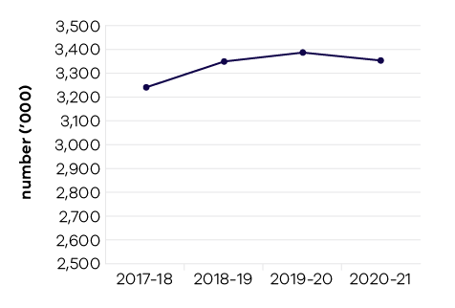
In 2020–21, the department contributed to the government’s investment attraction and assistance function by facilitating private sector investment outcomes and monitoring the health of Victoria’s key companies and employers. The department assisted 39 firms to invest in industry growth projects that will result in capital expenditure of over $1.6 billion and create nearly 3000 new jobs in Victoria. These projects will stimulate growth across a wide range of industry sectors, including medical technologies and pharmaceuticals, food manufacturing, defence and other advanced manufacturing, as well professional services, logistics and distribution.
In response to legislation strengthening the Local Jobs First Act 2003, passed in August 2018, the department implemented the Local Jobs First Policy. This policy comprises the Victorian Industry Participation Policy and the Major Project Skills Guarantee (MPSG). It supports Victorian businesses and workers by ensuring that small and medium sized enterprises (SMEs) are given a full and fair opportunity to compete for government contracts.
The Local Jobs First Act 2003 also established a Local Jobs First Commissioner. The Commissioner provides advocacy, facilitation and compliance functions, and works closely with industry and government departments to create opportunities
for SMEs, workers, apprentices, trainees and cadets.
Since December 2014 to June 2021, the government has set local content requirements under the Local Jobs First Policy for 198 Strategic Projects, with a combined total value of over $97.6 billion and supporting 40,000 local jobs. Since its introduction, the MPSG has been applied to 185 projects worth over $60.6 billion. In the 12 months to March 2021, commitments to provide work for apprentices, trainees and cadets under the MPSG have grown by 1.74 million hours, while 1.83 million hours were worked in the period. The department has formal reporting obligations in relation to the Local Jobs First Policy which are available in Appendix 6.
In 2020–21, the department delivered the assessment of over 1200 overseas qualifications. This assists overseas-qualified professionals to gain employment in the Victorian labour market and fills skill gaps for employers via the Skilled
and Business Migration Program. The department also nominated 600 business and investor migrants, and over 1600 skilled migrants to live, work and undertake business activity in Victoria, which included more than 200 in regional Victoria. Of the 1600 nominated skilled migrants, nearly 1300 are medical professionals, and many are working in COVID-19 critical care and on the vaccine rollout.

Jobs Victoria
Since October 2016, Jobs Victoria has supported more than 16,100 Victorians into a job through its services, most of whom were long-term unemployed or at risk of long-term unemployment. The Victorian Government’s record investment in employment services in the 2020–21 budget is seeing Jobs Victoria expand and scale up capacity to support more people into work. Through Jobs Victoria, the government is delivering an integrated suite of effective and personalised employment services that operate in all parts of Victoria – a step change to address labour market challenges and support
a full social and economic recovery to the COVID-19 pandemic.
In 2020–21, Jobs Victoria also played an important role in responding to impacts of the COVID-19 pandemic by delivering the $500 million Working for Victoria Fund. During the emergency response phase of the pandemic, Working for Victoria partnered with local governments, community service organisations and businesses to create time-limited jobs to help unemployed people, including those who lost their jobs due to the pandemic. Working for Victoria placed more than 13,500 people into jobs, providing them with an income at a very challenging time while delivering a long-lasting community benefit.

Performance against output performance measures
Table 2 represents performance against the Jobs output. This output includes initiatives to support existing workers and businesses by connecting Victorians experiencing disadvantage to job opportunities, supporting Aboriginal economic inclusion, working with the community to create and support social enterprises; as well as attracting new investment and talent into Victoria to grow the economy and share the benefits of economic prosperity.

Table 2: Output – Jobs
Performance measures | Unit of measure | 2020–21 actual | 2020–21 target | Performance variation (%) | Result
Quantity
Disadvantaged jobseekers who achieve sustainable employment (minimum number of 26 weeks) | number | 8,314 | 6,069 | 37.0% | *
Higher result because the Jobs Victoria Employment Network and the Working for Victoria initiative achieved strong results and supported more people into jobs.
Government Youth Employment Scheme traineeships commenced | number | 244 | 280 | -12.9% | #
Lower result due to impacts of COVID-19 on the program. Young people were also supported into jobs through Working for Victoria Youth Employment Program.
Jobseekers supported into work who sustain employment for at least 26 weeks | per cent | 50 | 45 | 11.1% | *
Higher result reflects the strong performance of the Jobs Victoria Employment Network
Jobseekers supported through Jobs Victoria services (mentors and advocates) | number | 31,544 | 34,000 | -7.2% | #
Lower result because the expanded suite of Jobs Victoria services announced in November 2020 was in the process of scaling up in the first part of 2021.
Jobseekers who gain employment with the support  of Jobs Victoria | number | 2,117 | 11,200 | -81.1% | #
Lower result because the expanded suite of Jobs Victoria services announced in November 2020 was in the process of scaling up in the first part of 2021. Over this period the number of people placed into work through Working for Victoria exceeded targets.
Number of jobs created through Working for Victoria | number | 12,512 | 10,000 | 25.1% | *
Higher result because the Working for Victoria initiative exceeded outcomes and supported more people into jobs than was expected.
Number of jobseekers placed into jobs through  Working for Victoria | number | 13,603 | 7,500 | 81.4% | *
Higher result because the Working for Victoria initiative exceeded outcomes and supported more people into jobs than was expected.
Retrenched workers supported with employment assistance | number | 598 | 2,000 | -70.1% | #
Lower result due to impacts of COVID-19 on the program.
Social enterprises assisted | number | 399 | 150 | 166.0% | *
Higher result due to the increased provision and uptake of learning and development supports, and support to social enterprises under the Working for Victoria initiative.
Subsidised jobs for Victorians at risk of long-term unemployment | number | 2,387 | 4,000 | -40.3% | #
Lower result because the expanded suite of Jobs Victoria services announced in November 2020 was in the process of scaling up in the first part of 2021.
Firms assisted from industry growth programs | number | 39 | 25 | 56.0% | *
Higher result due to accelerated assistance to companies due to government’s response to COVID-19 and economic recovery stimulus.
Industry stakeholders engaged with the Local Jobs  First Policy | number | 1,456 | 500 | 191.2% | *
Higher result due to accelerated assistance to companies due to government's response to COVID-19 and economic recovery stimulus.
Jobs created from industry growth programs | number | 2,282 | 1,000 | 128.2% | *
Higher result due to higher amount of funding available to secure investment in 2020–21. Jobs are counted in the year the contract is secured, though will be delivered over the life of the grant (generally two to five years).
Victoria’s market share of nominated investor  and business migrants | per cent | 13.5 | 45 | -70.0% | #
Lower result is due to a range of factors, including the number of business and investor migration places allocated to Victoria by the Commonwealth and a program focus on attracting high-quality skilled, business and investor talent who can support innovation and job creation in strategic sectors. The ‘Victoria’s market share of nominated investor and business migrants’ performance measure has been discontinued and replaced by the 2021–22 performance measure ‘Migrant talent nominated for the Skilled, Investor and Business Migration Program’ to better reflect the Victorian Government’s performance in nominating talent to migrate to Victoria.
Quality
Client satisfaction with investor, business and skilled migration services provided | per cent | 88 | 85 | 3.5% | *
Timeliness
Average processing time for investor, business and skilled migration visa nomination applications | days | 16.2 | 20 | 19.0% | *
This measure is considered met if the actual is below the target, and the measure requires applications to be processed within 20 business days. The department was required to deliver a full year program in only six months as the Commonwealth Government provided final state allocations in December 2020. Applications were processed more quickly as more resources were dedicated to assessment of applications.
Cost
Total output cost | $ million | 2,874.9 | 2,897.5 | -0.8% | *
Note:
* Performance target achieved or exceeded
- Performance target not achieved – within 5 per cent variance
# Performance target not achieved – exceeds 5 per cent variance

Objective 2: Foster a competitive business environment
This objective seeks to grow Victorian industries and businesses by working with priority industry sectors, supporting growth and innovation opportunities for industry, supporting startups and small businesses, and assisting industries in transition.

Progress towards achieving this objective
In 2020–21, the department reported progress against this objective using the following objective indicators and outputs:

Objective Indicators
- Change in Victoria’s real gross state product
- Engagement with businesses

Outputs
- Industry, Innovation, Medical Research and Small Business
  - Industry, Innovation and Small Business
  - Medical Research

Indicator: Change in Victoria’s real gross state product

Table 3: Change in Victoria’s real gross state product
Measure (unit of measure) | 2017–18 | 2018–19 | 2019–20 | 2020–21
Change in Victoria’s real gross state product  (per cent) | 3.5 | 3.0 | -0.5 | Data available November 2021

Figure 2: Change in Victoria’s real gross state product
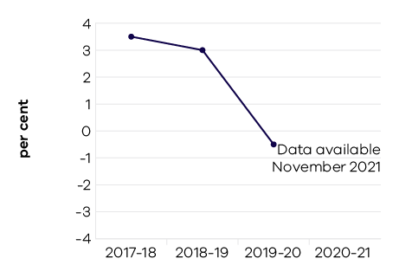
Following steady growth over the past decade, Victoria’s real gross state product (GSP) fell by 0.5 per cent in 2019–20 as economic activity was impacted by the COVID-19 pandemic related restrictions and containment measures.

Indicator: Engagement with businesses

Table 4: Engagement with business
Measure (unit of measure) | 2017–18 | 2018–19 | 2019–20 | 2020–21
Engagements with businesses (number) | 14,401 | 14,630 | 12,344 | 14,772

Figure 3: Engagements with businesses
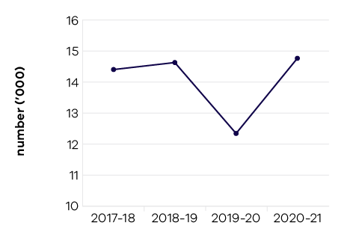
In 2020–21, the department recorded over 14,000 engagements with businesses through meetings, phone calls, and involvement in non-COVID-19 related business assistance programs. These engagements reflect a range of activities and services across the department. It includes small businesses to large employers across metropolitan and regional Victoria, in areas such as investment, trade, employment and skills, agriculture and biosecurity, digital and ICT, earth resources
and tourism.
It should be noted that the high volume of business and industry engagement due to COVID-19 is not reflected in the above measure and does not have a specific performance measure. This is due to the one-off nature of the funded programs and resourcing that were specifically directed towards supporting businesses and industries impacted by restricted operations during this period.
The Better Approvals Project was a partnership between the department and local councils to make it easier to do business in Victoria, by streamlining and creating a more customer-friendly approach to permit applications. Following engagement with 61 of the 79 Victorian councils, in 2020–21 the department engaged the remaining 18 councils, resulting in a significant reduction in permit approval times for small businesses.
Reforms to the Fair Payment Policy were also delivered, committing all Victorian Government departments and applicable agencies to pay small business invoices under $3 million within ten business days.
Small Business Victoria has continued to deliver information, training, mentoring and other support, such as bushfire recovery and mental health and well-being. The Business Victoria website and the subscribed newsletter have been instrumental in providing accurate and timely information to Victorian businesses.
The Technology Adoption and Innovation Program was launched to help Victorian SMEs onboard or develop innovative, commercial technologies. The program supported 134 applications for a total of $6.1 million in funding across a broad range
of industry sectors and applications.
For LaunchVic, the 2020–21 reporting year saw 127 companies, 2866 entrepreneurs and aspiring entrepreneurs, and 185 investors supported through activities to build a robust investor and startup community. LaunchVic established the Alice Anderson Fund, a $10 million sidecar fund that will co-invest in women-led startups in Victoria to improve access to capital.
The department supported over 300 digital tech events and engaged in the order of 60,000 people as part of Victoria’s annual Digital Innovation Festival. Other events and conferences supported by the department further stimulated the digital economy: such as Connecting Up Conference, Digital Creators Pilot Program, Australian Technologies Competition, AFR Innovation Summit, ACS Industry Development and engagement events, RoboCup, Municipal Association of Victoria Technology National Conference, the inaugural Women in AI Awards, and the GirledWorld WOW Summit.
Broadly, the department has also supported fostering a competitive business environment by improving digital connectivity across the state. This includes launching the Morwell Enhanced Broadband network and the free public Wi-Fi network in Shepparton, as well as delivering 27 new mobile base stations in 2020–21.
The demand for workers with digital skills in Victoria is strong and growing. The Victorian Government’s new Digital Jobs program aims to build the state’s digital workforce by training and reskilling mid-career Victorians so they can transition into digital careers. The program provides Victorian businesses with an opportunity to build their digital capability in a cost-effective way; backing businesses to thrive in a digital world, by finding great people with digital skills for digital jobs.

Performance against output performance measures
Table 5 represents performance against the Industry, Innovation, Medical Research and Small Business output. This output provides access to information and connections and builds the capability of Victorian businesses and industry to develop and effectively use new practices and technologies to increase productivity and competitiveness. Through this output, advocacy for a fair and competitive business environment and support for small business is also provided.

Table 5: Output – Industry, Innovation, Medical Research and Small Business
Performance measures | Unit of measure | 2020–21 actual | 2020–21 target | Performance variation (%) | Result
Industry, Innovation and Small Business
This sub-output supports Victorian businesses, from global enterprises to small, medium and start up businesses,
to grow, create more job opportunities, lead innovation, promote digital connectivity and develop strategic industries. This is achieved by facilitating new investments, investing in digital connectivity, developing and attracting world class talent, enhancing industry capability to build on the State’s reputation for innovation and encouraging a competitive and fair business environment and a strong, diversified economy.
Quantity
Businesses whose growth and productivity issues  are resolved by the Department | number | 2,263 | 1,200 | 88.6% | *
Higher result due to an increased number of companies receiving payments through programs that support growth and productivity.
Companies or new entrants supported through  the LaunchVic initiative | number | 127 | 127 | 0.0% | *
Engagements with businesses | number | 15,481 | 14,000 | 10.6% | *
Higher result due to meetings and phone calls relating to engagement occurring to support businesses during COVID-19. Opportunities created for COVID-19 related funding programs are excluded from the figures.
Individuals supported under digital skills initiatives | number | 573 | 500 | 14.6% | *
Higher result due to a higher number of enrolments in training courses. The figure excludes a proportion of participants who dropped out and those who deferred their offer to a later round of the program.
Industry roundtables and engagement forums | number | 520 | 25 | 1980.0% | *
Higher result due to the high volume of industry roundtables and engagement forums that were facilitated by the department as a result of COVID-19. Regular roundtables were convened to ensure key stakeholders and sector leads were consulted and briefed on the changing/easing of COVID-19 related restrictions. There also continued to be a high number of roundtables/engagement forums not related to COVID-19 that pivoted to be virtual and so were able to continue as in previous years.
New mobile base stations facilitated | number | 27 | 45 | -40.0% | #
Lower result due to the Commonwealth Government’s decisions regarding timing and quantum of funding awarded through their Mobile Black Spots Program, as well as delay in the rollout of the mobile towers managed by the mobile carriers. This delay is due to factors including COVID-19 impacts. It is expected that contracted new mobile base stations not completed in 2020–21 will be able to be completed in 2021–22.
Participation in Small Business Victoria targeted  and inclusive events and business programs | number | 27,014 | 30,000 | -10.0% | #
Lower result due to access impediments caused by COVID-19 restrictions, particularly in the first half of 2020–21.
Visits to Business Victoria digital channels | number | 11,939,871 | 3,000,000 | 298.0% | *
Higher result due to increased traffic which can be attributed to people accessing Business Support Fund grants, the Regional Travel Voucher Scheme, COVID-19 support programs and information on changes in business restrictions due to COVID-19. Traffic is expected to return to lower business as usual levels in 2021–22.
Quality
Client satisfaction of small business information, referral, mentoring service and business programs | per cent | 95.3 | 90 | 5.9% | *
Higher result due to significantly higher than expected results reported under the Business Recovery and Resilience Mentoring program. Mentee Satisfaction under this program reported 97.1 per cent were ‘satisfied’ to ‘very satisfied’ with the mentoring received, and found mentors’ insights and practical advice for their business to be very helpful in building confidence, solving business problems and overcoming obstacles.
Client satisfaction with the Victorian Government Business Offices | per cent | 76.4 | 80 | -4.5% | –
Client satisfaction with Victorian Small Business Commission mediation service | per cent | 81.2 | 85 | -4.5% | –
Proportion of business disputes presented to the Victorian Small Business Commission successfully mediated | per cent | 77 | 75 | 2.7% | *
Proportion of business disputes resolved by the Victorian Small Business Commission prior to mediation | per cent | 38.1 | 30 | 27.0% | *
Higher result due to increase in demand for dispute resolution services provided by the Victorian Small Business Commission. Many disputes involved claims for rent relief by tenants, landlords, licensees and licensors affected by the COVID-19 pandemic. Parties appeared motivated to settle “early” to avoid the matter escalating to a potentially drawn out tribunal/court process. Resolutions were facilitated by a bespoke team of Dispute Resolution Officers and the Commercial Tenancy Relief Scheme framework.
Cost
Total output cost | $ million | 995 | 409.4 | 143.0% | #
The 2020–21 result was higher than the 2020–21 budget mainly due to additional funding through the Circuit Breaker Support Package, release of central funding for the Victoria’s Digital Future Now initiative and the realignment of programs within the Business Support initiative from the Jobs output to the Industry, Innovation, Medical Research and Small Business output during 2020–21.
Medical Research
This sub-output supports maintaining Victoria’s position as a leader in health and medical research, while protecting and growing jobs in the sector by funding visionary research through providing critical infrastructure to flagship projects and research institutes and strengthening commercialisation.
Quantity
Operational infrastructure supports grants under management | number | 12 | 12 | 0.0% | *
Cost
Total output cost | $ million | 109.2 | 98.4 | 11.0% | #
The 2020–21 result was higher than the 2020–21 budget mainly due to the transfer of responsibilities for the Melbourne Genomics Health Alliance and Respiratory challenge trials into the output and additional funding for the Supporting Medical Research to Protect Victorians and Grow Jobs for the Future initiative.
Note:
* Performance target achieved or exceeded
– Performance target not achieved – within 5 per cent variance
# Performance target not achieved – exceeds 5 per cent variance

Objective 3: Be a globally connected economy
This objective seeks to connect Victoria to the world by helping Victorian businesses successfully trade into global markets, and growing Victoria’s proportion of international student enrolments in Australia.

Progress towards achieving this objective
In 2020–21, the department reported progress against this objective using the following objective indicators and outputs:

Objective Indicators
- Export sales generated from government programs
- Victoria’s share of international student enrolments.

Outputs
- Trade and Global Engagement

Indicator: Export sales generated from government programs

Table 6: Export sales generated from government programs
Measure (unit of measure) | 2017–18 | 2018–19 | 2019–20 | 2020–21
Actual export sales generated as a result of participation in government programs ($ million) | 807 | 668 | 709 | 569

Figure 4: Export sales generated from government programs
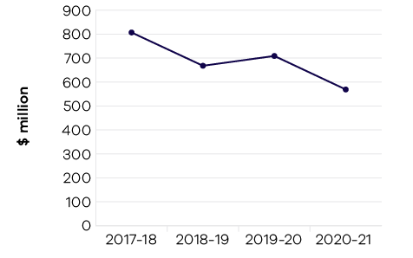
Victorian Government programs resulted in $3.8 billion of actual export sales over the six-year period from 2015–16 to 2020–21. In 2020–21 the department supported $569 million of actual export sales. This result was driven by a refreshed and updated suite of programs delivered to support Victorian companies to remain engaged and connected to overseas markets and international business opportunities whilst border restrictions were in place and physical travel was limited.
The suite of initiatives also focused on supporting the development of core export capabilities to ensure businesses were appropriately skilled to continue undertaking international business in a constrained operating environment.
In response to the COVID-19 pandemic, the Victorian Government announced a $15.7 million Export Recovery Package to address logistics and supply chain issues and establish new export channels.
The package of programs included:
- The Global Gateway Program – to support high performing Victorian exporters to stabilise and adapt to recovery
- A dedicated virtual trade mission program – for local businesses to re-introduce Victorian products and services to the fastest and strongest recovering international markets
- eCommerce initiatives – to increase the profile and sales of Victorian products through key eCommerce channels
- Freight Stabilisation initiatives – for exporters of high-value Victorian goods to address their logistics and supply chain issues.
The department experienced strong demand and uptake for export programs delivered during 2020–21 that was significantly buoyed by Export Recovery Package funding. Export programs delivered by the department with staff based in Melbourne and throughout the 23 Victorian Government Trade and Investment network offices provided tailored support to assist firms to realise and capture export sales. Over 3170 Victorian businesses participated in export programs, and over 1260 international delegates were involved in virtual missions and other key initiatives.
In 2021–22, with COVID-19 still presenting significant impediments on international business activities, the department will continue to deliver a suite of programs and services that assist Victorian businesses to remain engaged in key export markets. The department will work closely with key partner organisations to extend business outreach to facilitate and deliver support for Victorian companies engaging in international trade.

Indicator: International students attracted to Victoria

Table 7: Victoria’s proportion of international student enrolments in Australia
Measure (unit of measure) | 2017–18 | 2018–19 | 2019–20 | 2020–21
Victoria’s proportion of all international student enrolments in Australia (per cent) | 31.7 | 32.1 | 32.3 | 32.2
Note: Financial year data on international student enrolments is not available. Figures in the table are calendar year data reflecting the academic year and capturing peaks and troughs of enrolment periods.

Figure 5: Victoria’s proportion of international student enrolments in Australia
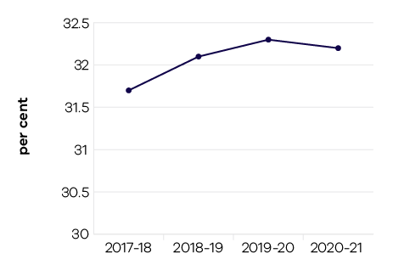
Victoria’s national market share of international students remained steady in 2020, at 32.2 per cent, down from 32.3 per cent in 2019 – the fourth consecutive year Victoria has held a 32 per cent market share. This result was built on significant growth from South Asian markets in recent years. It also reflects the broad impact of Australia’s closed international borders on all states and territories.
The impact of COVID-19 and prolonged international border closures on Victoria’s international education sector has been severe. While international education remained Victoria’s largest services export in 2020, education exports decreased by 23 per cent to $10.5 billion – down from a record high $13.7 billion in 2019. This has economy-wide ramifications given the sector’s critical role as a driver of future economic growth.
In 2020 the overall number of international students studying with Victorian providers (including student visa holders located offshore) declined by 9.8 per cent to around 226,000 students. This downward trend was even starker with international student commencements (enrolments beginning in a new sector, new course, or new provider) down 22.7 per cent to around 124,000. This major decline along with the diminishing student pipeline (graduating students not being replaced by new students) signals an impending and protracted period of significantly reduced enrolments.
In 2020–21 the government released its $33.4 million International Education Short-Term Recovery Plan, to stabilise Victoria’s international education sector and position it for recovery. This plan provided support for all segments of the international education sector and played to Victoria’s strengths – including being home to Australia’s best student city, a ranking retained despite the pandemic (QS Best Student Cities 2022).
Initiatives included a Pathway to Victoria scholarship and international research partnerships program to encourage prospective students to make Victoria their first choice. The Victorian Global Education Network was also expanded into the emerging high-growth markets of Vietnam, Brazil and Kenya, alongside investment in five new Study Melbourne Hubs located in strategic international markets – better supporting and connecting students studying online and offshore.
While expanding Study Melbourne’s global reach, the government continued its significant investment in Victoria’s onshore international student community. This included boosting Study Melbourne Student Centre services, providing critical support through referrals, complex casework, and emergency aid to around 4400 international students in need. The government also delivered its $45 million International Student Emergency Relief Fund, providing payments to more than 20,600 international students who experienced financial hardship in 2020–21 as a result of the COVID-19 pandemic.

Performance against output performance measures
Table 8 represents performance against the Trade and Global Engagement output. This output promotes business growth opportunities by connecting organisations to global business opportunities in priority markets and supporting the establishment and deepening of strategic commercial partnerships. It also positions Victoria as a destination of choice for international students.

Table 8: Output – Trade and Global Engagement
Performance measures | Unit of measure | 2020–21 actual | 2020–21 target | Performance variation (%) | Result
Quantity
Actual export sales generated as a result  of participation in government programs | $ million | 569 | 550 | 3.5% | *
Clients engaged in export and trade programs | number | 3,171 | 2,000 | 58.6% | *
Higher result due to stimulus funding from the Export Recovery Program, which enabled an increase in the number of trade engagement activities delivered by Global Victoria. Trade engagement activities have also been delivered digitally, enabling a larger cohort of businesses to participate.
International delegates participated in the virtual inbound trade mission and key initiatives | number | 1,267 | 1,000 | 26.7% | *
Higher result due to stimulus funding from the Export Recovery Program, which enabled an increase in the number of trade engagement activities delivered by Global Victoria.
Number of Victorian companies assisted  by Wine Industry initiatives | number | 60 | 60 | 0.0% | *
Significant interactions with Victorian agri-food companies and exporters, international customers  and trading partners that facilitate export and investment outcomes for Victoria | number | 258 | 250 | 3.2% | *
Victoria’s proportion of all international student enrolments in Australia | per cent | 32.2 | 30 | 7.3% | *
Higher result due to Victoria maintaining its national market share from previous years (which saw significant growth from South Asian markets), with closed international borders broadly impacting states and territories equally. Calendar year 2020 is the latest nationwide full year data available for 2020–21.
Visits to the Global Victoria website | number | 208,039 | 100,000 | 108.0% | *
Higher result due to stimulus funding from the Export Recovery Program, which enabled an increase in the number of trade engagement activities delivered by Global Victoria. Trade engagement activities have also been delivered digitally, enabling a larger cohort of businesses to participate. Significant interest in export stimulus funding and initiatives has resulted in a significantly higher visitation to the Global Victoria website.
Quality
Client satisfaction with export assistance offered | per cent | 90 | 90 | 0.0% | *
Cost
Total output cost | $ million | 99.6 | 106.1 | -6.1% | *
The 2020–21 result was lower than the 2020–21 budget mainly due to lower expenditure on International Education and Trade programs due to COVID-19.
Note:
* Performance target achieved or exceeded
– Performance target not achieved – within 5 per cent variance
# Performance target not achieved – exceeds 5 per cent variance

Objective 4: Build prosperous and liveable regions and precincts
This objective seeks to ensure that Victoria’s precincts, suburbs and regions are developed to create places where all Victorians have an opportunity to participate in communities that are well-connected, prosperous, vibrant and diverse.

Progress towards achieving this objective
In 2020–21, the department reported progress against this objective using the following objective indicators and outputs:

Objective Indicators
- Precincts developed and delivered
- Community satisfaction in public places
- Community satisfaction with the performance of councils as measured through the Local Government Community Satisfaction Survey

Outputs
- Business Precincts
- Local Government and Suburban Development
- Regional Development

Indicator: Precincts developed and delivered
Through its whole of government oversight in Business Precincts, the portfolio has delivered on the identification of, planning for and development in key areas of opportunity. This has established a long-term focus on precincts and their importance to Victoria’s economic performance as well as the future liveability of our urban centres. Specific activities to develop and deliver business precincts are described below.

Footscray – Health, research and hospitality
The department has engaged with key stakeholders to plan for development of the precinct to leverage the Victorian Government’s unparalleled investment in education, health, sporting facilities and transport infrastructure in Footscray and Melbourne’s inner west.
Early works have commenced on the new Footscray Hospital Project which is being built on land in close proximity to the current hospital. The $1.5 billion dollar build is scheduled to be completed in 2025. Options to repurpose the old hospital site will be identified in the coming year.

Parkville – Biomedical and research
The department has successfully conducted discussions across government regarding opportunities within the precinct to achieve the strategic vision for Parkville to become a global top ten biomedical precinct and driver of healthcare advances, economic growth and jobs for Victoria.
The department has secured $400 million for the establishment of the Australian Institute for Infectious Disease to lead the fight against future pandemics. This new Institute will be delivered in partnership with the University of Melbourne, Doherty Institute and the Burnet Institute.

Docklands
The department released the Docklands Media Precinct Expression of Interest to attract innovative commercial proposals to enhance Docklands Studios Melbourne’s capacity to secure and service high value local and international screen productions whilst delivering on a thriving media precinct that will see it become a globally recognised media destination.
Progress has been made on delivering on the state’s $225 million commitment towards the redevelopment of Marvel Stadium, including announcing the project designs, and appointing John Holland to undertake construction works to commence in the second half of 2021. This project will enhance Victoria’s major stadia infrastructure and better position Melbourne to host both domestic and world-class sporting and entertainment events over the next 30 years.

Fishermans Bend
The department has secured $179.4 million for the development of the first stage of the Fishermans Bend Innovation Precinct, announced in May 2021, which will transform the 32 hectare former General Motors Holden site into an innovation precinct focused on advanced manufacturing, engineering and design.
The Innovation Precinct is one of five precincts within Fishermans Bend, the largest urban renewal project in Australia. Fishermans Bend is expected to accommodate 80,000 jobs and 80,000 residents by 2050, unlocking $30 billion of development construction value.

Cremorne
The 2020–21 State Budget announced a $12 million investment in a Flagship Digital Hub at Cremorne to drive a significant uplift in digital capability, workforce skills, and innovation across Victorian industries. The Digital Hub will be a key initiative that supports the Victorian Government’s ambitions for the Cremorne precinct, which are set out in the Cremorne Place Implementation Plan.

Indicator: Community satisfaction in public places

Table 9: Community satisfaction in public places
Measure (unit of measure) | 2017–18 | 2018–19 | 2019–20 | 2020–21
Appearance of public areas (per cent) | n/a | 72 | 72 | 73
Community consultation and engagement (per cent) | n/a | 56 | 55 | 56
Planning for population growth in the area (per cent) | n/a | 52 | 51 | 53

Figure 6: Appearance of public areas
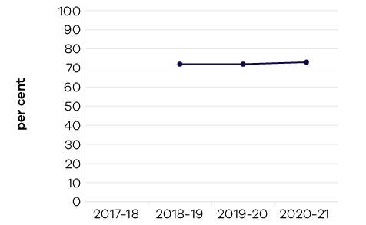

Figure 7: Community consultation and engagement
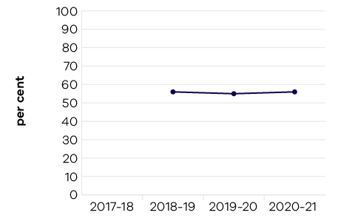

Figure 8: Planning for population growth in the area
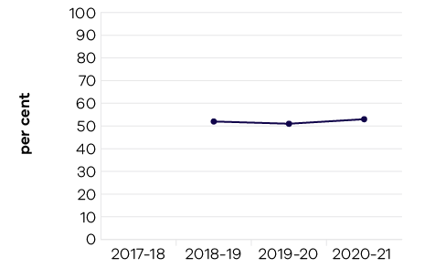
Community satisfaction with the appearance of public areas has increased by one point from 2020, with Metropolitan and Regional Cities rating higher than the statewide average. Further to these results, 10 per cent of residents mention volunteer parks and gardens as the best aspect of their local council (the leading response, alongside customer service) and seven per cent mention recreational and sporting facilities.
Community consultation and engagement remains consistent after recovering from the one-point decrease in 2019–20.
In 2021, 18 councils sought feedback on their planning for population growth. The result of 53 points is the highest since 2015. The participating rural and interface councils have performed below the average.

Indicator: Community satisfaction with performance of councils measured through the Local Government Community Satisfaction Survey

Table 10: Community satisfaction with performance of councils
Measure (unit of measure) | 2017–18 | 2018–19 | 2019–20 | 2020–21
Satisfaction with overall council performance  in the last 12 months (per cent) | 59 | 60 | 58 | 61
Satisfaction with council decisions made  in the interest of the community (per cent) | 54 | 55 | 53 | 56
Satisfaction with value for money in services  and infrastructure provided by council* (per cent) | N/A | N/A | N/A | 54
*New indicator in 2020–2021

Figure 9: Satisfaction with overall council performance in the last 12 months
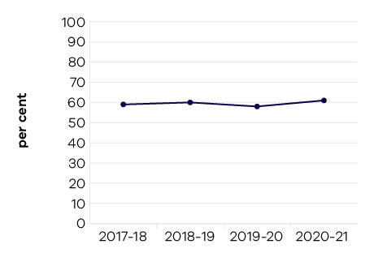

Figure 10: Satisfaction with council decisions made in the interest of the community
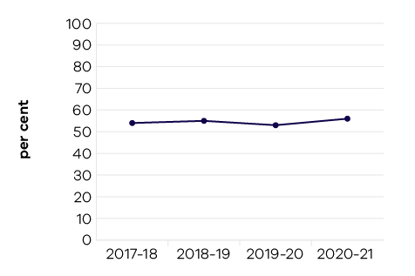
The overall performance index score of 61 for councils state wide represents a significant three-point increase on the 2019–20 result. Recovering from a two-point decline last year, overall performance is now equal to its previous highest level; last achieved in 2014.
Victoria’s youngest (18 to 34 years) and oldest (65+ years) residents remain most positive about their council’s performance (index scores of 64 and 62 respectively – both significantly higher than the state-wide average). This contrasts with the middle-aged cohorts (35 to 49 and 50 to 64 years) who continue to rate their council’s performance significantly lower than the state-wide average (index scores of 59 and 57 respectively).
Almost four in 10 residents (39 per cent) rate the value for money received from their council in infrastructure and services provided as ‘very good’ or ‘good’ – many more than those who rate it as ‘poor’ or ‘very poor’ (23 per cent). A further
34 per cent sit mid-scale, rating value for money as ‘average’.
With the implementation of the Local Government Act 2020 and the introduction of deliberative engagement practices in the development of council plans and documents, there is greater emphasis on engaging the community and placing residents and ratepayers at the centre of council decision making.

Suburban Revitalisation
In 2020–21, the Office for Suburban Development delivered grants of nearly $24 million for 114 Suburban Revitalisation projects. The Victorian Government’s investment, together with partner contributions, resulted in the leveraging of just
under $68 million in total value.
The Office for Suburban Development supported the continuation of the Frankston and Broadmeadows Suburban Revitalisation Boards and established six new Suburban Revitalisation Boards in Boronia, Lilydale, Melton, Noble Park, Reservoir and Tarneit. Through these boards, the Office for Suburban Development drove the delivery of local priorities to improve economic, social and liveability outcomes for the local community.
Suburban Revitalisation Boards are chaired by a local Member of Parliament, along with representatives from local government, local businesses, community organisations and local institutions.
In response to the pandemic, the Office for Suburban Development also ramped-up delivery of Suburban Revitalisation projects across Melbourne to deliver investments in three 20-Minute Neighbourhood pilot sites, revitalisation projects in Thomastown and Lalor, and 32 projects through the Neighbourhood Activity Centre Renewal program.

Metropolitan Partnerships
The Office for Suburban Development engaged 3800 people across 44 engagement activities, comprising virtual events and online engagement on regional priorities including transport, mental wellbeing, employment, business resilience and local living. The increase in engagement activities this year was to understand the impacts of COVID-19 on suburban communities.
Engagement activities included six round tables hosted by the Metropolitan Partnership to build understanding of local impacts of COVID-19 and identify local recovery solutions.
In addition, $1 million was invested in 10 projects across metropolitan Melbourne, focusing on transport, local economies and innovation, community connectedness, climate adaptation, health, and housing.

Regional Development
Rural and regional Victorians account for a quarter of the state’s population. In 2020–21, the Victorian Government, through the Rural and Regional Victoria Group (RRV), worked to ensure that Victoria’s rural and regional communities enabled and shared in the benefits of the state’s economic growth, were supported during the COVID-19 pandemic, and received ongoing assistance following the impacts of the 2019–20 summer bushfires.
COVID-19 brought significant challenges to regional Victoria including impacts on tourism, employment, export sales and investment. In 2020–21 Regional Development Victoria (RDV) worked closely with local stakeholders and communities to understand the impact of COVID-19, facilitate solutions, and inform the government’s response to the pandemic.
- Despite the challenges caused by COVID-19, two performance targets were exceeded:
- RDV supported 677 economic and service delivery projects in rural and regional Victoria, against a target of 150
- RDV achieved a rating of 98 per cent participant satisfaction with the implementation of its programs, against a target of 90 per cent.
The impacts of COVID-19 on the growth, employment and export opportunities of businesses in rural and regional Victoria impacted the ability to meet three performance targets in 2020–21:
- RDV generated $97 million of export sales against a target of $110 million, however actual exports reported from completed projects increased 73 per cent from the 2019–20 result
- RDV facilitated the creation of 1468 new jobs against a target of 1770, however new jobs created in regional Victoria showed a 20 per cent increase from the 2019–20 result
- RDV secured $906.7 million of new investments against a target of $1,400 million, however new investment in regional Victoria showed an eight per cent increase from the 2019–20 result.
In 2020–21 RDV supported the delivery of a number of government programs to address the impact of COVID-19 in rural and regional Victoria. This included the $51.3 million Agriculture Workforce Plan, through which RDV supported the delivery of 398 projects; the Crisis Committee of Cabinet (CCC) Infrastructure Stimulus package and the CCC Infrastructure Planning and Acceleration Fund, of which RDV supported the delivery of four and nine regional development projects respectively; and the COVID-19 Regional Recovery Fund, through which RDV supported the delivery of 54 projects.
RDV continues to support delivery of projects through the Regional Jobs and Infrastructure Fund (RJIF). In 2020–21 this consisted of 39 projects funded through round one of the Regional Infrastructure Fund including support for the Central Goldfields Shire Council Maryborough Railway Station Upgrade and Activation and the Port Campbell Town Centre Revitalisation Project. A further 12 projects were funded through the Regional Jobs Fund including supporting the $50 million redevelopment and modernisation of the H.W. Greenham and Sons meat processing facility at Tongala that will create 230 new jobs, and funding to Lancefield Brewery Holdings to facilitate investment in craft brewery development that will create 15 new jobs at Lancefield.
These are in addition to the 10 projects funded through the 2019–20 RJIF, including funding to the Goodman Group to facilitate 50 new jobs in Portland to establish a specialised conveyancing centre for its Victorian operations, and funding to SCT Logistics to invest in infrastructure at its Wodonga rail terminal, creating an estimated 80 supply chain jobs in the plantation forestry sector.
RDV continued to support delivery of the Geelong City Deal, a 10-year plan to revitalise Geelong and unlock the potential of the Great Ocean Road economy. This will deliver $370 million in government investment to the region and is estimated to create up to 1000 jobs through implementation of the projects under the City Deal.
In 2020–21 RDV supported completion of the Ballarat and Latrobe Valley GovHubs, which officially opened on 21 April 2021 and 7 July 2021 respectively. The Ballarat GovHub will house up to 1000 Victorian Government workers including up to 600 public sector positions relocated from Melbourne. This is expected to help revitalise a major part of the Ballarat CBD, generate long-term jobs growth, increase business confidence and attract further private sector investment. The Latrobe Valley GovHub will house 300 Victorian Government workers, including 200 new roles, and will provide a long-term annual boost of $15 million to the local economy.
In 2020–21 RDV commenced the Regional Workforce Pilots, which will support a number of regional workforce projects across pilot sites in the Barwon South West, Loddon Mallee, Hume and Grampians regions. These projects will test the effectiveness of different responses in place, and act as case studies for different types of regional workforce challenges and interventions.

Performance against output performance measures
Table 11 represents performance against the Business Precincts output. This output delivers activities
to build vibrant and prosperous precincts that drive economic growth and opportunities. The department
works collaboratively with government, industry and community stakeholders to identify opportunities for
the development and delivery of initiatives to strengthen our economy, create jobs and improve liveability
for all Victorians.

Table 11: Output – Business Precincts
Performance measures | Unit of measure | 2020–21 actual | 2020–21 target | Performance variation (%) | Result
Quantity
Precincts in the design or delivery phase | number | 4 | 7 | -42.9% | #
Lower result due to the three precincts which were previously measured by the department having moved to the Department of Transport, following a machinery of government change. The precincts of Fishermans Bend, Docklands, Footscray and Parkville are the four remaining precincts within the department measured as part of the output.
Quality
Key stakeholders satisfied with the services provided in relation to precincts | per cent | 83 | 80 | 3.8% | *
Timeliness
Delivery of financial obligations for departmental  public private partnership projects in accordance  with contractual timelines | per cent | 100 | 85 | 17.6% | *
Higher result due to the department having met all contractually required financial commitments for the Public Private Partnership projects it is responsible for within required timeframes for the year.
Cost
Total output cost | $ million | 28 | 24.4 | 14.6% | #
The 2020–21 result was higher than the 2020–21 budget mainly due to a funding realignment of capital funding to operating funding.
Note:
* Performance target achieved or exceeded
– Performance target not achieved – within 5 per cent variance
# Performance target not achieved – exceeds 5 per cent variance
Table 12 represents performance against the Local Government and Suburban Development output.
This output delivers activities in partnership with the local government sector to support effective and efficient local governance, leadership, infrastructure and service provision. The department also works collaboratively to develop Melbourne’s suburbs through the Suburban Revitalisation Program and the
six Metropolitan Partnerships and improve suburban liveability. Through this output, the department administers programs to support local governments to increase accountability and provide support
to the Victorian Local Government Grants Commission.

Table 12: Output – Local Government and Suburban Development
Performance measures | Unit of measure | 2020–21 actual | 2020–21 target | Performance variation (%) | Result
Quantity
Average number of monthly pageviews on  knowyourcouncil.vic.gov.au | number (000) | 140 | 140 | 0.0% | *
Community meetings held with Metropolitan Partnerships | number | 30 | 6 | 400.0% | *
Higher result due to additional stakeholder engagement by the Metropolitan Partnerships to better understand how COVID-19 impacted the community.
Meetings held annually with Victorian councils regarding the Victorian Local Government Grants Commission financial assistance grants allocation model | number | 19 | 19 | 0.0% | *
Meetings held with Local Government Mayoral  Advisory Panel | number | 4 | 4 | 0.0% | *
Projects in the planning or delivery phase to support and facilitate the revitalisation of Broadmeadows  and Frankston | number | 20 | 6 | 233.3% | *
Higher result due to additional funding provided to Broadmeadows and Frankston as part of the Building Works Stimulus, which resulted in more projects being planned or delivered under the program.
Quality
Council satisfaction with the communication, support and advice received from Local Government Victoria in relation to the Local Government Performance Reporting Framework | per cent | 70 | 70 | 0.0% | *
Councils with approved roadside weeds and pests control plan | number | 56 | 56 | 0.0% | *
Participants satisfied with their experience  of partnership assemblies | per cent | 88 | 80 | 10.0% | *
Higher result due to online engagements allowing for more inclusive participation, leading to increased satisfaction results.
Submissions that fully meet the objectives within the Growing Suburbs Fund program guidelines | per cent | 80 | 80 | 0.0% | *
Timeliness
Average number of days for Municipal Emergency Resource Program grant payments to be made following completion of agreed milestones in the funding agreement | days | 21 | 21 | 0.0% | *
Average number of days for Public Library Services grant payments to be made following completion  of agreed milestones in the funding agreement | days | 21 | 21 | 0.0% | *
Partnership priorities receiving a government response by 30 June | per cent | 100 | 100 | 0.0% | *
Projects completed in accordance with approved milestones within the Growing Suburbs Fund funding agreements | per cent | 80 | 80 | 0.0% | *
Roadside Weeds and Pests program grant payments made within 21 days of completion of agreed milestones in the funding agreement | per cent | 100 | 100 | 0.0% | *
Victoria Local Government Grants Commission allocations finalised to support the completion  of council budgets within statutory timeframes | per cent | 100 | 100 | 0.0% | *
Cost
Total output cost | $ million | 189.8 | 178.6 | 6.3% | #
The 2020–21 result was higher than the 2020–21 budget mainly due to expenditure on contingency released funding for the Suburban Revitalisation and Growth initiative.
Note:
* Performance target achieved or exceeded
– Performance target not achieved – within 5 per cent variance
# Performance target not achieved – exceeds 5 per cent variance
Table 13 represents performance against the Regional Development output. This output guides engagement with industry and communities to identify opportunities to support job growth and new investment in regional Victoria, including support and services to grow regional jobs and capability in regional communities.

Table 13: Output – Regional Development
Performance measures | Unit of measure | 2020–21 actual | 2020–21 target | Performance variation (%) | Result
Quantity
Actual export sales generated for regional businesses as a result of participation in government programs | $ million | 97 | 110 | -11.8% | #
Lower result due to the significant impacts of COVID-19 restrictions on businesses and their ability to export and the availability
of freight services.
Economic development and service delivery projects supported | number | 677 | 150 | 351.3% | *
Higher result due to the considerable amount of grant funding awarded as stimulus following the 2019–20 bushfires and COVID-19 pandemic; 80 per cent of the actual outcome is attributable to one-off COVID-19 and bushfire response programs, 20 per cent is attributable to ‘business as usual’ programs and activities.
Jobs in regional Victoria resulting from government investment facilitation services and assistance | number | 1,468 | 1,770 | -17.1% | #
Lower result due to the impacts of COVID-19 restrictions on businesses and their growth/employment intentions.
New investment in regional Victoria resulting from government facilitation services and assistance | $ million | 906.7 | 1,400 | -35.2% | #
Lower result due to the impacts of COVID-19 restrictions on businesses and their growth/employment intentions.
Quality
Participant satisfaction with implementation  of Regional Development Victoria programs | per cent | 98 | 90 | 8.9% | *
Higher result due to the implementation of a streamlined approach to the grants administration process. This coupled with a strong presence on the ground in its regional offices and the associated availability of its high quality advice and support services has produced a positive outcome.
Cost
Total output cost | $ million | 541.9 | 539.9 | 0.4% | –
Note:
* Performance target achieved or exceeded
– Performance target not achieved – within 5 per cent variance
# Performance target not achieved – exceeds 5 per cent variance

Objective 5: Grow vibrant, active and creative communities
This objective seeks to increase the economic, social and cultural value of the creative, sport and recreation industries to Victoria, grow the number and yield of visitors, position Victoria as a major events destination, and ensure the best cultural and sporting experiences are accessible to everyone.

Progress towards achieving this objective
In 2020–21, the department reported progress against this objective using the following objective indicators and outputs:

Objective Indicators
- Attendances at Creative Industries agencies and funded Major Performing Arts organisations
- Employment in the Creative Industries sector
- Employment in the Visitor Economy sector
- Tourists attracted to Victoria
- Increase rates of community engagement, including through participation in sport and recreation
- Wagering turnover on Victorian racing as a proportion of the national market.

Outputs
- Creative Industries Access, Development and Innovation
- Creative Industries Portfolio Agencies
- Cultural Infrastructure and Facilities
- Sport, Recreation and Racing
- Tourism and Major Events.

Indicator: Attendances at Creative Industries agencies and funded Major Performing Arts organisations

Table 14: Attendances at Creative Industries agencies
Measure (unit of measure) | 2017–18 | 2018–19 | 2019–20 | 2020–21
Attendances at creative industries portfolio agencies (number (‘000)) | 13,170 | 12,786 | 9,417 | 2,646

Figure 11: Attendances at Creative Industries agencies
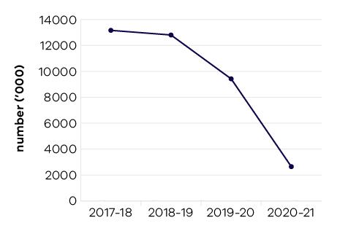
In 2020–21, Victoria’s state-owned arts and cultural institutions – Arts Centre Melbourne, Australian Centre for the Moving Image (ACMI), Geelong Arts Centre, Melbourne Recital Centre, Museums Victoria, National Gallery of Victoria (NGV), and State Library Victoria – were attended by 2.6 million visitors, a further reduction on record levels set prior to the pandemic. The decline in attendances occurred as a result of the COVID-19 related lockdowns and public health restrictions continuing through 2020–21.
Despite the significant impact of restrictions, these agencies kept Victorians engaged, connected and entertained through a range of on-site and online programs, including:
- Live at the Bowl, produced by Arts Centre Melbourne at the open-air Sidney Myer Music Bowl featuring headline acts, symphonic masterpieces, festivals and other performances. This provided employment to 3250 Victorians on and off the stage and injected more than $27 million into the state economy
- NGV Triennial, a free entry contemporary art, design and architecture program featuring major new commissions by some of the world’s most accomplished artists and designers, while also providing a platform for local and emerging practitioners
- The reopening of ACMI following its major redevelopment project that showcases new innovations in moving image technology, and the opening in May 2021 of Disney: The Magic of Animation, an Australian exclusive exhibition of rare artworks and sketches from Walt Disney Animation Studios
- The Summer Sessions hosted by Geelong Arts Centre including performances and creative, educational activities outdoors under a big top to welcome live arts back to the region
- Melbourne Museum Summer Sessions, presented by Melbourne Museum and hosting over 120 performers in a series of outdoor shows in the Melbourne Museum Plaza.
With doors closed to the public for a significant proportion of 2020–21, the arts and cultural institutions facilitated creative jobs and human connection through digital technology and online offerings including digital education, commissioned live streams and performance recordings, behind the scenes tours, and interviews with artists.

Table 15: Attendances at funded Major Performing Arts organisations
Measure (unit of measure) | 2017–18 | 2018–19 | 2019–20 | 2020–21
Attendances at funded Major Performing Arts organisations (number (‘000)) | 1,067 | 1,127 | 1,169 | 287

Figure 12: Attendances at funded Major Performing Arts organisations
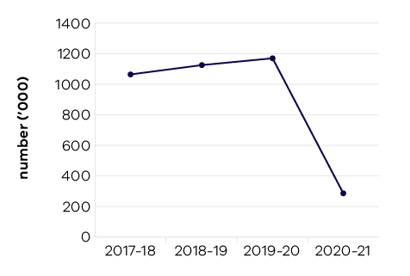
Funded Major Performing Arts companies recorded significant reductions in audiences as a result of COVID-19 restrictions, with many performances cancelled or showing to vastly reduced audiences. The figures are for the calendar ending in that financial year, in line with companies’ programming, so 2020–21 is the first reporting year which reflects the impact of restrictions associated with COVID-19.
More than $20 million was allocated to support more than 95 creative organisations across the state to sustain their operations through the pandemic, of which more than a third went to support Major Performing Arts companies.
Victorian funded Major Performing Arts companies in 2020–21 were Melbourne Theatre Company, The Australian Ballet, Opera Australia, Orchestra Victoria, Melbourne Symphony Orchestra, Malthouse Theatre, Circus Oz and Victorian Opera.

Indicator: Employment in the Creative Industries sector

Table 16: Employment in the Creative Industries sector
Measure (unit of measure) | 2017–18 | 2018–19 | 2019–20 | 2020–21
Number of first jobs in the creative industries  (number) | 261,000 | 289,000 | 292,000 | 305,000

Figure 13: Number of first jobs in the creative industries
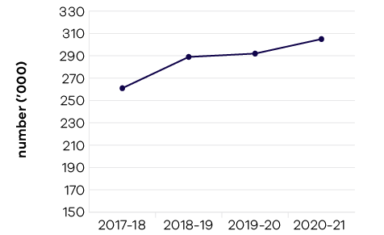
In 2020–21, 305,000 people were employed in the cultural and creative industries in Victoria, representing nine per cent of the total state workforce.
The annual figure is the average of four quarterly results from the ABS Labour Force Survey. There is a 4.5 per cent increase in 2020–21 on last year’s figures (compared to a 1.0 per cent increase in 2019–20). The percentage rate of employment growth has declined since 2018–19 due to the impact of COVID-19.
With the completion of the Victorian Government’s first four-year creative industries strategy in 2020, Creative Victoria focused on the development of its follow up, Creative State 2025, in consultation with the sector. Over the period of the original Creative State (2016–2020) Creative and Cultural Industries employment grew by 27.5 per cent. The new strategy has a strong focus on creating new and better job opportunities and employment pathways, particularly in the wake of the pandemic. The new strategy aims to underpin the creation of 60,000 new jobs and to upskill and diversify the workforce while ensuring Victorians can access and benefit from Victoria’s rich creative offerings.
While international engagement was heavily impacted by COVID-19 restrictions on travel and physical gatherings, Creative Victoria supported Victorian businesses to connect online via a range of digital platforms, including:
- Virtual trade missions to Canada (Performing Arts), Hong Kong (Design, Performing Arts), Korea (Games, Performing Arts), the United States (Performing Arts, Games and Music)
- Artist residencies in China, the United Kingdom (UK), India and Indonesia
- Online industry forums and workshops in Timor Leste, India and Canada
- Public sculpture commissioned for China and the UK.
Additionally, local online platforms saw record levels of international participation including:
- Melbourne Art Fair online
- ReelOzInd! short film festival
- Sangam Performing Arts Festival of South Asia and Diaspora
- Melbourne Design Week
- Melbourne International Film Festival online
- Melbourne International Games Week.
With Creative Victoria support through dedicated funding for online and eCommerce projects, funded entities undertook significant levels of online activity during the year to maintain crucial markets and audiences, and support Victoria’s international relationships.
The government delivered a range of relief and rescue packages and initiatives during 2020–21, supporting continued employment in the creative industries in Victoria.
In 2019–20 and 2020–21, $188.25 million was allocated to Creative Industries sector survival, recovery and activation, including:
- More than $25 million in dedicated support to the live music industry
- More than $36 million to support the rebound of the Victorian screen industry.

Indicator: Employment in the Visitor Economy

Table 17: Employment in the Visitor Economy
Measure (unit of measure) | 2017–18 | 2018–19 | 2019–20* | 2020–21
Number of jobs in the visitor economy sector (number) | 247,900 | 263,300 | 232,000 | Data expected  in 2022
* This is the latest available data from the State Tourism Satellite Accounts 2019–20, produced by Tourism Research Australia, March 2021. Changes to the inputs used to produce this data have resulted in revised historical estimates that should not be compared to previously published results.

Figure 14: Number of jobs in the visitor economy sector
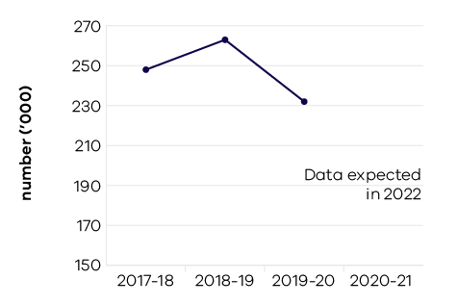
Tourism in Victoria generated employment of approximately 232,000 people (direct and indirect jobs) in 2019–20, noting a decline of 11.9 per cent (or down 31,200 jobs) compared to 2018–19 estimates.
The decline in tourism employment in Victoria has been driven by the COVID-19 pandemic and associated restrictions on both international and domestic travel. Given that the latest results are for the 2019–20 financial year they may not fully reflect the impact of the pandemic on tourism jobs.
Looking at the distribution of direct tourism jobs across Victorian industries in 2019–20, cafés, restaurants and takeaway food services (31 per cent) accounted for the largest share of direct tourism employment, followed by retail trade (15 per cent), accommodation (13 per cent), and education and training (10 per cent).

Indicator: Tourists attracted to Victoria

Table 18: Tourists attracted to Victoria
Measure (unit of measure) | 2017–18 | 2018–19 | 2019–20 | 2020–21*
Number of domestic overnight visitors (number (million)) | 24 | 27.8 | 28.3 | 13.4
Number of international visitors (number (million)) | 3 | 3.1 | 2.8 | 0.01
Visitor expenditure: domestic ($ billion) | 18.8 | 21.5 | 23.2 | 9.7
Visitor expenditure: international ($ billion) | 8 | 8.5 | 8.1 | 0.08
Visitor expenditure: regional Victoria (domestic) ($ billion) | 9.1 | 10.4 | 11.3 | 7.0
Visitor expenditure: regional Victoria (international)  ($ million) | 570 | 582 | 538 | n/a**
* This is the latest available data for the year ending March 2021 from the National Visitor Survey and International Visitor Survey (published by Tourism Research Australia, 30 June 2021).
**International visitor data is currently limited to state-wide results.

Figure 15: Number of domestic overnight visitors
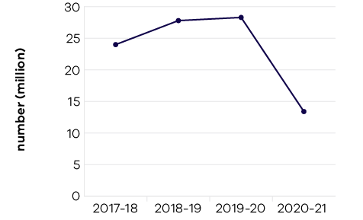

Figure 16: Number of international visitors
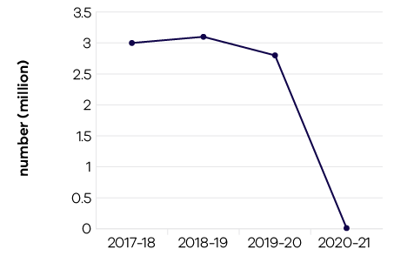

Figure 17: Visitor expenditure: domestic
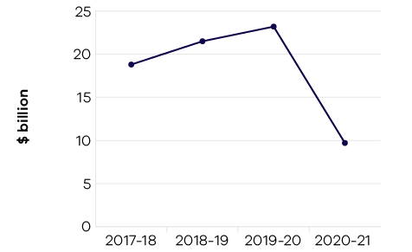

Figure 18: Visitor expenditure: international
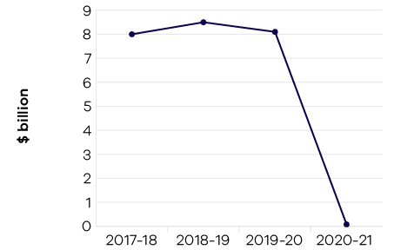

Figure 19: Visitor expenditure: regional Victoria (domestic)
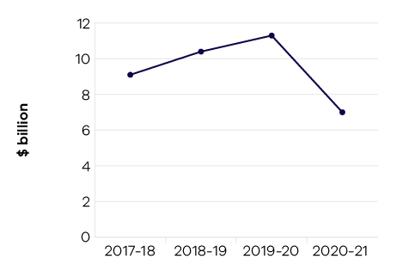

Figure 20: Visitor expenditure: regional Victoria (international)
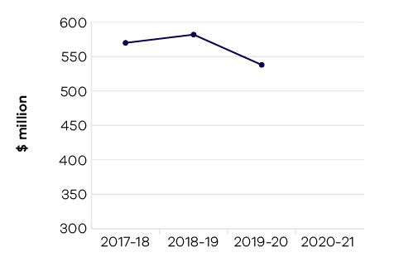
The COVID-19 pandemic has had a negative impact on Victoria’s tourism sector. As at the year ending March 2021 (latest available data), there were 46.5 million total visitors to and within Victoria; a decline of 51 per cent compared to the previous year. Total tourism expenditure also fell from $31.3 billion to $9.8 billion (international overnight and domestic).
- Domestic overnight visitors declined by 53 per cent in the year ending March 2021 compared to the previous year to 13.4 million. The rate of decline softened in the March 2021 quarter results but remained below the March 2019 quarter pre-COVID-19 result by 25 per cent.
- International overnight spend in Victoria was estimated at just $80 million in the year ending March 2021, representing a year-on-year decline of 99 per cent due to COVID-19 related restrictions on international travel.
The Visitor Economy Recovery and Reform Plan is a whole-of-state strategy which aims to achieve $35 billion in Victoria’s annual visitor expenditure alongside a roadmap to support the generation of 300,000 tourism jobs state-wide by June 2024. The plan will strengthen the state’s nation-leading tourism offering through the development of new experiences, products and infrastructure.
The plan is supported by a $633 million investment. Notable announcements as part of the delivery of this have included:
- Thirty projects to be delivered as part of the $46 million Stimulus Round of the Regional Tourism Investment Fund
- Nineteen tourism flagship projects totalling $120 million to attract more visitors to regional Victoria and activate regions
- Three rounds of regional travel vouchers and one round of Melbourne travel vouchers
- Marketing activities throughout 2020–21 to support recovery, delivered by Visit Victoria, including the successful Click for Vic, Stay Close, Go Further and Visit Melbourne – Get Set campaigns.
The department supported the Regional Tourism Boards and the Victorian Tourism Industry Council to develop business mentoring and crisis preparedness support programs.
The department continued to work with Visit Victoria and the Melbourne Convention Bureau (MCB) to secure major and business events for Victoria, including SpineWeek 2023, International Mass Spectrometry Conference 2024 and the International Geographical Congress 2028.
The department supported industry and portfolio entities through the COVID-19 pandemic. Agencies including Visit Victoria, Melbourne Convention and Exhibition Trust, Emerald Tourist Railway Board, and Australian Grand Prix Corporation were assisted in adapting operations in response to COVID-19.

Indicator: Increase rates of community engagement, including through participation in sport and recreation

Table 19: Increase rates of community engagement, including through participation in sport and recreation
Measure (unit of measure) | 2017–18 | 2018–19 | 2019–20 | 2020–21
Percentage of adult Victorians participating in sport  at least once per year (per cent) | 90.9 | 91.6 | 91.2 | 90.5*
*This figure is for six months only

Figure 21: Percentage of adult Victorians participating in sport at least once per year
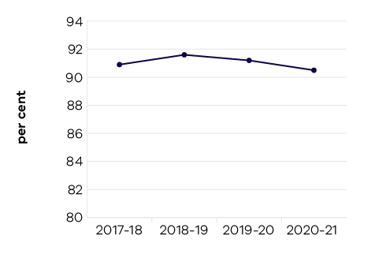

Participation
Public health restrictions due to the COVID-19 pandemic have impacted sport and recreation participation rates in 2019–20 and 2020–21. Many sports seasons were cancelled in 2020 due to the pandemic, impacting Victoria’s participation in sport during this period. The half year figure of 90.5 per cent to December 2020 marks a small decline from the previous half year figure of 91.3 per cent in December 2019.
Support has been provided through the COVID-19 Short-Term Survival Program and the Sporting Club Grants program, to support the operational viability of community sport and active recreation organisations impacted by the pandemic. This support has helped secure the financial viability of the sector and ensure it is able to continue to support Victorians participate in sport.
The government is continuing to support a strong sport sector through the Together More Active and Change Our Game programs, which help to develop sector capability and increase participation by enhancing the equity, diversity and inclusiveness of sport and recreation.
Australia’s highly successful Tokyo 2020 Summer Olympic Games campaign comprised 114 Victorians in the Olympic team (23 per cent of the national team) and 45 Victorians in the Paralympic team (25 per cent of the national team). This included 82 Victorian Institute of Sport (VIS) scholarship holders. A further eight VIS scholarship holders are in preparation for the Beijing 2022 Winter Olympic and Paralympic Games.
Our high-performance athletes, coaches and support staff benefit from government’s investment in the world class network of 44 state sport facilities that support 51 professional teams. There are 96 recognised national sporting organisations of which 32 are based in Victoria.
Many of Victoria’s professional sporting teams enjoyed success across major domestic competitions throughout 2020–21, including those that relocated interstate under COVID-19 restrictions. Championship winning teams included Melbourne Vixens (Suncorp Super Netball), Melbourne Victory (W-League), Southside Flyers (Women’s National Basketball League), Melbourne City (A-League), Melbourne Storm (National Rugby League), Richmond Football Club (Australian Football League), Melbourne Aces (Australian Baseball League), and Melbourne United (National Basketball League).
All teams have provided opportunities for Victorians to reach their potential – especially those that are traditionally under-represented.

Infrastructure
The Victorian Government has had record levels of investment in community sport and active recreation infrastructure in 2020–21, with over $290 million allocated to 239 community sport and recreation infrastructure projects. The objective of these investments is to secure the many benefits of participating in sport and active recreation and to support Victorians, particularly disadvantaged communities and under-represented groups, to achieve better health, wellbeing, social and economic outcomes.
Investment in major sports facilities continued through the $101 million investment in the La Trobe University Sports Park, which includes the Home of the Matildas. Additional funding was provided to the State Basketball Centre and Kardinia Park Stadium Upgrade Stage Five. Investment in professional women’s sport included completion of female facility upgrades at Mars Stadium in Ballarat, Casey Fields, Cranbourne East and Victoria Park, Abbotsford. Further investment occurred in AFLW facilities at Essendon Football Club, North Melbourne Football Club and Richmond Football Club.
The $64.6 million State Netball and Hockey Centre upgrade was completed. The $15.3 million investment in the Home of Golf at Sandringham, the $13.3 million to upgrade Melbourne Arena and the near $1 billion Melbourne Park redevelopment
all advanced to near completion. Investment in world class infrastructure supports the continued success of our athletes and professional sporting teams and readies the state for the full resumption of the major events calendar, which has a global broadcast reach. The 2021 Australia Open, for example, was broadcast to more than 210 territories.

Women’s Participation
The government has recently committed over $11 million to continue the Office for Women in Sport and Recreation, and the Change Our Game suite of initiatives over the next four years. This follows initial funding of over $7 million since 2017. The government has also committed over $37 million to the Female Friendly Facilities Fund over the past five years to upgrade existing and develop new infrastructure to support female participation in sport and active recreation.
There has been a significant increase in female participation across a range of non-traditional female sports, such as Australian Rules football, cricket and soccer. In the past decade, the number of female Australian Rules football teams has increased 20-fold, from 58 teams in 2010 to over 1000 teams in 2020, with more than 29,400 participants.

Indicator: Wagering turnover on Victorian racing as a proportion of the national market

Table 20: Wagering turnover on Victorian racing as a proportion of the national market
Measure (unit of measure) | 2017–18 | 2018–19 | 2019–20 | 2020–21
Wagering turnover on Victorian racing as a proportion  of the national market (per cent) | 38.2 | 38.5 | 37.5 | 36.8

Figure 22: Wagering turnover on Victorian racing as a proportion of the national market
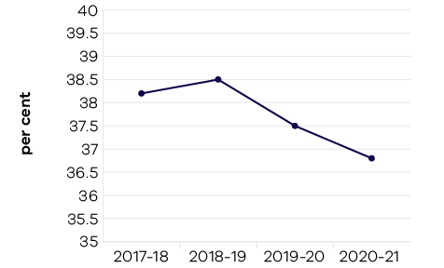
Government support for racing is based on its economic, social and cultural contribution to communities across Victoria. The objective indicator of Tabcorp customers nationwide who bet on Victorian racing as a proportion of the national market is used to determine the health of the Victorian racing industry. The measure includes all racing turnover held by Tabcorp on Victorian racing events.
While Victoria has approximately 25 per cent of the national population and hosts around 25 per cent of the national racing program, it attracts a greater percentage of the national wagering pool. In 2020–21, 36.8 per cent of the national wagering pool was held by Tabcorp on Victorian product, slightly down from 37.5 per cent in 2019–20, 38.5 per cent in 2018–19 and 38.2 per cent in 2017–18. This significant market share reflects confidence in the racing product and in the integrity of Victorian racing.
The slight reduction in this indicator may in part be attributed to both the closure of retail TAB outlets during the 2020–21 financial year and the increased interstate competition from both New South Wales and Queensland. New South Wales made significant increases to prize money and programmed new feature races in direct competition with established Victorian events, while Queensland has included many former non-TAB race meetings in its broadcast and wagering schedule.

Performance against output performance measures
Table 21 represents performance against the Creative Industries Access, Development and Innovation output. This output supports the creative industries to deliver economic, social and cultural benefit through talent and leadership; the creative and business ecology; innovation and social impact; participation and place making; and international engagement.

Table 21: Output – Creative Industries Access, Development and Innovation
Performance measures | Unit of measure | 2020–21 actual | 2020–21 target | Performance variation (%) | Result
Quantity
Attendances at major performing arts organisations | number (000) | 287 | 1,000 | -71.3% | #
Lower result due to major performing arts companies being unable to present due to COVID-19 lockdowns. The attendance figure of 287,462 is for live attendances. It does not include any online attendances that organisations attracted due to organisations pivoting to online delivery.
Creative Learning Partnerships | number | 14 | 14 | 0.0% | *
Design organisations supported | number | 21 | 22 | -4.5% | –
International market development and exchange initiatives | number | 12 | 12 | 0.0% | *
Organisations recurrently funded | number | 140 | 140 | 0.0% | *
Project companies and artists funded | number | 903 | 900 | 0.3% | *
Project companies and artists funded which are regionally based | per cent | 21.2 | 23 | -7.8% | #
Lower result reflects the impact of additional COVID-19 support to metro-based companies and creative workers as a result of more significant restrictions, particularly the Live Music sector.
Regionally based organisations recurrently funded | number | 53 | 54 | -1.9% | –
Quality
Creative Victoria grant recipients who met or exceeded agreed milestones | per cent | 81 | 85 | -4.7% | –
Public information rated ‘informative’ or ‘very informative’ by grant applicants | per cent | 89.83 | 90 | -0.2% | –
Timeliness
Performance and grant agreements acquitted within timeframes specified in the funding agreement | per cent | 86 | 83 | 3.6% | *
VicArts Grant acquittals assessed within 30 days  of submission date | per cent | 98 | 95 | 3.2% | *
VicArts Grant applications processed within 45 days  for Ministerial consideration | per cent | 0 | 100 | -100.0% | #
Lower result due to delays resulting from a significant increase in the number of applications received as a result of the impacts of COVID-19 on the sector. Six hundred and eighty applications were received in the September 2020 round, compared with an average of 350 of the previous five pre-COVID rounds (two rounds per year in February and September, with September 2020 the final round of the program).
Cost
Total output cost | $ million | 95.1 | 78.7 | 20.8% | #
The 2020–21 result was higher than 2020–21 budget primarily due to additional funding received in 2020–21 for the Creative Industries Survival package.
Note:
* Performance target achieved or exceeded
– Performance target not achieved – within 5 per cent variance
# Performance target not achieved – exceeds 5 per cent variance
Table 22 represents performance against the Creative Industries Portfolio Agencies output. This output promotes, presents and preserves our heritage and the creative industries through Victoria’s creative industries agencies: Arts Centre Melbourne, Australian Centre for the Moving Image (ACMI), Docklands Studios Melbourne, Film Victoria, Geelong Performing Arts Centre, Melbourne Recital Centre, Museums Victoria, National Gallery of Victoria (NGV), and the State Library Victoria.

Table 22: Output – Creative Industries Portfolio Agencies
Performance measures | Unit of measure | 2020–21 actual | 2020–21 target | Performance variation (%) | Result
Quantity
Additional employment from production supported  by Film Victoria | number | 9,558 | 8,732 | 9.5% | *
Higher result due to the two COVID-19 support packages from government (Creative State: Screen Industry Survival Package and Screen Industry Crisis Recovery Plan), which enabled greater support for local production and helped to attract a diverse range of film, screen and games production activity to Victoria.
Agency website visitation | number (000) | 18,747 | 21,200 | -11.6% | #
Lower result due to the impact of COVID-19 and closures at the agencies. Greatly reduced programming which adversely affected online visitation to agency websites.
Attendances at Arts Centre Melbourne | number (000) | 450 | 2,200 | -79.5% | #
Lower result due to impact of COVID-19 restrictions which resulted in closures and restricted programming.
Attendances at Australian Centre for the Moving Image | number (000) | 263 | 800 | -67.1% | #
Lower result due to impact of COVID-19 restrictions, and the closure during the extensive redevelopment completed in February 2021.
Attendances at Geelong Arts Centre | number (000) | 18 | 100 | -82.0% | #
Lower result due to impact of COVID-19 and closures, and the “Stage 3” construction works taking place throughout 2021.
Attendances at Melbourne Recital Centre | number (000) | 34 | 230 | -85.2% | #
Lower result due to impact of COVID-19 restrictions which resulted in closures and restricted programming.
Attendances at Museums Victoria | number (000) | 698 | 2,000 | -65.1% | #
Lower result due to impact of COVID-19 restrictions which resulted in closures and restricted programming.
Attendances at National Gallery of Victoria | number (000) | 773 | 2,235 | -65.4% | #
Lower result due to impact of COVID-19 restrictions which resulted in closures and restricted programming.
Attendances at State Library Victoria | number (000) | 410 | 2,250 | -81.8% | #
Lower result due to impact of COVID-19 restrictions which resulted in closures and restricted programming.
Members and friends of agencies | number | 53,247 | 57,000 | -6.6% | #
Lower result due to impact of COVID-19 restrictions which resulted in closures and restricted programming.
Students participating in agency education programs | number | 435,501 | 550,000 | -20.8% | #
Lower result due to the impact of COVID-19 and closures at the agencies, which meant school groups were unable to attend the various education programs hosted by agencies. Agencies are offering online education programs.
Value of film, television and digital media production supported by Film Victoria | $ million | 391 | 327 | 19.6% | *
Higher result due to the two COVID-19 support packages from government (Creative State: Screen Industry Survival Package and Screen Industry Crisis Recovery Plan), which enabled greater support for local production and helped to attract a diverse range of film, screen and games production activity to Victoria.
Volunteer hours | number | 14,928 | 98,900 | -84.9% | #
Lower result due to the impact of COVID-19 and closures at the agencies.
Quality
Agency collections storage meeting industry standard | per cent | 83 | 86 | -3.5% | –
Visitors satisfied with visit: Arts Centre Melbourne | per cent | 93 | 90 | 3.3% | *
Visitors satisfied with visit: Australian Centre for the Moving Image | per cent | 95 | 95 | 0.0% | *
Visitors satisfied with visit: Geelong Arts Centre | per cent | 98 | 98 | 0.0% | *
Visitors satisfied with visit: Melbourne Recital Centre | per cent | 97 | 95 | 2.1% | *
Visitors satisfied with visit: Museums Victoria | per cent | 90 | 95 | -5.3% | #
Lower result due to the impact of COVID-19, reflecting lower satisfaction levels with the removal of some hands-on exhibits and some capacity restrictions (e.g. Children’s Gallery).
Visitors satisfied with visit: National Gallery of Victoria | per cent | 95 | 95 | 0.0% | *
Visitors satisfied with visit: State Library Victoria | per cent | 96 | 90 | 6.7% | *
Higher result due to an increase in satisfaction in key areas of cleanliness, staff approachability and staff availability.
Cost
Total output cost | $ million | 438.3 | 463.2 | -5.4% | *
The 2020–21 result was lower than 2020–21 budget due to lower expenditure by the Creative Industries portfolio agencies, as a result
of closures due to the COVID-19 pandemic.
Note:
* Performance target achieved or exceeded
– Performance target not achieved – within 5 per cent variance
# Performance target not achieved – exceeds 5 per cent variance
Table 23 represents performance against the Cultural Infrastructure and Facilities output. This output supports Victorian cultural venues and state-owned facilities through strategic assessment and provision
of advice on portfolio infrastructure proposals and projects. The output includes consolidation of portfolio asset management plans and management of funding programs for maintenance and minor capital works.

Table 23: Output – Cultural Infrastructure and Facilities
Performance measures | Unit of measure | 2020–21 actual | 2020–21 target | Performance variation (%) | Result
Quantity
All facility safety audits conducted | number | 16 | 16 | 0.0% | *
Infrastructure development projects underway | number | 8 | 8 | 0.0% | *
Quality
State-owned tenanted cultural facilities maintained  to agreed service standards | per cent | 100 | 90 | 11.1% | *
Higher result due to COVID-19 closures which reduced the need for routine maintenance activities that would normally result from utilisation, and enabled all necessary routine and periodic maintenance activities to occur.
Success measures of projects achieved | per cent | 90 | 90 | 0.0% | *
Timeliness
Cultural Facilities Maintenance Fund projects delivered within agreed timeframes | per cent | 87 | 90 | -3.3% | –
Cost
Total output cost | $ million | 123.8 | 139.1 | -11.0% | *
The 2020–21 result was lower than 2020–21 budget mainly due to adjustment of the funding profile of initiatives within the output.
Note:
* Performance target achieved or exceeded
– Performance target not achieved – within 5 per cent variance
# Performance target not achieved – exceeds 5 per cent variance
Table 24 represents performance against the Sport, Recreation and Racing output. This output provides
strategic leadership and investment in the sport, recreation and racing industries through innovation,
sector and industry development and funding support. It supports community participation and inclusion
in the sport, recreation and racing sectors by strengthening the capacity of sport and recreation
organisations to deliver participation opportunities, improving community sport and recreation facilities
across the state and guiding the development and management of state-level sporting facilities and
events, to encourage participation by all Victorians.
This output also supports the development of the Victorian racing industry through strategic investment
in world class racing and training infrastructure, the promotion of animal welfare and integrity initiatives
and encourages participation and investment in the breeding industry to cement Victoria’s position as Australia’s premier racing state.

Table 24: Output – Sport, Recreation and Racing
Performance measures | Unit of measure | 2020–21 actual | 2020–21 target | Performance variation (%) | Result
Quantity
Combat sports licences, registrations  and permits issued | number | 323 | 550 | -41.3% | #
Lower result due to the impact of COVID-19 and activity restrictions on sport and recreation resulting in a significant reduction in the amount of combat sports events that were able to be held, leading to a reduction in applications for licences, registrations and permits.
Community Facility Grants: number approved | number | 239 | 200 | 19.5% | *
Higher result due to a greater number of high quality applications which were able to be supported within the program budget.
Organisations submitting nominations for  the Community Sport and Recreation Awards | number | 55 | 70 | -21.4% | #
Lower result due to the impact of COVID-19 and activity restrictions on sector activity and participation throughout 2020 and reduction in awards categories offered for the 2021 Community Sport and Recreation Awards from 19 to eight.
Projects in progress that relate to the planning  and development of state level facilities | number | 26 | 19 | 36.8% | *
Higher result due to additional planning studies and infrastructure projects commencing in 2020–21.
Racing industry development initiatives | number | 9 | 9 | 0.0% | *
Racing matters processed (including licences,  permits and grant applications) | number | 129 | 300 | -57.0% | #
Lower result due to the impact of COVID-19 and activity restrictions on racing resulting in a significant reduction in crowds attending race meetings and minor licencing requests.
Significant Sporting Events Program –  Events Facilitated | number | 23 | 75 | -69.3% | #
Lower result due to the impact of COVID-19 and activity restrictions on sport and recreation resulting in a significant reduction in events being held during 2020–21.
Sport and recreation organisations undertaking programs or activities to enhance participation | number | 112 | 112 | 0.0% | *
Sporting club grants to recipients which are based in low socio-economic areas as identified by the SEIFA index | per cent | 50 | 45 | 11.1% | *
Higher result due to a higher number of applications received and grants approved to recipients in low socio-economic areas.
Sporting club grants to recipients which are regionally based | per cent | 42 | 35 | 20.0% | *
Higher result due to a higher number of applications received and grants approved to recipients in regional areas.
Sporting club grants: number approved | number | 4,125 | 2,500 | 65.0% | *
Higher result due to a higher number of applications that were able to be funded from within the available program budget.
Sports with athletes on Victorian Institute of Sport (VIS) scholarships | number | 44 | 25 | 76.0% | *
Higher result due to the increased funding provided to the VIS from national sporting organisations which led to an increase in the number of sport partnerships and athlete scholarships.
Victorian Institute of Sport scholarship holders on national teams/squads | per cent | 67 | 60 | 11.7% | *
Higher result due to the higher percentage of VIS scholarship holders selected to national teams and squads over athletes from other national institutes of sport.
Quality
Contract management of outdoor recreation camps meets agreed key performance indicators | per cent | 87 | 90 | -3.3% | –
Timeliness
Community Cricket Program milestones delivered within agreed timeframes | per cent | 97 | 90 | 7.8% | *
Higher result due to strong performance of programs through the first two rounds of the Community Cricket Program in meeting milestones and the finalisation of agreements through the 2020–21 Community Cricket Program.
Cost
Total output cost | $ million | 685.4 | 779.4 | -12.1% | *
The 2020–21 result was lower than 2020–21 budget primarily due to the timing of payments related to Major Stadia Funding program.
Note:
* Performance target achieved or exceeded
– Performance target not achieved – within 5 per cent variance
# Performance target not achieved – exceeds 5 per cent variance
Table 25 represents performance against the Tourism and Major Events output. This output maximises employment and the long-term economic benefits of tourism and major events to Victoria by developing
and marketing the State as a competitive destination.

Table 25: Output – Tourism and Major Events
Performance measures | Unit of measure | 2020–21 actual | 2020–21 target | Performance variation (%) | Result
Quantity
Business program grants delivered | number | 9 | 12 | -25.0% | #
Lower result due to the impact of COVID-19 and associated restrictions on the tourism and events sector, as some programs were
unable to proceed.
Major sporting and cultural events held | number | 8 | 21 | -61.9% | #
Lower result due to the impacts of COVID-19 and associated restrictions resulting in a number of events not proceeding.
Tourism infrastructure projects facilitated | number | 32 | 30 | 6.7% | *
Higher result due to two additional tourism flagship projects which were also scoped, funded and commenced in 2020–21.
Visit Victoria’s total engaged digital audience | number (million) | 5.46 | 5.4 | 1.1% | *
Visitor expenditure: domestic | $ billion | 9.7 | 23.2 | -58.2% | #
Lower result predominantly due to the impact of COVID-19, and the legacy impacts of the 2020 summer bushfires in Victoria. This is the latest available data for the year ending March 2021 from the National Visitor Survey (published by Tourism Research Australia, 30 June 2021).
Visitor expenditure: international | $ billion | 0.08 | 9 | -99.1% | #
Lower result due to the impact of COVID-19 and associated travel restrictions on international travel. This is the latest available data for the year ending March 2021 from the International Visitor Survey (published by Tourism Research Australia, 30 June 2021).
Visitor expenditure: regional Victoria (domestic) | $ billion | 7.0 | 11.1 | -36.9% | #
Lower result predominantly due to the impact of COVID-19, and the legacy impacts of the 2020 summer bushfires in Victoria. This is the latest available data for the year ending March 2021 from the National Visitor Survey (published by Tourism Research Australia, 30 June 2021).
Visitor expenditure: regional Victoria (international) | $ million | n/a | 600 | n/a | #
Due to international border closures and the cessation of survey interviewing for the International Visitor Survey, international visitor data is currently limited to state-wide results and no regional estimates are available for the year ending March 2021 (latest available data).
Visitor expenditure: regional Victoria  (intrastate overnight) | $ billion | 4.5 | 5.7 | -21.1% | #
Lower result predominantly due to the impact of COVID-19, and the legacy impacts of the 2020 summer bushfires in Victoria. This is the latest available data for the year ending March 2021 from the National Visitor Survey (published by Tourism Research Australia, 30 June 2021).
Visitors (domestic overnight) | number (million) | 13.4 | 29.5 | -54.6% | #
Lower result predominantly due to the impact of COVID-19, and the legacy impacts of the 2020 summer bushfires in Victoria. This is the latest available data for the year ending March 2021 from the National Visitor Survey (published by Tourism Research Australia, 30 June 2021).
Visitors (international) | number (million) | 0.01 | 3.2 | -99.7% | #
Lower result due to the impact of COVID-19 and associated travel restrictions on international travel. This is the latest available data
for the year ending March 2021 from the International Visitor Survey (published by Tourism Research Australia, 30 June 2021).
Visitors: regional Victoria (intrastate overnight) | number (million) | 10.3 | 16.4 | -37.2% | #
Lower result predominantly due to the impact of COVID-19, and the legacy impacts of the 2020 summer bushfires in Victoria. This is the latest available data for the year ending March 2021 from the National Visitor Survey (published by Tourism Research Australia, 30 June 2021).
Quality
Value of media coverage generated: domestic | $ million | 37.9 | 22 | 72.3% | *
Higher result due to Visit Victoria increasing its domestic public relations activities. Significant highlights included the launch of the Click for Vic campaign, launch of the intrastate ‘Stay close, Go Further’ campaign, Silo Art Hotel activation announcement and family coverage from the rescheduled Wine Down Pop Up activation.
Value of media coverage generated: international | $ million | 17.89 | 46 | -61.1% | #
Lower result due to COVID-19 and the ongoing closures of international borders. Visit Victoria significantly reduced its international public relations activities for 2020–21, resulting in a significant reduction in Advertising Value Equivalent results for the year.
Timeliness
Completion of post-event reports and economic  impact assessments of each event (where required) within agreed timeframes | per cent | 100 | 100 | 0.0% | *
Cost
Total output cost | $ million | 390.3 | 355.6 | 9.8% | #
The 2020–21 result was higher than the 2020–21 budget primarily due to additional major events funding that was held centrally
until contractual arrangements were finalised.
Note:
* Performance target achieved or exceeded
– Performance target not achieved – within 5 per cent variance
# Performance target not achieved – exceeds 5 per cent variance

Objective 6: Promote productive and sustainably used natural resources
This objective supports more productive, globally competitive, sustainable and jobs-rich agriculture, food and fibre, and resources sectors and creates the conditions to grow the forestry and game resource economies. The department delivers the objective in collaboration with partners, local communities and industry to deliver outcomes that provide benefits to all Victorians.

Progress towards achieving this objective
In 2020–21, the department reported progress against this objective using the following objective indicators and outputs:

Objective Indicators
- Value of Victorian agriculture production
- Value of Victorian food and fibre exports
- Metres drilled for minerals exploration in Victoria
- Level of production of minerals and extractives

Outputs
- Agriculture
- Agriculture Industry Development and Regulation
- Agriculture Research
- Biosecurity and Agriculture Services
- Sustainably manage forest and game resources
- Resources
The department supports a productive, globally competitive and sustainable Victorian economy for the states’ innovative and resilient agriculture, food and fibre sector. The department works with community and industry to enhance productivity; connect the sector with international markets and create jobs; support growth; maintain effective biosecurity; and improve the welfare of domestic and production animals.

Indicator: Value of Victorian agriculture production

Table 26: Value of Victorian agriculture production
Measure (unit of measure) | 2017–18 | 2018–19 | 2019–20 | 2020–21
Gross value of Victorian agriculture production  ($ billion) | 14.9 | 15.8 | 17.8 | Data available May 2022

Figure 23: Gross value of Victorian agriculture production
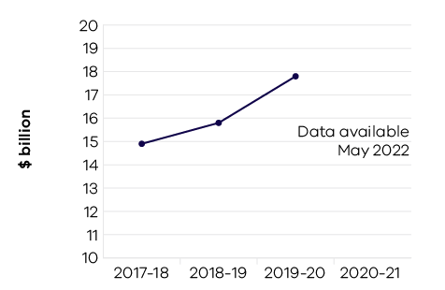
The total value of agriculture production in Victoria increased by 12.3 per cent to $17.8 billion in 2019–20 (the latest available data), compared to $15.8 billion in 2018–19. There were increases in the value of production in beef and lamb livestock, grain, and horticulture industries.
The impact of COVID-19 on Victorian agricultural produce and food and beverage products is estimated at $1.24 billion in 2019–20 and has continued in 2020–21. To mitigate the impact, the Victorian Government introduced a $57 million Agriculture Workforce Plan. An additional $19.3 million was provided for the seasonal workforce program. The program was introduced to support agriculture businesses throughout the COVID-19 pandemic and to help address seasonal workforce shortages.
Post 2019–20 bushfire recovery services in the North East and East Gippsland regions were well received in 2020–21. Support has been provided through delivery of over 2000 services despite COVID-19 impacts. Agriculture Victoria has provided technical information and assistance focused on pasture recovery, managing debris in stock water supplies, erosion control, feed planning and seasonal forecasting outlook. In addition, the department promoted other assistance available including grants, health and well-being support, and the Rural Financial Counselling Services.
In 2020–21, the Victorian agriculture sector experienced a significant flood and storm event across the Central Highlands, Yarra Ranges, and Central Gippsland, and is still recovering from the dry seasonal conditions particularly in the far North West, Central and East Gippsland regions of the state. Support was provided to producers and industry in affected regions to identify any urgent animal welfare needs and record property, livestock, and horticulture impacts. Recovery support will continue for some time to assist impacted producers with technical advice on issues including stock health, nutrition and feed budgeting, fencing, pasture recovery and grazing management, soil erosion, dams and waterways, and horticulture.
In 2020–21, Agriculture Victoria responded to the largest recorded outbreak of avian influenza in Australia, which included three different strains of avian influenza across six commercial poultry properties and one related composting property. Victoria’s response involved containment through movement restrictions, with declaration of control and restricted control areas, and eradication of the virus and decontamination of the infected premises. A surveillance program is underway to provide confidence that the disease has been eradicated and support a case for Australia being declared free from the disease. Over 17,000 diagnostic tests have been performed as part of this process.
Agriculture Victoria continued to deliver critical research and innovation in 2020–21. Research and innovation in major industries, including dairy, grains and horticulture, as well as in emerging bioindustries, was delivered through multi-disciplinary research collaborations with industry that accelerate and enhance productivity impacts. For example, the DairyBio initiative, a partnership with the dairy industry, has delivered accelerated precision breeding of forages with commercial partners using genomic selection and hybrid breeding. The result is a significant boost to genetic gain – up to five times – and an increase in yields of 20 per cent.
Agriculture Victoria developed the Agriculture Sector Pledge that commits to protect and enhance the future of the Victorian agriculture sector, respond to climate change and reduce emissions. The program is delivering a long-term vision, flagship research trials, and practical information, tools and services to help farmers reduce emissions while maintaining productivity.
Agriculture Victoria is shaping the future of agriculture through delivery of skills programs in Science, Technology, Engineering and Mathematics (STEM) and digital agriculture to schools, PhD students, agriculture industries and regional communities. In 2020–21, over 800 students were able to participate in AgSTEM workshops delivered remotely under COVID-19 restrictions.

Indicator: Value of Victorian food and fibre exports

Table 27: Value of Victorian food and fibre exports
Measure (unit of measure) | 2017–18 | 2018–19 | 2019–20 | 2020–21
Food and fibre exports from Victoria ($ billion) | 14.1 | 14.2 | 14.5 | Data available May 2022

Figure 24: Food and fibre exports from Victoria
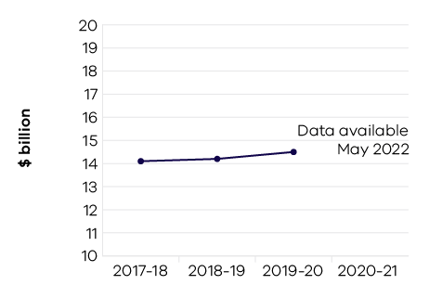
The government has a target to grow Victorian food and fibre exports to $20 billion per annum by 2030. In 2019–20, Victoria maintained its strong export performance, generating food and fibre exports valued at $14.5 billion despite challenges caused by COVID-19, drought and dry seasonal conditions. This was an increase of nearly $300 million (two per cent) on the previous year – keeping Victoria as the nation’s largest food and fibre exporter with 28 per cent of the national total. China was Victoria’s largest food and fibre export destination at $4.8 billion.
Food and fibre exports from Victoria represented almost half (47 per cent) of all Victoria’s goods exports in 2019–20. Victoria’s top five valuable food exports are meat ($4.7 billion), dairy ($2.1 billion), horticulture ($1.6 billion), prepared foods ($1.3 billion) and grains ($1.1 billion).
Export performance for Victorian meat products remained strong despite challenging domestic conditions, with export value increasing from $4.1 billion in 2018–19 to $4.7 billion in 2019–20, an increase of $600 million (14 per cent). Beef ($2.9 billion – total farm gate production) and sheep meat ($2.2 billion – total farm gate production) were the most valuable meat export categories.
The value of fibre exports decreased by $1.7 billion on the previous year to $1.4 billion in response to market volatility and seasonal conditions. Victoria is the largest wool producing state and the largest wool exporter, producing 28 per cent of Australia’s total wool and accounting for 52 per cent of the nation’s exports in 2019–20.

Indicator: Metres drilled for minerals exploration in Victoria

Table 28: Metres drilled for minerals exploration in Victoria
Measure (unit of measure) | 2017–18 | 2018–19 | 2019–20 | 2020–21
Metres drilled for minerals exploration in Victoria (metres) | 191,229 | 337,654 | 388,662 | Data available November 2021
Source: Geological Survey of Victoria, (GSV) mineral companies’ exploration reports that GSV is required to audit.

Figure 25: Metres drilled for minerals exploration in Victoria
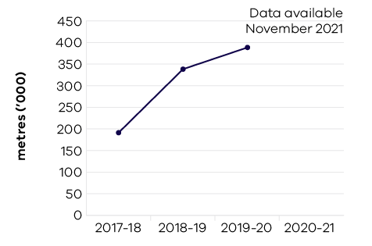
The level of metres drilled for minerals exploration in Victoria during 2019–20 was 388,662 metres. This represents an increase of 51,009 metres or 15.1 per cent compared to 2018–19. The increased level of minerals drilling in 2019–20 reflects a combination of drilling at existing mining licences (i.e. operations) such the Fosterville, Stawell and Ballarat East mines and increased mineral exploration drilling activity for new resources
across the State.
Mineral exploration on mining licences accounts for 58 per cent of the drill metres, this reflects existing operations investing in exploration with the aim of replacing the resource that has been mined to deliver future production opportunities. Mineral exploration drilling on exploration licences accounts for 33 per cent of the metres drilled in 2020–21 and combined with retention licences has increased year on year since 2014–15, which highlights the increasing level of interest and investment to discover new mineral resources in Victoria. Retention licences account for the remaining nine per cent.
The level of metres drilled for minerals exploration has more than quadrupled since 2014–15 reflecting the renewed interest for exploring in Victoria. The Stavely Minerals Exploration Initiative in western Victoria and the north central Victorian goldfields ground release, supported by world class pre-competitive geoscience data and knowledge (generated and made available by the Geological Survey of Victoria), are attracting further exploration investment to the state. This is demonstrated through the $114 million increase in mineral exploration since 2014–15, with Victoria experiencing record levels of exploration investment. Total exploration for 2019–20 was $136.5 million. This has continued in 2020–21 with the nine months to March generating exploration investment of $129.2 million. The March 2021 quarter expenditure for Victorian minerals exploration was $51.5 million, the highest ever recorded.

Indicator: Level of production of minerals and extractives

Table 29: Level of production of minerals and extractives
Measure (unit of measure) | 2017–18 | 2018–19 | 2019–20 | 2020–21
Annual production of brown coal (1000 tonnes) | 45,062 | 42,256 | 40,372 | Data available November 2021
Annual production of gold (ounces) | 364,294 | 567,501 | 792,267 | Data available November 2021
Annual production of antimony (tonnes) | 2,570 | 2,016 | 3,141 | Data available November 2021
Annual production of mineral sands (tonnes) | 100,286 | 0 | 61,197 | Data available November 2021
Annual production of extractives (million tonnes) | 61.16 | 62.86 | 63.11 | Data available November 2021
Source: Earth Resources Regulation 2018-19 Statistical Report

Figure 26: Annual production of brown coal (1000 tonnes)
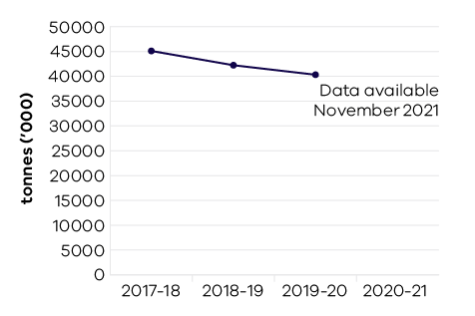

Figure 27: Annual production of gold (ounces)
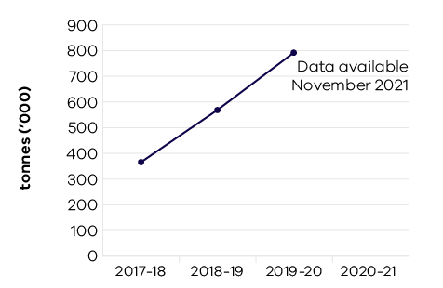

Figure 28: Annual production of antimony (tonnes)
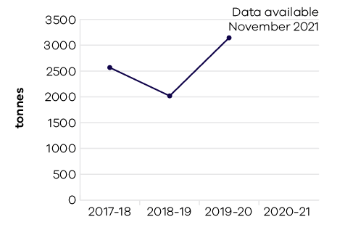

Figure 29: Annual production of mineral sands (tonnes)
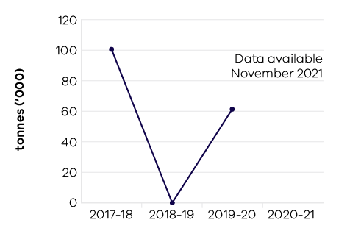

Figure 30: Annual production of extractives (million tonnes)
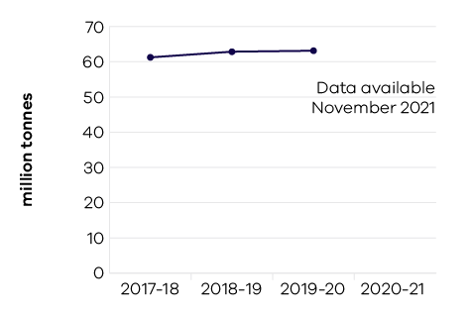
Gold production in Victoria has continued to grow with a 39.6 per cent increase during 2019–20 compared to 2018–19. Since 2014–15 annual gold production has increased by 593,880 ounces, a quadrupling of the 2014–15 production level. This mainly reflects the successful exploration and development activities at the Fosterville gold mine in central Victoria. Future success in the gold industry will be driven by new exploration in the Stavely region in western Victoria, new activity generated from the north central Victorian Goldfields Ground Release and further development of existing mines.
Victoria’s ‘Big Build’ is seeing record levels of investment in critical infrastructure covering major construction and transport initiatives. This continues to drive the current demand for extractives material and is projected to grow to over 100 million tonnes by 2050. Secure supplies of sand, stone and gravel resources will support ongoing construction investment. During 2019–20 extractives production slightly increased to 63.1 million tonnes.
This represents an increase of 24 per cent over five years from 2014–15.
Brown coal production decreased by 4.5 per cent during 2019–20 to 40.4 million tonnes. This reflects the impact of increasing renewable energy sources for electricity generation and the impact of the closure of the Hazelwood coal mine on 31 March 2017. This trend is forecast to continue, and it was announced by Energy Australia in March 2021 that the Yallourn coal mine would close in 2028, four years ahead of schedule.
Reported mineral sands production in 2019–20 was 61,197 tonnes consisting of Ilmenite extracted from stockpiles near Ouyen, western Victoria. There is significant potential for new mineral sands projects in Victoria in the Murray and Gippsland Basins. The Fingerboards Mineral Sands Project in the Glenaladale deposit, about 20km northwest of Bairnsdale in East Gippsland, Victoria, is working through the approval’s pathway. The Minister for Planning has appointed an Inquiry and Advisory Committee (IAC) to consider submissions to the Environment Effects Statement. The project has the potential to be a major producer of zircon, ilmenite, rutile and rare earths. This project may generate $200 million in new investment and create 200 direct jobs over the 15 to 20-year life of the project.
Antimony is produced from Australia’s only antimony mine at Costerfield in central Victoria. Production increased by 56 per cent in 2019–20 from a low base.

Performance against output performance measures
Table 30 represents performance against the Agriculture output. This output delivers services to the agriculture, food and fibre sectors to enhance productivity, connect the sector with international markets, create jobs, support growth and maintain effective biosecurity. It delivers effective and efficient regulation, compliance, emergency management, biosecurity research and development, and diagnostic services to protect and enhance market access by addressing trade barriers and managing the risks of pests, diseases and chemical use. The department undertakes research and development to develop new technologies and practices, and provides services to enhance their adoption to increase farm productivity and supply chain efficiencies. It provides policy advice and support to industries and businesses to innovate, manage economic and climatic volatility, natural disasters and biosecurity emergencies, and meet consumer and community expectations for food quality, food safety and animal welfare and environmental standards.
The output also creates the conditions to grow the natural resources economy by ensuring forestry and game resources are sustainably allocated and used for both recreational and commercial purposes.

Table 30: Output – Agriculture
Performance measures | Unit of measure | 2020–21 actual | 2020–21 target | Performance variation (%) | Result
Agriculture Industry Development and Regulation
This sub-output supports a more productive, competitive, sustainable and jobs-rich food and fibre sector by delivering policy advice, regulation and support to meet consumer and community expectations for agriculture industry development, pets and animal welfare, regulatory policies and frameworks.
Quantity
Farms and related small businesses facing  significant adjustment pressures supported  to make better-informed decisions by the  Rural Financial Counselling Service | number | 1,511 | 1,700 | -11.1% | #
Lower result due to favourable seasonal conditions and commodity pricing, indicating less financial stress for farmers and therefore less demand for the Rural Financial Counselling Service, which is a demand driven service.
Inspections or audits of scientific establishments undertaken to provide assurance of compliance with relevant industry standards for animal welfare | number | 18 | 25 | -28.0% | #
Lower result due to COVID-19 restrictions which impacted the ability to conduct site visits for inspections and audits. Emergency deployments of staff also reduced capacity.
Number of small scale local and craft producers attending workshops / mentoring programs | number | 52 | 50 | 4.0% | *
Strategic agriculture industry development  and regulatory policy briefings | number | 8 | 8 | 0.0% | *
Visits of the Responsible Pet Ownership program  to Victorian kindergartens and primary schools | number | 243 | 3,100 | -92.2% | #
Lower result due to COVID-19 restrictions, which required learning from home and prohibited external visitors to pre-schools and schools. Responsible Pet Ownership (RPO) educators and their dogs could not undertake school visits for an extended period of time. Learning materials were developed to provide access to some aspects of the RPO Program online.
Young farmer scholarships awarded | number | 13 | 12 | 8.3% | *
Higher result due to availability of program budget. The allocated annual budget allows for twelve $10,000 scholarships to be awarded each year. Where applications are received for less than the maximum scholarship allowable, this provides the opportunity to provide additional scholarships.
Quality
Grant recipients who met or exceeded agreed milestones | per cent | 75 | 75 | 0.0% | *
Timeliness
Performance and grant agreements acquitted within timeframes specified in the funding agreement | per cent | 90 | 90 | 0.0% | *
Cost
Total output cost | $ million | 211.2 | 224.9 | -6.1% | *
The 2020–21 result was lower than the 2020–21 budget primarily due to the accounting treatment associated with the Royal Melbourne Showgrounds Redevelopment expenditure.
Agriculture Research
This sub-output supports more productive, competitive, sustainable and jobs-rich food and fibre sectors by delivering research and innovation to develop innovative new technologies and farming systems that increase food and fibre productivity and product quality.
Quantity
Applications for intellectual property protection | number | 17 | 16 | 6.3% | *
Higher result due to an increase in the number of new trademarks filed that provide key branding for previously registered intellectual property.
Commercial technology licence agreements finalised | number | 16 | 16 | 0.0% | *
Genetic improvement of dairy cows achieved through breeding contributing to increased milk production  and dairy productivity | per cent | 1 | 1 | 0.0% | *
Key bioscience platform technologies established | number | 1 | 1 | 0.0% | *
Postgraduate-level/PhD students in training | number | 68 | 65 | 4.6% | *
Value of co-investment from external (non-state) funding sources attracted to the Department’s research projects that support productive agriculture | $ million | 42.9 | 41 | 4.6% | *
Quality
Satisfaction rating of industry investors in agriculture productivity research and development | number | 9 | 7 | 28.6% | *
Higher result due to the continued success of the Agriculture Victoria Research partnership model where research is jointly designed, delivered and evaluated through a direct engagement and long-term partnership model with industry. This engagement model with industry will continue in 2021–22.
Scientific and technical publications subjected to independent peer review in international and national journals that promote productive agriculture | number | 264 | 260 | 1.5% | *
Timeliness
Provision of technical advice, diagnostic identification tests on pests and diseases including suspected exotics within agreed timeframes | per cent | 89 | 85 | 4.7% | *
Research project milestones and reports completed  on time | per cent | 85.6 | 90 | -4.9% | –
Cost
Total output cost | $ million | 150.1 | 147 | 2.1% | –
Biosecurity and Agriculture Services
This sub-output delivers biosecurity, agriculture and emergency management services and regulatory programs which support the food and fibre sector to achieve sustainable growth while managing risks and minimising adverse impacts
to the economy, environment and public health and safety.
Quantity
Animal pest, disease and residue control programs maintained to ensure Victorian agricultural produce complies with food safety and biosecurity standards required to access markets | number | 4 | 5 | -20.0% | #
Lower result due to redirection of staff to Biosecurity emergencies, Whole of Victorian Government response to COVID-19, and COVID-19 public health restrictions to service delivery.
Clients engaged with agriculture services | number | 3,456 | 4,300 | -19.6% | #
Lower result due to redirection of staff to Biosecurity emergencies, Whole of Victorian Government response to COVID-19, and COVID-19 public health restrictions impact to service delivery.
Improved agricultural services, programs and products developed | number | 10 | 10 | 0.0% | *
Known state prohibited weed sites monitored and treated in line with the relevant weed action plan | per cent | 95 | 95 | 0.0% | *
New or amended Interstate Certificate Assurance (ICA) or other market access accreditations developed  to restore or enable trade | number | 5 | 2 | 150.0% | *
Higher result due to external factors that are not directly influenced by the department. This includes changes to requirements of other jurisdictions, chemical use patterns, industry demand, and in response to new pest and/or disease incursions.
Plant pest, disease and residue control programs maintained to ensure Victorian agricultural produce complies with food safety and biosecurity standards required to access markets | number | 6 | 6 | 0.0% | *
Properties inspected for invasive plant and animal priority species | number | 2,581 | 2,700 | -4.4% | –
Quality
Client satisfaction rating of agricultural services | number | 8.6 | 8 | 7.5% | *
Higher result due to greater emphasis on the design of client-focused services.
National biosecurity, agriculture/veterinary chemical use and animal welfare programs implemented  in accordance with agreed plans | per cent | 100 | 95 | 5.3% | *
Higher result due to Victoria responding to all requests associated with national work programs (i.e. National Management Group, National Biosecurity Committee, Agriculture Ministers meeting, Agriculture Secretaries Committee).
Preparedness activities implemented, in line  with agreed plans, to ensure response readiness  for emergency animal and plant pest, disease  and natural disaster incidents | per cent | 86 | 90 | -4.4% | –
Timeliness
Animal and plant certificates issued within specified timeframes to support domestic and international market access | per cent | 96.5 | 95 | 1.6% | *
Initial action taken to respond to reported emergency animal and plant pest, disease and natural disaster incidents complies with national agreements  and obligations | per cent | 100 | 100 | 0.0% | *
Cost
Total output cost | $ million | 140.2 | 113.5 | 23.6% | #
The 2020–21 result was higher than 2020–21 budget primarily due to additional expenditure incurred in 2020–21 for the avian influenza
and Khapra beetle biosecurity responses.
Sustainably manage forest and game resources
This sub-output creates the conditions to grow the natural resources economy by ensuring forestry and game resources are sustainably allocated and used for both recreational and commercial purposes.
Quantity
Key statutory obligations relevant to the Game Management Authority complied with (tabling annual report, audits, business plan and board appointments) | per cent | 100 | 100 | 0.0% | *
Key statutory obligations relevant to VicForests complied with (tabling annual reports, audits, corporate plan and board appointments) | per cent | 75 | 100 | -25.0% | #
VicForests did not provide a Corporate Plan for 2020–21 due to ongoing uncertainty and legal challenges associated with the transition away from native timber harvesting.
Timeliness
Facilitate the delivery of game projects in line with  key project milestones | per cent | 100 | 100 | 0.0% | *
Facilitate the delivery of the Victorian Forestry Plan  in line with key project milestones | per cent | 100 | 100 | 0.0% | *
Cost
Total output cost | $ million | 85.3 | 78.8 | 8.3% | #
The 2020–21 result was higher than 2020–21 budget primarily due to additional funding received in 2020–21 for the implementation of the Victorian Forestry Plan.
Note:
* Performance target achieved or exceeded
– Performance target not achieved – within 5 per cent variance
# Performance target not achieved – exceeds 5 per cent variance
Table 31 represents performance against the Resources output. This output develops and delivers policy, programs and regulation to enable investment and generate jobs through the sustainable development
of the state’s earth resources, including extractives, minerals and petroleum.
The department acquires and provides access to high-quality geoscience data and knowledge to inform government decision making and attract new investment and jobs to the state. It develops and implements legislative and regulatory reforms in the earth resources sector to improve outcomes for all stakeholders.
By supporting investment in resources and low emission technologies, the department fosters innovation, productivity, jobs and trade in the state’s earth resources sector. Through strategic resource and related land use planning, new opportunities are able to be identified for Victoria’s earth resources, along with supporting major infrastructure development in the state.
The department also regulates the earth resources sector through transparent, consistent and timely regulatory processes that provide industry with confidence to invest and have regard to the needs
of communities and minimise impacts to the environment.

Table 31: Output – Resources
Performance measures | Unit of measure | 2020–21 actual | 2020–21 target | Performance variation (%) | Result
Quantity
Community and stakeholder engagement  information forums | number | 55 | 55 | 0.0% | *
Quality
Exploration and mining licences which are active | per cent | 82.6 | 82.5 | 0.1% | *
Timeliness
Delivery of key CarbonNet milestones, in line with funding agreements and agreed project deliverables | per cent | 81.8 | 100 | -18.2% | #
Lower result mainly due to the impact of legislative delays impacting the submission of a regulatory application.
The application will proceed once the legislation is in place.
Extractive Industries Work Authority work plans processed within regulatory timeframes | per cent | 97 | 95 | 2.1% | *
Facilitate the delivery of resources projects in line  with grant agreements and project milestones | per cent | 82.3 | 100 | -17.7% | #
Lower result mainly due to the impact of delays in obtaining native title approvals delaying the award of TARGET exploration grants, and scheduling delays for other programs.
Industry geoscience data packages released  for minerals and petroleum sectors consistent  with agreed timelines | number | 10 | 10 | 0.0% | *
Mineral licence applications and work plans processed within regulatory timeframes | per cent | 71.3 | 95 | -24.9% | #
Lower result due to the impact of the record level of minerals exploration activity in Victoria, driving a significant increase in the volume of licence applications.
Regulatory audits completed within agreed timelines | per cent | 98.6 | 98 | 0.6% | *
Cost
Total output cost | $ million | 74.6 | 73.2 | 2.0% | –
Note:
* Performance target achieved or exceeded
– Performance target not achieved – within 5 per cent variance
# Performance target not achieved – exceeds 5 per cent variance

